Table of Contents

UNITED STATES

SECURITIES AND EXCHANGE COMMISSION
Washington, D.C. 20549

SCHEDULE 14A INFORMATION

Proxy Statement Pursuant to Section 14(a) of the
Securities Exchange Act of 1934

Filed by the Registrant ☒

Filed by a Party other than the Registrant o

Check the appropriate box:

- Preliminary Proxy Statement

- Confidential, For Use of the Commission only (as permitted by Rule 14a-6(e)(2))

- Definitive Proxy Statement

- Definitive Additional Materials

- Soliciting Material Pursuant to ss.240.14a-12

ALTISOURCE PORTFOLIO SOLUTIONS S.A.

(Name of Registrant as Specified in its Charter)

N/A

(Name of Person(s) Filing Proxy Statement, if other than the Registrant)

Payment of Filing Fee (Check the appropriate box):

- No Fee Required

- Fee computed on table below per Exchange Act Rules 14a-6(i)(1) and 0-11

- Title of each class of securities to which transaction applies: N/A

- Aggregate number of securities to which the transaction applies: N/A

- Per unit price or other underlying value of transaction computed pursuant to Exchange Act Rule 0-11 (Set forth the amount on which the filing fee is calculated and state how it was determined.):

N/A

- Proposed maximum aggregate value of transaction:
N/A
- Total fee paid:

oFee paid previously with preliminary materials.

  - Check box if any part of the fee is offset as provided by Exchange Act Rule 0-11(a)(2) and identify the filing for which the offsetting fee was paid previously. Identify the previous filing by registration statement number, or the Form or Schedule and the date of its filing.

- Amount Previously Paid:
N/A
- Form, Schedule or Registration Statement No.: N/A

- Filing Party:
N/A
- Date Filed: N/A

Table of Contents


April [ ], 2017

Dear Fellow Shareholder:

On behalf of the Board of Directors, we cordially invite you to attend the Annual Meeting of Shareholders of Altisource Portfolio Solutions S.A. (the "Annual Meeting") which will be held at the registered office of the Company located at 40, avenue Monterey, L-2163 Luxembourg City, Grand Duchy of Luxembourg on Wednesday, May 17, 2017, at 9:00 a.m. Central European Time. We will also hold an Extraordinary Meeting of Shareholders (the "Extraordinary Meeting") at 10:00 a.m. Central European Time on the same day and in the same location. The Board of Directors is convening the Extraordinary Meeting in order to consider certain amendments to the Company's Articles of Incorporation, as more fully set forth in the accompanying materials. Further details regarding admission to the Annual Meeting and Extraordinary Meeting as well as the business to be conducted at each meeting are also more fully described in the accompanying materials.

It is very important that you be represented at the Annual Meeting and the Extraordinary Meeting regardless of the number of shares you own or whether you are able to attend the meetings in person. IMPORTANT NOTE REGARDING PROXY CARDS: If you are a shareholder of record (that is, you hold your shares in your name as a holder of record with our transfer agent), you will receive two proxy cards—one for the Annual Meeting and one for the Extraordinary Meeting. It is very important that you return all proxy cards to ensure that your vote is represented at the relevant meetings. Whether or not you plan to attend the meetings, please complete, date and sign the enclosed proxy cards and return them in the enclosed envelope as promptly as possible so that your shares may be represented at the relevant meetings and voted in accordance with your wishes. If your shares are held through a bank or broker, please follow the voting instructions you receive from your bank or broker. This will not prevent you from voting in person but will ensure that your vote is counted if you are unable to attend.

Thank you for your support and interest in Altisource Portfolio Solutions S.A.

Sincerely,

Timo Vättö | William B. Shepro
Chairman of the Board of Directors | Chief Executive Officer and Director
 | 40, avenue Monterey, L-2163 Luxembourg, +352 2469 7900

Table of Contents

ALTISOURCE PORTFOLIO SOLUTIONS S.A.

JOINT PROXY STATEMENT

TABLE OF CONTENTS

 |  |  |  |  |  |  |  |  |  |  |  |  |  |  |  |  |  |  |  |  |  |  |  |  |  |  |  |  |  | PAGE
NOTICE OF ANNUAL MEETING OF SHAREHOLDERS AND IMPORTANT NOTICE REGARDING THE AVAILABILITY OF PROXY
 | MATERIALS FOR THE ANNUAL MEETING OF SHAREHOLDERS TO BE HELD ON MAY 17, 2017 |  |  |  |  |  |  |  |  |  |  |  |  |  |  |  |  |  |  |  |  |  |  |  |  |  |  |  |  |  |  | 4
NOTICE OF EXTRAORDINARY MEETING OF SHAREHOLDERS AND IMPORTANT NOTICE REGARDING THE AVAILABILITY OF
 | PROXY MATERIALS FOR THE EXTRAORDINARY MEETING OF SHAREHOLDERS TO BE HELD ON MAY 17, 2017 |  |  |  |  |  |  |  |  |  |  |  |  |  |  |  |  |  |  |  |  |  |  |  |  |  |  |  |  | 7
ANNUAL MEETING OF SHAREHOLDERS AND EXTRAORDINARY MEETING OF SHAREHOLDERS |  |  |  |  |  |  |  |  |  |  |  |  |  |  |  |  |  |  |  |  |  |  |  |  |  |  |  |  |  | 9
 | ANNUAL MEETING OF SHAREHOLDERS |  |  |  |  |  |  |  |  |  |  |  |  |  |  |  |  |  |  |  |  |  |  |  |  |  |  |  |  | 12
 |  | PROPOSAL ONE: ELECTION OF DIRECTORS |  |  |  |  |  |  |  |  |  |  |  |  |  |  |  |  |  |  |  |  |  |  |  |  |  |  |  |  | 12
 |  | BOARD OF DIRECTORS AND CORPORATE GOVERNANCE |  |  |  |  |  |  |  |  |  |  |  |  |  |  |  |  |  |  |  |  |  |  |  |  |  |  |  | 16
 |  | BOARD OF DIRECTORS COMPENSATION |  |  |  |  |  |  |  |  |  |  |  |  |  |  |  |  |  |  |  |  |  |  |  |  |  |  |  |  | 23
 |  | EXECUTIVE OFFICERS WHO ARE NOT DIRECTORS |  |  |  |  |  |  |  |  |  |  |  |  |  |  |  |  |  |  |  |  |  |  |  |  |  |  |  | 26
 |  | SECURITY OWNERSHIP OF CERTAIN BENEFICIAL OWNERS AND RELATED SHAREHOLDER MATTERS |  |  |  |  |  |  |  |  |  |  |  |  |  |  |  |  |  |  |  |  |  |  |  |  |  |  |  | 28
 |  | COMPENSATION DISCUSSION AND ANALYSIS |  |  |  |  |  |  |  |  |  |  |  |  |  |  |  |  |  |  |  |  |  |  |  |  |  |  |  |  | 32
 |  | EXECUTIVE COMPENSATION |  |  |  |  |  |  |  |  |  |  |  |  |  |  |  |  |  |  |  |  |  |  |  |  |  |  |  |  | 48
 |  | PROPOSAL TWO: APPOINTMENT OF INDEPENDENT REGISTERED CERTIFIED ACCOUNTING FIRM AND CERTIFIED
 |  |  | AUDITOR (RÉVISEUR D'ENTREPRISES) |  |  |  |  |  |  |  |  |  |  |  |  |  |  |  |  |  |  |  |  |  |  |  |  |  |  | 56
 |  | PROPOSAL THREE: APPOINTMENT OF SUPERVISORY AUDITOR (COMMISSAIRE AUX COMPTES) |  |  |  |  |  |  |  |  |  |  |  |  |  |  |  |  |  |  |  |  |  |  |  |  |  |  |  | 61
 |  | PROPOSAL FOUR: APPROVAL OF THE COMPANY'S ANNUAL ACCOUNTS PREPARED IN ACCORDANCE WITH
 |  |  | LUXEMBOURG GAAP FOR THE YEAR ENDED DECEMBER 31, 2016 AND ITS CONSOLIDATED FINANCIAL STATEMENTS
 |  |  | PREPARED IN ACCORDANCE WITH U.S. GAAP INCLUDING A FOOTNOTE RECONCILIATION OF EQUITY AND NET
 |  |  | INCOME TO IFRS AS OF AND FOR THE YEAR ENDED DECEMBER 31, 2016 |  |  |  |  |  |  |  |  |  |  |  |  |  |  |  |  |  |  |  |  |  |  |  |  |  |  | 62
 |  | PROPOSAL FIVE: RECEIPT AND APPROVAL OF THE DIRECTORS' REPORTS FOR THE LUXEMBOURG STATUTORY
 |  |  | ACCOUNTS AND RECEIPT OF THE SUPERVISORY AUDITOR'S REPORTS FOR THE LUXEMBOURG ANNUAL ACCOUNTS |  |  |  |  |  |  |  |  |  |  |  |  |  |  |  |  |  |  |  |  |  |  |  |  |  |  |  | 63
 |  | PROPOSAL SIX: ALLOCATION OF THE RESULTS IN THE LUXEMBOURG ANNUAL ACCOUNTS FOR THE YEAR ENDED
 |  |  | DECEMBER 31, 2016 |  |  |  |  |  |  |  |  |  |  |  |  |  |  |  |  |  |  |  |  |  |  |  |  |  |  |  | 64
 |  | PROPOSAL SEVEN: DISCHARGE OF EACH OF THE DIRECTORS AND THE SUPERVISORY AUDITOR OF ALTISOURCE
 |  |  | PORTFOLIO SOLUTIONS S.A. FOR THE PERFORMANCE OF THEIR MANDATES |  |  |  |  |  |  |  |  |  |  |  |  |  |  |  |  |  |  |  |  |  |  |  |  |  |  | 65
 |  |  | 2

Table of Contents

 |  |  |  |  |  |  |  |  |  |  |  |  |  |  |  |  | PAGE
 |  | PROPOSAL EIGHT: RENEWAL OF OUR SHARE REPURCHASE PROGRAM |  |  |  |  |  |  |  |  |  |  |  |  |  |  | 66
 |  | PROPOSAL NINE: ADVISORY VOTE ON EXECUTIVE COMPENSATION ("SAY-ON-PAY") |  |  |  |  |  |  |  |  |  |  |  |  |  |  | 67
 |  | PROPOSAL TEN: ADVISORY VOTE ON FREQUENCY OF EXECUTIVE COMPENSATION SHAREHOLDER ADVISORY VOTE
 |  |  | ("SAY-ON-FREQUENCY") |  |  |  |  |  |  |  |  |  |  |  |  |  |  | 68
 | EXTRAORDINARY MEETING OF SHAREHOLDERS |  |  |  |  |  |  |  |  |  |  |  |  |  |  |  | 69
 |  | PROPOSAL ONE: AMEND THE COMPANY'S ARTICLES OF INCORPORATION TO RENEW AND EXTEND THE BOARD OF
 |  |  | DIRECTORS' AUTHORIZATION TO ISSUE SHARES OF THE COMPANY'S COMMON STOCK, WITHIN THE LIMITS OF THE
 |  |  | COMPANY'S AUTHORIZED SHARE CAPITAL |  |  |  |  |  |  |  |  |  |  |  |  |  | 69
 |  | PROPOSAL TWO: AMEND THE COMPANY'S ARTICLES OF INCORPORATION TO EFFECTUATE RECENT CHANGES IN
 |  |  | LUXEMBOURG COMPANY LAW |  |  |  |  |  |  |  |  |  |  |  |  |  | 71
BUSINESS RELATIONSHIPS AND RELATED PERSON TRANSACTIONS |  |  |  |  |  |  |  |  |  |  |  |  |  |  |  |  |  | 73
SHAREHOLDER PROPOSALS AND ANNUAL REPORTS |  |  |  |  |  |  |  |  |  |  |  |  |  |  |  |  |  | 75
OTHER MATTERS |  |  |  |  |  |  |  |  |  |  |  |  |  |  |  |  |  | 76
APPENDIX A: AMENDED AND RESTATED ARTICLES OF INCORPORATION |  |  |  |  |  |  |  |  |  |  |  |  |  |  |  |  | A-1
3

Table of Contents

ALTISOURCE PORTFOLIO SOLUTIONS S.A.

40, avenue Monterey
L-2163 Luxembourg City
Grand Duchy of Luxembourg

R.C.S. Luxembourg B 72 391

NOTICE OF ANNUAL MEETING OF SHAREHOLDERS AND IMPORTANT NOTICE REGARDING THE AVAILABILITY OF PROXY MATERIALS FOR THE ANNUAL MEETING OF SHAREHOLDERS TO BE HELD ON MAY 17, 2017

NOTICE

Our Annual Meeting of Shareholders ("Annual Meeting") will be held:

Date: Wednesday, May 17, 2017

Time: 9:00 a.m., Central European Time

Location: Altisource Portfolio Solutions S.A.

40, avenue Monterey
L-2163 Luxembourg City

Grand Duchy of Luxembourg

PURPOSE

- To elect six (6) Directors for a one (1) year term and/or until their successors are duly elected and qualified;

- To approve the appointment of Mayer Hoffman McCann P.C. to be our independent registered certified public accounting firm for the year ending December 31, 2017 and the appointment of Atwell S.à r.l to be our certified auditor (Réviseur d'Entreprises) for the same period;

- To approve the appointment of Michelle D. Esterman, Chief Financial Officer of the Company, to be our supervisory auditor (Commissaire aux Comptes) to report on Altisource Portfolio Solutions S.A.'s unconsolidated annual accounts prepared in accordance with accounting principles generally accepted in Luxembourg ("Luxembourg GAAP")(the "Luxembourg Annual Accounts") for the years ending December 31, 2017 through December 31, 2022, or until her successor is duly elected and qualified, and to ratify her appointment by the Board of Directors as our supervisory auditor to report on the Luxembourg Annual Accounts for the years ended December 31, 2009 through December 31, 2016;

- To approve the Luxembourg Annual Accounts for the year ended December 31, 2016 and Altisource Portfolio Solutions S.A.'s consolidated financial statements prepared in accordance with accounting principles generally accepted in the United States ("U.S. GAAP") including a footnote reconciliation of equity and net income to International Financial Reporting Standards ("IFRS") (the "Consolidated Accounts" and, together with the Luxembourg Annual Accounts, the "Luxembourg Statutory Accounts") as of and for the year ended December 31, 2016;

- To receive and approve the Directors' reports for the Luxembourg Statutory Accounts for the year ended December 31, 2016 and to receive the reports of the supervisory auditor (Commissaire aux Comptes) for the Luxembourg Annual Accounts for the years ended December 31, 2009 through December 31, 2016;

- To allocate the results in the Luxembourg Annual Accounts for the year ended December 31, 2016;

4

Table of Contents

- To discharge each of the Directors of Altisource Portfolio Solutions S.A. for the performance of their mandates for the year ended December 31, 2016 and the supervisory auditor (Commissaire aux Comptes) for the performance of her mandate for the years ended December 31, 2009 through December 31, 2016;

- To renew our share repurchase program such that Altisource Portfolio Solutions S.A. is authorized, for a period of five years from the date of the Annual Meeting, to repurchase up to twenty-five percent (25%) of the outstanding shares of its common stock (as of the close of business on the date of the Annual Meeting) at a minimum price of one dollar ($1.00) per share and a maximum price of five hundred dollars ($500.00) per share;

- To approve, on an advisory (non-binding) basis, the compensation of Altisource's named executive officers as disclosed in the joint proxy statement ("Say-on-Pay");

- To approve, on an advisory (non-binding) basis, the frequency of future shareholder advisory votes on executive compensation ("Say-on-Frequency"); and

- To transact such other business as may properly come before the meeting and any adjournment or postponement of the meeting.

PROCEDURES

- Our Board of Directors has fixed March 20, 2017 as the record date for the determination of shareholders entitled to notice of and to vote at the Annual Meeting.

- Only shareholders of record at the close of business on the record date will be able to vote at the Annual Meeting. In order to be admitted to the meeting, each shareholder will be asked to present proof of share ownership as of the record date and valid government-issued photo identification. If your shares are held in "street name" by a bank or broker, you will also need to obtain a "legal proxy" from the holder of record to vote at the meeting. Even if you plan to attend the Annual Meeting, we recommend that you vote your shares in advance of the meeting pursuant to the instructions listed in the accompanying materials so that your vote will be counted if you are unable to attend the Annual Meeting.

- The joint proxy statement for our Annual Meeting and Extraordinary Meeting of Shareholders and our annual report to shareholders on Form 10-K for the year ended December 31, 2016 are available on our website under Investor Relations-Financial Information at http://ir.altisource.com/financials.cfm. In accordance with Securities and Exchange Commission ("SEC") rules, you may access our joint proxy statement at http://www.proxyvote.com, a website that does not identify or track visitors to the site, by entering the Control Number found on your Notice and Access Card or on your proxy card in the space provided. Although Luxembourg law does not require a quorum for the conduct of business at the Annual Meeting, in accordance with the requirements of the NASDAQ listing standards, the Company has established that the presence at the Annual Meeting of holders of at least thirty-three and one-third percent (33¹/3%) of our issued and outstanding shares of common stock able to be voted, represented in person or by proxy, will constitute a quorum for the transaction of business at the Annual Meeting.

- The Luxembourg Statutory Accounts, the Directors' reports for the Luxembourg Statutory Accounts, the statutory auditor's report on the Consolidated Accounts and the supervisory auditor's reports on the Luxembourg Annual Accounts will be available for inspection at the Company's registered office from May 8, 2017 until the conclusion of the Annual Meeting. Copies are also available to any shareholder who requests them by writing to our Corporate Secretary at Altisource Portfolio

5

Table of Contents

Solutions S.A., 40, avenue Monterey, L-2163 Luxembourg City, Grand Duchy of Luxembourg after May 8, 2017.

By Order of the Board of Directors,

Kevin J. Wilcox
Corporate Secretary

April [ ], 2017
Luxembourg City, Grand Duchy of Luxembourg

6

Table of Contents

ALTISOURCE PORTFOLIO SOLUTIONS S.A.

40, avenue Monterey
L-2163 Luxembourg City
Grand Duchy of Luxembourg

R.C.S. Luxembourg B 72 391

NOTICE OF EXTRAORDINARY MEETING OF SHAREHOLDERS AND IMPORTANT NOTICE REGARDING THE AVAILABILITY OF PROXY MATERIALS FOR THE EXTRAORDINARY MEETING OF SHAREHOLDERS TO BE HELD ON MAY 17, 2017

NOTICE

Our Extraordinary Meeting of Shareholders ("Extraordinary Meeting") will be held:

Date: Wednesday, May 17, 2017

Time: 10:00 a.m. Central European Time

Location: Altisource Portfolio Solutions S.A.

40, avenue Monterey
L-2163 Luxembourg City

Grand Duchy of Luxembourg

PURPOSE

- To amend the Company's Articles of Incorporation to (i) renew and extend the authorization of the Board of Directors to issue shares of the Company's common stock, within the limits of the Company's authorized share capital of one hundred million dollars ($100,000,000) and, in connection with any such issuance, to limit or cancel the preferential subscription rights of shareholders, each for a period of five (5) years, as set forth in the proposed Amended and Restated Articles of Incorporation and (ii) receive the report issued by the Board of Directors pursuant to article 32 -3 (5) of the Luxembourg Law of 10 August 1915 on commercial companies, as amended (the "Luxembourg Company Law");

- To amend the Company's Articles of Incorporation to effectuate recent changes in the Luxembourg Company Law, as the Company is required to do pursuant to the Luxembourg Law of 10 August 2016 and to make certain other administrative changes as set forth in the proposed Amended and Restated Articles of Incorporation; and

- To transact such other business as may properly come before the meeting and any adjournment or postponement of the meeting.

PROCEDURES

- Our Board of Directors has fixed March 20, 2017 as the record date for the determination of shareholders entitled to notice of and to vote at the Extraordinary Meeting.

- Only shareholders of record at the close of business on the record date will be entitled to vote at the Extraordinary Meeting. In order to be admitted to the meeting, each shareholder will be asked to present proof of share ownership as of the record date and valid government-issued photo identification. If your shares are held in "street name" by a bank or broker, you will also need to obtain a "legal proxy" from the holder of record to vote at the meeting. Even if you plan to attend the Extraordinary Meeting, we recommend that you vote your shares in advance of the meeting in

7

Table of Contents

one of the manners listed in the accompanying materials so that your vote will be counted if you later are unable to attend the Extraordinary Meeting.

- The joint proxy statement for our Annual Meeting and Extraordinary Meeting, including the Company's proposed Amended and Restated Articles of Incorporation are available on our website under Investor Relations-Financial Information at http://ir.altisource.com/financials.cfm. In accordance with Securities and Exchange Commission ("SEC") rules, you may access our joint proxy statement at http://www.proxyvote.com, a website that does not identify or track visitors of the site, by entering the Control Number found on your Notice and Access Card or on your proxy card in the space provided.

- In accordance with Luxembourg law, the Extraordinary Meeting will validly deliberate on its agenda, provided, that a quorum representing fifty percent (50%) of our issued and outstanding shares of common stock able to be voted is reached. Under Luxembourg law, if a quorum is not reached at an extraordinary meeting for the purpose of resolving on the agenda thereof, the meeting may be adjourned or postponed to a later date at which time no quorum will be required, provided that certain notice procedures are fulfilled. In accordance with the requirements of the NASDAQ listing standards, in the event of such adjournment or postponement of the Extraordinary Meeting, the Company will require a quorum of thirty-three and one-third percent (33¹/3%) of our issued and outstanding shares of common stock able to be voted for the transaction of business. The resolutions concerning the agenda of the Extraordinary Meeting, or any adjournment or postponement thereof, will be approved by the affirmative vote of the holders of at least two-thirds of the shares validly voted.

- A copy of the proposed Amended and Restated Articles of Incorporation and the report of the Board of Directors pursuant to
article 32-3 (5) of the Luxembourg Company Law will be available for inspection at the Company's registered office from May 8, 2017 until the conclusion of the Extraordinary Meeting. Copies are also available to any shareholder who requests them by writing to our Corporate Secretary at Altisource Portfolio Solutions S.A., 40, avenue Monterey, L-2163 Luxembourg City, Grand Duchy of Luxembourg.

By Order of the Board of Directors,

Kevin J. Wilcox
Corporate Secretary

April [ ], 2017
Luxembourg City, Grand Duchy of Luxembourg

8

Table of Contents

ALTISOURCE PORTFOLIO SOLUTIONS S.A.

JOINT PROXY STATEMENT

ANNUAL MEETING OF SHAREHOLDERS AND EXTRAORDINARY MEETING OF SHAREHOLDERS

General Information

We have made this joint proxy statement available to you on or about April [ ], 2017 as a holder of common stock of Altisource Portfolio
Solutions S.A. ("Altisource" or the "Company") because our Board of Directors is soliciting your proxy to be used at our 2017 Annual Meeting and

our Extraordinary Meeting, and any adjournment or postponement thereof. The Annual Meeting will be held on Wednesday, May 17, 2017, at
9:00 a.m. Central European Time for the purposes listed in the Notice of Annual Meeting of Shareholders. The Extraordinary Meeting will be held

on the same day at 10:00 a.m. Central European Time for the purposes listed in the Notice of Extraordinary Meeting of Shareholders. Both
meetings will be held at our registered office located at 40, avenue Monterey, L-2163 Luxembourg City, Grand Duchy of Luxembourg.

Who May Vote

You are entitled to vote at the Annual Meeting and the Extraordinary Meeting, and any adjournment or postponement thereof, if you are a holder of our common stock at the close of business on March 20, 2017. At the close of business on March 20, 2017, there were 18,426,969 shares of common stock issued, outstanding and able to be voted and no other class of equity securities outstanding. Each share of our common stock is entitled to one (1) vote at the Annual Meeting and one (1) vote at the Extraordinary Meeting on all matters presented for a vote at such meetings.

Voting Procedures

If you are a shareholder of record, you will receive two proxy cards, one for the Annual Meeting and one for the Extraordinary Meeting. You must return the proxy cards by mail or vote by attending the meetings. The proxy cards will tell you how to vote your shares.

If the shares you own are held in "street name" by a bank or broker, you will need to follow the directions such bank or broker provides to you. As in prior years, we have elected to provide access to our proxy materials over the Internet by mailing a Notice of Internet Availability of Proxy Materials (the "Notice") to the majority of our shareholders. Shareholders may access the proxy materials on the website referred to in the Notice or request a printed set of the proxy materials. Instructions on how to access the proxy materials over the Internet or to request a printed copy may be found in the Notice.

In order to comply with Luxembourg legal requirements, our shareholders of record (shareholders who own our shares in their own name through our transfer agent) will not be able to vote their shares over the Internet or by telephone; however, shareholders who own our shares through a bank or broker will be authorized to vote their shares in any manner authorized by their bank or broker.

Shareholders may also vote in person at the meetings. All shareholders must present valid government-issued photo identification to vote at the meeting. If your shares are held by a bank or broker, you will also need to obtain a "legal proxy" from the holder of record to vote at the meeting. For specific instructions, please refer to the proxy card or Notice you receive.

Even if you plan to attend the meetings, we recommend that you vote your shares in advance of the meetings in one of the manners available to you so that your vote will be counted if you are unable to attend.

9

Table of Contents

How a Proxy Works

If you properly submit your proxy to Altisource and do not revoke it prior to its use, it will be voted in accordance with your instructions. Other than as discussed below with respect to "broker non-votes," if no contrary instructions are given, each proxy received for the Annual Meeting will be voted "FOR" each of the nominees for Director named in this joint proxy statement and "FOR" each of the other proposals identified in the agenda for the Annual Meeting; each proxy received for the Extraordinary Meeting will be voted "FOR" the proposals identified in the agenda for the Extraordinary Meeting; and, with regard to any other business that properly comes before either meeting, each proxy will be voted in accordance with the discretion of the persons appointed as proxies.

If the shares you own are held by a bank or broker and you do not provide specific voting instructions to your bank or broker on a "non-routine" item as defined by the New York Stock Exchange, the bank or broker will be prohibited from voting your shares. This is commonly referred to as a "broker non-vote." All of our proposals other than the proposal to approve the appointment of our independent registered certified accounting firm and certified auditor are expected to be "non-routine" proposals and, therefore, if you do not instruct your bank or broker how to vote your shares with respect to these proposals, your shares will not be counted.

How to Revoke a Proxy

Your proxies may be used only at the relevant meetings and any adjournment or postponement thereof, and will not be used for any other meeting.

You have the power to revoke your proxy at any time before it is exercised by:

- filing written notice with our Corporate Secretary at the following address:

Kevin J. Wilcox, Corporate Secretary
Altisource Portfolio Solutions S.A.
40, avenue Monterey
L-2163 Luxembourg City

Grand Duchy of Luxembourg

- submitting a properly executed proxy bearing a later date; or

- appearing at the relevant meeting and giving the Corporate Secretary notice of your intention to vote in person.

Quorum and Voting Information

Although Luxembourg law does not require a quorum for the conduct of business at the Annual Meeting, in accordance with the requirements of the NASDAQ listing standards, the Company has established that the presence at the Annual Meeting of holders of at least thirty-three and one-

third percent (33¹/3%) of our issued and outstanding shares of common stock able to be voted, represented in person or by proxy, will constitute a quorum for the transaction of business at the Annual Meeting.

For the transaction of business at the Extraordinary Meeting, the presence of holders of at least fifty percent (50%) of our issued and outstanding shares of common stock able to be voted will constitute a quorum in accordance with Luxembourg law. Under Luxembourg law, if a quorum is not reached at an extraordinary meeting for the purpose of resolving on the agenda thereof, the meeting may be adjourned or postponed to a later date at which time no quorum will be required, provided that certain notice procedures are fulfilled. In accordance with the requirements of the NASDAQ listing standards, in the event of such adjournment or postponement of the Extraordinary Meeting, the Company will require a quorum of thirty-three and one-third percent (33¹/3%) of our issued and outstanding shares of common stock able to

10

Table of Contents

be voted for the transaction of business. Abstentions and "broker non-votes" will be treated as present for purposes of a quorum.

Pursuant to Luxembourg law and assuming a quorum, the six (6) nominees for Director will be elected as Directors of Altisource at the Annual Meeting so long as the votes cast in favor of each such person exceed the votes cast against such person. You may vote for, against or abstain from voting for one (1) or more nominees for Director. The following Annual Meeting proposals will be approved if the votes cast in favor of the action exceed the votes cast against the action: the proposal to approve the appointment of Mayer Hoffman McCann P.C. ("Mayer Hoffman") to be our independent registered certified public accounting firm for the year ending December 31, 2016 and Atwell S.à r.l. ("Atwell") (Réviseur d'Entreprises) to be our certified auditor for all statutory accounts as required by Luxembourg law for the same period; the proposal to approve the appointment of Michelle D. Esterman, Chief Financial Officer of the Company, to be our supervisory auditor (Commissaire aux Comptes) to report on the Luxembourg Annual Accounts for the years ending December 31, 2017 through December 31, 2022, or until her successor is duly elected and qualified, and to ratify her appointment by the Board of Directors as our supervisory auditor to report on the Luxembourg Annual Accounts for the years ended December 31, 2009 through December 31, 2016; the proposal to approve the Luxembourg Statutory Accounts as of and for the year ended December 31, 2016; the proposal to receive and approve the Directors' reports for the Luxembourg Statutory Accounts for the year ended December 31, 2016 and to receive the reports of the supervisory auditor for the Luxembourg Annual Accounts for the years ended December 31, 2009 through December 31, 2016; the proposal to allocate the results in the Luxembourg Annual Accounts for the year ended December 31, 2016; the proposal to approve the discharge of each of the Directors of Altisource Portfolio Solutions S.A. for the performance of their mandate during the year ended December 31, 2016 and the supervisory auditor for the performance of her mandate for the years ended December 31, 2009 through December 31, 2016; the proposal to approve the renewal of our share repurchase program whereby Altisource Portfolio Solutions S.A. is authorized, for a period of five years, to repurchase up to twenty-five percent (25%) of the outstanding shares of its common stock (as of the close of business on the date of the Annual Meeting) at a minimum price of one dollar ($1) per share and a maximum price of five hundred dollars ($500) per share; the advisory vote to approve the compensation of Altisource's named executive officers as disclosed in the Proxy Statement ("Say-on-Pay"); and any other matter properly submitted for your consideration at the Annual Meeting. The approval of the advisory vote on the frequency of future shareholder advisory votes on executive compensation ("Say-On-Frequency") will be determined based on the frequency that receives the most votes. While our Board of Directors intends to carefully consider the shareholder votes resulting from the Say-On-Pay and Say-On-Frequency proposals, the final votes will not be binding on us and are advisory in nature.

Pursuant to Luxembourg law and assuming a quorum, the following Extraordinary Meeting proposals will be approved if the votes cast in favor of the action exceed two-thirds of the shares validly voted: the proposal to amend the Company's Articles of Incorporation to (i) renew and extend the authorization of the Board of Directors to issue shares of the Company's common stock, within the limits of the Company's authorized share capital of one hundred million dollars ($100,000,000) and, in connection with any such issuance, to limit or cancel the preferential subscription rights of shareholders, each for a period of five (5) years, as set forth in the proposed Amended and Restated Articles of Incorporation and (ii) receive the report issued by the Board of Directors pursuant to article 32 -3 (5) of the Luxembourg Company Law; the proposal to amend the Company's Articles of Incorporation to effectuate recent changes in the Luxembourg Company Law, as the Company is required to do pursuant to the Luxembourg Law of 10 August 2016 and to make certain other administrative changes as set forth in the proposed Amended and Restated Articles of Incorporation; and any other matter properly submitted for your consideration at the Extraordinary Meeting.

Any other matter properly submitted for your consideration will be approved with such vote as required by Luxembourg law. Abstentions will not be counted in determining the votes cast in connection with the proposals in the agendas of the Annual Meeting and Extraordinary Meeting.

11

Table of Contents

PROPOSALS TO BE CONSIDERED AT THE ANNUAL MEETING OF SHAREHOLDERS

ELECTION OF DIRECTORS

(Proposal One)

Our Articles of Incorporation provide that our Board of Directors shall consist of no less than three (3) and no more than seven (7) members with the exact number to be decided by our shareholders.

We are proposing the six (6) nominees listed below for election as Directors at the Annual Meeting for a one (1) year term and/or until their successors are duly elected and qualified.

All nominees other than Mr. Morettini currently serve as our Directors. There are no arrangements or understandings between any nominee and any other person for selection as a nominee.

If any nominee is unable or unwilling to stand for election at the time of the Annual Meeting, the shares represented by a validly executed proxy will be voted for the election of such other person as the Board of Directors may recommend in his place, unless the Board of Directors chooses to reduce the number of Directors serving on the Board. At this time, our Board of Directors knows of no reason why any of the nominees would not be able or willing to serve as Director if elected.

The following table sets forth certain information concerning each of our nominees for Director:

 |  |  |  |  |  |  |  |  |  |  |  |  |  | Nomination/
 |  | Age⁽¹⁾ |  | Director |  | Executive |  | Audit |  | Compensation |  | Compliance |  | Governance
Name |  | Age⁽¹⁾ |  | Since |  | Committee |  | Committee |  | Committee |  | Committee |  | Committee
Orin S. Kramer | 71 |  | 2016 |  |  |  |  |  |  | _{X}(2) |  | _{X}(2) |  | _{X}(2)
W. Michael Linn | 68 |  | 2011 |  |  |  |  | X |  | _{X}(3) |  | _{X}(4) |  | _{X}(4)
Roland Müller-Ineichen | 56 |  | 2009 |  |  |  |  | _{X}(4) |  | X |  | X |  | _{X}(3)
William B. Shepro | 48 |  | 2009 |  |  | X
Timo Vättö⁽⁵⁾ | 52 |  | 2009 |  |  | _{X}(4) |  | X |  | _{X}(4) |  | _{X}(3) |  | X
Joseph L. Morettini⁽⁶⁾ | 64 |  |  | N/A
- As of March 20, 2017

- Committee member effective November 15, 2016
- Committee member through November 14, 2016
- Committee Chairman for 2016

- Chairman of the Board of Directors
- Mr. Morettini will be appointed to one or more Committees after the Annual Meeting if he is elected to our Board of Directors

The principal occupation for the last five (5) years and additional biographical information of each nominee for Director are set forth below.

All nominees for Director bring a wealth of leadership experience derived from their service in executive and managerial roles as well as extensive board experience.

Orin S. Kramer. Mr. Kramer was appointed to the Board of Directors of Altisource in August 2016. Mr. Kramer manages Boston Provident, L.P., a private investment fund founded in 1992. He has served as Chairman of the New Jersey State Investment Council from 2002 to 2010, Chairman of the Robert F. Kennedy Center from 2009 to 2013, and in his region as Chairman of the Community Chest from 1998 to 2007. Mr. Kramer chairs the Investment Committee of the National Park Foundation and has served on the Board of the Climate Reality Project, chaired by former Vice President Gore, since 2004. Mr. Kramer has also served on the boards of a number of financial services firms, both public and private.

In 2011, Mr. Kramer was appointed to the New York State Council of Economic and Fiscal Advisors by Governor Cuomo. In 2007, he was appointed by the Pennsylvania State Treasurer as a member of the

12

Table of Contents

Financial Asset Management Commission, which reviewed the State's investment practices. In 1995, he was designated by the Secretary of Treasury to serve as a member of the Advisory Commission on Financial Services. He was named by President Clinton as a member of the Commission to Study Capital Budgeting. In 1992, he served as a coordinator of President-elect Clinton's transition team on financial services issues. In 1990, he was appointed by the Governor of California as Executive Director of the California Commission on Ratemaking for Workers Compensation Insurance. In 1986, he served as Vice-chairman and Executive Director of a special commission appointed by Governor Cuomo to study the liability insurance crisis and civil justice reform and he co-authored the New York DeWind Commission report on product deregulation for banks. Mr. Kramer has published two books and a number of studies on the financial services industry. He has taught financial institutions law at Columbia Law School.

From 1981 to 1983, Mr. Kramer was a member of the Financial Institutions group at the management-consulting firm of McKinsey & Co. From 1977 to 1981, he served as Associate Director of the White House Domestic Policy Staff. Previously, Mr. Kramer had been an associate with the law firm of Simpson Thacher & Bartlett and Executive Director of the New York State Commission on Living Costs and the Economy. He received a Bachelor of Arts from Yale College and a Juris Doctorate from Columbia Law School.

Mr. Kramer has over thirty-five years of experience in various public sector roles in the financial services industry. With his extensive experience in business advisory services and investment activity and his deep knowledge of the financial services industry, Mr. Kramer offers both financial expertise and a valuable perspective on government, regulation and risk management.

W. Michael Linn. Mr. Linn was appointed to the Board of Directors of Altisource in May 2011. Mr. Linn also serves as a Board member of Panua Partners in Hope, a charitable organization dedicated to demonstrating a cost effective methodology for eliminating multigenerational poverty. In addition, Mr. Linn is a private investor in energy-related industries. Mr. Linn previously served as President and Chief Executive Officer of Greensleeves, LLC from January 2010 to April 2014. He also served on the Board of Directors of National Lime and Stone from 1994 through 2012. Mr. Linn served on the Board of Directors of Ocwen from August 2002 to May 2008 and as the Executive Vice President of Sales and Marketing of Ocwen from February 2004 to May 2007. Prior to joining Ocwen, Mr. Linn served on the Board of Directors and as the Executive Vice President of Sales and Marketing of Solomon Software, Inc., a corporation now owned by Microsoft Corporation. He has also served on the Board of Directors and as President and Chief Executive Officer of Saunders, Inc., a venture backed, privately held financial services and technology solutions company. Mr. Linn holds a Bachelor of Arts from Harvard College and a Master of Business Administration from Harvard University.

Mr. Linn's extensive experience in rolling out emerging technologies and in the development of strategic relationships brings valuable operational, sales and strategic expertise to our Board of Directors. Furthermore, Mr. Linn is financially literate and qualifies as a financial expert as defined by NASDAQ listing standards and SEC rules. Through his five plus years of service on our Board of Directors, Mr. Linn has developed a thorough understanding of our business and industry.

Roland Müller-Ineichen. Mr. Müller-Ineichen was appointed to the Board of Directors of Altisource in July 2009. He also serves on the Board of Directors of Bank Arner SA, a provider of private banking services based in Lugano, Switzerland; of SWA Swiss Auditors AG, a private company based in Freienbach, Switzerland that provides auditing and consulting services for financial institutions in Switzerland; of Citibank (Switzerland) Ltd. based in Zurich and Geneva, Switzerland, a subsidiary of Citigroup that provides private banking services to High Net Worth individuals; and of Sberbank (Switzerland) Ltd, based in Zurich, Switzerland, a subsidiary of Sberbank Russia, offering trade finance, trading and corporate banking services. In addition, from May 2010 to September 2011, Mr. Müller-Ineichen served as a member of the Board of Directors of Absolute Private Equity AG, a Switzerland-based investment company. Mr. Müller-Ineichen served as a Partner with KPMG Switzerland and KPMG Europe LLP where he was the lead partner on audits

13

Table of Contents

of national and international Banks, Security Dealers and Fund Management Companies. Mr. Müller-Ineichen began working in the Zurich office of KPMG in June 1995 as a Senior Manager in the audit department focused on the banking and financial services industries and served as a Partner from January 1999 until his retirement in December 2008. Prior to joining KPMG, Mr. Müller-Ineichen progressed through various audit and managerial roles with Switzerland-based financial institutions. Mr. Müller-Ineichen is a Swiss Certified Public Accountant. He completed a commercial and banking business apprenticeship with UBS in 1980. Mr. Müller-Ineichen holds a Business Commerce degree.

Mr. Müller-Ineichen's past employment experience provides the Board of Directors with accounting expertise, and his experience in the financial services industry provides the Board of Directors with valuable strategic and financial insights. Furthermore, Mr. Müller-Ineichen is financially literate and qualifies as a financial expert as defined by NASDAQ listing standards and SEC rules. Through his seven plus years of service on our Board of Directors, Mr. Müller-Ineichen has developed a thorough understanding of our business and industry.

William B. Shepro. Mr. Shepro was appointed Chief Executive Officer and to the Board of Directors of Altisource in July 2009. Mr. Shepro previously served as the President and Chief Operating Officer of Ocwen Solutions, a business unit of Ocwen Financial Corporation ("Ocwen"). From 2003 to 2009, he served as President of Global Servicing Solutions, LLC, a joint venture between Ocwen and Merrill Lynch. Mr. Shepro also held the positions of Senior Vice President of Ocwen Recovery Group and Senior Vice President, Director and Senior Manager of Commercial Servicing at Ocwen. He joined Ocwen in 1997. Mr. Shepro serves on the Boards of Altisource and certain of its subsidiaries. He holds a Bachelor of Science in Business from Skidmore College and a Juris Doctorate from the Florida State University College of Law.

Mr. Shepro's day-to-day leadership and intimate knowledge of our business and operations provides the Board of Directors with Company-specific experience and expertise. Furthermore, Mr. Shepro's legal background and operational experience in the residential and commercial mortgage servicing industries provide the Board of Directors with valuable strategic, industry and operational insights.

Timo Vättö. Mr. Vättö was appointed to the Board of Directors of Altisource in August 2009, as Lead Independent Director in May 2014 and as Chairman of the Board of Directors in January 2015. He is the founder and owner of Cundo Management AG, a provider of independent corporate advisory services, which was founded in November 2008. Mr. Vättö serves as Chairman of the Board of Directors of Evalueserve Ltd, a privately held global professional services provider offering research, analytics and data management services. He also serves on the Board of Directors of IHAG Holding AG, a family-owned company that holds a diversified portfolio of majority and minority shareholdings in a variety of sectors, on the Board of Directors of Rettig Group, a privately held investment company, and as Chairman of the Board of Directors of KYC Exchange Net AG, a privately held company that provides a secure platform for Know Your Customer and Customer Due Diligence purposes. Previously, Mr. Vättö was employed by Citigroup in Switzerland and the U.S. for almost twenty years in senior client coverage and business head roles within Corporate and Investment Banking, most recently as Head of Swiss Investment Banking. In addition, from 2004 to 2009, Mr. Vättö served as a member of the Board of Directors, including as a member of the Audit Committee, of Citibank (Switzerland) AG, part of Citigroup's Wealth Management Business. Mr. Vättö holds a Master of Science in Economics and Business Administration from the University of Tampere in Finland.

Mr. Vättö's experience with Cundo Management AG and Citigroup makes him financially literate and qualifies him as a financial expert as defined by NASDAQ listing standards and SEC rules, and his knowledge of the financial services industry provides the Board of Directors with subject matter expertise. Through his seven plus years of service on our Board of Directors, Mr. Vättö has developed a thorough understanding of our business and industry.

Joseph L. Morettini. Mr. Morettini served as Partner of Deloitte & Touche LLP ("Deloitte") from 1989 until his retirement in 2015, and in various positions with Deloitte from 1984 to 1989. During his tenure at

14

Table of Contents

Deloitte, his client responsibilities included companies in the financial services and mortgage servicing industries in addition to various public companies from small cap to large cap. Mr. Morettini also served on the Board of Directors and as Audit Committee Chairman of TechBridge, an Atlanta, Georgia based nonprofit organization, from 2003 to 2005. Mr. Morettini holds a Bachelor of Arts in Liberal Arts and Sciences from the University of Illinois and a Master of Accountancy from Western Illinois University. Mr. Morettini is a Certified Public Accountant.

Mr. Morettini was selected to serve on our Board based on his extensive experience with other large financial institutions and public corporations in the financial services and mortgage servicing industries. Additionally, as a Certified Public Accountant with over thirty years of experience at Deloitte, Mr. Morettini offers valuable insight from an accounting and audit perspective.

OUR BOARD OF DIRECTORS UNANIMOUSLY RECOMMENDS

THAT YOU VOTE "FOR" EACH OF THE NOMINEES FOR DIRECTOR

15

Table of Contents

BOARD OF DIRECTORS AND CORPORATE GOVERNANCE

Meetings of the Board of Directors

The Board of Directors plays an active role in overseeing the Company's business and representing the interests of the shareholders. Directors generally attend all meetings of the Board of Directors and all meetings of committees on which they serve. Directors are also consulted for advice and counsel between formal meetings.

Our Board of Directors met twelve (12) times and took action pursuant to written consent one (1) time in 2016. Each incumbent Director attended at least seventy-five percent (75%) of these meetings as well as the meetings held by all Committees of our Board of Directors on which he served during the period.

Although we do not have a formal policy regarding Director attendance at the Annual Meeting, our Directors are expected to attend. Each incumbent Director attended our 2016 Annual Meeting of Shareholders.

Independence of Directors

Our Corporate Governance Guidelines provide that a majority of our Directors must qualify as independent Directors under NASDAQ listing standards and applicable law.

Our Board of Directors annually reviews the direct and indirect relationships that the Company has with each Director. The purpose of this review is to determine whether any transactions or relationships are inconsistent with a determination that the Director is independent. Only those Directors who are determined by our Board of Directors to have no material relationship with Altisource are considered independent. This determination is based in part on the analysis of questionnaire responses that follow the independence standards and qualifications established by NASDAQ and applicable law. The Board of Directors also considers beneficial ownership of our common stock by each of the Directors, as set forth under "Security Ownership of Certain Beneficial Owners and Related Shareholder Matters," although our Board of Directors generally believes that stock ownership tends to further align a Director's interests with those of our other shareholders.

The Board of Directors has determined that all of our current Directors other than Mr. Shepro are independent under the rules of NASDAQ listing standards. Mr. Shepro is deemed not to be independent because he serves as the Chief Executive Officer of Altisource. Upon his election, the Board of Directors has determined that Mr. Morettini will also qualify as independent. In making this determination, the Board of Directors considered the fact that Mr. Morettini is a former partner of Deloitte, who previously served as the Company's independent registered public accountants and concluded that such service did not impair his independence pursuant to the requirements of the NASDAQ listing standards.

Our Corporate Governance Guidelines also provide that the Board may appoint a lead independent director unless the Chairman of the Board is an independent director, in which case the Chairman of the Board will perform the functions of a lead independent director. Mr. Vättö, an independent director, is the Chairman and, as a result, we do not currently have a lead independent director.

Executive Sessions of Independent Directors

Our Independent Directors met in executive session of the Board of Directors without management four (4) times in 2016.

Board Leadership Structure

The Board of Directors currently believes that separating the positions of Chief Executive Officer and Chairman is the best structure for the Company's needs. The Board periodically reviews the leadership

16

Table of Contents

structure and may make changes in the future as it deems to be in the best interests of the Company and our shareholders at such time.

The Chief Executive Officer is responsible for our day-to-day operations and for formulating and executing our long-term strategy in collaboration with the Board of Directors. The Chairman of the Board leads the Board and oversees meetings of the Board of Directors, ensures the delivery of information necessary for the Board's informed decision-making and, together with the Board, approves the strategy for Altisource. We believe that the current leadership structure best serves the Board's ability to carry out its roles and responsibilities on behalf of the shareholders and allows the Chief Executive Officer to focus his time and energy on operating and managing the Company.

Shareholder Engagement

Altisource has a practice of directly engaging with significant shareholders throughout the year to obtain their input. Such discussions typically include our Chief Executive Officer, our Chief Financial Officer and/or the Chairman of the Board of Directors. In addition to input on capital allocation, current governance and executive compensation topics specific to Altisource, we invite discussion on any other topics or trends shareholders wish to share with us. Relevant feedback is shared with the Board and any Committees, as appropriate.

In 2016 and in the early part of 2017, we had discussions, either by phone or in person, with shareholders owning more than a majority of our issued and outstanding shares.

Committees of the Board of Directors

Our Board of Directors has established an Audit Committee, a Compensation Committee, a Compliance Committee, a Nomination/Governance Committee and an Executive Committee. Except as otherwise required by applicable laws or rules, the Committees' responsibilities and procedures are designed to remain flexible, so that they may be in a position to best react or respond to changing circumstances or conditions. A brief description of each committee is provided below.

Audit Committee. The Audit Committee of our Board of Directors oversees the relationship with our independent registered certified public accounting firm; provides assistance to our Board of Directors with respect to matters involving the accounting, auditing, financial reporting and internal control functions; establishes procedures for the receipt, retention and treatment of complaints received by the Company relating to the financial reporting process and our system of accounting, internal controls, auditing and federal securities law matters; reviews and approves transactions with "Related Persons," as defined by SEC Regulation S-K in accordance with the Company's Related Person Transactions Policy; reviews the scope and results of the annual audit conducted by the independent registered certified public accounting firm, including any significant matters regarding internal controls over financial reporting; and reviews the Company's internal audit plan, internal audit budget and enterprise risk assessment.

The members of the Audit Committee for 2016 were Messrs. Müller-Ineichen, Linn and Vättö, with Mr. Müller-Ineichen serving as the Chairman. Each member of our Audit Committee is independent as defined in regulations adopted by the SEC and NASDAQ listing standards. Our Board of Directors has determined that all members of our Audit Committee are financially literate, possess accounting or related financial management experience that results in the individual's financial sophistication within the meaning of NASDAQ listing standards and qualify as audit committee financial experts as that term is defined in SEC rules. Pursuant to the Company's Corporate Governance Guidelines, no director may serve as a member of the Audit Committee if such director serves on the audit committee of more than two other public companies, unless the Board determines that such simultaneous service would not impair the ability of such director to effectively serve on the Committee.

Our Audit Committee operates under a written charter approved by our Board of Directors, a copy of which is available on our website at www.altisource.com and is available in print to any shareholder who

17

Table of Contents

requests it. On an annual basis, the Audit Committee reviews its charter and presents any recommendations for amendments to the Board. The Audit Committee also evaluates its performance under its charter and delivers a report to the Board setting forth the results of its evaluation, including an assessment of the adequacy of its charter. The charter was last reviewed by the Audit Committee in February 2017. The Audit Committee met twenty-one (21) times and took action pursuant to written consent one (1) time in 2016. The Audit Committee met in executive session with both the Company's internal and external auditors five (5) times, solely with the Company's internal auditors two (2) times and solely with the Company's external auditors five (5) times in 2016.

Compensation Committee. The Compensation Committee of our Board of Directors oversees our compensation and employee benefit plans and practices. Our Compensation Committee also evaluates and makes recommendations to our Board of Directors for human resource and compensation matters relating to our executive officers. The Compensation Committee reviews with the Chief Executive Officer and the Chief Administration and Risk Officer (except as it relates to their own compensation) and subsequently approves all executive compensation programs, any severance or termination arrangements applicable to executive officers and any equity compensation plans that are not subject to shareholder approval. The Compensation Committee is responsible for reviewing Director compensation and recommending changes, subject to the approval of our shareholders. The Compensation Committee also has the power to review our other compensation plans, including the goals and objectives thereof and to recommend changes to these plans to our Board of Directors. The Compensation Committee has the authority to administer awards under the 2009 Equity Incentive Plan. The Compensation Committee may request that any of our Directors, officers, employees or other persons attend its meetings to provide advice, counsel or pertinent information as the Committee requests. The Compensation Committee is also empowered to retain independent compensation consultants, counsel or other advisors as it deems necessary in connection with its responsibilities at the Company's expense. In determining whether a compensation consultant, counsel or other advisor is independent, the Compensation Committee considers all factors set forth in SEC rules and the NASDAQ listing standards with respect to advisor independence, as well as any other factors the Compensation Committee deems relevant. Based on its consideration of the various factors as set forth in SEC rules and NASDAQ listing standards, the Compensation Committee determined that Exequity LLP ("Exequity") is independent and that the engagement of Exequity by the Company as its compensation consultant raises no conflict of interest.

In 2016, our Compensation Committee engaged Exequity to review the compensation levels for our Chief Executive Officer, Chief Administration and Risk Officer and Chief Financial Officer. Exequity reviewed the pay levels compared to pay levels among our peer companies to help identify the competitive positioning of our pay practices. Please see "Role of Compensation Consultant" in our Compensation Discussion and Analysis for further information.

The members of the Compensation Committee during 2016 were Messrs. Vättö, Linn, Müller-Ineichen and Kramer, with Mr. Vättö serving as the Chairman. In line with the Board's belief that it is in the best interests of the Company that the membership of the Committees of the Board change from time to time, Mr. Linn resigned as a member of the Compensation Committee and Mr. Kramer was appointed to the Compensation Committee, effective November 15, 2016.

Each member of the Compensation Committee is independent as defined by NASDAQ listing standards, as revised in 2013. While we have no specific qualification requirements for members of the Compensation Committee, our members have knowledge and experience regarding compensation matters as developed through their respective business experience in both management and advisory roles, including general business management, executive compensation and employee benefits experience. We believe that their collective achievements and knowledge provide us with extensive diversity in experience, culture and viewpoints.

Our Compensation Committee operates under a written charter approved by our Board of Directors, a copy of which is available on our website at www.altisource.com and is available in print to any shareholder who

18

Table of Contents

requests it. On an annual basis, the Compensation Committee reviews its charter and presents any recommendations for amendments to the Board. The Compensation Committee also evaluates its performance under its charter and delivers a report to the Board setting forth the results of its evaluation, including an assessment of the adequacy of its charter. The charter was last reviewed by the Compensation Committee in February 2017. The Compensation Committee met eight (8) times and took action pursuant to written consent three (3) times in 2016.

Compensation Committee Interlocks and Insider Participation. No current member of the Compensation Committee has ever been an officer or employee of the Company, and no member has ever had any relationship with us requiring disclosure under Item 404 of SEC Regulation S-K. None of our executive officers has served on the Board of Directors or compensation committee of any other entity that has or had one (1) or more executive officers who served as a member of our Board of Directors or our Compensation Committee during the 2016 fiscal year.

Compliance Committee. The Compliance Committee of our Board of Directors provides assistance to the Board with the development, monitoring and evaluation of the Company's compliance function, including its compliance management system, and the Company's compliance with applicable laws, rules and regulations governing its businesses. The Compliance Committee performs such other duties as may be prescribed pursuant to its charter. The members of the Compliance Committee for 2016 were Messrs. Linn, Müller-Ineichen, Vättö and Kramer, with Mr. Linn serving as the Chairman. In line with the Board's belief that it is in the best interests of the Company that the membership of the Committees of the Board change from time to time, Mr. Vättö resigned as a member of the Compliance Committee and Mr. Kramer was appointed to the Compliance Committee effective November 15, 2016. Each member of the Compliance Committee is independent as defined by NASDAQ listing standards.

Our Compliance Committee operates under a written charter approved by our Board of Directors, a copy of which is available on our website at www.altisource.com and is available in print to any shareholder who requests it. On an annual basis, the Compliance Committee reviews its charter and presents any recommendations for amendments to the Board. The Compliance Committee also evaluates its performance under its charter and delivers a report to the Board setting forth the results of its evaluation, including an assessment of the adequacy of its charter. The charter was last reviewed by the Compliance Committee in February 2017. The Compliance Committee met four (4) times in 2016.

Nomination/Governance Committee. The Nomination/Governance Committee of our Board of Directors makes recommendations to our Board of Directors of individuals qualified to serve as Directors and committee members for our Board of Directors, advises our Board of Directors with respect to Board of Directors composition, procedures and committees, develops and presents our Board of Directors with a set of corporate governance guidelines and oversees the evaluation of our Board of Directors.

The members of the Nomination/Governance Committee during 2016 were Messrs. Linn, Müller-Ineichen, Vättö and Kramer, with Mr. Linn serving as the Chairman. In line with the Board's belief that it is in the best interests of the Company that the membership of the Committees of the Board change from time to time, Mr. Müller-Ineichen resigned as a member of the Nomination/Governance Committee and Mr. Kramer was appointed to the Nomination/Governance Committee effective November 15, 2016. Each member of the Nomination/Governance Committee is independent as defined by NASDAQ listing standards.

Our Nomination/Governance Committee operates under a written charter approved by our Board of Directors, a copy of which is available on our website at www.altisource.com and is available in print to any shareholder who requests it. On an annual basis, the Nomination/Governance Committee reviews its charter and presents any recommendations for amendments to the Board. The Nomination/Governance Committee also evaluates its performance under its charter and delivers a report to the Board setting forth the results of its evaluation, including an assessment of the adequacy of its charter. The charter was last reviewed by the Nomination/Governance Committee in February 2017. The Nomination/Governance Committee met five (5) times in 2016.

19

Table of Contents

The Nomination/Governance Committee regularly assesses the appropriate size of the Board of Directors and whether any vacancies on the Board of Directors are anticipated. Various potential candidates for Director are then identified. Candidates may come to the attention of the Nomination/Governance Committee through current members of the Board of Directors, professional search firms, shareholders or industry sources.

In evaluating candidates for nomination to the Board, our Nomination/Governance Committee takes into account the applicable requirements for Directors under the Securities Exchange Act of 1934, as amended (the "Exchange Act"), and NASDAQ listing standards. In addition, our Nomination/Governance Committee takes into account Altisource's best interests as well as such factors as knowledge, experience, skills, expertise, diversity and the interplay of the candidate's experience with the background of other members of our Board of Directors.

Pursuant to the Company's Diversity Policy, the Nomination/Governance Committee will consider diversity when it recommends Director nominees to the Board of Directors, viewing diversity in an expansive way to include differences in prior work experience, viewpoint, education and skill set. In particular, the Nomination/Governance Committee considers diversity in professional experience, skills, expertise, training, broad-based business knowledge and understanding of the Company's business environment when recommending Director nominees to the Board of Directors, with the objective of achieving a Board with diverse business and educational backgrounds. Directors should have individual backgrounds that, when combined, provide a portfolio of experience and knowledge that will serve the Company's governance and strategic needs. The Nomination/Governance Committee does not discriminate against candidates for the Board of Directors based on race, color, religion, sex, sexual orientation, national origin, or any other personal attribute that does not speak to a person's ability to serve as a Director.

In evaluating a particular candidate, the Nomination/Governance Committee will also consider factors other than the candidate's qualifications including the current composition of the Board of Directors, the balance of management and independent Directors, the need for Audit Committee expertise and the evaluation of other prospective nominees.

In connection with this evaluation, one or more members of the Nomination/Governance Committee, and others as appropriate, interview prospective nominees. After completing this evaluation and interview, the Nomination/Governance Committee makes a recommendation to the full Board of Directors as to the persons who should be nominated by the Board of Directors. The Board of Directors determines whether the candidates will be nominated and presented to the shareholders for election, after considering the recommendation and report of the Nomination/Governance Committee.

In 2016, in conducting its assessment of the size and makeup of our Board of Directors, our Nomination/Governance Committee determined to recruit one or more additional Board members with relevant skills, experience and industry knowledge. In June 2016, following the recommendation of the Nomination/Governance Committee, the Board nominated Mr. Kramer for election to the Board of Directors. Mr. Kramer was elected to the Board by our shareholders on August 18, 2016 and the size of the Board was increased to five (5) Directors. In February 2017, following the recommendation of the Nomination/Governance Committee, the Board of Directors nominated Mr. Joseph L. Morettini for election at the Annual Meeting which would further increase the size of the Board of Directors to six (6) Directors. In selecting Messrs. Kramer and Morettini to serve on our Board, the Board determined that their qualifications, experience and abilities would bring valuable insights to our Board.

If you want to recommend persons for consideration by our Nomination/Governance Committee as nominees for election to our Board of Directors, you can do so by writing to our Corporate Secretary at Altisource Portfolio Solutions S.A., 40, avenue Monterey, L-2163 Luxembourg City, Grand Duchy of Luxembourg. Should you recommend a candidate for Director, our Nomination/Governance Committee would evaluate such candidate in the same manner that it evaluates any other candidate. You should provide each proposed nominee's name, biographical data, qualifications and expertise. Your

20

Table of Contents

recommendation should also include a written statement from the proposed nominee consenting to be named as a nominee and, if nominated and elected, to serve as a Director. To date, we have not received any shareholder proposals relating to Director nominees for the Annual Meeting. Please see the "Shareholder Proposals" section for additional information regarding shareholder proposals.

Executive Committee. Our Executive Committee is generally responsible to act on behalf of our Board of Directors during the intervals between meetings of our Board and to otherwise assist the Board in fulfilling its oversight responsibilities within the limits set forth in its charter. The Executive Committee was re-established in November 2016. The members of the Executive Committee during 2016 were Messrs. Vättö and Shepro, with Mr. Vättö serving as the Chairman.

Our Executive Committee operates under a written charter approved by our Board of Directors, a copy of which is available on our website at www.altisource.com and is available in print to any shareholder who requests it. On an annual basis, the Board of Directors reviews and approves the charter. The Executive Committee also evaluates its performance under its charter and delivers a report to the Board setting forth the results of its evaluation, including an assessment of the adequacy of its charter, except to the extent the Executive Committee has not taken any action during the year. The charter was last reviewed by the Board of Directors in February 2017. The Executive Committee took no formal actions in 2016.

Corporate Governance Guidelines

The Corporate Governance Guidelines adopted by our Board of Directors provide guidelines for effective corporate governance. The Corporate Governance Guidelines cover topics such as Director qualification standards, Board of Directors and committee composition, Director responsibilities, Director access to management and independent advisors, Director compensation, Director orientation and continuing education, management succession and annual performance reviews of the Board of Directors.

Our Nomination/Governance Committee reviews our Corporate Governance Guidelines at least once a year and, if necessary, recommends changes to the Corporate Governance Guidelines to our Board of Directors. Our Corporate Governance Guidelines were last reviewed by the Nomination/Governance Committee in February 2017. Our Corporate Governance Guidelines are available on our website at www.altisource.com and are available to any shareholder who requests a copy by writing to our Corporate Secretary at Altisource Portfolio Solutions S.A., 40, avenue Monterey, L-2163 Luxembourg City, Grand Duchy of Luxembourg.

Communications with Directors

If you desire to contact our Board of Directors or any individual Director regarding Altisource, you may do so by mail addressed to our Corporate Secretary at Altisource Portfolio Solutions S.A., 40, avenue Monterey, L-2163 Luxembourg City, Grand Duchy of Luxembourg. Relevant communications received in writing are distributed to our Board of Directors or to individual Directors, as appropriate, depending on the facts and circumstances outlined in the communication received.

Code of Ethics

We have adopted a Code of Business Conduct and Ethics that applies to our Directors, officers and employees as required by NASDAQ listing standards. We have also adopted a Code of Ethics for Senior Financial Officers that applies to our Chief Executive Officer, Chief Financial Officer and Chief Accounting Officer. The Code of Business Conduct and Ethics and the Code of Ethics for Senior Financial Officers are available on our website at www.altisource.com and are available to any shareholder who requests a copy by writing to our Corporate Secretary at 40, avenue Monterey, L-2163 Luxembourg City, Grand Duchy of Luxembourg. On an annual basis, the Board of Directors reviews and approves the Code of Business Conduct and Ethics and the Code of Ethics for Senior Financial Officers. The Code of Business Conduct and Ethics and the Code of Ethics for Senior Financial Officers were last reviewed by the Board of Directors in

21

Table of Contents

February 2017. Any amendments to the Code of Business Conduct and Ethics or the Code of Ethics for Senior Financial Officers, as well as any waivers that are required to be disclosed under SEC rules or NASDAQ listing standards, must be approved by our Board of Directors or the Audit Committee and will be posted on our website at www.altisource.com or otherwise disclosed in accordance with such rules.

Risk Management and Oversight Process

Our Board of Directors and each of its committees play a key role in the oversight of the Company's risk management.

Through regular reviews with management and internal and external auditors, the Board of Directors and the Audit Committee monitor Altisource's credit risk, liquidity risk, operational risk, legal and regulatory risk and enterprise risk. In its periodic meetings with internal and external auditors, the Audit Committee discusses the scope and plan for the internal audit department and, in conjunction with management, considers whether accounting and financial controls are aligned with business risks. In its periodic meetings with the external auditors, the Audit Committee reviews the external audit scope, the external auditors' responsibilities and independence under the Standards of the Public Company Accounting Oversight Board ("PCAOB"), accounting policies and practices and other required communications.

The Board of Directors and the Compliance Committee monitor Altisource's overall compliance function, including the compliance management system, and Altisource's compliance with legal and regulatory requirements and related risks, through regular reviews with both management and internal auditors. At least quarterly, the Compliance Committee reviews and discusses with management the Company's compliance with legal and regulatory requirements and compliance programs.

In addition, working closely with management, the Nomination/Governance Committee assists the Board of Directors in monitoring the Company's governance and succession risks, and the Compensation Committee assists the Board of Directors in monitoring the Company's compensation policies and related risks.

The role of the Board of Directors in risk oversight is consistent with the Company's leadership structure, with the Chief Executive Officer, the Chief Administration and Risk Officer and other members of management having responsibility for assessing and managing the Company's risk exposure, and our Chairman, the Board of Directors and its committees providing oversight in connection with these efforts.

22

Table of Contents

BOARD OF DIRECTORS COMPENSATION

The following table discloses compensation earned by each non-management member of our Board of Directors who served as a Director during 2016. Our management Director does not receive an annual retainer or any other compensation for his service on the Board of Directors.

 |  |  | Fees Earned | Stock Awards⁽²⁾ |  |  |  | All Other
 | Name |  | or Paid in Cash⁽¹⁾ |  |  |  | Compensation |  |  | Total
 | Orin S. Kramer⁽³⁾ |  | $22,683 |  | $15,768⁽⁴⁾ |  | - |  | $38,451
W. Michael Linn |  | $92,905 |  | $70,689 |  |  | - |  | $163,594
 | Roland Müller-
 | Ineichen⁽⁵⁾ | $92,269 |  | $70,689 |  |  | - |  | $162,958
Timo Vättö⁽⁶⁾ |  | $185,085 |  | $70,689 |  |  | - |  | $255,774

- Cash compensation for our non-management directors is established on a "service year" basis running from one annual meeting of shareholders to the next annual meeting of shareholders, and is paid in equal installments at the end of each quarter during which the non-management director served as a member of our Board of Directors. Director compensation may be prorated for a Director serving less than a full one (1) year term, as in the case of a Director joining the Board of Directors after an annual meeting of shareholders but during the service year. This table shows the amounts earned for service in 2016, including amounts earned for service in the fourth quarter of 2016 and paid in the first quarter of 2017. Please see the "Cash Compensation" section below for additional information regarding cash compensation paid to our non-management Directors.

- Non-management Directors who attended at least 75% of all meetings of the Board of Directors and committees on which they served for the 2015 to 2016 service year were entitled to receive an award of Altisource common stock at the end of such service year. The number of shares of common stock was determined by dividing $75,000 by the average of the high and low prices of the common stock as reported on the NASDAQ Global Select Market on the first day of the service year. This table shows the aggregate award date fair value of such shares on the date received in May 2016. Please see the "Equity Compensation" section below for additional information regarding non-management Director stock awards.

- Mr. Kramer joined the Board of Directors effective August 19, 2016 and was appointed by the Board of Directors to the Compensation Committee, Compliance Committee and Nomination/Governance Committee, effective November 15, 2016. These amounts reflect compensation for service from those dates.

- On the date of his initial election, Mr. Kramer received a one-time grant of 500 shares of common stock, with an aggregate fair market value of $15,768. This award vests in four (4) equal installments beginning on the date of the Annual Meeting and continuing on the dates of the next three (3) annual meeting of shareholders, subject to his continued service on the Board.

- Mr. Müller-Ineichen's cash compensation was paid in Swiss francs for the first, second and fourth quarters, using the following exchange rates that were in effect on the 15th day of the last month of the quarter for which payment was made: for the first quarter, an exchange rate of 0.98523 Swiss francs to the U.S. dollar; for the second quarter, an exchange rate of 0.96388 Swiss francs to the U.S. dollar; and for the fourth quarter, an exchange rate of 1.02602 Swiss francs to the U.S. dollar. The amounts reported in the table above are the U.S. dollar amounts prior to conversion to Swiss francs. Mr. Müller-Ineichen's cash compensation was paid in U.S. dollars in the third quarter.

- Mr. Vättö's cash compensation was paid in euros, using the following exchange rates that were in effect on the 15th day of the last month of the quarter for which payment was made: for the first quarter, an exchange rate of 0.89836 euros to the U.S. dollar; for the second quarter, an exchange rate of 0.88893 euros to the U.S. dollar; for the third quarter, an exchange rate of 0.89032 euros to the U.S. dollar and for the fourth quarter, an exchange rate of 0.95521 euros to the U.S. dollar. The amounts reported in the table above are the U.S. dollar amounts prior to conversion to euros.

23

Table of Contents

Cash Compensation

For the 2015 to 2016 service year, we provided the following annual cash compensation to our non-management Directors in quarterly installments:

- a retainer of $54,000;

- an additional $85,000 to the Chairman of the Board of Directors;
- an additional $20,000 to the Audit Committee chairman;
- an additional $12,500 to the Compliance Committee chairman;

- an additional $7,500 to each of the Compensation Committee and Nomination/Governance Committee chairmen;
- an additional $7,500 to all Audit Committee members (other than the Audit Committee chairman);
- an additional $5,000 to all Compliance Committee members (other than the Compliance Committee chairman); and

- an additional $15,000 to the Executive Committee chairman.

As approved by our shareholders at our 2016 Annual Meeting of Shareholders, beginning in the 2016 to 2017 service year, we provide the following annual cash compensation to our non-management Directors in quarterly installments:

- a retainer of $54,000;
- an additional $100,000 to the Chairman of the Board of Directors;

- an additional $25,000 to the Audit Committee chairman;
- an additional $17,500 to the Compliance Committee chairman;
- an additional $15,000 to the Compensation Committee chairman;

- an additional $12,500 to the Nomination/Governance Committee chairman;
- an additional $10,000 to all Audit Committee members (other than the Audit Committee chairman);

- an additional $10,000 to all Compliance Committee members (other than the Compliance Committee chairman);
- an additional $7,500 to all Compensation Committee members (other than the Compensation Committee chairman); and
- an additional $5,000 to all Nomination/Governance Committee members (other than the Nomination/Governance Committee chairman).

Equity Compensation

Non-management Directors who attend at least seventy-five percent (75%) of all meetings of the Board of Directors and committees on which they serve are entitled to receive an award of shares of our common stock at the end of the applicable service year. We determine the number of shares to be granted by dividing the dollar amount of the award approved by our shareholders (the "Award Value") by the average of the high and low prices of our common stock as reported on the NASDAQ Global Select Market on the first day of the service year.

For the 2015 to 2016 service year, all of our non-management Directors attended at least seventy-five percent (75%) of all meetings of the Board of Directors and committees on which they served and received an award of 2,596 shares of our common stock at the end of the service year, based on an Award Value of $75,000 divided by the average of the high and low prices of the common stock as reported on the NASDAQ Global Select Market on the first day of the service year.

For the 2016 to 2017 service year, our non-management Directors who have served on the Board of Directors for the full service year and have attended at least seventy-five percent (75%) of all meetings of the Board of Directors and committees on which they serve will receive 4,126 shares of our common stock at the end of the service year, based on an Award Value of $110,000 divided by the average of the high and low prices of the common stock as reported on the NASDAQ Global Select Market on the first day of

24

Table of Contents

the 2016 to 2017 service year. For the 2016 to 2017 service year, our non-management Director who has served on the Board of Directors less than a full service year, Mr. Kramer will receive 2,627 shares at the end of the service year if he attends seventy-five percent (75%) of all meetings of the Board of Directors and committees on which he served from his date of joining to the end of the service year based on an award value of $81,972 ($110,000 prorated to his date of joining).

In addition, new non-management Directors are granted a one-time award of 500 shares of common stock, which are scheduled to vest in four
- equal installments beginning on the date of the annual meeting following the award and continuing on the dates of the next three (3) annual meeting of shareholders. If elected, Mr. Morettini will receive a one-time grant of 500 shares of common stock on the date of the Annual Meeting which will vest in four (4) equal installments beginning on the date of the 2018 annual meeting of shareholders and continuing on the dates of the next three (3) annual meeting of shareholders, subject to his continued service.

Other Compensation

Directors are reimbursed for reasonable travel and other expenses incurred in connection with attending meetings of the Board of Directors and its Committees.

25

Table of Contents

EXECUTIVE OFFICERS WHO ARE NOT DIRECTORS

The following table sets forth certain information with respect to each person who currently serves as one of our executive officers but does not serve on our Board of Directors. Our executive officers are determined annually by our Board of Directors and generally serve at the discretion of our Board of Directors. None of our Directors and/or executive officers is related to any other Director and/or executive officer of Altisource by blood, marriage or adoption.

 | Name |  | _{Age}(1) |  | Position
 | Kevin J. Wilcox | 53 |  | Chief Administration and Risk Officer
Michelle D. Esterman |  | 44 |  | Chief Financial Officer
 | Joseph A. Davila | 47 |  | President, Servicer Solutions
Gregory J. Ritts |  | 48 |  | General Counsel
 | Vivek Bhandari | 41 |  | President, Real Estate Investor Solutions

- As of March 20, 2017

The principal occupation for the last five (5) years, as well as certain other biographical information, for each of our executive officers that is not a Director is set forth below.

Kevin J. Wilcox. Mr. Wilcox serves as Chief Administration and Risk Officer of Altisource. Mr. Wilcox has served as Chief Administration Officer since August 2009 and as General Counsel from August 2009 through October 2014. Before joining Altisource, he served as Executive Vice President, Chief Administration Officer and Corporate Secretary for Ocwen since May 2008. Mr. Wilcox also served as Senior Vice President of Human Resources and Corporate Services for Ocwen. He joined Ocwen in March 1998 as Senior Manager, Litigation in the Law Department, where he was responsible for the management and resolution of all corporate litigation. He holds a Bachelor of Science in Business Administration from the University of Florida and a Juris Doctorate from the Florida State University College of Law.

Michelle D. Esterman. Ms. Esterman serves as Chief Financial Officer of Altisource. Before joining Altisource in March 2012, she served as Senior Manager, Audit & Enterprise Risk Services for Deloitte since 2003, including a two year rotation with Deloitte Touche Tohmatsu, and in various positions within Deloitte & Touche LLP from 1996 to 2003. Ms. Esterman began her career with Georgia Pacific Corporation in 1994 and is a Certified Public Accountant (Florida). She holds a Bachelor of Business Administration with a concentration in Accounting and a Master of Accountancy with a concentration in Tax from the University of North Florida.

Joseph A. Davila. Mr. Davila serves as President, Servicer Solutions of Altisource. Mr. Davila previously served as President, Mortgage Services from February 2013 to May 2016 and as Senior Vice President, Real Estate Services from July 2011 to February 2013. Before joining Altisource, he served as Vice President of Operations of Capital One Financial Corporation beginning in 2007. Mr. Davila began his career as a consultant with Price Waterhouse and, subsequently, Bain & Company. He holds a Bachelor of Science from Southern Methodist University and a Master of Business Administration from the Kellogg School of Management at Northwestern University.

Gregory J. Ritts. Mr. Ritts serves as General Counsel of Altisource. Before joining Altisource in October 2014, he served as Senior Vice President, Deputy General Counsel of Publicis Groupe beginning in June 2010. Mr. Ritts also served as Global Vice President of Business Affairs and Corporate Development at Razorfish LLC, and held various senior legal positions with aQuantive, Inc. and Microsoft Corporation. Mr. Ritts began his career with Nixon Peabody and Perkins Coie as an associate attorney. He holds a Bachelor of Arts from Miami University and a Juris Doctorate from the University of Michigan Law School.

26

Table of Contents

Vivek Bhandari. Mr. Bhandari serves as President, Real Estate Investor Solutions of Altisource since May 2016 and as head of our Financial Services business since July 2013. He also led our Technology Infrastructure division from January 2015 to May 2016 and served as Vice President, Operations, Financial Services from August 2009 to July 2013. Before joining Altisource, he served as Vice President, Collections at Ocwen and in various other positions within Ocwen from 2005. Mr. Bhandari began his career with Tata Technologies India Ltd. as a systems consultant. He subsequently worked with ICICI Bank in its mortgage and retail finance business. He holds a Bachelor of Technology and Manufacturing Science and Engineering from the Indian Institute of Technology, Delhi and a Master of Business Administration from the Indian Institute of Management, Calcutta.

27

Table of Contents

SECURITY OWNERSHIP OF CERTAIN BENEFICIAL OWNERS

AND RELATED SHAREHOLDER MATTERS

Beneficial Ownership of Common Stock

The following table sets forth certain information regarding the beneficial ownership of our common stock as of the record date by:

- all persons known by Altisource to own beneficially five (5%) or more of the outstanding common stock;

- each Director and Named Executive Officer (as defined in "Compensation Discussion and Analysis") of Altisource; and
- all Directors and executive officers of Altisource as a group.

The table is based upon information supplied to us by Directors, executive officers and principal shareholders and filings under the Exchange Act and is based on an aggregate of 18,426,969 shares issued and outstanding as of March 20, 2017. Unless otherwise indicated in the corresponding footnotes, the address of all persons below is: Altisource, 40, avenue Monterey, L-2163 Luxembourg City, Grand Duchy of Luxembourg.

 |  |  | Shares Beneficially Owned as of March 20, 2017⁽¹⁾
Name of Beneficial Owner: |  |  |  |  |  | Amount |  | Percent
 | William C. Erbey⁽²⁾ |  |  |  | 6,000,709 |  |  | 32.56%
Putnam Investments, LLC⁽³⁾ |  |  |  |  | 3,041,994 |  |  | 16.51%
 | Leon G. Cooperman⁽⁴⁾ |  |  |  | 1,806,865 |  |  | 9.81%
Deer Park Road Management Company, LP⁽⁵⁾ |  |  |  |  | 1,003,609 |  |  | 5.45%
 | The Vanguard Group, Inc.⁽⁶⁾ |  |  |  | 958,438 |  |  | 5.20%
D. John Devaney⁽⁷⁾ |  |  |  |  | 948,983 |  |  | 5.15%
Directors and Named Executive Officers:
 | William B. Shepro⁽⁸⁾ |  |  |  | 659,153 |  |  | 3.48%
Kevin J. Wilcox⁽⁹⁾ |  |  |  |  | 353,677 |  |  | 1.89%
 | Orin S. Kramer⁽¹⁰⁾ |  |  |  | 117,233 |  |  | *
Michelle D. Esterman⁽¹¹⁾ |  |  |  |  | 60,766 |  |  | *
 | Joseph A. Davila⁽¹²⁾ |  |  |  | 41,423 |  |  | *
Roland Müller-Ineichen |  |  |  |  | 18,991 |  |  | *
 | Timo Vättö |  |  |  | 14,291 |  |  | *
W. Michael Linn⁽¹³⁾ |  |  |  |  | 12,330 |  |  | *
 | Gregory J. Ritts⁽¹⁴⁾ |  |  |  | 11,417 |  |  | *
All Directors and Executive Officers as a Group (10 persons) |  |  |  |  | 1,308,368 |  |  | 6.75%
* |  | Less than 1%

- For purposes of this table, an individual is considered the beneficial owner of shares of common stock if he or she directly or indirectly has, or shares, voting power or investment power as defined in the rules promulgated under the Exchange Act or has the right to acquire such beneficial ownership within 60 days after March 20, 2017. Therefore, the table includes options to acquire shares of our common stock which are currently exercisable or will become exercisable within such 60 day period and restricted shares that vest within 60 days, but does not include restricted shares that do not vest within such 60 day period and under which the holder has no voting rights until vested. With respect to shares, unless otherwise indicated, an individual has sole voting power and sole investment power with respect to the indicated shares. No shares have been pledged as security for indebtedness by the Named Executive Officers or Directors.

28

Table of Contents

- Based on information contained in a Schedule 13D/A filed with the SEC on November 23, 2016. Includes 5,452,489 shares held by Salt Pond Holdings, LLC ("Salt Pond"), a United States Virgin Islands limited liability company, of which the members are the Christiansted Trust (as defined below), the Frederiksted Trust (as defined below) and Erbey Holding Corporation (as defined below); the Christiansted Trust, a United States Virgin Islands trust, of which Mr. Erbey, John Erbey (Mr. Erbey's brother), Mrs. Erbey and Salt Pond are co-trustees (the "Christiansted Trust"); the Frederiksted Trust, a United States Virgin Islands trust, of which Mr. Erbey, John Erbey and Salt Pond are co-trustees (the "Frederiksted Trust"); and Erbey Holding Corporation, Inc., a Delaware corporation, wholly-owned by Mr. Erbey ("Erbey Holding Corporation"); and 548,220 shares of common stock held by Mrs. Erbey. Mr. and Mrs. Erbey's business address is P.O. Box 25437, Christiansted, U.S. Virgin Islands 00824.

- Based on information contained in a Schedule 13G/A filed with the SEC on February 14, 2017, jointly by Putnam Investments, LLC d/b/a Putnam Investments ("PI"); two of its wholly-owned subsidiaries, Putnam Investment Management, LLC ("PIM") and The Putnam Advisory Company, LLC ("PAC"); and Putnam Equity Spectrum Fund, investment adviser subsidiary of PI. Includes 3,041,994 shares held by PIM, as to which sole dispositive power is claimed. The shares held by PIM include 2,101,093 shares held by Putnam Equity Spectrum Fund as to which sole voting and dispositive power is claimed. The business address of PI, PIM, PAC and Putnam Equity Spectrum Fund is One Post Office Square, Boston, Massachusetts 02109.

- Based on information contained in a Schedule 13G/A filed with the SEC on February 14, 2017. Mr. Cooperman is the ultimate controlling person of Associates, Capital LP, Investors LP, Equity LP, Charitable LP, Overseas and Advisors (each as defined below and, collectively, the "Omega Entities"). Mr. Cooperman is the managing member of Omega Associates, L.L.C.

("Associates"), a private investment firm formed to invest in and act as general partner of investment partnerships or similar investment vehicles. Associates is the general partner of limited partnerships known as Omega Capital Partners, L.P. ("Capital LP"), Omega Capital Investors, L.P. ("Investors LP") and Omega Equity Investors, L.P. ("Equity LP"), and also the general partner of Omega Charitable Partnership L.P., an exempted limited partnership registered in the Cayman Islands ("Charitable LP"). Mr. Cooperman is the President, Chief Executive Officer, and sole stockholder of Omega Advisors, Inc., a corporation engaged in providing investment management services ("Advisors") and Mr. Cooperman controls said entity. Advisors serves as the investment manager to Omega Overseas Partners, Ltd., a Cayman Island exempted company ("Overseas") and as a discretionary investment advisor to a limited number of institutional clients (the "Managed Accounts"). Includes 487,701 shares owned by Capital LP., as to which sole dispositive and voting power is claimed; 149,835 shares owned by Investors LP as to which sole dispositive and voting power is claimed; 271,987 shares owned by Equity LP as to which sole dispositive and voting power is claimed; 360,442 shares owned by Overseas as to which sole dispositive and voting power is claimed; 500,000 shares owned by Charitable LP as to which sole dispositive and voting power is claimed; and 36,900 shares owned by Managed Accounts as to which shared dispositive and voting power is claimed.

Mr. Cooperman's address is St. Andrew's Country Club, 7118 Melrose Castle Lane, Boca Raton, FL 33496. The business address of the Omega Entities is 810 Seventh Avenue, 33rd Floor, New York, New York 10019.

- Based on information contained in a Schedule 13G filed with the SEC on January 30, 2017 by Deer Park Road Management Company, LP ("Deer Park"), a limited partnership, on behalf of itself and Deer Park Road Management GP, LLC, Deer Park Road Corporation and Michael David Craig-Scheckman (collectively, the "Deer Park Reporting Persons"). Consists of 982,320 shares held for the account of the STS Master Fund, Ltd. ("STS Master Fund") and 21,289 held for the account of the SBF Opportunities Master Fund Limited ("SBF Master Fund"), each as to which shared voting and dispositive power is claimed. Deer Park serves as investment adviser to STS Master Fund and SBF Master Fund, each an exempted company organized under the laws of the Cayman Islands. The business address of Deer Park Reporting Persons is 1195 Bangtail Way, Steamboat Springs, Colorado 80487.

- Based on information contained in a Schedule 13G filed with the SEC on February 9, 2017 by The Vanguard Group, Inc. on behalf of itself and of Vanguard Fiduciary Trust Company and Vanguard

29

Table of Contents

Investments Australia, Ltd. (the "Vanguard Entities"). Includes 23,017 shares as to which sole voting power is claimed; 900 shares as to which shared voting power is claimed; 935,221 shares as to which sole dispositive power is claimed; and 23,217 shares as to which shared dispositive power is claimed. 22,317 shares are beneficially owned by Vanguard Fiduciary Trust Company and 1,600 shares are beneficially owned by Vanguard Investments Australia, Ltd, each a wholly-owned subsidiary of The Vanguard Group, Inc. The business address of The Vanguard Group, Inc. is 100 Vanguard Blvd, Malvern, PA 19355.

- Based on information contained in a Schedule 13G filed with the SEC on January 26, 2017 (containing figures as of January 18, 2017) by D. John Devaney ("Devaney") on behalf of himself and United Capital Markets Holdings, Inc. ("UCMHI") and United Real Estate Ventures, Inc. ("UREVI"), two entities controlled by Devaney, and United Aviation Holdings, Inc. ("UAHI" and, together with Devaney, UCMHI and UREVI, the "United Reporting Persons"), a wholly owned subsidiary of UCMHI. Includes 50 shares beneficially owned by Devaney, as to which sole voting and sole dispositive power is claimed; and 948,933 shares as to which shared voting and shared dispositive power is claimed, of which 70,343 are beneficially owned by UAHI and UCMHI and 878,590 are beneficially owned by UREVI. The address of the United Reporting Persons is 240 Crandon Boulevard Suite 167, Key Biscayne, FL 33149.

- Consists of options to acquire 499,934 shares which are exercisable on or within 60 days after March 20, 2017; 18,867 restricted shares which are scheduled to vest on or within 60 days after March 20, 2017; and 140,352 shares held by the William B. Shepro Revocable Trust (as to which Mr. and Mrs. Shepro share voting and dispositive power), of which 35,000 were purchased in the open market on April 29, 2015, 7,200 were purchased in the open market on March 22, 2016, 2,300 were purchased in the open market on March 29, 2016, 1,700 were purchased in the open market on May 2, 2016, 21,066 were acquired as a result of a stock option exercise on August 19, 2016, 6,130 were purchased in the open market on November 4, 2016, 5,250 were purchased in the open market on February 21, 2017 and 4,608 were purchased in the open market on February 24, 2017.

- Consists of options to acquire 289,335 shares which are exercisable on or within 60 days after March 20, 2017; 6,833 restricted shares which are scheduled to vest on or within 60 days after March 20, 2017; and 57,509 shares, of which 18,000 were purchased in the open market on April 29, 2015, 8,130 were purchased as a result of a stock option exercise on March 30, 2016, 1,700 were purchased in the open market on May 2, 2016 and 22,999 were acquired as a result of a stock option exercise on August 19, 2016.

- Consists of 117,108 shares held by Boston Provident Partners, L.P., a private investment fund managed by Mr. Kramer, of which 25,000 were purchased in the open market on February 24, 2017, and 125 restricted shares which are scheduled to vest on or within 60 days after March 20, 2017.

- Consists of options to acquire 55,933 shares which are exercisable on or within 60 days after March 20, 2017 and 4,833 restricted shares which are scheduled to vest on or within 60 days after March 20, 2017.

- Consists of options to acquire 36,606 shares which are exercisable on or within 60 days after March 20, 2017, 1,867 restricted shares which are scheduled to vest on or within 60 days after March 20, 2017 and 2,950 shares purchased in the open market on May 11, 2015.

- Includes 2,070 shares held by the W M Linn Trust and 580 shares held by S & S Agriculture & Oil, LP, a limited partnership in which Mr. Linn shares voting and dispositive power.

- Consists of options to acquire 8,950 shares which are exercisable on or within 60 days after March 20, 2017, 1,867 restricted shares which are scheduled to vest on or within 60 days after March 20, 2017 and 500 shares purchased in the open market on March 21, 2016.

30

Table of Contents

Equity Compensation Plan Information

The following table sets forth information as of the end of the most recently completed fiscal year with respect to compensation plans under which our equity securities are authorized for issuance.

 |  | Number of securities to |  |  | Weighted average
 |  |  | be issued upon |  | exercise price of |  | Number of securities
 |  |  | exercise | outstanding options, |  |  | remaining available for
 |  |  | of outstanding options, |  | warrants and |  | future issuance under
 | Plan Category |  | warrants and rights |  | rights | equity compensation plans
 | Equity compensation plans
 | approved by security holders | 1,996,509 |  | $25.98 |  | 1,603,420

Section 16(a) Beneficial Ownership Reporting Compliance

Section 16(a) of the Exchange Act requires our executive officers, Directors and persons who own more than ten percent (10%) of our common stock to file reports of ownership and changes in ownership with the SEC. Executive officers, Directors and greater than ten percent (10%) shareholders are required by SEC regulations to furnish us with copies of all Section 16(a) forms they file. Based upon the Company's review of Section 16(a) reports, the Company believes that all Section 16(a) filing requirements applicable to such reporting persons were complied with in 2016.

31

Table of Contents

COMPENSATION DISCUSSION AND ANALYSIS

Introduction, Philosophy and Objectives

We believe an effective executive compensation program aligns executives' interests with shareholders by rewarding performance that achieves or exceeds specific financial targets and strategic goals designed to improve shareholder value. We seek to provide our executives with long-term incentive opportunities that promote consistent, high-level financial performance and individual service longevity. The Compensation Committee evaluates both performance and compensation opportunities to ensure that we maintain our ability to attract and retain superior employees in key positions and that compensation provided to key employees remains competitive relative to the compensation paid to similarly situated executives of our peer companies.

To achieve these objectives, we generally believe executive compensation packages should include both cash and equity-based compensation that rewards performance as measured against established goals.

This compensation discussion and analysis provides information regarding the following:

- compensation governance practices

- compensation programs for our Chief Executive Officer, Chief Financial Officer and three other most highly compensated executive officers in 2016 ("Named Executive Officers")

- overall objectives of our compensation program and what it is designed to reward

- each element of compensation that we provide

- the reasons for the compensation decisions we have made regarding our Named Executive Officers

Our Named Executive Officers for 2016 are:
 | Name |  | Position
 | William B. Shepro | Chief Executive Officer
Kevin J. Wilcox |  | Chief Administration and Risk Officer
 | Michelle D. Esterman | Chief Financial Officer
Joseph A. Davila |  | President, Servicer Solutions
 | Gregory J. Ritts | General Counsel
Compensation Governance Practices

Our compensation program maintains and continues to build upon the Company's compensation governance framework. In evaluating the design of our compensation program, our Compensation Committee considers whether such program discourages behavior that may result in unnecessary or excessive risk.

Key features of our compensation program and practices include, among other things:

- Performance-based Compensation. Pay is closely linked to performance. Our 2016 incentive cash compensation awards make up a significant portion of the cash compensation for each of our Named Executive Officers, including the majority of the compensation for our Chief Executive Officer, and are based on financial goals (e.g., service revenue, pre-tax income and/or earnings per share targets), strategic initiatives and individual performance goals. In addition, each of our Named Executive Officers has received performance-based stock option awards upon joining and/or during his or her tenure with the Company.

- Independent Compensation Consultant. We use an independent compensation consultant to review, analyze and provide recommendations regarding executive compensation.

32

Table of Contents

- Restrictive Covenants. With respect to equity grants made after January 1, 2013, we have the right to cancel outstanding equity awards and recover realized gains if an executive breaches certain restrictive covenants within two years following his or her departure from the Company.

- Golden Parachute Excise Tax Protection. We do not provide golden parachute excise tax gross-up protection for our executives.

- Insider Trading and Anti-Hedging Policies. Our Insider Trading policy prohibits Company personnel, including our Named Executive Officers, and our Directors from engaging in any short-term, speculative securities transactions, including purchasing securities on margin, engaging in short sales, buying or selling put or call options and trading in options (other than those granted by the Company). In addition, in May 2016 the Company adopted anti-hedging rules prohibiting Company personnel, including our Named Executive Officers, and our Directors from engaging in transactions that are designed to or have the effect of hedging or offsetting any decrease in the market value of Company stock.

- Claw-Back Policy. The SEC has issued a proposed rule that would require companies to adopt policies to recoup, or "claw-back," certain incentive-based compensation paid to executive officers in connection with an accounting restatement. We anticipate adopting a claw-back policy prior to or shortly following the adoption of a final rule in accordance with any applicable SEC and NASDAQ requirements.

Role of Executive Officers in Compensation Decisions

Certain executives are involved in the design and implementation of our executive compensation programs. Our Chief Executive Officer and Chief Administration and Risk Officer generally attend Compensation Committee meetings, except that such executive officers are not present during any voting or deliberations on their own compensation. These executives actively participate in performance reviews and compensation discussions for our executive officers, including making recommendations to the Compensation Committee as to the amount and form of compensation (other than their own). The Committee exercises its discretion in accepting, rejecting and/or modifying any such executive compensation recommendations; however, executive compensation matters are generally delegated to the Chief Executive Officer and the Chief Administration and Risk Officer for further development and execution following approval by the Committee. Please see "Equity Incentive Plan" for information relating to the authority delegated by the Compensation Committee to these executive officers to approve stock option awards within certain limits.

Role of Compensation Consultant

Pursuant to its authority to retain independent counsel or other advisers as it deems necessary, the Compensation Committee has entered into an agreement with Exequity to provide compensation consulting services to the Compensation Committee as needed from time to time, pursuant to individual engagements. These services assist the Compensation Committee in making decisions on pay that are informed by marketplace practices. With the consent of the Compensation Committee or the Compensation Committee Chairman, Exequity coordinates with the Company's human resources function to gather information necessary to provide these services and reviews, validates and provides input on information, programs and recommendations.

As previously disclosed, in 2014 and 2015, the Compensation Committee engaged Exequity to assist in conducting an analysis to ensure that Altisource's peer group for any future compensation benchmarking consists of the most appropriate benchmark companies. As part of this analysis, Exequity reviewed and provided research related to appropriate peer group companies for Altisource, taking into consideration many factors, including industry, company size (based on revenues, market capitalization and number of employees), recent growth, similarities in product and service offerings, financial results and operational complexity.

33

Table of Contents

In 2016, the Compensation Committee and Exequity reviewed the companies in our peer group to determine if adjustments were necessary to provide appropriate information on market practices and executive and Director compensation levels. As a result of such reviews, Heartland Payment Systems, Inc. was removed from the peer group following its April 2016 merger with Global Payments Inc.

The resulting group of 17 peer companies is as follows:

  - CoreLogic, Inc.

  - Equifax, Inc.
  - ExlService Holdings, Inc.
  - FleetCor Technologies, Inc.

  - Genpact Ltd.
  - Nationstar Mortgage Holdings, Inc.
  - Virtusa Corp.

  - WEX, Inc.

  - Everi Holdings, Inc.⁽¹⁾
  - Jack Henry & Associates Inc.

  - PRGX Global, Inc.
  - Stewart Information Services Corp.
  - Sykes Enterprises, Inc.

  - Syntel, Inc.
  - Walter Investment Management Corp.

  - PennyMac Financial Services, Inc.
  - Black Knight Financial Services, Inc.

- Everi Holdings, Inc. was previously known as Global Cash Access Holdings, Inc.

To further the objectives of our compensation program, our Compensation Committee conducted an analysis of the compensation levels of our Directors in 2016, with the assistance of Exequity. As part of the analysis, Exequity reviewed compensation trends and "best practices" in Director compensation among the peer group companies. Compensation data and other resources provided by Exequity set the foundation for the Committee's review and analysis of Director compensation levels.

Utilizing a similar analysis, in 2016, Exequity reviewed the compensation levels of our Chief Executive Officer, Chief Administration and Risk Officer and Chief Financial Officer and concluded that the total compensation for these executives is below the peer group's median level. Based in part on this analysis, the Compensation Committee is evaluating the compensation levels of these executives, in particular their possible participation in an equity-based long-term incentive plan in 2017. Please see the "Equity Incentive Plan" section below for additional information.

Based on its consideration of the various factors as set forth in SEC rules and NASDAQ listing standards, the Compensation Committee determined that Exequity is independent and that the engagement of Exequity by the Company raises no conflict of interest.

Employment Agreements

As required by Luxembourg law, Altisource has entered into employment agreements with each of our Named Executive Officers. The employment terms continue indefinitely until the executive's separation from the Company. The agreements provide for a base salary and annual incentive compensation based on the satisfaction of relevant performance criteria. In addition, the executives may receive relocation and foreign living allowances, as well as benefits such as health insurance. Please see the "Relocation and Foreign Living Allowances" section and the Summary Compensation Table under the "Executive Compensation" section below for additional details.

34

Table of Contents

In order to terminate the employment agreement, each party must provide notice in accordance with the time periods set forth in article L.124-1 of the Luxembourg Labor Code. In the event of the termination by the Company for "Cause" ("motifs graves," as defined in article L.124-10 of the Luxembourg Labor Code), no notice period is required. In addition, in the event of termination by the Company without "Cause" or, in some instances, resignation by the executive for "Good Reason," the executive will receive severance benefits. Furthermore, the executive may be entitled to receive additional payments in accordance with article L.124-7 of the Luxembourg Labor Code if executive has been employed for more than five (5) years.

The agreements also include a covenant not to disclose our confidential information and to enter into an intellectual property agreement. In addition, the executive is bound by non-competition and non-solicitation covenants for a minimum period of one (1) year following the termination of the agreement. The agreements are governed, interpreted and performed by and in accordance with the laws of the Grand Duchy of Luxembourg.

Elements of Annual Compensation

The current annual compensation package for our Named Executive Officers consists of base salary and annual cash incentive compensation. This compensation structure was developed in order to provide each Named Executive Officer with a competitive salary while emphasizing an incentive compensation element that is tied to the achievement of financial goals and strategic initiatives as well as individual performance. We believe that the elements of compensation discussed below are appropriate in light of our performance, industry, alignment with peer practices, strategic initiatives and environment.

Additionally, long-term incentive awards may be granted on a periodic basis separately from the annual compensation process to assist with the retention of our Named Executive Officers and to align the interests of these executives with the interests of our shareholders. As previously disclosed, on April 15, 2015, the Compensation Committee approved retention and long-term incentive awards to provide for equity (restricted shares and stock options) to our Named Executive Officers. Our Chief Executive Officer, Chief Administration and Risk Officer and Chief Financial Officer also received cash awards payable on March 31, 2017, subject to continued employment. Because these executives were still employed by Altisource on such date, these cash awards [vested and were paid on or around March 31, 2017].

In instances where the Compensation Committee believes an executive's scorecard performance does not result in an incentive compensation amount that is reflective of the executive's efforts and accomplishments, the Compensation Committee may also grant our Named Executive Officers a one-time cash award in recognition of their performance during the period. In that regard, in 2016, a one-time cash award was made to Mr. Davila, President, Servicer Solutions to reflect his efforts and accomplishments leading our Servicer Solutions business to position it for continued growth. Mr. Ritts, General Counsel, also received a one-time cash award in recognition of his efforts overseeing our legal and regulatory matters and his significant contributions to our strategic initiatives. Please see the Summary Compensation Table under "Executive Compensation" for additional information.

Base Salary. Base salaries for our Named Executive Officers are established based on individual qualifications and job responsibilities while taking into account compensation levels at companies in our peer group for similar positions. The Compensation Committee sets the base salary for the Chief Executive Officer and approves the base salaries for all other Named Executive Officers.

Base salaries for our Named Executive Officers are reviewed periodically with adjustments made based on market information, internal review of the Named Executive Officer's compensation in relation to other officers, individual performance of the executive officer and corporate performance. Salary levels are also considered upon a relocation, a promotion or other change in job responsibility. Salary adjustment recommendations are based on our overall performance and an analysis of compensation levels necessary to maintain and attract quality personnel.

35

Table of Contents

Base salaries for our Named Executive Officers are set in U.S. dollars and paid in euros. Please see the Summary Compensation Table under "Executive Compensation" for additional information.

2016 Annual Non-Equity Incentive Compensation. Pursuant to an annual incentive plan, a participant can earn cash incentive compensation as determined by the Compensation Committee. The plan provides the Compensation Committee and our management with the authority to establish incentive award guidelines which are further discussed below.

Each Named Executive Officer has a targeted annual cash incentive award that is expressed as a percentage of his or her annual cash total target compensation. Incentive compensation awards make up a significant portion of the annual cash compensation for each of our Named Executive Officers, including the majority of the compensation for our Chief Executive Officer. In 2016, thirty-five percent (35%) to sixty percent (60%) of total annual cash target compensation of our Named Executive Officers was payable only upon achievement of certain minimum Company and individual performance levels. The appropriate targeted percentage typically varies based upon the nature and scope of each Named Executive Officer's responsibilities.

The table below reflects the percentage of each Named Executive Officer's target total annual cash compensation that was allocated to each of base salary and incentive compensation in 2016 and the percentage of each Named Executive Officer's actual total annual cash compensation that was allocated to each of base salary and incentive compensation in 2016:

 |  |  |  |  | Incentive |  |  |  | Incentive
 |  |  | Base Salary % | Compensation % |  |  | Base Salary % | Compensation %
 |  |  | of Target Total |  | of Target Total |  | of Actual Total |  | of Actual Total
 |  |  | Annual Cash |  | Annual Cash |  | Annual Cash |  | Annual Cash
 |  | Compensation |  |  | Compensation | Compensation |  |  | Compensation
 | Name |  | in 2016 |  | in 2016 |  | in 2016 |  | in 2016
 | William B. Shepro | 40% |  | 60% |  | 49% |  | 51%
Kevin J. Wilcox |  | 50% |  | 50% |  | 58% |  | 42%
 | Michelle D. Esterman | 60% |  | 40% |  | 67% |  | 33%
Joseph A. Davila |  | 57% |  | 43% |  | 57%⁽¹⁾ |  | 43%⁽¹⁾
 | Gregory J. Ritts | 65% |  | 35% |  | 61%⁽²⁾ |  | 39%⁽²⁾

- "Actual Incentive Compensation" used to calculate percentage includes one-time discretionary cash award of $9,375. Please see the "2016 Annual Incentive Compensation" section of the Compensation Discussion and Analysis for additional information regarding this award.

- "Actual Incentive Compensation" used to calculate percentage includes one-time discretionary cash award of $3,938. Please see the "2016 Annual Incentive Compensation" section of the Compensation Discussion and Analysis for additional information regarding this award.

Our annual incentive-based cash compensation is structured in a manner that is intended to motivate executives to achieve pre-established key performance indicators by rewarding executives for such achievement. This is accomplished by utilizing a scorecard methodology which incorporates multiple financial and non-financial performance indicators (with a majority being financial performance indicators) developed through our annual strategic planning process and designed to enhance Company performance and long-term shareholder value. This corporate scorecard is approved annually by the Compensation Committee and/or the Board of Directors and is utilized by the Compensation Committee as a factor to determine the appropriate amount of incentive compensation to be paid to the Chief Executive Officer and other Named Executive Officers. During the development of the corporate scorecard each year, the Board considers the level of difficulty associated with the attainment of each goal in the corporate scorecard. The intent of the Board is to establish target levels in the scorecard that are challenging to achieve. The 2016 corporate scorecard was approved by the Board of Directors at its meeting on November 6, 2015. Certain

36

Table of Contents

amendments/exceptions to the corporate scorecard were approved at subsequent Board of Directors meetings. Typically, these amendments/exceptions to the corporate scorecard reflected adjustments deemed by the Board of Directors to be appropriate in light of changed conditions or changes to the business during the year.

The Company's corporate scorecard for 2016 included achieving consolidated service revenue and adjusted diluted earnings per share⁽¹⁾ targets and achieving growth initiative or business segment specific service revenue and adjusted pre-tax income⁽²⁾ targets. In addition, the corporate scorecard provided for successful completion of our strategic initiatives. Due to longer than anticipated sales cycles, we did not achieve our non-Ocwen service revenue targets. Further, we invested significantly in our growth initiatives. As a result, we did not achieve a majority of our earnings targets. While we did not achieve our non-Ocwen service revenue targets, we did grow non-Ocwen service revenue by 22% in 2016, which followed two consecutive years of annual growth of more than 40%. In addition, we achieved our consolidated service revenue target, and we successfully completed many of the remaining strategic initiatives, positioning the Company for long-term growth across our strategic initiatives. Our key 2016 accomplishments also included adding seven (7) new large Servicer Solutions and Origination Solutions clients, developing a pipeline of active prospects and improving our value proposition through new product launches.

The incentive award for our Chief Executive Officer is based on: (i) the Company's performance versus the goals (comprising financial objectives and strategic initiatives) established in the corporate scorecard (eighty percent (80%)) and (ii) a performance appraisal (twenty percent (20%)). The incentive awards of our other Named Executive Officers are based on: (i) performance within the corporate, business unit or support unit scorecard, as expressly assigned in each of their scorecards (eighty percent (80%)) and (ii) a performance appraisal (twenty percent (20%)). Typically, fifty percent (50%) to sixty percent (60%) of the total incentive award opportunity for our Named Executive Officers is tied to the achievement of financial objectives.

The components in each scorecard are weighted individually based on relevance to the ultimate financial performance of the Company and the importance of the achievement to the success of our corporate strategy. Within each component of the scorecard, there are typically three
- established levels of achievement: threshold, target and outstanding. Each level of achievement is typically tied to a relative point on a percentage scale which indicates the level of goal achievement within each component of the scorecard. Generally, achieving the threshold level of achievement will earn the executive fifty percent (50%) of the target incentive compensation tied to such goal; the target level of achievement will earn the executive one hundred percent (100%) of the target incentive compensation tied to such goal and the outstanding level of achievement will earn the executive one hundred fifty (150%) of the target incentive compensation tied to such goal. An achievement below the threshold level will generally not entitle the executive to compensation for the associated goal.

The goals are further cascaded down through the organization to incentive-eligible employees in their personal scorecards, which are also tied to performance linked to corporate profitability and the achievement of our strategic initiatives. The scorecards are communicated to all incentive-eligible employees by the Human Resources department or the employee's immediate supervisor and are available to employees in our performance management tracking system. Performance against such scorecards is generally reviewed with management on a monthly basis through monthly business reviews and after the end of each year. This incentive compensation structure is intended to align the goals of our incentive-eligible employees with the overall success of the Company, while establishing clear performance standards within their respective business or support units.

- Adjusted diluted earnings per share is calculated by dividing net income attributable to Altisource plus intangible asset amortization expense (net of tax), plus litigation settlement loss, net of insurance recovery (net of tax) by the weighted average number of diluted shares.

- Adjusted pretax income is calculated by adding intangible asset amortization expense and litigation settlement loss, net of insurance recovery to, and deducting net income attributable to non-controlling interests from, income before income taxes and non-controlling interests.

37

Table of Contents

Our corporate scorecard for 2016, as amended, and corresponding achievement levels are detailed below. Percentages indicated in the "Actual Level of Achievement" column represent the achievement against the goal. Certain strategic initiatives comprise multiple goals. Where there are multiple goals, the percentage achievements indicated against such strategic initiatives represent the weighted average achievement against these goals:

2016 Corporate Scorecard Elements

 |  | Levels of Achievement |  |  |  |  |  | Actual Level of
Element |  | Threshold |  | Target |  | Outstanding |  | Achievement
Achieve Service Revenue Targets:⁽¹⁾
i. Altisource Consolidated-Corporate (applicable to the Chief |  | i. $759.3 million |  | i. $893.3 million |  | i. $1,027.3 million |  | i. $942.6 million
Executive Officer ("CEO"), the Chief Administration and Risk Officer |  |  |  |  |  |  |  | Target
("CARO") and the Chief Financial Officer ("CFO"))
ii. Servicer Solutions business (applicable to the President, Servicer |  | ii. $484.8 million |  | ii. $570.3 million |  | ii. $655.8 million |  | ii. $658.2 million
Solutions and the General Counsel) |  |  |  |  |  |  |  | Outstanding
iii. Real Estate Investor Solutions business (applicable to the |  | iii. $106.9 million |  | iii. $125.7 million |  | iii. $144.6 million |  | iii. $84.1 million
General Counsel) |  |  |  |  |  |  |  | Below
 |  |  |  |  |  |  |  | Threshold
iv. Origination Solutions business (applicable to the General Counsel) |  | iv. $46.5 million |  | iv. $54.7 million |  | iv. $62.9 million |  | iv. $51.3 million
 |  |  |  |  |  |  |  | Threshold
v. Consumer Real Estate Solutions business (applicable to the |  | v. $43.1 million |  | v. $50.7 million |  | v. $58.3 million |  | v. $1.2 million
General Counsel) |  |  |  |  |  |  |  | Below
 |  |  |  |  |  |  |  | Threshold
Achieve Income Targets:⁽¹⁾
i. Altisource Consolidated Corporate: Adjusted Diluted Earnings Per |  | i. $5.10 |  | i. $6.00 |  | i. $6.90 |  | i. $4.59 Below
Share ("Adjusted EPS") (applicable to the CEO, the CARO and the |  |  |  |  |  |  |  | Threshold
CFO)

- Servicer Solutions business: Adjusted Pretax Income (applicable to the President, Servicer Solutions)

- Law Department: Expense Target⁽²⁾ (applicable to the General Counsel)

ii. $194.2 million ii. $228.5 million ii. $262.8 million ii. $243.0 million
Target

iii. $9.9 million iii. $8.6 million iii. $7.3 million iii. $6.3 million
Outstanding

Successfully complete the key | See Strategic | See Strategic | See Strategic | See Strategic
Strategic Initiatives of the Company | Initiatives below | Initiatives below | Initiatives below | Initiatives below

- The business segment goals are generally established such that the sum of all business goals is higher than the corresponding goal at the Altisource consolidated corporate level.

- These expenses exclude professional service fees that are recorded by the applicable business units for services provided to those business units.

38

Table of Contents

Strategic Initiatives

 |  |  |  | Levels of Achievement |  |  |  |  | Actual
 |  |  |  |  |  |  |  |  | Level of
Element |  |  | Threshold |  | Target |  | Outstanding |  | Achievement^{(1),(2)}
1. Support customer's operational |  |  | Achieve predetermined |  | Achieve predetermined |  | Achieve predetermined |  | CEO—
objectives |  |  | threshold levels |  | target levels |  | outstanding levels |  | Outstanding
2. Grow Servicer Solutions business |  |  | Achieve predetermined |  | Achieve predetermined |  | Achieve predetermined |  | CEO and CARO—
 |  |  | threshold levels |  | target levels |  | outstanding levels |  | Threshold at
 |  |  |  |  |  |  |  | 25.0%⁽³⁾,
 |  |  |  |  |  |  |  |  | President, Servicer
 |  |  |  |  |  |  |  |  | Solutions—
 |  |  |  |  |  |  |  |  | Threshold at
 |  |  |  |  |  |  |  | 22.5%⁽⁴⁾
3. Grow Origination Solutions business |  |  | Achieve predetermined |  | Achieve predetermined |  | Achieve predetermined |  | CEO and CARO—
 |  |  | threshold levels |  | target levels |  | outstanding levels |  | Below Threshold
4. Grow Consumer Real Estate Solutions |  |  | Achieve predetermined |  | Achieve predetermined |  | Achieve predetermined |  | CEO and CARO—
business |  |  | threshold levels |  | target levels |  | outstanding levels |  | Threshold
5. Grow Real Estate Investor Solutions |  |  | Achieve predetermined |  | Achieve predetermined |  | Achieve predetermined |  | CEO and CARO—
business |  |  | threshold levels |  | target levels |  | outstanding levels |  | Below Threshold
6. Continue to enhance our Compliance |  |  | Achieve predetermined |  | Achieve predetermined |  | Achieve predetermined |  | CEO, CARO, CFO
Management System |  |  | threshold levels |  | target levels |  | outstanding levels |  | —
 |  |  |  |  |  |  |  |  | Outstanding
 |  |  |  |  |  |  |  |  | President, Servicer
 |  |  |  |  |  |  |  |  | Solutions—
 |  |  |  |  |  |  |  |  | Outstanding
 |  |  |  |  |  |  |  |  | at 133.3%⁽⁵⁾,
 |  |  |  |  |  |  |  |  | General
 |  |  |  |  |  |  |  |  | Counsel—
 |  |  |  |  |  |  |  |  | Outstanding at
 |  |  |  |  |  |  |  | 125.0%⁽⁶⁾
7. Achieve operations and cost savings |  |  | Achieve predetermined |  | Achieve predetermined |  | Achieve predetermined |  | CARO—
initiatives |  |  | threshold levels |  | target levels |  | outstanding levels |  | Outstanding, CFO
 |  |  |  |  |  |  |  |  | —Outstanding
 |  |  |  |  |  |  |  |  | at 125.0%⁽⁷⁾,
 |  |  |  |  |  |  |  |  | General
 |  |  |  |  |  |  |  |  | Counsel—
 |  |  |  |  |  |  |  |  | Outstanding
 |  |  |  |  |  |  |  |  | at 148.6%⁽⁸⁾

- Unless otherwise noted, achieving the below threshold level of achievement will not earn the executive any incentive compensation, the threshold level of achievement will earn the executive fifty

39

Table of Contents

percent (50%) of the target incentive compensation tied to such goal; the target level of achievement will earn the executive one hundred percent (100%) of the target incentive compensation tied to such goal and the outstanding level of achievement will earn the executive one hundred fifty (150%) of the target incentive compensation tied to such goal.

- The CEO's achievement against the strategic initiatives is determined based on the weighted average achievement of the initiatives applicable to him.

- Comprises two goals, one of which was achieved at Threshold and the other at Below Threshold.

- Comprises four goals. Goal one, with a weight of thirty percent (30%), was achieved at Below Threshold; goal two, with a weight of twenty percent (20%), was achieved at seventy-five percent (75%); goal three, with a weight of ten percent (10%), was achieved at seventy-five percent (75%); and goal four, with a weight of forty percent (40%), was achieved at Below Threshold.

- Comprises two goals. Goal one, with a weight of sixty-six point seven percent (66.7%), was achieved at Outstanding; and goal two, with a weight of thirty-three point three percent (33.3%), was achieved at Target.

- The goal was achieved at one hundred and twenty-five percent (125%).

- Comprises two goals, one of which was achieved at Outstanding and the other at Target.

- Comprises six goals. Goals one through five, with a total weight of eighty-five point seven percent (85.7%), were achieved at Outstanding; and goal six, with a weight of fourteen point three percent (14.3%), was achieved at one hundred and forty percent (140.0%).

40

Table of Contents

The 2016 personal scorecards for our Chief Executive Officer and other Named Executive Officers and their corresponding levels of achievement are as follows:

 |  |  |  |  |  |  | Levels of Achievement |  |  |  |  | Actual
 |  |  |  | 2016 Scorecard |  |  |  |  |  |  |  | Level of
Name |  | % |  | Elements |  | Threshold |  | Target |  | Outstanding |  | Achievement
William B. Shepro | 25.0% |  |  | Achieve |  | $759.3 million |  | $893.3 million |  | $1,027.3 million |  | $942.6 million
 |  |  |  | Altisource |  |  |  |  |  |  |  | Target
 |  |  |  | Consolidated
 |  |  |  | Corporate
 |  |  |  | Service
 |  |  |  | Revenue Target
 |  | 35.0% |  | Achieve |  | $5.10 | $6.00 |  |  | $6.90 |  | $4.59 Below
 |  |  |  | Adjusted EPS |  |  |  |  |  |  |  | Threshold
 |  |  |  | Target
 |  | 20.0% |  | Successfully |  | Weighted |  | Weighted |  | Weighted Average |  | Weighted
 |  |  |  | complete the |  | Average of 60.0% |  | Average of 80.0% |  | of 100.0% or more |  | Average of 84.4%
 |  |  |  | key strategic |  | to 79.9% for |  | to 99.9% for |  | for Strategic |  | Target
 |  |  |  | initiatives of the |  | Strategic |  | Strategic |  | Initiatives
 |  |  |  | Company |  | Initiatives |  | Initiatives |  | 1,2,3,4,5,6
 |  |  |  |  |  | 1,2,3,4,5,6 | 1,2,3,4,5,6
Kevin J. Wilcox | 25.0% |  |  | Achieve |  | $759.3 million |  | $893.3 million |  | $1,027.3 million |  | $942.6 million
 |  |  |  | Altisource |  |  |  |  |  |  |  | Target
 |  |  |  | Consolidated
 |  |  |  | Corporate
 |  |  |  | Service
 |  |  |  | Revenue Target
 | 35.0% |  |  | Achieve |  | $5.10 | $6.00 |  |  | $6.90 |  | $4.59 Below
 |  |  |  | Adjusted EPS |  |  |  |  |  |  |  | Threshold
 |  |  |  | Target
 | 20.0% |  |  | Successfully |  | See Strategic |  | See Strategic |  | See Strategic | 84.4%
 |  |  |  | complete the |  | Initiatives |  | Initiatives |  | Initiatives
 |  |  |  | key strategic |  | 2,3,4,5,6,7 | 2,3,4,5,6,7 |  |  | 2,3,4,5,6,7
 |  |  |  | initiatives of the
 |  |  |  | Company
Michelle D. | 25.0% |  |  | Achieve |  | $759.3 million |  | $893.3 million |  | $1,027.3 million |  | $942.6 million
Esterman |  |  |  | Altisource |  |  |  |  |  |  |  | Target
 |  |  |  | Consolidated
 |  |  |  | Corporate
 |  |  |  | Service
 |  |  |  | Revenue Target
 |  | 40.0% |  | Achieve |  | $5.10 | $6.00 |  |  | $6.90 |  | $4.59 Below
 |  |  |  | Adjusted EPS |  |  |  |  |  |  |  | Threshold
 |  |  |  | Target
 |  | 15.0% |  | Successfully |  | See Strategic |  | See Strategic |  | See Strategic | 133.3%
 |  |  |  | complete the |  | Initiatives 6,7 |  | Initiatives 6,7 |  | Initiatives 6,7
 |  |  |  | key strategic
 |  |  |  | initiatives of the
 |  |  |  | Company
Joseph A. Davila | 17.5% |  |  | Achieve Service |  | $484.8 million |  | $570.3 million |  | $655.8 million |  | $658.2 million
 |  |  |  | Revenue Target |  |  |  |  |  |  |  | Outstanding
 |  |  |  | for Servicer
 |  |  |  | Solutions
 |  |  |  | business
 | 30.0% |  |  | Achieve |  | $194.2 million |  | $228.5 million |  | $262.8 million |  | $243.0 million
 |  |  |  | Adjusted Pretax |  |  |  |  |  |  |  | Target
 |  |  |  | Income Target
 |  |  |  | for Servicer
 |  |  |  | Solutions
 |  |  |  | business
 | 32.5% |  |  | Successfully |  | See Strategic |  | See Strategic |  | See Strategic | 48.1%
 |  |  |  | complete the |  | Initiatives 2,6 |  | Initiatives 2,6 |  | Initiatives 2,6
 |  |  |  | key strategic
 |  |  |  | initiatives of the
 |  |  |  | Company

41

Table of Contents

 |  |  |  |  |  |  | Levels of Achievement |  |  |  |  | Actual
 |  |  |  | 2016 Scorecard |  |  |  |  |  |  |  | Level of
Name |  | % |  | Elements |  | Threshold |  | Target |  | Outstanding |  | Achievement
Gregory J. Ritts | 7.5% |  |  | Achieve Service |  | $484.8 million |  | $570.3 million |  | $655.8 million |  | $658.2 million
 |  |  |  | Revenue Target |  |  |  |  |  |  |  | Outstanding
 |  |  |  | for Servicer
 |  |  |  | Solutions
 |  |  |  | business
 |  | 7.5% |  | Achieve Service |  | $46.5 million |  | $54.7 million |  | $62.9 million |  | $51.3 million
 |  |  |  | Revenue Target |  |  |  |  |  |  |  | Threshold
 |  |  |  | for Origination
 |  |  |  | Solutions
 |  |  |  | business
 |  | 7.5% |  | Achieve Service |  | $106.9 million |  | $125.7 million |  | $144.6 million |  | $84.1 million
 |  |  |  | Revenue Target |  |  |  |  |  |  |  | Below Threshold
 |  |  |  | for Real Estate
 |  |  |  | Investor
 |  |  |  | Solutions
 |  |  |  | business
 |  | 7.5% |  | Achieve Service |  | $43.1 million |  | $50.7 million |  | $58.3 million |  | $1.2 million
 |  |  |  | Revenue Target |  |  |  |  |  |  |  | Below Threshold
 |  |  |  | for Consumer
 |  |  |  | Real Estate
 |  |  |  | Solutions
 |  |  |  | business
 |  | 10.0% |  | Achieve Law |  | $9.9 million |  | $8.6 million |  | $7.3 million |  | $6.3 million
 |  |  |  | Department |  |  |  |  |  |  |  | Outstanding
 |  |  |  | Expense Target
 |  | 40.0% |  | Successfully |  | See Strategic |  | See Strategic |  | See Strategic | 145.6%
 |  |  |  | complete the |  | Initiatives 6,7 |  | Initiatives 6,7 |  | Initiatives 6,7
 |  |  |  | key strategic
 |  |  |  | initiatives of the
 |  |  |  | Company

As noted above, twenty percent (20%) of the incentive compensation for the Chief Executive Officer and other Named Executive Officers is determined by their performance appraisal for the service year. Each of our Named Executive Officers performs a self-assessment as to his or her performance against his or her goals for the applicable year. Our Chief Executive Officer and, in the case of Mr. Ritts, our Chief Administration and Risk Officer, utilize these assessments, as well as their own observations, to deliver a written performance appraisal for other Named Executive Officers. These performance appraisals rate performance based on criteria related to three key factors: (i) the executive's ability to improve and develop their organization throughout the year (ii) the executive's individual performance (iii) the executive's alignment to the Company's core values.

The Chief Executive Officer's scorecard performance and personal performance appraisal are determined by the Compensation Committee taking into consideration whether the Company's performance and corresponding incentive results present a fair representation of the Chief Executive Officer's performance.

For our Named Executive Officers other than the Chief Executive Officer, the Chief Executive Officer, in conjunction with the Chief Administration and Risk Officer, presents the personal scorecard performance and the performance appraisal scores to the Compensation Committee and makes recommendations as to the incentive compensation for each executive officer (except for the Chief Administration and Risk Officer, whose performance is reviewed without the presence of such executive). The Compensation Committee evaluates the recommendations in light of the Company's overall performance and the executive's business unit or support unit's performance and makes the final compensation award determinations for each executive. Annual incentive compensation is paid to our executives and other incentive-eligible employees following such determinations. For 2016, incentive compensation was awarded accordingly.

Incentive compensation is set in U.S. dollars and, at the executive's discretion, may be paid in U.S. dollars and/or in euros converted from U.S. dollars at the exchange rate in effect as of the date of payment. Please

42

Table of Contents

see the Summary Compensation Table under "Executive Compensation" for the actual amounts awarded for 2016.

2017 Annual Incentive Compensation. The Company's 2017 key performance indicators have been developed and the corporate scorecard was approved by the Board of Directors at its meeting on November 15, 2016. On March 3, 2017, the Board of Directors approved certain amendments to the corporate scorecard and the Compensation Committee approved the annual incentive components for the Chief Executive Officer and other executives for 2017.

The corporate scorecard for 2017 includes achieving overall service revenue and adjusted earnings per share targets and achieving growth initiative or business segment specific service revenue and adjusted pre-tax income targets. In addition, the corporate scorecard provides for successful completion of strategic initiatives established to enhance long-term corporate and shareholder value.

The 2017 corporate strategic initiatives relate to:

- Supporting customer's operational objectives

- Growing our Servicer Solutions business
- Growing our Origination Solutions business
- Growing our Consumer Real Estate Solutions business

- Growing our Real Estate Investor Solutions business
- Launching the REALDoc and marketplace products
- Enhancing our compliance management system

- Achieving operations and cost savings initiatives
- Improving customer experience
- Accomplishing other corporate level initiatives

Relocation and Foreign Living Allowances. Since we are a Luxembourg company, each of our Named Executive Officers is based in our corporate headquarters in Luxembourg. This is consistent with our view that daily interaction of our leadership team at our headquarters helps us to efficiently develop and execute our strategic initiatives. Often the executive talent we seek to attract to Luxembourg is based in the United States. To attract and appropriately incent our Named Executive Officers, we provide each with certain relocation and foreign living allowances that the Committee believes are reasonable and consistent with our overall compensation philosophy to attract and retain superior employees for key positions requiring relocation. Please see the Summary Compensation Table under the "Executive Compensation" section below for additional details.

Setting Compensation Levels

We believe our executive compensation programs are effectively designed, aligned with the interests of our shareholders and instrumental to achieving our business strategy. In determining executive compensation for fiscal year 2016, our Compensation Committee considered the overwhelming shareholder support that the "Say-on-Pay" proposal received at our 2014 Annual Meeting of Shareholders. As a result, our Compensation Committee continued to apply the same effective principles and philosophy it has used in previous years in determining executive compensation and will continue to consider shareholder concerns and feedback in the future.

From time to time, the Company conducts benchmarking on chief executive officer and other named executive officer compensation among peer companies of comparable size, industry, location and similar attributes that may compete with Altisource for qualified management talent. In 2016, our Compensation Committee engaged our independent compensation consultant, Exequity, to assist the Compensation Committee in reviewing the compensation levels for the Chief Executive Officer, the Chief Administration and Risk Officer and the Chief Financial Officer. Exequity reviewed our executive compensation levels compared to pay levels among our peer companies to help identify the competitive positioning of our pay practices and concluded that the total compensation for these executives is below the peer group's median level. All information was obtained from publicly available proxy disclosures and included base salary, annual incentive compensation and long-term incentive compensation. Please see "Role of Compensation Consultant" for information on the peer group companies the Compensation Committee used in its analysis.

43

Table of Contents

The Compensation Committee believes this peer group benchmarking methodology provides a fair representation of the competitive arena for executive talent and is an effective approach for setting compensation levels to ensure that the Company's pay practices allow it to attract and retain executive employees of the highest quality.

Based in part on this analysis, the Compensation Committee is evaluating the compensation levels of these executives, in particular their possible participation in an equity-based long-term incentive plan in 2017. Please see the "Equity Incentive Plan" section below for additional information.

In setting compensation levels, the Committee also considers the Named Executive Officers' performance, scope of responsibility and other relevant factors, such as retention.

Compensation Increases

In 2016, the Compensation Committee did not increase the base salaries or target cash incentive opportunities for our Named Executive Officers. As noted above, the Compensation Committee is currently evaluating the compensation levels of these executives, in particular their possible participation in an equity-based long-term incentive plan in 2017.

Under article L.223-1 of the Luxembourg Labor Code, all compensation owed pursuant to an employment agreement is required to be adapted based upon the cost of living index in the Grand Duchy of Luxembourg. Effective January 1, 2017, there was a required two and a half percent
(2.5%) increase in compensation pursuant to this law. The base salaries for our Named Executive Officers and the incentive compensation for the Chief Executive Officer and the Chief Administration and Risk Officer were adjusted accordingly.

Equity Incentive Plan

The Compensation Committee administers the 2009 Equity Incentive Plan, which was approved by our shareholders in 2009. The purpose of the 2009 Equity Incentive Plan is to provide additional incentives to key employees to make extraordinary contributions to the Company, to assist with the retention of key employees and to align the interests of our employees with the interests of our shareholders. The 2009 Equity Incentive Plan authorizes the award of restricted shares, options, stock appreciation rights, stock purchase rights or other equity-based awards to our employees. Options awarded under the 2009 Equity Incentive Plan may be either "incentive stock options" as defined in Section 422 of the United States Internal Revenue Code of 1986, as amended, or nonqualified stock options, as determined by the Compensation Committee.

Each award granted under the 2009 Equity Incentive Plan is evidenced by a written award agreement between the participant and the Company, which describes the award and states the terms and conditions to which the award is subject. If any shares subject to award are forfeited or if any award terminates, expires or lapses without being exercised, shares of common stock subject to such award will again be available for future awards.

Typically, equity awards are provided in the form of stock option grants, with seventy-five percent (75%) of the granted stock options beginning to vest only if the stock price is double or triple the exercise price as further detailed below. Our Compensation Committee uses stock options as our primary long-term incentive vehicle because stock options align the interests of executives with those of our shareholders, foster employee share ownership, support a pay-for-performance culture and focus the executive team on increasing value for our shareholders. In addition, stock option grants generally vest over a three- to five-year period following the grant date or the achievement of performance criteria for retention purposes.

Stock option grants are generally made to Named Executive Officers upon joining the Company and, from time to time thereafter, following a significant change in job responsibilities, following the accomplishment of vesting performance hurdles for prior grants, to meet other special retention objectives or for other

44

Table of Contents

reasons our Compensation Committee deems appropriate. The Compensation Committee reviews and approves stock option awards to executive officers based upon its assessment of the individual's position, scope of responsibility, ability to affect profits and shareholder value, individual performance, a review of the executive's existing long-term incentives, retention considerations and the value of stock options in relation to other elements of the individual executive's total compensation.

In line with the objectives of our compensation philosophy, Mr. Ritts received 10,000 stock options on August 29, 2016. The vesting schedule for these options has a service-based component, in which 50% of the options vest in equal increments over three (3) years, and a market-based component, in which up to 50% of the options could vest in equal increments, with one-third vesting immediately upon the achievement of certain performance criteria related to the Company's stock price and its annualized rate of return and the remaining two-thirds vesting over the next two

- years. Two-thirds of the market-based options would commence vesting if the stock price realizes a compounded annual gain of at least 20% over the exercise price, so long as the stock price is at least double the exercise price. The remaining third of the market-based options would commence vesting if the stock price realizes a 25% compounded annual gain, so long as it is at least triple the exercise price.

On February 11, 2016, the Compensation Committee delegated authority to the Chief Executive Officer and the Chief Administration and Risk Officer to approve awards of up to 5,000 stock options for new hires (other than hires of executive officers), with an exercise price of up to $50 per share, for an aggregate amount of options granted pursuant to such delegation of up to 75,000 stock options for fiscal year 2016. This authorization expired on December 31, 2016. For fiscal year 2017, the Compensation Committee approved a new authorization, pursuant to which these Named Executive Officers are authorized to approve awards for new hires as well as existing employees (in each case, other than executive officers), subject to the same individual and aggregate limitations as the prior authorization for such period. Unless renewed, this authorization will automatically expire on December 31, 2017.

The Company's other share-based and similar types of awards consist of restricted shares, issued under our 2009 Equity Incentive Plan. The restricted shares are service-based awards that generally vest over three or four years after the grant of the award with either annual cliff vesting, vesting of all of the restricted shares at the end of the vesting period or vesting beginning after two years of service.

Award agreements applicable to stock option grants and restricted shares include a covenant not to disclose our confidential information. In addition, the award recipient is generally bound by non-competition and non-solicitation covenants for a minimum period of two (2) years following the end of his or her employment with the Company.

As noted above, in 2016, the Company's independent compensation consultant Exequity analyzed the pay levels for our Chief Executive Officer, Chief Administration and Risk Officer and Chief Financial Officer compared to pay levels among our peer companies to help identify the competitive positioning of our pay practices. Based on this analysis, Exequity concluded that the total compensation for these executives is below the peer group's median level. In the first quarter of 2017, the Company conducted further peer group studies and analyzed the practices of our peer companies with respect to long-term equity incentive plans. Based on these analyses, the Compensation Committee is evaluating the possible implementation of an equity-based long-term incentive plan for our Named Executive Officers and certain other key executives and employees to provide them with greater long-term incentive opportunities that align their performance with the interests of our shareholders and assist in their retention.

The Compensation Committee anticipates that the awards would be made under our 2009 Equity Incentive Plan and would likely include annual grants of restricted shares and stock options that vest over several years providing a strong retention incentive. Consistent with our strategic focus, these awards are expected to begin vesting primarily based upon the achievement of performance hurdles designed to grow and diversify our revenue base and create shareholder value.

45

Table of Contents

In determining the level of equity granted to executives and employees, the Compensation Committee typically considers factors such as total compensation opportunity, responsibilities, contributions and the value of their expected performance.

Stock Ownership Policies

Although we do not have stock ownership requirements, our philosophy is that equity ownership by our Directors and executives is important to attract, motivate, retain and align their interests with the interests of our shareholders. The Compensation Committee believes that the Company's equity incentive plan is adequate to achieve this philosophy. We also maintain a management directive detailing our trading window period policy and our insider trading policy.

Other Compensation

The Compensation Committee's policy with respect to employee benefit plans is to provide benefits to our employees, including our Named Executive Officers, that are comparable to benefits offered by companies of a similar size and circumstance to ours. A competitive comprehensive benefit program is essential to achieving the goal of attracting and retaining highly qualified employees.

46

Table of Contents

Report of the Compensation Committee

The Compensation Committee of the Board of Directors has reviewed and discussed the Compensation Discussion and Analysis included on pages 32 through 46 of this proxy statement with management.

Based on this review and discussion, the Compensation Committee recommended to the Board of Directors that the Compensation Discussion and Analysis be included in this proxy statement.

Compensation Committee:

Timo Vättö, Chairman
Orin S. Kramer, Director⁽¹⁾
W. Michael Linn, Director⁽¹⁾
Roland Müller-Ineichen, Director
April [ ], 2017

- Mr. Linn resigned from the Committee and Mr. Kramer joined the Committee, effective November 15, 2016 47

Table of Contents

EXECUTIVE COMPENSATION

Summary Compensation Table

The following table discloses compensation of our Named Executive Officers for fiscal years 2014, 2015 and 2016.

 |  |  |  |  |  |  |  |  |  |  |  |  | Non-Equity
 |  |  |  |  |  |  |  |  |  |  |  |  | Incentive
 | Name and Principal |  |  |  |  |  |  |  | Stock |  | Option |  | Plan |  | All Other
 | Position |  | Year |  | Salary⁽¹⁾ |  | Bonus |  | Awards⁽²⁾ |  | Awards⁽³⁾ |  | Compensation⁽⁴⁾ |  | Compensation⁽⁵⁾ |  | Total
 | William B. Shepro | 2014 |  |  | $685,625 |  | - |  | - | - |  |  | $1,079,859 | $477,103 |  | $2,242,587
 | Chief Executive |  | 2015 |  | $780,000 |  | - |  | $1,044,270 | $524,689 |  |  | $1,158,300 | $1,253,780 |  | $4,761,039
 | Officer |  | 2016 |  | $780,000⁽⁶⁾ |  | - |  | - | - |  |  | $819,000⁽⁷⁾ | $908,488⁽⁸⁾ |  | $2,507,488
Kevin J. Wilcox |  | 2014 |  |  | $444,010 |  | - |  | - | - |  |  | $489,521 | $378,432 |  | $1,311,963
Chief Administration |  | 2015 |  |  | $450,000 |  | - |  | $378,225 | $190,250 |  |  | $460,688 | $294,894 |  | $1,774,057
and Risk Officer |  | 2016 |  |  | $450,000⁽⁹⁾ |  | - |  | - | - |  |  | $323,438 | $362,435⁽¹⁰⁾ |  | $1,135,873
 | Michelle D. Esterman | 2014 |  |  | $364,948 |  | - |  | - | - |  |  | $250,277 | $51,234 |  | $666,459
 | Chief Financial Officer |  | 2015 |  | $415,833 |  | - |  | $267,525 | $423,141 |  |  | $322,725 | $169,232 |  | $1,598,456
 |  |  | 2016 |  | $420,000⁽¹¹⁾ |  | - |  | - | - |  |  | $210,000 | $246,575⁽¹²⁾ |  | $876,575
Joseph A. Davila |  | 2014 |  |  | $365,521 |  | - |  | - | $730,306 |  |  | $287,676 | $66,266 |  | $1,449,769
President, Servicer |  | 2015 |  |  | $394,124 |  | $72,000 |  | $103,320 | $78,103 |  |  | $243,000 | $134,345 |  | $1,024,892
Solutions |  | 2016 |  |  | $395,863⁽¹³⁾ |  | $9,375⁽¹⁴⁾ |  | - | - |  |  | $290,625 | $143,285⁽¹⁵⁾ |  | $839,148
 | Gregory J. Ritts | 2014 |  |  | - |  | - |  | - | - |  |  | - | - |  | -
 | General Counsel⁽¹⁶⁾ |  | 2015 |  | $425,000 |  | - |  | $103,320 | $78,103 |  |  | $309,375 | $135,673 |  | $1,051,471
 |  |  | 2016 |  | $425,000⁽¹⁷⁾ |  | $3,938⁽¹⁸⁾ |  | - | $188,241 |  |  | $266,063 | $133,422⁽¹⁹⁾ |  | $1,016,664

- Represents amounts earned in corresponding year.

- Represents the grant date fair value in accordance with Financial Accounting Standards Board Accounting Standards Codification Topic 718 of the restricted share awards granted on April 15, 2015. The value was determined by using the weighted average expense per award multiplied by the shares granted, as per the grant date.

- For awards of options, the amount disclosed represents the aggregate grant date fair value computed in accordance with Financial Accounting Standards Board Accounting Standards Codification Topic 718. We estimated the grant date fair value of stock option awards in

2016 using a Black-Scholes option-pricing model and a binomial option pricing model utilizing the following assumptions:

Service-Based Awards - Black-Scholes Option Pricing Model

 |  | Expected |  | Expected |  |  |  | Risk-Free |  | Expected
 |  | Volatility |  | Dividend |  | Exercise Price |  | Interest |  | Term in
Performance Year |  | (%) |  | Yield (%) |  | ($) |  | Rate (%) |  | Years
2014 | 38% |  | - |  | $105.11 |  | 1.80% |  | 6.25
2014 | 40% |  | - |  | $72.78 |  | 1.86% |  | 6.25
2015 | 55% |  | - |  | $21.89 |  | 1.67% |  | 6.25
2015 | 57% |  | - |  | $18.79 |  | 1.50% |  | 6.00
2016 | 62% |  | - |  | $32.64 |  | 1.31% |  | 6.00

Market-Based Awards - Binomial Option Pricing Model

 |  |  |  | Expected |  | Expected |  |  |  | Risk-Free |  | Expected
 |  |  |  | Volatility |  | Dividend |  | Exercise Price |  | Interest |  | Term in
 | Performance Year |  |  | (%) |  | Yield (%) | ($) |  |  | Rate (%) |  | Years
 |  | 2014 |  | 40% |  | - |  | $72.78 |  | 0.04% - 2.38% |  | 4.36 - 5.51
2015 |  |  |  | 55% | - |  | $21.89 |  | 0.02% - 2.01% |  | 4.45 - 4.92
 |  |  |  | 57% | - |  | $18.79 |  | 0.02% - 1.91% |  | 4.10 - 4.41
 | 2016 |  |  | 62% | - |  | $32.64 |  | 0.25% - 1.57% |  | 4.04 - 4.36
 |  |  |  |  |  |  | 48

Table of Contents

- Consists of the cash portion of annual incentive compensation related to performance measures satisfied in the year indicated and awarded in the first quarter of the following year.

- Consists of contributions paid by Altisource to each Named Executive Officer for housing allowances, personal use of company car(s), settling-in allowances, education allowances, goods and services allowances, travel allowances, medical benefits and tax-related allowances as detailed below.

- Mr. Shepro's base salary is set in U.S. dollars and paid in euros. His base salary was converted to euros using an exchange rate of
0.83 euros to the U.S. dollar, the exchange rate applicable to his salary since April 2015 following an adjustment of the exchange rates for all of our Named Executive Officers by the Compensation Committee to address the significant and expected long-term strengthening of the U.S. dollar relative to the euro. The number reported on the table above is the U.S. dollar base salary applicable for the period prior to conversion to euros.

- Eighty percent (80%) of Mr. Shepro's incentive compensation for 2016 was paid in U.S. dollars and the remaining twenty percent (20%) was paid in euros. For purposes of the table, the portion of his incentive compensation paid in euros was converted to U.S. dollars at an exchange rate of 0.943 euros to the U.S. dollar, the exchange rate on the date of payment.

- Includes $134,960 for housing allowance, $13,145 for personal use of two company cars, $66,384 for education allowance, $19,687 for goods and services allowance, $26,649 for travel allowance, $33,257 for medical benefits, $604,374 for tax normalization allowance for 2015 earnings, and $10,032 for tax preparation services. Mr. Shepro's other compensation is paid in euros and, for purposes of the table, is converted into U.S. dollars based on the OANDA one-year average exchange rate ending on December 31, 2016, 0.904 euros to the U.S. dollar.

- Mr. Wilcox's base salary is set in U.S. dollars and paid in euros. His base salary was converted to euros using an exchange rate of
0.83 euros to the U.S. dollar, the exchange rate applicable to his salary since April 2015 following an adjustment of the exchange rates for all of our Named Executive Officers by the Compensation Committee to address the significant and expected long-term strengthening of the U.S. dollar relative to the euro. The number reported on the table above is the U.S. dollar base salary applicable for the period prior to conversion to euros.

- Includes $117,103 for housing allowance, $2,842 for personal use of a company car, $19,687 for goods and services allowance, $5,875 for travel allowance, $10,787 for medical benefits, $196,109 for tax normalization allowance for 2015 earnings, and $10,032 for tax preparation services. Mr. Wilcox's other compensation is paid in euros and, for purposes of the table, is converted into U.S. dollars based on the OANDA one-year average exchange rate ending on December 31, 2016, 0.904 euros to the U.S. dollar.

- Ms. Esterman's base salary is set in U.S. dollars and paid in euros. Her base salary was converted to euros using an exchange rate of
0.83 euros to the U.S. dollar, the exchange rate applicable to her salary since April 2015 following an adjustment of the exchange rates for all of our Named Executive Officers by the Compensation Committee to address the significant and expected long-term strengthening of the U.S. dollar relative to the euro. The number reported on the table above is the U.S. dollar base salary applicable for the period prior to conversion to euros.

- Includes $26,554 for housing allowance, $4,872 for personal use of a company car, $19,860 for education allowance, $10,154 for travel allowance, $10,092 for medical benefits, $164,061 for tax equalization allowances for 2014 and 2015 earnings, and $10,982 for tax preparation services. Ms. Esterman's other compensation is paid in euros and, for purposes of the table, is converted into U.S. dollars based on the OANDA one-year average exchange rate ending on December 31, 2016, 0.904 euros to the U.S. dollar.

- Mr. Davila's base salary is set in U.S. dollars and paid in euros. His base salary was converted to euros using an exchange rate of
0.786 euros to the U.S. dollar, the exchange rate applicable to his salary since April 2015 following an adjustment of the exchange rates for all of our Named Executive Officers by the Compensation Committee to address the significant and expected long-term strengthening of the U.S. dollar relative to the euro. The number reported on the table above is the U.S. dollar base salary applicable for the period prior to conversion to euros.

- Represents a one-time discretionary award to reflect Mr. Davila's efforts and accomplishments leading our Servicer Solutions business to position it for continued growth.

- Includes $26,554 for housing allowance, $32,238 for education allowance, $7,285 for travel allowance, $71,772 for tax equalization allowance for 2014 earnings, and $5,436 for tax preparation services. Mr. Davila's other compensation is paid in euros and, for purposes of the table, is converted into U.S. dollars based on the OANDA one-year average exchange rate ending on December 31, 2016, 0.904 euros to the U.S. dollar.

49

Table of Contents

- Information for 2014 is not provided for Mr. Ritts because he joined the Company on October 1, 2014 and was therefore not determined to be an "executive officer" for purposes of Rule 16a-1(f) under the Exchange Act until that date.

- Mr. Ritts' base salary is set in U.S. dollars and paid in euros. His base salary was converted to euros using an exchange rate of 0.80 euros to the U.S. dollar, the exchange rate applicable to his salary since April 2015 following an adjustment of the exchange rates for all of our Named Executive Officers by the Compensation Committee to address the significant and expected long-term strengthening of the U.S. dollar relative to the euro. The number reported on the table above is the U.S. dollar base salary applicable for the period prior to conversion to euros.

- Represents a one-time discretionary award in recognition of his efforts overseeing our legal and regulatory matters and his significant contributions to our strategic initiatives.

- Includes $26,554 for housing allowance, $54,228 for education allowance, $16,187 for travel allowance, $30,187 for medical benefits and $6,266 for tax preparation services. Mr. Ritts' other compensation is paid in euros and, for purposes of the table, is converted into U.S. dollars based on the OANDA one-year average exchange rate ending on December 31, 2016, 0.904 euros to the U.S. dollar.

For more information about the elements of compensation paid to our Named Executive Officers, see "Compensation Discussion and Analysis" above.

Grants of Plan Based Awards for 2016

The following table provides information related to non-equity incentive plan compensation and equity incentive plan awards pursuant to our annual incentive compensation and our 2009 Equity Incentive Plan for the individuals named in the Summary Compensation Table.

Estimated Future Payouts Under

Non-Equity Incentive Plan Awards(1)

Name Grant Date Threshold Target Maximum

All Other | All Other
Stock | Option
Awards: | Awards: |  | Grant Date
Number of | Number of | Exercise or | Fair Value
Shares of | Securities | Base Price | of Stock
Stock or | Underlying | of Option | and Option
Units | Options | Awards | Awards

William B. Shepro |  | - |  | $585,000 |  | $1,170,000 |  | $1,755,000 |  | - |  | - |  | - |  | -
Kevin J. Wilcox | - |  | $225,000 |  |  | $450,000 | $675,000 |  |  | - | - |  | - |  |  | -
Michelle D. Esterman | - |  | $140,000 |  |  | $280,000 | $420,000 |  |  | - | - |  | - |  |  | -
Joseph A. Davila | - |  | $150,000 |  |  | $300,000 | $450,000 |  |  | - | - |  | - |  |  | -
Gregory J. Ritts | - |  | $112,500 |  |  | $225,000 | $337,500 |  |  | - | - |  | - |  |  | -
 | 8/29/16⁽²⁾ |  | - |  |  | - | - |  |  | - | 10,000 |  | $32.64 |  |  | $188,241

- These amounts represent the possible non-equity compensation that may have been earned by each respective executive officer in 2016 under the different achievement levels presented on their personal scorecards which are more fully discussed in our Compensation Discussion and Analysis.

- Granted pursuant to our 2009 Equity Incentive Plan. The vesting schedule for these options has a service-based component, in which 50% of the options vest in equal increments over three (3) years, and a market-based component, in which up to 50% of the options could vest in equal increments, with one-third vesting immediately upon the achievement of certain performance criteria related to the Company's stock price and its annualized rate of return and the remaining two-thirds vesting over the next two (2) years. Two-thirds of the market-based options would commence vesting if the stock price realizes a compounded annual gain of at least 20% over the exercise price, so long as the stock price is at least double the exercise price. The remaining third of the market-based options would commence vesting if the stock price realizes a 25% compounded annual gain, so long as it is at least triple the exercise price.

50

Table of Contents

Outstanding Equity Awards at Fiscal Year-End

The following table provides information regarding outstanding equity awards as of December 31, 2016 for the individuals named in the Summary Compensation Table.

 |  |  |  |  |  | Option Awards |  |  |  |  |  |  |  | Stock Awards
 |  |  |  |  |  |  |  | Equity
 |  |  |  |  |  |  |  | Incentive
 |  |  |  |  |  |  | Plan Awards:
 |  |  | Number of |  | Number of |  |  | Number of
 |  |  | Securities |  | Securities |  |  | Securities |  |  |  |  |  |  |  | Market
 |  |  | Underlying |  | Underlying |  |  | Underlying |  |  |  |  |  | Number of |  | Value of
 |  | Unexercised |  |  | Unexercised |  |  | Unexercised |  | Option |  | Option |  | Securities |  | Securities
 |  |  | Options |  | Options |  |  | Unearned | Exercise |  |  | Expiration |  | That Have |  | That Have
 | Name |  | Exercisable |  | Unexercisable⁽¹⁾ |  |  | Options⁽²⁾ |  | Price⁽³⁾ |  | Date | Not Vested⁽⁴⁾ |  | Not Vested
 | William B. Shepro⁽⁵⁾ |  | 51,563 |  | - |  |  | - |  | $9.14 |  | 7/14/2018 |  | - |  | -
 |  |  | 104,688 | - |  |  | - |  | $9.14 |  | 7/14/2018 |  | - |  | -
 |  |  | 68,750 | - |  |  | - |  | $9.14 |  | 7/14/2018 |  | - |  | -
 |  |  | 60,000 | - |  |  | - |  | $23.80 |  | 5/19/2020 |  | - |  | -
 |  |  | 120,000 | - |  |  | - |  | $23.80 |  | 5/19/2020 |  | - |  | -
 |  |  | 60,000 |  | - | (6) | - |  | $23.80 |  | 5/19/2020 |  | - |  | -
 |  |  | 17,467 |  | 34,933 | (6) | - |  | $18.79 |  | 4/15/2025 |  | - |  | -
 |  |  | - |  | - |  | - |  | - |  | - |  | 56,600⁽⁷⁾ |  | $1,504,994
Kevin J. Wilcox⁽⁵⁾ |  | 38,750 |  | - |  |  | - |  | $9.14 |  | 7/14/2018 |  | - |  | -
 |  | 77,500 |  | - |  |  | - |  | $9.14 |  | 7/14/2018 |  | - |  | -
 |  | 40,418 |  | - |  |  | - |  | $9.14 |  | 7/14/2018 |  | - |  | -
 |  | 30,000 |  | - |  |  | - |  | $23.80 |  | 5/19/2020 |  | - |  | -
 |  | 60,000 |  | - |  |  | - |  | $23.80 |  | 5/19/2020 |  | - |  | -
 |  | 30,000 |  | - |  |  | - |  | $23.80 |  | 5/19/2020 |  | - |  | -
 |  | 6,333 |  | 12,667⁽⁶⁾ |  |  | - |  | $18.79 |  | 4/15/2025 |  | - |  | -
 |  | - |  | - |  |  | - |  | - |  | - |  | 20,500⁽⁷⁾ |  | $545,095
 | Michelle D. Esterman⁽⁵⁾ | 14,625 |  | - |  |  | - |  | $60.76 |  | 3/12/2022 |  | - |  | -
 |  |  | 29,250 | - |  |  | - |  | $60.76 |  | 3/12/2022 |  | - |  | -
 |  |  | - | - |  |  | 14,625⁽⁸⁾ |  | $60.76 |  | 3/12/2022 |  | - |  | -
 |  |  | - | - |  |  | 6,250⁽⁹⁾ |  | $21.89 |  | 2/10/2025 |  | - |  | -
 |  |  | - | - |  |  | 12,500⁽¹⁰⁾ |  | $21.89 |  | 2/10/2025 |  | - |  | -
 |  |  | 1,563 |  | 4,687⁽¹¹⁾ |  | - |  | $21.89 |  | 2/10/2025 |  | - |  | -
 |  |  | 4,467 |  | 8,933 | (6) | - |  | $18.79 |  | 4/15/2025 |  | - |  | -
 |  |  | - |  | - |  | - |  | - |  | - |  | 14,500⁽⁷⁾ |  | $385,555
Joseph A. Davila |  | 6,250 |  | - |  |  | - |  | $32.55 |  | 7/28/2021 |  | - |  | -
 |  | 12,500 |  | - |  |  | - |  | $32.55 |  | 7/28/2021 |  | - |  | -
 |  | 6,250 |  | - |  |  | - |  | $32.55 |  | 7/28/2021 |  | - |  | -
 |  | 1,406 |  | ₄₆₉(12) |  |  | - |  | $95.12 |  | 5/15/2023 |  | - |  | -
 |  | 938 |  | ₉₃₇(13) |  |  | - |  | $105.11 |  | 5/15/2024 |  | - |  | -
 |  | 3,125 |  | 3,125⁽¹⁴⁾ |  |  | - |  | $72.78 |  | 11/11/2024 |  | - |  | -
 |  | - |  | - |  |  | 12,500⁽¹⁵⁾ |  | $72.78 |  | 11/11/2024 |  | - |  | -
 |  | - |  | - |  |  | 6,250⁽¹⁶⁾ |  | $72.78 |  | 11/11/2024 |  | - |  | -
 |  | 2,600 |  | 5,200⁽⁶⁾ |  |  | - |  | $18.79 |  | 4/15/2025 |  | - |  | -
 |  | - |  | - |  |  | - |  | - |  | - |  | 5,600⁽⁷⁾ |  | $148,904
 | Gregory J. Ritts | 3,750 |  | 3,750⁽¹⁷⁾ |  |  | - |  | $96.87 |  | 10/1/2024 |  | - |  | -
 |  |  | - | - |  |  | 7,500⁽¹⁸⁾ |  | $96.87 |  | 10/1/2024 |  | - |  | -
 |  |  | - | - |  |  | 15,000⁽¹⁹⁾ |  | $96.87 |  | 10/1/2024 |  | - |  | -
 |  |  | 2,600 | 5,200⁽⁶⁾ |  |  | - |  | $18.79 |  | 4/15/2025 |  | - |  | -
 |  |  | - | 5,000⁽²⁰⁾ |  |  | - |  | $32.64 |  | 8/29/2026 |  | - |  | -
 |  |  | - |  | - |  | 1,667⁽²¹⁾ |  | $32.64 |  | 8/29/2026 |  | - |  | -
 |  |  | - |  | - |  | 3,333⁽²²⁾ |  | $32.64 |  | 8/29/2026 |  | - |  | -
 |  |  | - |  | - |  | - |  | - |  | - |  | 5,600⁽⁷⁾ |  | $155,736

- Options awarded for which the performance hurdles have been achieved but remain subject to additional service-based criteria.

51

Table of Contents

- Options awarded for which the performance hurdles have not been achieved.

- The exercise price of each outstanding stock option of Altisource was adjusted to reflect the value of Altisource Asset Management Corporation ("AAMC") and Altisource Residential Corporation ("Residential") common stock distributed to Altisource shareholders in connection with the spin-off transactions completed on December 21, 2012.

- Restricted shares awarded but remain subject to additional service-based criteria.

- A one-time AAMC Restricted Stock award was granted on December 11, 2012 to our Chief Executive Officer, Chief Administration and Risk Officer and Chief Financial Officer pursuant to the Altisource Asset Management Corporation 2012 Equity Incentive Plan. Mr. Shepro received 29,216 shares of AAMC Restricted Stock, of which 7,304 had not vested as of December 31, 2016. As of December 31, 2016, the 7,304 unvested shares of AAMC Restricted Stock have a market value of $390,764. Mr. Wilcox received 14,608 shares of AAMC Restricted Stock, of which 3,652 had not vested as of December 31, 2016. As of December 31, 2016, the 3,652 unvested shares of AAMC Restricted Stock have a market value of $195,382. Ms. Esterman received 8,765 shares of AAMC Restricted Stock, of which 2,189 had not vested as of December 31, 2016. As of December 31, 2016, the 2,189 unvested shares of AAMC Restricted Stock have a market value of $117,112. Awards vest in accordance with a vesting schedule (over a four-year period) if the market value of AAMC's stock meets the established market value and other criteria, which were met on January 11, 2013 (first 25%), April 26, 2013 (next 50%) and May 21, 2013 (remaining 25%).

- Options vest in two (2) equal installments on April 15, 2017 and April 15, 2018.

- Restricted shares vest in three (3) equal installments on April 15, 2017, April 15, 2018 and April 15, 2019.

- 25% of options vest upon Altisource achieving a stock price of $182.28 and an annual rate of return of 25% over the exercise price with the balance vesting 25% each subsequent anniversary thereof.

- 25% of options vest upon Altisource achieving a stock price of $65.67 and an annual rate of return of 25% over the exercise price with the balance vesting 25% each subsequent anniversary thereof.

- 25% of options vest upon Altisource achieving a stock price of $43.78 and an annual rate of return of 20% over the exercise price with the balance vesting 25% each subsequent anniversary thereof.

- Options vest in three (3) equal installments on February 10, 2017, February 10, 2018 and February 10, 2019.

- Options vest on May 15, 2017.

- Options vest in two (2) equal installments on May 15, 2017 and May 15, 2018.

- Options vest in two (2) equal installments on November 11, 2017 and November 11, 2018.

- 25% of options vest upon Altisource achieving a stock price of $145.56 and an annual rate of return of 20% over the exercise price with the balance vesting 25% each subsequent anniversary thereof.

- 25% of options vest upon Altisource achieving a stock price of $218.34 and an annual rate of return of 25% over the exercise price with the balance vesting 25% each subsequent anniversary thereof.

- Options vest in two (2) equal installments on October 1, 2017 and October 1, 2018.

- 25% of options vest upon Altisource achieving a stock price of $290.61 and an annual rate of return of 25% over the exercise price with the balance vesting 25% each subsequent anniversary thereof.

- 25% of options vest upon Altisource achieving a stock price of $193.74 and an annual rate of return of 20% over the exercise price with the balance vesting 25% each subsequent anniversary thereof.

- Options vest in three (3) equal installments on August 29, 2017, August 29, 2018 and August 29, 2019.

- One-third of options vest upon Altisource achieving a stock price of $97.92 and an annual rate of return of 25% over the exercise price with the balance vesting one-third each subsequent anniversary thereof.

- One-third of options vest upon Altisource achieving a stock price of $65.28 and an annual rate of return of 20% over the exercise price with the balance vesting one-third each subsequent anniversary thereof.

52

Table of Contents

Option Exercises and Stock Vested

The following table provides information regarding the exercise of stock options during the fiscal year ended December 31, 2016 for our Named Executive Officers:

 |  |  | Number of Shares |  | Value Realized
 | Name | Acquired on Exercise |  |  | on Exercise⁽¹⁾
 | William B. Shepro |  | 21,066⁽²⁾ |  | $1,103,000⁽²⁾
Kevin J. Wilcox |  | 8,310 |  | $82,154
 | Kevin J. Wilcox | 22,999⁽³⁾ |  | $1,103,000⁽³⁾

- Based on the actual market price of the Company's common stock at the time the stock options were exercised. The shares of the Company's common stock received in connection with the stock option exercises were acquired and held.

- 21,066 shares were acquired as a result of the exercise of 50,000 stock options awarded as part of the July 14, 2008 stock option grant that expires on July 14, 2018, of which 28,934 shares were foregone to pay for the exercise price and tax withholdings.

- 22,999 shares were acquired as a result of the exercise of 50,000 stock options awarded as part of the July 14, 2008 stock option grant that expires on July 14, 2018, of which 27,001 shares were foregone to pay for the exercise price and tax withholdings.

No restricted share awards applicable to our Named Executive Officers vested during the 2016 fiscal year.

Potential Payments upon Termination or Change of Control

Below is a description of the amounts payable to each Named Executive Officer assuming the executive's employment had terminated under various scenarios, or a change of control had occurred, on December 31, 2016. Due to the number of factors that affect the nature and amount of any benefits under the various scenarios, actual amounts paid or distributed may be different.

As discussed in our Compensation Discussion and Analysis, our Chief Executive Officer and other Named Executive Officers have entered into employment agreements with the Company. Under these agreements, if employment is terminated by the executive officer's retirement or disability, as defined therein, the Company will pay all standard relocation costs to relocate the executive officer to the United States. If the Company terminates the employment of the executive officer other than for "Cause" ("motifs graves," as defined in L.124-10 of the Luxembourg Labor Code) and, in some instances, where employment is terminated for "good reason" (as defined in the applicable employment agreement) by the executive officer, the Company shall make a cash payment of between four (4) and twelve (12) months' base salary in addition to certain notice and additional payments required under articles L.124-1 and L.124-7 of the Luxembourg Labor Code. In the case of the Chief Executive Officer and Chief Administration and Risk Officer, the Company shall pay at least one (1) year's target incentive compensation in such instance. Additionally, in the event that the Company terminates the employment of such executive officers other than for "Cause" after October 1 of the service year and before incentives are paid for the respective service year, these executive officers will be entitled to receive incentive compensation for such service year. In these instances, the Company will also pay all standard relocation costs to relocate the executive officer to the United States. If an executive officer is terminated by the Company for "Cause," the Company may terminate without notice and with no liability to make any further payment to the executive, other than amounts accrued and unpaid at the date of termination.

With respect to stock options, typically, upon termination of a Named Executive Officer's employment other than for "Cause," as defined by the applicable stock option agreement, or by reason of resignation, the executive officer will be entitled to retain any vested portion of prior awards granted and any unvested market-based options for which the vesting hurdles have already been achieved. In addition, certain of the stock option agreements provide for accelerated vesting of service-based options as described below. Typically, the executive officer's right to retain any options following termination of employment is subject

53

Table of Contents

to the requirement that he or she has been employed with the Company for a period of at least two (2) years. Upon termination of employment for "Cause," all vested and unvested stock options awarded pursuant to such agreement will be forfeited.

Certain of the stock option agreements provide for accelerated vesting. Typically, upon a Named Executive Officer's death, disability, retirement or, in some instances, resignation for "Good Reason" (as defined in the applicable stock option agreement), all service-based options will immediately vest; provided however that, typically, the executive officer's right to the acceleration of options following termination of employment is subject to the requirement that he or she has been employed with the Company for a period of at least three (3) years in the case of retirement and two

- years in other instances. Additionally, pursuant to certain of these agreements, if there is a corporate restructuring or a change of control transaction ("Transaction"), the Compensation Committee may, inter alia, adjust the vesting conditions of the options in its discretion, which could result in the immediate vesting of some or all of the options. Under the terms of the stock option awards granted to our Named Executive Officers on April 15, 2015 and to Mr. Ritts on August 29, 2016, in the event of a Transaction, a buyer will have the option to cancel the stock options in exchange for the stock options' intrinsic value or allow them to remain in place.

Generally, for termination not due to death, disability or retirement, the executive officer has six (6) months within which to exercise vested stock options pursuant to our stock option agreements.

Under the terms of the awards of restricted shares granted to our Named Executive Officers on April 15, 2015, if the Company terminates the executive officer's employment for reasons other than "Cause," as defined by the applicable award agreement, and no Transaction has occurred, any unvested restricted shares will vest within thirty (30) days of such termination. If the executive officer's employment is terminated due to death or disability, all unvested restricted shares shall immediately vest, subject to the requirement that the executive officer has been employed with the Company for a period of at least two (2) years on the date of death or disability. If the executive officer voluntarily resigns or his or her employment is terminated for "Cause," any unvested restricted shares will be forfeited. In the event of a Transaction, the percentage of shares vesting is dependent on the date of the Transaction. In the event of a Transaction occurring (i) on or before six months after April 15, 2015, 50% of the restricted share award would have vested and the remainder would have been forfeited, (ii) between six (6) and 18 months after April 15, 2015, 75% of the restricted share award would have vested and the remainder would have been forfeited and (iii) more than 18 months from April 15, 2015, 100% of the restricted share award will vest.

Except as specified above, any portion of an equity award not vested will generally be forfeited unless alternate arrangements are made at the discretion of the Compensation Committee.

The following table estimates and summarizes the potential payments and benefits that each of our Named Executive Officers would have received if their employment had been terminated on December 31, 2016 under each of the circumstances described below, excluding benefits ordinarily available to all employees (such as benefits mandated by Luxembourg law) and any relocation benefits that may be provided in connection with such termination.

54

Table of Contents
 |  |  | William B. |  | Kevin J. |  | Michelle D. |  | Joseph A. |  | Gregory J.
 |  |  | Shepro |  | Wilcox |  | Esterman |  | Davila |  | Ritts
 | Death
 |  | Accelerated vesting of options and | $1,777,471⁽¹⁾ |  | $643,898⁽¹⁾ |  | $477,261⁽¹⁾ | $189,464⁽¹⁾ |  | $189,464⁽¹⁾
 |  | restricted shares
 | Disability
 |  | Accelerated vesting of options and | $1,777,471⁽¹⁾ |  | $643,898⁽¹⁾ |  | $477,261⁽¹⁾ | $189,464⁽¹⁾ |  | $189,464⁽¹⁾
 |  | restricted shares
 | Retirement by the Named Executive
 | Officer
 |  | Accelerated vesting of options | $272,477⁽¹⁾ |  | $98,803⁽¹⁾ |  | $91,706⁽¹⁾ | $40,560⁽¹⁾ |  | $40,560⁽¹⁾
 | Termination by the Company other
 | than for "Cause"
 |  | Severance payment | $2,769,000⁽²⁾ |  | $1,223,438⁽²⁾ |  | $140,000⁽³⁾ | $131,954⁽³⁾ |  | $141,667⁽³⁾
 |  | Accelerated payment of cash award | $1,500,000⁽⁴⁾ |  | $750,000⁽⁴⁾ |  | $500,000⁽⁴⁾ | - |  | -
 |  | Accelerated vesting of restricted
 |  | shares | $1,504,994 |  | $545,095 |  | $385,555 | $148,904 |  | $148,904
 | Termination by the Named Executive
 | Officer for "Good Reason" with
 | ninety (90) days' notice, and failure
 | by the Company to correct such
 | "Good Reason" within ninety
 | (90) days
 |  | Severance payment | $2,769,000⁽²⁾ |  | $1,223,438⁽²⁾ |  | - | - |  | -
 | Change of Control
 |  | Accelerated payment of cash award | $1,500,000⁽⁵⁾ |  | $750,000⁽⁵⁾ |  | $500,000⁽⁵⁾ | - |  | -
 |  | Accelerated vesting of options and | $1,504,994⁽⁶⁾ |  | $545,095⁽⁶⁾ |  | $495,709⁽⁶⁾ | $148,904⁽⁶⁾ |  | $148,904⁽⁶⁾
 |  | restricted shares

- Represents amounts that would have been received in connection with the accelerated vesting of Altisource restricted shares and/or service-based options upon the occurrence of death, disability or retirement. For Mr. Ritts, the amount assumes the Compensation Committee authorizes accelerated vesting of stock options for retirement despite having less than three

(3) years of service as of December 31, 2016.

- Represents one (1) year of base salary, plus one (1) year of target incentive compensation, plus actual incentive compensation that would have been earned for the 2016 service year. Pursuant to their employment agreements, Messrs. Shepro and Wilcox are only entitled to receive actual incentive compensation earned in the event employment is terminated after October for the service year and before incentives are paid for such service year.

- Represents four (4) months' base salary as provided under the executive's employment agreement, the receipt of which is contingent upon the executive's execution of a Separation Agreement with the Company.

- Represents amounts that would have been received upon the termination by the Company of the executive officers' employment other than for "Cause" pursuant to the executive's Cash Award Agreement dated April 15, 2015. Pursuant to the Cash Award Agreement, amounts are [scheduled to be paid] on March 31, 2017.

- Represents amounts that would have been received upon occurrence of a Transaction pursuant to the executive's Cash Award Agreement dated April 15, 2015. Pursuant to the Cash Award Agreement, amounts are [scheduled to be paid] on March 31, 2017.

- Represents amounts that would have been received in connection with the accelerated vesting of all Altisource restricted shares and options in the event the Compensation Committee authorizes the accelerated vesting of all options following a change of control or a restructuring.

55

Table of Contents

APPOINTMENT OF

INDEPENDENT REGISTERED CERTIFIED PUBLIC ACCOUNTING FIRM AND CERTIFIED AUDITOR
(Proposal Two)

The Audit Committee of our Board of Directors has recommended the appointment of Mayer Hoffman to be our independent registered certified public accounting firm for the year ending December 31, 2017 and Atwell to be our certified auditor (Réviseur d'entreprises) for the same period.

As previously disclosed in our proxy statement for our 2016 Annual Meeting of Shareholders, Management and the Audit Committee of our Board of Directors completed a competitive process to review the appointment of the Company's independent registered public accounting firm for the year ended December 31, 2016. The Audit Committee invited several firms to participate in this process, including Deloitte, the Company's independent registered public accounting firm since September 22, 2009.

As a result of this process and following careful deliberation, on March 24, 2016, the Audit Committee approved the engagement of Mayer Hoffman as the Company's independent registered public accounting firm, conditioned and effective upon completion of their client acceptance process, subject to approval by our shareholders for the year ending December 31, 2016. On March 25, 2016, Mayer Hoffman advised the Company that it had successfully completed its client acceptance procedures and the Company dismissed Deloitte from its role as the Company's independent registered public accounting firm.

The Audit Committee also approved the engagement of Atwell to be our certified auditor for all statutory accounts as required by Luxembourg law for the year ending December 31, 2016, subject to approval by our shareholders.

Deloitte's audit reports on the Company's consolidated financial statements as of and for the years ended December 31, 2015 and 2014 did not contain an adverse opinion or a disclaimer of opinion and were not qualified or modified as to audit scope or accounting principles. Such reports included an explanatory paragraph related to the concentration of revenue with Ocwen and an emphasis of a matter paragraph related to uncertainties faced by Ocwen.

During the years ended December 31, 2015 and 2014, and the subsequent interim period through March 24, 2016, there were (i) no disagreements with Deloitte on any matter of accounting principles or practices, financial statement disclosure, or auditing scope or procedure, which disagreements, if not resolved to the satisfaction of Deloitte, would have caused Deloitte to make reference to the subject matter of the disagreements in its reports on the financial statements for such years, and (ii) no "reportable events" as defined in Item 304(a)(1)(v) of Regulation S-K except that the Company's internal control over financial reporting was not effective as of December 31, 2015 due to the existence of a material weakness in the Company's internal control over financial reporting related to the review of impairment indicators of long-lived assets, including premises and equipment and intangible assets, and the impairment analysis of indefinite-lived assets, primarily goodwill. Deloitte discussed this matter with the Audit Committee. As a result of the material weakness, Deloitte's audit report dated March 15, 2016 on the effectiveness of the Company's internal control over financial reporting as of December 31, 2015 expressed an adverse opinion. The Company authorized Deloitte to fully respond to the inquiries of Mayer Hoffman, the successor independent registered public accounting firm, concerning this matter.

The Company provided Deloitte with a copy of its Current Report on Form 8-K prior to its filing with the SEC. The Company requested that Deloitte furnish the Company with a letter addressed to the SEC stating whether or not Deloitte agreed with the above statements that are related to Deloitte. A copy of Deloitte's letter, dated March 28, 2016, was attached as Exhibit 16.1 to the Company's Current Report on Form 8-K filed on March 28, 2016.

During the years ended December 31, 2015 and 2014 and through March 24, 2016, neither the Company nor anyone on its behalf consulted with Mayer Hoffman with respect to either (i) the application of

56

Table of Contents

accounting principles to a specified transaction, either completed or proposed, or the type of audit opinion that might be rendered on the Company's consolidated financial statements, and no written report or oral advice was provided by Mayer Hoffman to the Company that Mayer Hoffman concluded was an important factor considered by the Company in reaching a decision as to any accounting, auditing or financial reporting issue, or (ii) any matter that was either the subject of a disagreement (as defined in Item 304(a)(1)(iv) of Regulation S-K and the related instructions to that item) or a reportable event (as described in Item 304(a)(1)(v) of Regulation S-K).

On May 18, 2016, our shareholders approved the appointment of Mayer Hoffman as our independent registered certified public accounting firm for the year ended December 31, 2016 and the appointment of Atwell as our certified auditor for the same period.

In February 2017, the Audit Committee approved recommending that Mayer Hoffman and Atwell be re-appointed to serve in such capacities for the year ending December 31, 2017 and that such appointments be submitted for approval by our shareholders at our Annual Meeting.

Representatives of Mayer Hoffman and Atwell will be present at the Annual Meeting and will be available to respond to questions from shareholders.

OUR BOARD OF DIRECTORS UNANIMOUSLY RECOMMENDS THAT YOU VOTE "FOR" THE APPOINTMENT OF MAYER HOFFMAN MCCANN P.C. AS THE INDEPENDENT REGISTERED CERTIFIED PUBLIC ACCOUNTING FIRM FOR 2017 AND ATWELL S.À R.L. AS THE CERTIFIED AUDITOR FOR THE SAME PERIOD

57

Table of Contents

Report of the Audit Committee

As described more fully in our charter, the Audit Committee reports to and acts on behalf of the Board of Directors by providing oversight of the financial management, independent auditors and financial reporting procedures of the Company. The Company's management is responsible for the preparation and presentation of the Company's financial statements, the effectiveness of internal control over financial reporting, and procedures that are reasonably designed to assure compliance with accounting standards and applicable laws and regulations. The independent registered public accounting firm is responsible for performing an independent audit of the Company's consolidated financial statements and of the effectiveness of its internal control over financial reporting in accordance with the Standards of the Public Company Accounting Oversight Board ("PCAOB").

In connection with these responsibilities, the Audit Committee met with management and the independent registered public accounting firm to review and discuss the December 31, 2016 audited consolidated financial statements and the effectiveness of the internal control over financial reporting. The Audit Committee has discussed with the independent registered public accounting firm the matters required to be discussed by the PCAOB Auditing Standards No. 61, as amended (AICPA, Professional Standards, Vol. 1, AU Section 380). The Audit Committee has also received written disclosures from the Company's independent registered public accounting firm, as required by the applicable requirements of the PCAOB, and discussed with the independent registered public accounting firm that firm's independence.

Based upon the Audit Committee's discussions with management and the independent registered public accounting firm referred to above, and the Audit Committee's review of the representations of management, the Audit Committee recommended that the Board of Directors include the December 31, 2016 audited consolidated financial statements in Altisource's Annual Report on Form 10-K for the year ended December 31, 2016.

Audit Committee:

Roland Müller-Ineichen, Chairman
W. Michael Linn, Director

Timo Vättö, Director

April [ ], 2017

58

Table of Contents

External Auditor Fees

The following table shows the aggregate fees billed to Altisource for professional services by Deloitte & Touche LLP, the member firms of Deloitte Touche Tohmatsu and their respective affiliates in fiscal year 2015 and by Mayer Hoffman and its affiliates, Atwell and Deloitte in fiscal year 2016:

Category |  | 2015 |  | 2016
Audit Fees | $1,851,789 |  |  | $2,336,043
Audit-Related Fees | $2,945 |  |  | -
Tax Fees | $469,096 |  |  | $127,494
All Other Fees |  | - |  | $76,290
Total | $2,323,830 |  |  | $2,539,827⁽¹⁾

- Represents $1,329,677 billed by Mayer Hoffman ($1,256,082 for audit fees and $73,595 for other fees); $97,369 billed by Atwell (for audit fees); and $1,112,781 billed by Deloitte ($982,592 primarily related to 2015 audit fees billed in 2016, $127,494 for tax services and $2,695 for other fees).

Audit Fees. This category includes the aggregate fees and expenses billed for professional services rendered for the audits of Altisource's consolidated financial statements for fiscal years 2015 and 2016, for the reviews of the financial statements included in Altisource's quarterly reports on Form 10-Q during fiscal years 2015 and 2016 and for services that are normally provided by the independent registered certified public accounting firm and affiliates in connection with statutory and regulatory filings or engagements for the relevant fiscal year.

Audit-Related Fees. This category includes the aggregate fees billed by the independent registered certified public accounting firm for fiscal years 2015 and 2016 for audit-related services that are reasonably related to the performance of the audits or reviews of the financial statements and are not reported above under "Audit Fees" and generally consist of fees for other attest engagements under professional auditing standards, internal control-related matters, audits of employee benefit plans and due diligence.

Tax Fees. This category includes the aggregate fees billed for fiscal years 2015 and 2016 for professional services rendered by the independent registered certified public accounting firm for tax compliance, tax planning and tax advice.

All Other Fees. This category includes the aggregate fees billed for fiscal years 2015 and 2016 for products and services provided by the independent registered certified public accounting firm that are not reported above under "Audit Fees," "Audit-Related Fees" or "Tax Fees."

The Audit Committee considered the compatibility of the non-audit-related services provided by and fees paid to Deloitte & Touche LLP in fiscal years 2015 and Mayer Hoffman in 2016 and determined that such services and fees are compatible with their independence.

The Audit Committee is required to pre-approve the audit and non-audit services performed by the independent registered certified public accounting firm in order to assure that the provision of such services does not impair the independent registered certified public accounting firm's independence. In fiscal years 2015 and 2016, all services associated with the independent registered certified public accounting firm were pre-approved by the Audit Committee or by the Chairman of the Audit Committee pursuant to authority delegated to him as described in the following section.

Representatives from Mayer Hoffman and Atwell will be present at the Annual Meeting and will be available to respond to questions from shareholders.

59

Table of Contents

Audit Committee Pre-Approval Policy

Pursuant to its charter, the Audit Committee has delegated authority to the Chairman of the Audit Committee to pre-approve all audit and permitted non-audit services to be performed by the independent auditors. The Chairman shall report any pre-approval decisions to the Audit Committee at its next scheduled meeting for ratification. The Audit Committee does not delegate to management its responsibilities to pre-approve services performed by the independent auditor.

60

Table of Contents

APPOINTMENT OF SUPERVISORY AUDITOR (COMMISSAIRE AUX COMPTES)

(Proposal Three)

Under the Luxembourg Law of 10 August 1915 on commercial companies, as amended (the "Luxembourg Company Law"), we are required to submit both consolidated and unconsolidated annual accounts for Altisource Portfolio Solutions S.A. for approval by our shareholders.

Further, we are required to appoint a supervisory auditor to report on Altisource Portfolio Solutions S.A.'s unconsolidated annual accounts prepared in accordance with Luxembourg GAAP (the "Luxembourg Annual Accounts"). The supervisory auditor does not audit the Company's Luxembourg Annual Accounts, but provides an annual report confirming that the Company's unconsolidated accounts agree with the accounting records and documents of the Company. The supervisory auditor may be a member of the Company's management (who is not a member of the Board of Directors) or a third party, and may be appointed for a renewable term of up to six (6) years.

Based on the foregoing, our Board of Directors has recommended the appointment of Michelle D. Esterman, Chief Financial Officer of the Company, to be our supervisory auditor for the Luxembourg Annual Accounts for the years ending December 31, 2017 through December 31, 2022 or until her successor is duly elected and qualified. The Board of Directors has further recommended that such appointment be submitted for approval by our shareholders at the Annual Meeting.

Our Board of Directors has also appointed Ms. Esterman as our supervisory auditor for the Luxembourg Annual Accounts for the years ended December 31, 2009 through December 31, 2016, subject to ratification by our shareholders.

Ms. Esterman will be present at the Annual Meeting and will be available to respond to questions from shareholders.

OUR BOARD OF DIRECTORS UNANIMOUSLY RECOMMENDS THAT YOU VOTE "FOR" THE APPOINTMENT OF MICHELLE D.

ESTERMAN, CHIEF FINANCIAL OFFICER OF THE COMPANY, TO BE OUR SUPERVISORY AUDITOR (COMMISSAIRE AUX COMPTES) TO REPORT ON THE LUXEMBOURG ANNUAL ACCOUNTS FOR THE YEARS ENDING DECEMBER 31, 2017 THROUGH DECEMBER 31, 2022 OR UNTIL HER SUCCESSOR IS DULY ELECTED AND QUALIFIED AND THE RATIFICATION OF HER APPOINTMENT BY THE BOARD OF DIRECTORS AS OUR SUPERVISORY AUDITOR TO REPORT ON THE LUXEMBOURG ANNUAL ACCOUNTS FOR THE YEARS ENDED DECEMBER 31, 2009 THROUGH DECEMBER 31, 2016

61

Table of Contents

APPROVAL OF THE COMPANY'S UNCONSOLIDATED ANNUAL ACCOUNTS PREPARED IN ACCORDANCE WITH LUXEMBOURG GAAP FOR THE YEAR ENDED DECEMBER 31, 2016 AND ITS CONSOLIDATED FINANCIAL STATEMENTS PREPARED IN ACCORDANCE WITH U.S. GAAP INCLUDING A FOOTNOTE RECONCILIATION OF EQUITY AND NET INCOME TO IFRS
AS OF AND FOR THE YEAR ENDED DECEMBER 31, 2016

(Proposal Four)

Pursuant to Luxembourg law, the Luxembourg Statutory Accounts must be submitted each year to shareholders for approval at the Annual Meeting.

The Luxembourg Annual Accounts are prepared in accordance with Luxembourg GAAP and consist of a balance sheet, a profit and loss account

and the notes for the unconsolidated Altisource Portfolio Solutions S.A. entity. There is no statement of movements in equity or statement of cash

flows included in the Luxembourg Annual Accounts under Luxembourg GAAP. Profits earned by the subsidiaries of Altisource Portfolio
Solutions S.A. are not included in the Luxembourg Annual Accounts unless such amounts are distributed to Altisource Portfolio Solutions S.A. The

Luxembourg Annual Accounts as of and for the year ended December 31, 2016 reflect total assets of $2,411.8 million and a loss for the year then

ended of $38.9 million.

The Consolidated Accounts are prepared in accordance with U.S. GAAP, including a footnote reconciliation of equity and net income to IFRS, and consist of a balance sheet, statement of operations, statement of changes in stockholders' equity, statement of cash flows and the accompanying notes. The Consolidated Accounts present the financial position and results of operations for Altisource and all of its subsidiaries as if the individual entities were a single company. As of December 31, 2016, the Consolidated Accounts reflect IFRS total equity of $62.5 million and IFRS net income for the year then ended of $27.5 million.

Pursuant to Luxembourg law, following shareholder approval of the Luxembourg Statutory Accounts, such accounts must be filed with the Luxembourg trade registry as public documents. If Altisource does not receive shareholder approval of the Luxembourg Statutory Accounts, we cannot make this filing.

Altisource's Luxembourg Statutory Accounts will be available to shareholders from May 8, 2017 until the conclusion of the Annual Meeting at Altisource's registered office.

OUR BOARD OF DIRECTORS UNANIMOUSLY RECOMMENDS

THAT YOU VOTE "FOR" THE APPROVAL OF THE LUXEMBOURG STATUTORY ACCOUNTS

62

Table of Contents

RECEIPT AND APPROVAL OF THE DIRECTORS' REPORTS FOR THE LUXEMBOURG STATUTORY ACCOUNTS FOR THE YEAR ENDED DECEMBER 31, 2016 AND RECEIPT OF THE REPORTS OF THE SUPERVISORY AUDITOR (COMMISSAIRE AUX COMPTES) FOR THE LUXEMBOURG ANNUAL ACCOUNTS FOR THE YEARS ENDED DECEMBER 31, 2009 THROUGH DECEMBER 31, 2016 (Proposal Five)

Under Luxembourg law, the Board of Directors is required to prepare annual Directors' reports for the Luxembourg Statutory Accounts (the "Directors' Reports"). The Directors' Reports present the Luxembourg Statutory Accounts for the relevant fiscal year, provide an explanation as to the results and certain other required Company matters and propose the allocation of such results to the shareholders.

Luxembourg law also requires the Company's supervisory auditor to provide an annual report confirming that the Company's Luxembourg Annual Accounts agree with the accounting records and documents of the Company.

The Directors' Reports for the Luxembourg Statutory Accounts for the year ended December 31, 2016 and the reports of the supervisory auditor for the Luxembourg Annual Accounts for the years ended December 31, 2009 through December 31, 2016 will be available to shareholders from May 8, 2017 until the conclusion of the Annual Meeting at Altisource's registered office. Following shareholder approval of the Luxembourg Statutory Accounts, these reports will be filed with the Luxembourg trade registry as public documents.

OUR BOARD OF DIRECTORS UNANIMOUSLY RECOMMENDS

THAT YOU VOTE "FOR" THE RECEIPT AND APPROVAL OF THE DIRECTORS' REPORTS FOR THE LUXEMBOURG STATUTORY
ACCOUNTS FOR THE YEAR ENDED DECEMBER 31, 2016 AND OF THE RECEIPT OF THE REPORTS OF THE SUPERVISORY AUDITOR

(COMMISSAIRE AUX COMPTES) FOR THE LUXEMBOURG ANNUAL ACCOUNTS FOR THE YEARS ENDED DECEMBER 31, 2009
THROUGH DECEMBER 31, 2016

63

Table of Contents

ALLOCATION OF THE RESULTS IN THE LUXEMBOURG ANNUAL ACCOUNTS FOR THE YEAR ENDED DECEMBER 31, 2016 (Proposal Six)

Each year, the shareholders of Altisource are required to approve the allocation of the results of the unconsolidated Altisource Portfolio Solutions S.A. entity, as determined by the Luxembourg Annual Accounts.

Luxembourg law requires that at least five percent (5%) of the net profits, if any, for the Luxembourg Annual Accounts be allocated to a legal reserve; provided, however that an allocation ceases to be compulsory when the legal reserve reaches ten percent (10%) of the share capital of Altisource, but again becomes compulsory when the reserve amount falls below this threshold. As the Company had a net loss pursuant to its Luxembourg Annual Accounts for the year ended December 31, 2016, there is no requirement to make such allocation.

As of December 31, 2016, the Luxembourg Annual Accounts for Altisource reflect total assets of $2,411.8 million and a loss for the year then ended of $38.9 million. As noted in Proposal Four, profits earned by subsidiaries of Altisource are not included in the calculation of net profits for Altisource's Luxembourg Annual Accounts unless such profits have been distributed to Altisource.

The Board of Directors proposes to allocate the loss of $38.9 million reflected in the Luxembourg Annual Accounts to reduce profit brought forward.

OUR BOARD OF DIRECTORS UNANIMOUSLY RECOMMENDS THAT YOU VOTE "FOR" THE ALLOCATION OF THE RESULTS IN THE LUXEMBOURG ANNUAL ACCOUNTS FOR THE YEAR ENDED DECEMBER 31, 2016

64

Table of Contents

DISCHARGE OF EACH OF THE DIRECTORS AND SUPERVISORY AUDITOR (COMMISSAIRE AUX COMPTES) OF ALTISOURCE PORTFOLIO SOLUTIONS S.A. FOR THE PERFORMANCE OF THEIR MANDATES (Proposal Seven)

Pursuant to Luxembourg law, after the approval of the Luxembourg Statutory Accounts (as discussed in Proposal Four above), shareholders must vote on whether to discharge Altisource's Directors for the performance of their mandate and the supervisory auditor for the performance of her mandate, in each case for the relevant fiscal year(s). If the shareholders grant the discharge for the relevant fiscal year(s), shareholders will not be able to initiate a liability claim against such Directors and/or supervisory auditor in connection with the performance of their mandates for such fiscal year(s). However, such discharge will not be valid in certain instances as specified in article 74 of the Luxembourg Company Law. For fiscal year 2016, Altisource believes no such instances have occurred.

OUR BOARD OF DIRECTORS UNANIMOUSLY RECOMMENDS THAT YOU VOTE "FOR" THE DISCHARGE OF EACH OF THE DIRECTORS OF ALTISOURCE PORTFOLIO SOLUTIONS S.A. FOR THE PERFORMANCE OF THEIR MANDATE FOR THE YEAR ENDED DECEMBER 31, 2016 AND DISCHARGE OF THE SUPERVISORY AUDITOR (COMMISSAIRE AUX COMPTES) FOR THE PERFORMANCE OF HER MANDATE FOR THE YEARS ENDED DECEMBER 31, 2009 THROUGH DECEMBER 31, 2016

65

Table of Contents

APPROVAL TO RENEW OUR SHARE REPURCHASE PROGRAM

(Proposal Eight)

At our 2016 Annual Meeting of Shareholders, our shareholders approved a share repurchase program authorizing the repurchase of up to twenty-five percent (25%) of the outstanding shares of the Company's stock as of the close of business on the date of shareholder approval (the "Share Repurchase Program"). Under that program, shares are eligible for repurchase at a minimum price of one dollar ($1) per share and a maximum price of five hundred dollars ($500) per share. As of March 20, 2017, 3,474,238 shares of common stock remain available for repurchase under our Share Repurchase Program. Therefore, the Board of Directors has approved renewing our Share Repurchase Program such that the Board of Directors is empowered to continue to purchase outstanding shares of the Company's stock within the following limits.

Our Share Repurchase Program will continue to be subject to Luxembourg law and provides for the equal treatment of shareholders. The term of authorization for repurchases will be five (5) years from the date of the Annual Meeting. The maximum number of shares authorized to be repurchased will be twenty-five percent (25%) of shares outstanding as of the close of business on the date of the Annual Meeting. Shares will be eligible for purchase at a minimum price of one dollar ($1) per share and a maximum price of five hundred dollars ($500) per share. The purchase volumes will be subject to daily volume restrictions per SEC regulations. The Board of Directors shall be empowered to give authority to the Company's Chief Executive Officer, with power of substitution, to decide, within the limits of the authorization set out above, the timing and conditions of the share repurchases under the Share Repurchase Program. The authority granted under the Share Repurchase Program shall apply to all classes of shares authorized pursuant to our Articles of Incorporation.

Altisource has historically demonstrated strong cash earnings capabilities. The Board of Directors believes the Share Repurchase Program could be an effective use of Altisource's cash earnings and provide flexibility for Altisource to be opportunistic in repurchasing shares. Additionally, the Board of Directors believes the Share Repurchase Program will assist in offsetting shareholder dilution resulting from periodic grants of equity incentive awards.

OUR BOARD OF DIRECTORS UNANIMOUSLY RECOMMENDS

THAT YOU VOTE "FOR" THE RENEWAL OF OUR SHARE REPURCHASE PROGRAM SUCH THAT ALTISOURCE IS AUTHORIZED, FOR A PERIOD OF FIVE YEARS FROM THE DATE OF THE ANNUAL MEETING, TO REPURCHASE UP TO TWENTY-FIVE PERCENT (25%) OF THE OUTSTANDING SHARES OF ITS COMMON STOCK (AS OF THE CLOSE OF BUSINESS ON THE DATE OF THE ANNUAL MEETING) AT A MINIMUM PRICE OF ONE DOLLAR ($1) PER SHARE AND A MAXIMUM PRICE OF FIVE HUNDRED DOLLARS ($500) PER SHARE

66

Table of Contents

ADVISORY VOTE ON EXECUTIVE COMPENSATION

"SAY-ON-PAY"
(Proposal Nine)

As required by Section 14A of the Securities Exchange Act of 1934, as amended, the Company is presenting this proposal, which gives shareholders the opportunity to approve or not approve our pay program for Named Executive Officers.

As described in detail under the heading "Compensation Discussion and Analysis," our executive compensation programs are designed to attract, incent and retain our Named Executive Officers, who are critical to our success. Pursuant to these programs, the Company seeks to reward the Named Executive Officers for achieving strategic business goals designed to deliver long-term shareholder value. Please read the "Compensation Discussion and Analysis" for additional details about our executive compensation programs, including information about the fiscal year 2016 compensation of our Named Executive Officers.

While our Board of Directors intends to carefully consider the shareholder vote resulting from this proposal, the final vote will not be binding on us and is advisory in nature.

You may vote for or against the approval of the compensation of the Company's Named Executive Officers as disclosed in the Compensation Discussion and Analysis, the compensation tables and the related disclosure contained in the proxy statement.

OUR BOARD OF DIRECTORS UNANIMOUSLY RECOMMENDS THAT YOU VOTE "FOR" THE PROPOSAL TO APPROVE, ON AN ADVISORY BASIS, THE COMPENSATION OF THE NAMED EXECUTIVE OFFICERS, AS DISCLOSED IN THE COMPANY'S PROXY STATEMENT FOR THE 2017 ANNUAL MEETING OF SHAREHOLDERS PURSUANT TO THE COMPENSATION DISCLOSURE RULES OF THE SEC, INCLUDING THE COMPENSATION DISCUSSION AND ANALYSIS, THE COMPENSATION TABLES AND OTHER RELATED DISCLOSURES

67

Table of Contents

ADVISORY VOTE ON FREQUENCY OF EXECUTIVE COMPENSATION VOTE

"SAY-ON-FREQUENCY"
(Proposal Ten)

As required by Section 14A of the Securities Exchange Act, the Company is presenting this proposal which gives you, as a shareholder, the opportunity to inform the Company as to how often you wish the Company to include a Say-On-Pay proposal, similar to Proposal Nine, in our proxy statement.

While our Board of Directors intends to carefully consider the shareholder vote resulting from this proposal, the final vote will not be binding on us and is advisory in nature.

You may vote to include an advisory vote on the compensation of the Company's Named Executive Officers pursuant to Section 14A of the Securities Exchange Act every one (1), two (2) or three (3) years or you may abstain.

Signed proxies returned without specific voting directions will be voted for a frequency of one (1) year.

OUR BOARD OF DIRECTORS UNANIMOUSLY RECOMMENDS THAT YOU VOTE "FOR" THE OPTION OF "ONE (1) YEAR" AS THE FREQUENCY WITH WHICH SHAREHOLDERS ARE PROVIDED AN ADVISORY VOTE ON THE COMPENSATION OF NAMED EXECUTIVE OFFICERS

68

Table of Contents

PROPOSALS TO BE CONSIDERED AT THE EXTRAORDINARY MEETING OF SHAREHOLDERS:

APPROVAL OF AMENDMENT OF THE ARTICLES OF INCORPORATION TO RENEW AND EXTEND THE BOARD OF DIRECTORS' AUTHORIZATION TO ISSUE SHARES OF THE COMPANY'S COMMON STOCK WITHIN THE LIMITS OF THE COMPANY'S AUTHORIZED SHARE CAPITAL

(Proposal One)

Pursuant to Article 5 of the Company's Articles of Incorporation, the Company's authorized share capital is set at one hundred million dollars ($100,000,000) divided into one hundred million (100,000,000) shares with a par value of one dollar ($1) per share, each with the same rights attached as the existing shares.

Additionally, pursuant to Article 5, of the Company's Articles of Incorporation, the shareholders delegated to the Board of Directors, for a period of five (5) years, the authority to: (i) realize one or more increases of the issued share capital within the limits of the authorized share capital, by the issuance of new shares, against payment in cash or in kind, by conversion of claims, by the increase of the par value of existing shares or in any other manner; (ii) determine the terms and conditions of any such increase and, more specifically, but not limited to, the place and date of the issuance or the successive issuances, the issue price, the amount of new shares to be issued, whether the new shares are to be issued and subscribed, with or without an issue premium and the terms and conditions of the subscription of and paying up of the new shares (in cash or in kind); and (iii) limit or waive the preferential subscription right reserved to the then existing shareholder(s) in case of issuance of shares against payment in cash.

The foregoing delegation of authority expired as of July 22, 2014.

The Board of Directors believes that it is in the best interests of the Company to have the flexibility to issue shares of its common stock within the limits of the authorized share capital in order to be able to timely react to circumstances supporting the issuance of such shares (directly or indirectly) at such time or times as the Board of Directors in its discretion deems advisable including, by way of example, in connection with capital raising, financing and acquisition transactions. The Directors' report concerning the proposed authorizations will be available for inspection from May 8, 2017 unitl the conclusion of the Extraordinary Meeting in accordance with article 32(5) of the Luxembourg Company Law.

The Board of Directors also considers it to be in the best interests of the Company to renew the Board of Directors' authority to limit or waive any of the preferential rights of shareholders of the Company in connection with the issuance of shares of common stock.

Therefore, the Board of Directors is seeking approval of the renewal and extension of its authorization to issue shares of the Company's common stock within the limits of the Company's authorized share capital and related authorizations for a period of five (5) years. We are not seeking your approval of a specific issuance of shares. Approval of this proposal will only grant the Board of Directors the authority to issue shares that are already authorized under our Articles of Incorporation upon the terms described above.

The proposed amendment is incorporated in Articles 5 and 6 of the Amended and Restated Articles of Incorporation, a copy of which is attached as Appendix A to this proxy statement and marked to show the proposed amendment. The above description of the amendment is qualified in its entirety by reference to Appendix A. We encourage you to carefully read the Amended and Restated Articles of Incorporation in their entirety.

Under Luxembourg law, amendments to the articles of incorporation of a company require an extraordinary meeting of shareholders. As such, the Amended and Restated Articles of Incorporation will be adopted if approved by holders of two-thirds of the shares validly voted provided that a quorum of half of the issued and outstanding shares of common stock able to be voted is reached. If approved by our shareholders at this Extraordinary Meeting, the minutes of the Extraordinary Meeting and Amended and Restated Articles of Incorporation will be filed with the Luxembourg trade registry (Registre de Commerce et des Sociétés) as public documents. The Amended and Restated Articles of Incorporation will take effect immediately upon

69

Table of Contents

publication of the notarial deed recording the minutes of the Extraordinary Meeting in the Luxembourg Official Gazette (Recueil Electronique des Sociétés et Associations). The authorizations described herein will end on the fifth anniversary of the date of such publication.

OUR BOARD OF DIRECTORS UNANIMOUSLY RECOMMENDS THAT YOU VOTE "FOR" THE AMENDMENT OF THE ARTICLES OF INCORPORATION TO (I) RENEW AND EXTEND THE AUTHORIZATION OF THE BOARD OF DIRECTORS TO ISSUE SHARES OF THE COMPANY'S COMMON STOCK WITHIN THE LIMITS OF THE COMPANY'S AUTHORIZED SHARE CAPITAL (ONE HUNDRED MILLION DOLLARS ($100,000,000) WITH A PAR VALUE OF ONE DOLLAR ($1)) AND, IN CONNECTION WITH ANY
SUCH ISSUANCE, TO LIMIT OR CANCEL THE PREFERENTIAL SUBSCRIPTION RIGHTS
OF SHAREHOLDERS, EACH FOR A PERIOD OF FIVE (5) YEARS AS SET FORTH IN THE AMENDED AND RESTATED ARTICLES OF INCORPORATION ATTACHED AS APPENDIX A TO THIS PROXY STATEMENT AND
- RECEIVE THE REPORT ISSUED BY THE BOARD OF DIRECTORS PURSUANT TO ARTICLE 32-3(5) OF THE LUXEMBOURG COMPANY LAW

70

Table of Contents

PROPOSAL TO AMEND THE COMPANY'S ARTICLES OF INCORPORATION TO EFFECTUATE RECENT CHANGES IN THE LUXEMBOURG COMPANY LAW AND MAKE CERTAIN OTHER ADMINISTRATIVE CHANGES

(Proposal Two)

The Board of Directors recommends that our shareholders approve the amendments to our Articles of Incorporation described below. The proposed amendments were drafted in consultation with Luxembourg counsel and are recommended primarily in view of the Luxembourg Law of 10 August 2016 (the "New Company Law"), which went in effect on August 23, 2016 and which amends and modernizes the Law of 10 August 1915 on commercial companies (as amended).

Pursuant to the New Company Law, Luxembourg companies have a period of twenty-four (24) months as of August 23, 2016 within which to amend their articles. Under our existing Articles of Incorporation, we may not be able to take advantage of certain provisions of the New Company Law or may not have sufficient flexibility to take advantage of subsequent changes in the evolving corporate governance landscape. In other instances, we would like to expressly include provisions that are now permissible under applicable law. Certain additional changes are recommended for administrative purposes.

The proposed amendments are incorporated in the Amended and Restated Articles of Incorporation, a copy of which is attached as Appendix A to this proxy statement and marked to show the proposed amendments. The description below of the changes to the Articles of Incorporation is qualified in its entirety by reference to Appendix A. We encourage you to carefully read the Amended and Restated Articles of Incorporation in their entirety.

The Amended and Restated Articles of Incorporation would include the following changes to our existing Articles of Incorporation:

- Proposed amendments allowing a transfer of the registered office of the Company within the Grand Duchy of Luxembourg by decision of the Board of Directors without prior shareholder approval as permitted by the New Company Law. See Article 2 of the
Amended and Restated Articles of Incorporation.

- Proposed amendments permitting the establishment of capital contribution accounts (compte 115 "Apport en capitaux propres non rémunéré par des titres"), in addition to share premium accounts. See Articles 5 and 6 of the Amended and Restated Articles of

Incorporation.

- Proposed amendments clarifying that shareholders holding their shares via a depository may exercise the rights attaching to those shares, including admission to and directly voting at shareholders' meetings. See Article 7 of the Amended and Restated Articles of Incorporation.

- Proposed amendments establishing a non-disclosure obligation of the Directors after the end of their term. See Article 15 of the

Amended and Restated Articles of Incorporation.

- Proposed amendments permitting the date of the annual meeting of shareholders to be determined by the Board of Directors in the convening notice as authorized by the New Company Law. See Article 20 of the Amended and Restated Articles of

Incorporation.

- Proposed amendments authorizing the Board of Directors to suspend the voting rights of shareholders who fail to comply with their obligations under the Articles of Incorporation and/or the provisions of any agreement which may be entered into among the shareholders from time to time. See Article 22 of the Amended and Restated Articles of Incorporation.

- Proposed amendments providing that the record date for such meetings shall be set by the Board of Directors before the date of the meeting. See Article 23 of the Amended and Restated Articles of Incorporation.

- Proposed amendments authorizing the Board of Directors in its sole discretion to allow shareholders to participate by electronic means in a general meeting and to vote from a remote location by

71

Table of Contents

means of a form provided by the Company. See Article 23 of the Amended and Restated Articles of Incorporation.

- Proposed amendments addressing the payment of interim dividends. See Article 26 of the Amended and Restated Articles of

Incorporation.

- Additional administrative and other amendments as set forth in Appendix A.

The Board of Directors believes that the adoption of Amended and Restated Articles of Incorporation will align the Articles with applicable law, provide flexibility to the Board of Directors to respond to the needs of Altisource and its shareholders and is in the best interest of Altisource and its shareholders.

Under Luxembourg law, amendments to the articles of incorporation of a company require an extraordinary meeting of shareholders. As such, the Amended and Restated Articles of Incorporation will be adopted if approved by holders of two-thirds of the shares validly voted provided that a quorum of half of the issued share capital of the Company is reached. If approved by our shareholders at this Extraordinary Meeting, the minutes of the Extraordinary Meeting and Amended and Restated Articles of Incorporation will be filed with the Luxembourg trade registry (Registre de Commerce et des Sociétés) as public documents and will take effect immediately upon publication of the notarial deed recording the minutes of the Extraordinary Meeting in the Luxembourg Official Gazette (Recueil Electronique des Sociétés et Associations).

OUR BOARD OF DIRECTORS UNANIMOUSLY RECOMMENDS

THAT YOU VOTE "FOR" THE PROPOSAL TO AMEND THE COMPANY'S ARTICLES OF INCORPORATION TO EFFECTUATE RECENT CHANGES IN THE LUXEMBOURG COMPANY LAW AND MAKE CERTAIN OTHER ADMINISTRATIVE CHANGES AS SET FORTH IN THE AMENDED AND RESTATED ARTICLES OF INCORPORATION ATTACHED AS APPENDIX A TO THIS PROXY STATEMENT

72

Table of Contents

BUSINESS RELATIONSHIPS AND RELATED PERSON TRANSACTIONS

The Board of Directors has adopted, as set forth within our written Code of Business Conduct and Ethics, certain policies and procedures for the review and approval of transactions in which a conflict of interest may arise. The Code of Business Conduct and Ethics is available at www.altisource.com. Any situation that potentially qualifies as a conflict of interest is to be immediately disclosed to the head of the internal audit function and/or the General Counsel to assess the nature and extent of any concern as well as the appropriate next steps. The head of the internal audit function or the General Counsel will notify the Chairman of the Board of Directors or the Chairman of the Audit Committee, as appropriate, if any such situation requires Board of Directors or Audit Committee review.

The Audit Committee of the Board of Directors has adopted written policies and procedures to govern the review and approval of transactions involving Altisource and a Related Person. A "Related Person," as defined by SEC Regulation S-K, includes (i) any executive officers, directors and nominees for election as director of the Company or any of its subsidiaries; (ii) shareholders beneficially owning five percent (5%) or greater of the Company's outstanding stock or other equity securities; (iii) an immediate family member of any of the foregoing persons or (iv) an entity in which an individual identified in (i) or (iii) has a direct or indirect material interest. Pursuant to these policies, transactions with a Related Person that meet the threshold for disclosure under the relevant SEC rules ("Related Person Transactions") must be approved by the Audit Committee. In considering a Related Person Transaction, the Audit Committee will consider relevant factors which may include (i) the reasons for the transaction;

- whether the transaction was initiated by the Company or the Related Person (iii) the expected benefits to the Company; (iv) alternatives to the transaction; (v) whether the transaction is on terms comparable to those available to non-related third parties; (vi) the potential for the transaction to lead to an actual or apparent conflict of interest and any safeguards in place to prevent such actual or apparent conflicts; (vii) whether the transaction includes appropriate contractual protections; (viii) whether the transaction was undertaken in the ordinary course of business of the Company; (iv) the overall fairness of the transaction to Altisource; (x) and any other information regarding the Related Person Transaction that would be material to investors in light of the circumstances of the transaction. The Audit Committee may also follow these procedures for transactions with Related Persons that do not meet the threshold for disclosure under the relevant SEC rules or for transactions with related parties as defined by Financial Accounting Standards Board's Accounting Standards Codification Topic 850, Related Party Disclosure, where such transactions may present actual or potential conflicts of interests.

We have significant business relationships with and provide services to Ocwen and Residential. We also provide certain services to AAMC. Our largest shareholder William C. Erbey, owns or controls common stock in each of these companies. As of December 31, 2016, Mr. Erbey owned or controlled approximately thirty-two percent (32%) of the common stock of Altisource, approximately fourteen percent (14%) of the common stock of Ocwen, approximately forty percent (40%) of the common stock of AAMC and approximately four (4%) of the common stock of Residential. As a result of his ownership interests in Ocwen and AAMC, Related Person Transactions with these entities are required to be disclosed. Because AAMC is Residential's external manager, we currently also disclose Altisource's transactions with Residential.

Ocwen

For the year ended December 31, 2016, the Company generated segment revenue from Ocwen of $481.6 million for Mortgage Services,
$12.9 million for Financial Services and $67.4 million for Technology Services. Services provided to Ocwen during such period included real estate asset management and sales, residential property valuation, trustee management services, property preservation and inspection services, insurance services, mortgage charge-off collections, information technology infrastructure management and software applications. Altisource derived fifty-six percent (56%) of its revenues in 2016 directly from Ocwen and revenue earned from loans serviced by Ocwen when Ocwen designates us as the service provider.

73

Table of Contents

The Company earns additional revenue on the portfolios serviced by Ocwen when a party other than Ocwen selects Altisource as the service provider. For the year ended December 31, 2016, the Company recognized revenue of $188.0 million related to the portfolios serviced by Ocwen when a party other than Ocwen selects Altisource as the service provider.

At times, we have used Ocwen's contractors and/or employees to support Altisource-related services. Ocwen also provides certain valuation services to Altisource. Ocwen generally bills us for these contractors and/or employees based on their fully-allocated cost. For the year ended December 31, 2016, Ocwen billed us less than $0.1 million for these items.

In 2016, we provided certain other services to Ocwen and Ocwen provided certain other services to us in connection with support services agreements. These services related to office facilities and related services. Billings for these services were generally based on the office rent per square foot and other facility-related costs. For the year ended December 31, 2016, we billed Ocwen $0.3 million for these items and Ocwen billed us $0.1 million for these items.

AAMC

AAMC is an asset-management company that provides portfolio management and corporate governance services to investment vehicles that own real estate assets. Its initial client is Residential. We have an agreement with AAMC pursuant to which we may provide services such as finance, human resources, facilities, technology and insurance risk management. Further, we have separate agreements for certain services related to income tax matters, trademark licenses and technology products and services.

For the year ended December 31, 2016, we billed AAMC $0.4 million under the services agreements, of which $0.1 million is reflected in revenue in the consolidated statements of operations and $0.3 million is reflected as a component of SG&A in the consolidated statements of operations.

Residential

We have service agreements, which extend through 2027, to provide Residential with renovation management, lease management, property management real estate owned asset management, title insurance, settlement and valuation services.

For the year ended December 31, 2016, we generated revenue from Residential of $59.7 million for services provided under these services agreements.

Directors and Executive Officers

In 2016, the Company entered into one Related Person Transaction requiring disclosure involving our directors or executive officers. The Company engaged the law firm of Jones Day to provide tax-related legal services to the Company and to represent the Company, our Chief Executive Officer and our Chief Financial Officer in the West Palm Beach Firefighters' Pension Fund v. Altisource Portfolio Solutions S.A., William C. Erbey, William B. Shepro, and Michelle D. Esterman litigation. Geoffrey Ritts, an equity partner at Jones Day, is the brother of Gregory Ritts, our General Counsel, and is involved in the representation of the Company in the litigation. The total billings by Jones Day in 2016 and in 2017 as of March 20, 2017 were $391,887.

74

Table of Contents

SHAREHOLDER PROPOSALS

Pursuant to SEC rules, any proposal which a shareholder desires to have included in our proxy materials relating to our 2018 Annual Meeting of Shareholders, which is scheduled to be held on May 16, 2018, must be received at our registered office no later than December [6], 2017. In addition to any shareholders' rights under the Luxembourg Company Law and the Company's Articles of Incorporation, for any proposal that is not submitted for inclusion in the proxy statement for the 2018 Annual Meeting of Shareholders, but is instead sought to be presented directly at the 2018 Annual Meeting of Shareholders, SEC rules permit the persons appointed as proxies to vote shares represented by valid proxies in their discretion if we (i) receive the proposal before the close of business on February [19], 2018 and advise shareholders in the 2018 proxy statement about the nature of the matter and how the persons appointed as proxies intend to vote on such matter or (ii) receive notice of the proposal after the close of business on February [19], 2018.

Notice of intent to present a proposal at the 2018 Annual Meeting of Shareholders should be directed to our Corporate Secretary at Altisource Portfolio Solutions S.A., 40, avenue Monterey, L-2163 Luxembourg City, Grand Duchy of Luxembourg. We recommend that you send any shareholder proposal by certified mail, return-receipt requested.

We did not receive notice of any shareholder proposals relating to the Annual Meeting.

ANNUAL REPORTS

A copy of our annual report to shareholders on Form 10-K for the year ended December 31, 2016 was made available to shareholders on February 16, 2017. The annual report can be found on our website www.altisource.com under Investor Relations. We will furnish without charge to each person whose proxy is solicited and to any beneficial owner entitled to vote at the meeting, on written request, a copy of our annual report on Form 10-K for the year ended December 31, 2016, required to be filed by us with the SEC under the Exchange Act. Such requests should be directed to Investor Relations, Altisource Portfolio Solutions S.A., 40, avenue Monterey, L-2163 Luxembourg City, Grand Duchy of Luxembourg.

75

Table of Contents

OTHER MATTERS

Proxies will be solicited on behalf of the Board of Directors by mail or electronic means, and we will pay the solicitation costs. Copies of the annual report for 2016 and this joint proxy statement will be made available to banks or brokers, for the purpose of soliciting proxies from beneficial owners. In addition to solicitations by mail or electronic means, our Directors, officers and employees may solicit proxies personally or by telephone without additional compensation.

The shares represented by all valid proxies will be voted in the manner specified. Where specific choices are not indicated, except with respect to "broker non-votes," each proxy received for the Annual Meeting will be voted "FOR" each of the nominees for Director named in this joint proxy statement, "FOR" Proposal Two through Proposal Nine and "FOR" one year to be the frequency of future shareholder advisory votes on executive compensation ("Say-On-Frequency"); and each proxy received for the Extraordinary Meeting will be voted "FOR" the proposals identified in the agenda for the Extraordinary Meeting. Should any matter not described above be properly presented at either meeting, the persons appointed as proxies will vote according to their discretion.

If you are the beneficial owner, but not the record holder of shares of our common stock and have requested a copy of this joint proxy statement, your bank or broker may only deliver one (1) copy of this joint proxy statement and our 2016 annual report to multiple shareholders who share an address unless the bank or broker has received contrary instructions from one (1) or more of the shareholders. Shareholders at an address to which a single copy of this joint proxy statement and our 2016 annual report was sent may request a separate copy by contacting Investor Relations, Altisource Portfolio Solutions S.A., 40, avenue Monterey, L-2163 Luxembourg City, Grand Duchy of Luxembourg, or by calling our Investor Relations department at +352 2469 7950. Beneficial owners sharing an address who are receiving multiple copies and who wish to receive a single copy of the materials in the future will need to contact their bank or broker to request that only a single copy of each document be mailed to all shareholders at the shared address.

This joint proxy statement and our 2016 annual report are available on our website under Investor Relations-Financial Information at http://ir.altisource.com/financials.cfm. In addition, this joint proxy statement and our 2016 annual report are available at www.proxyvote.com. If you are a shareholder of record, you can elect to access future proxy statements and annual reports electronically by following the instructions on your proxy cards. If you choose this option, you will receive a notice by mail listing the website locations, and your choice will remain in effect until you notify us by mail that you wish to resume mail delivery of these documents. If you hold your common stock through a bank or broker, please refer to the information provided by that entity for instructions on how to elect this option.

76

APPENDIX A—PROPOSED AMENDED AND RESTATED ARTICLES OF INCORPORATION
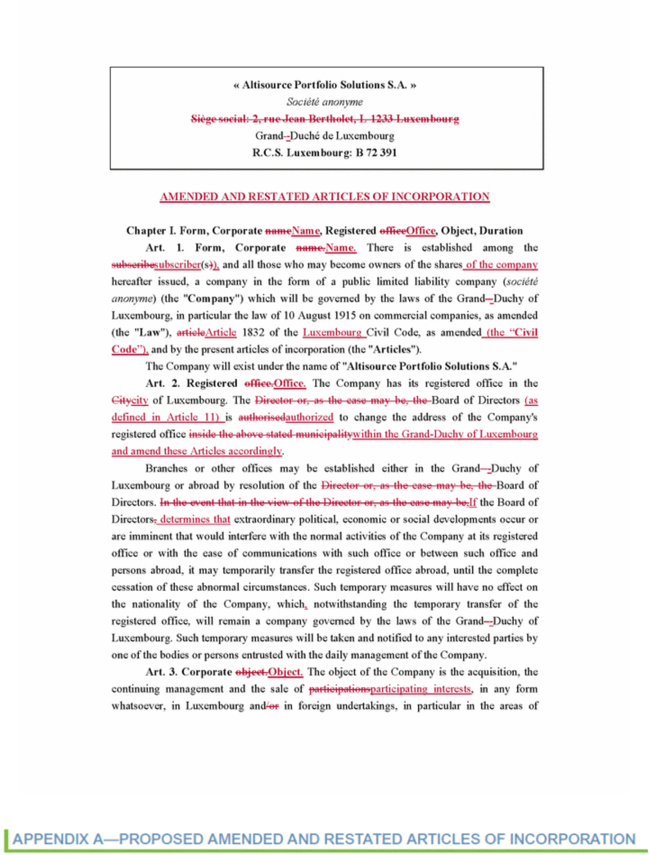

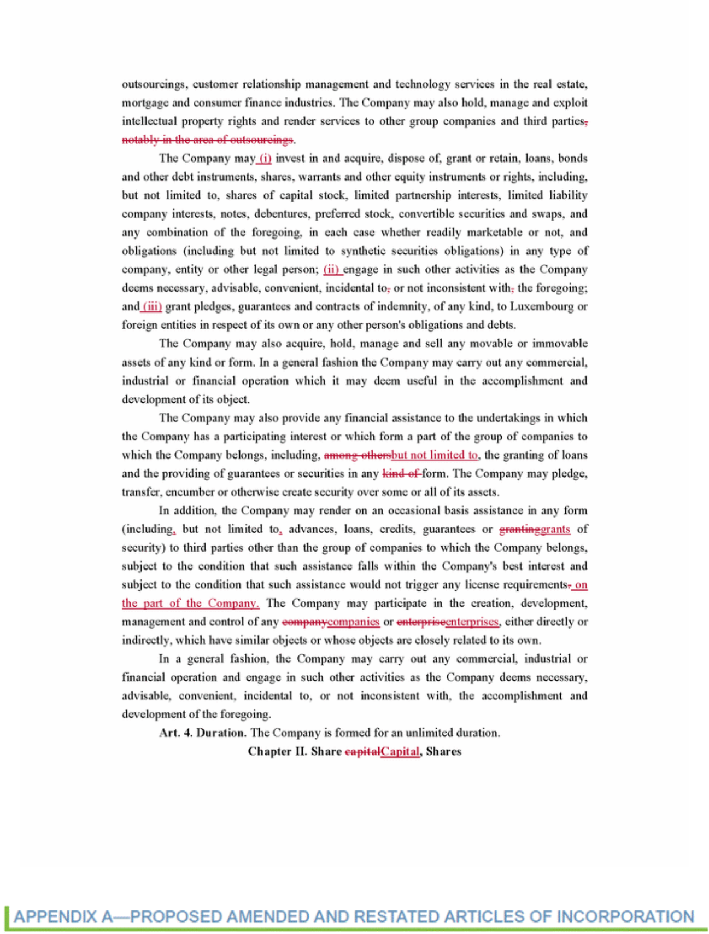

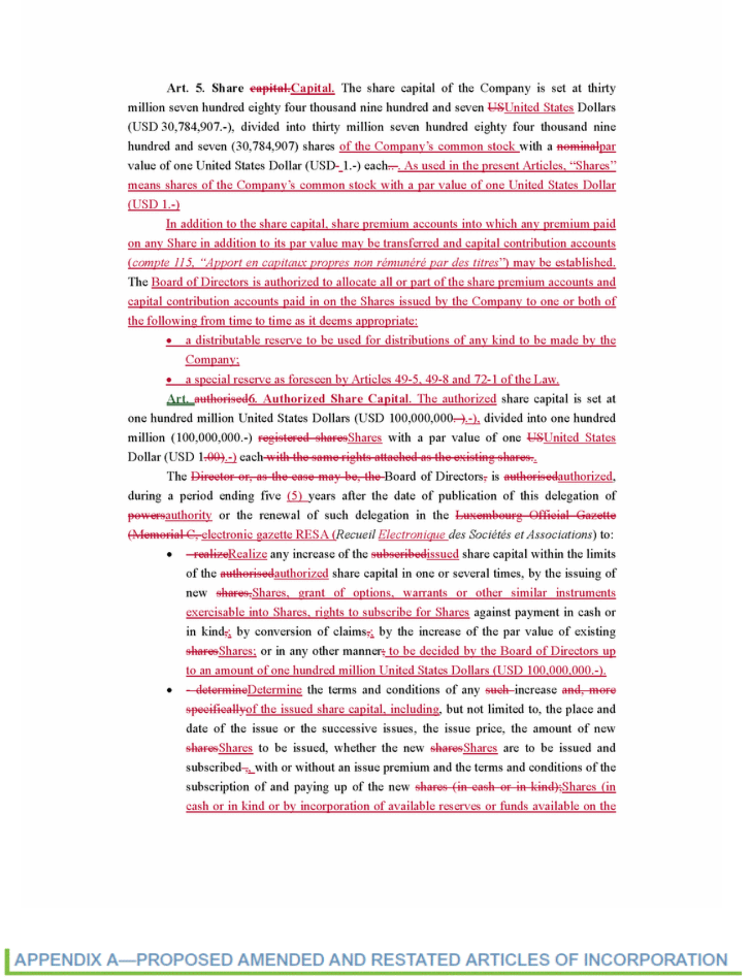

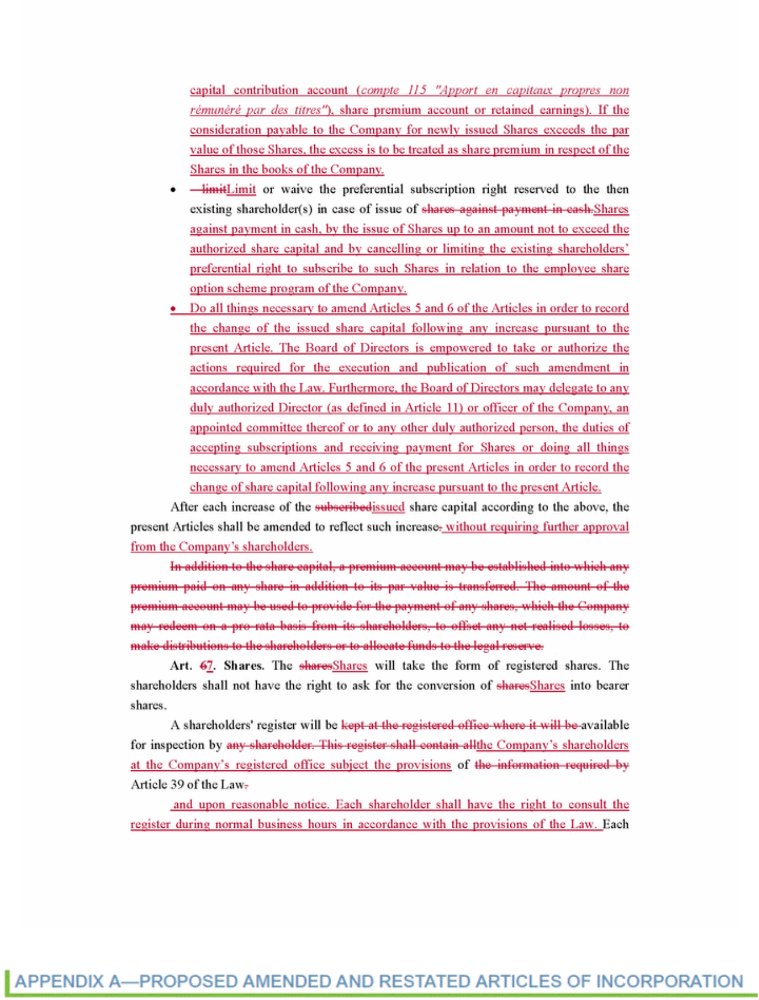

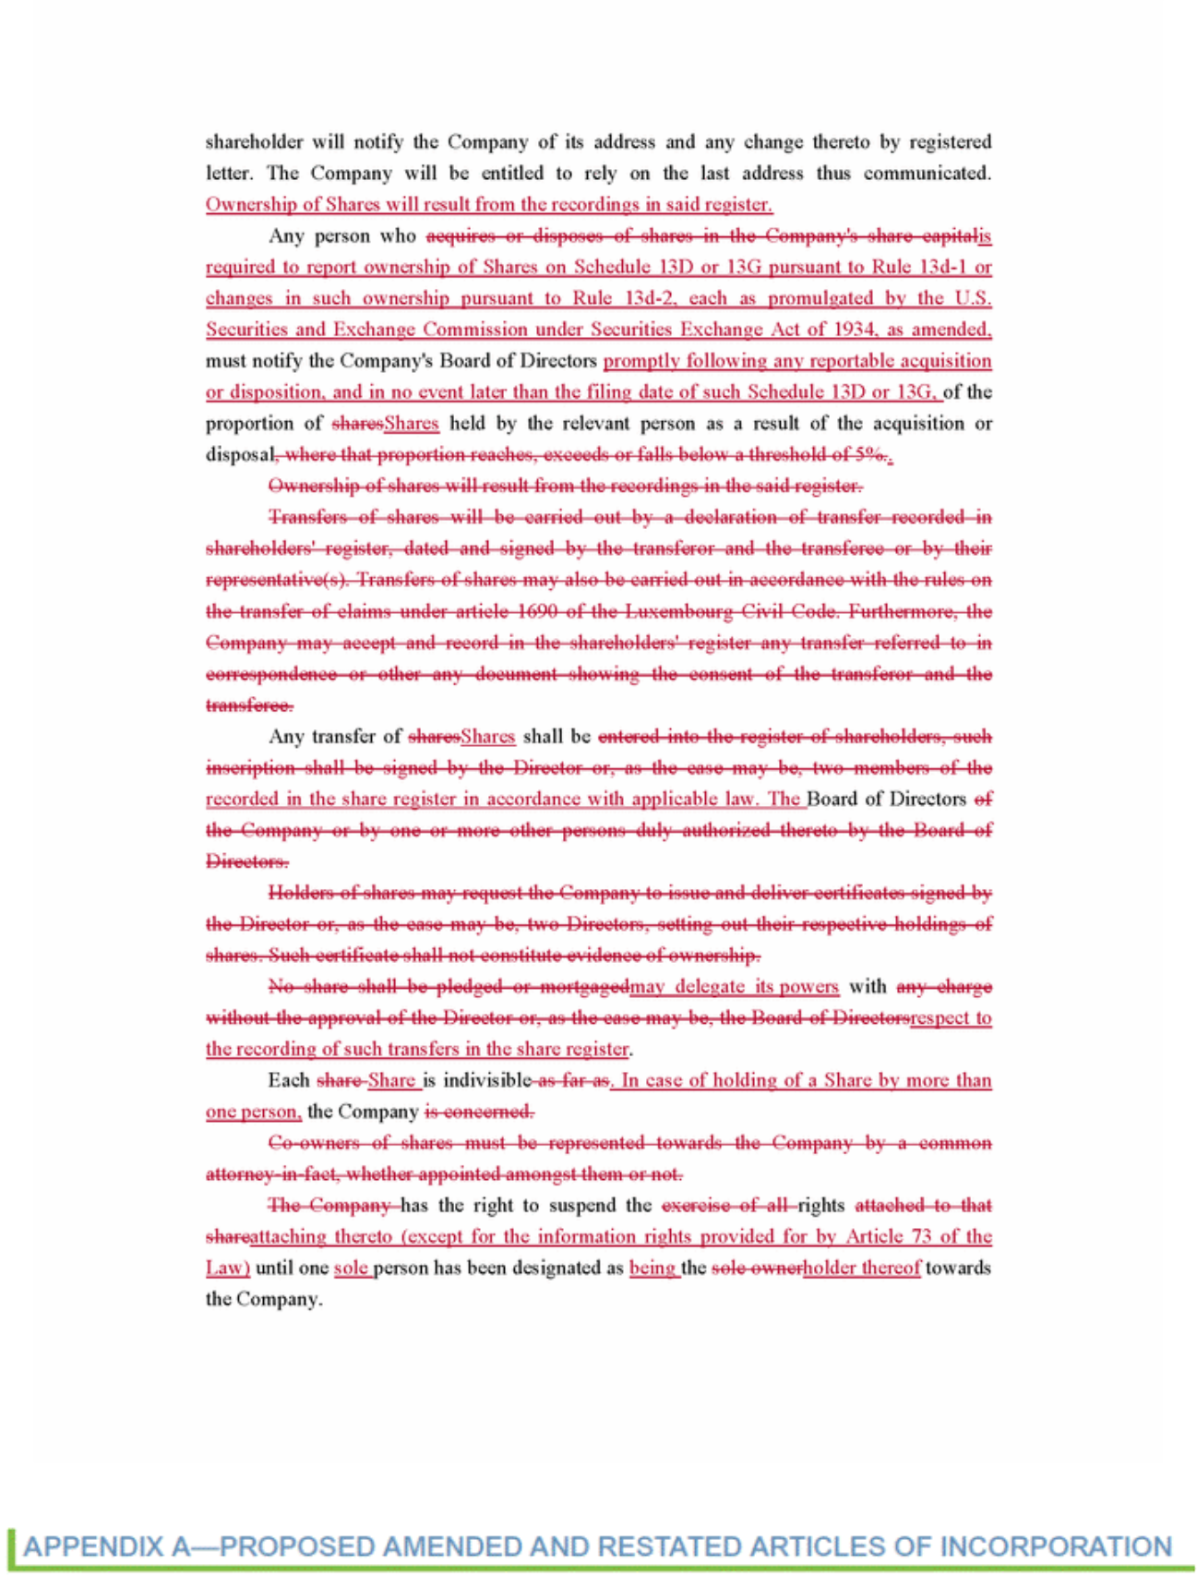

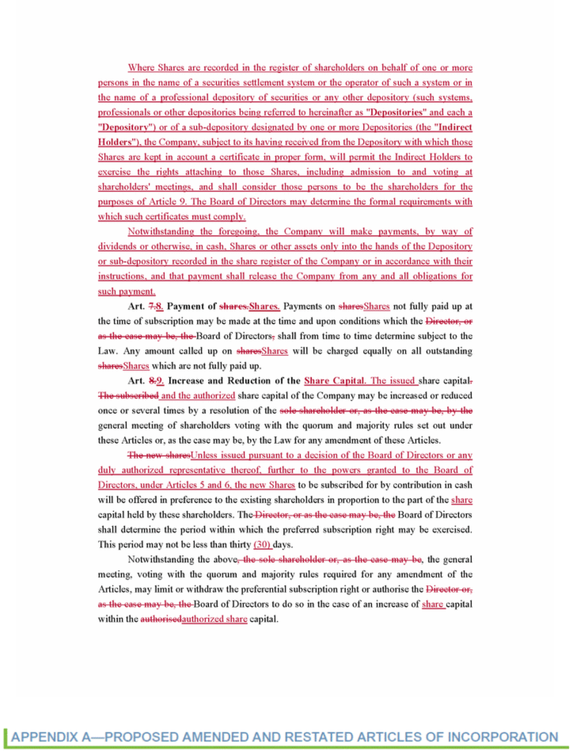

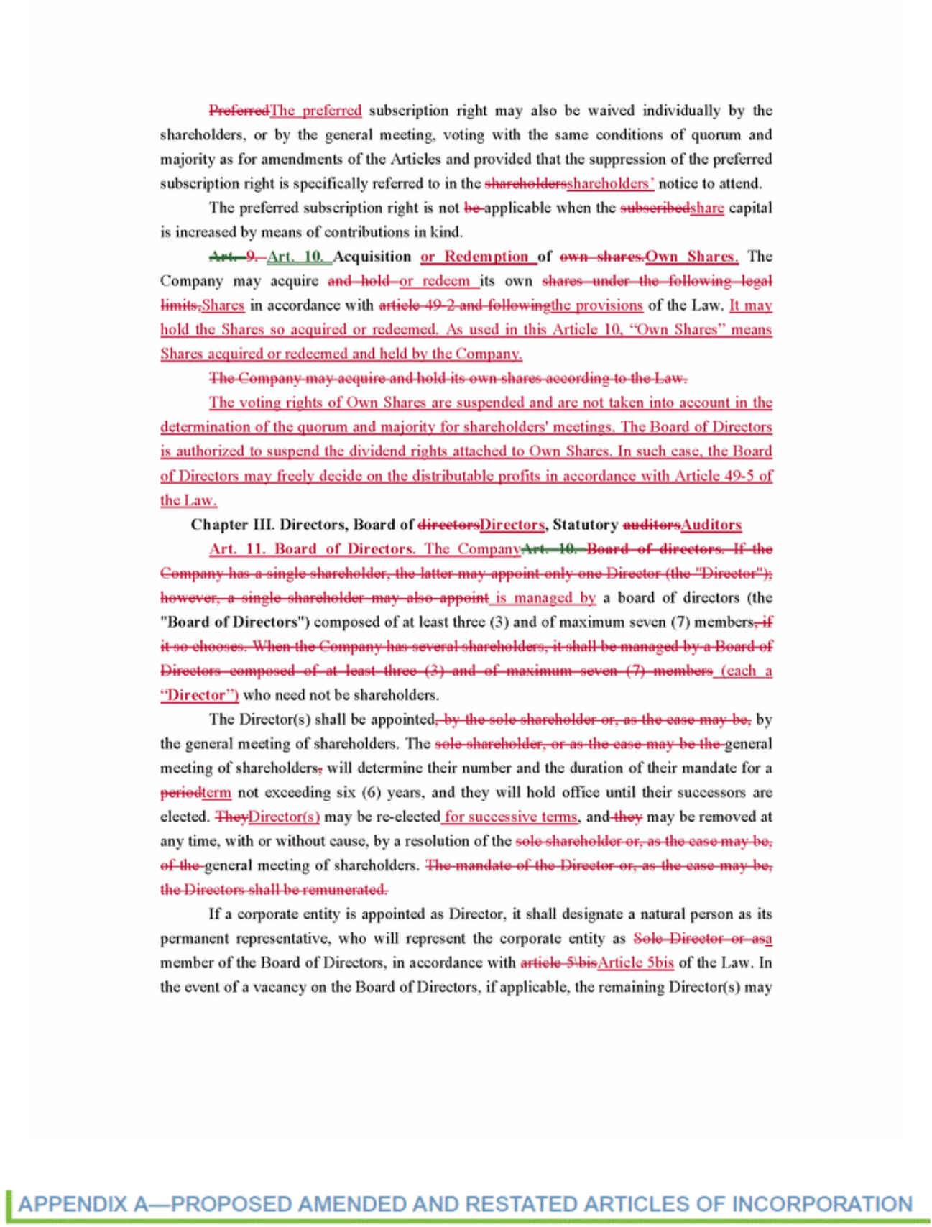

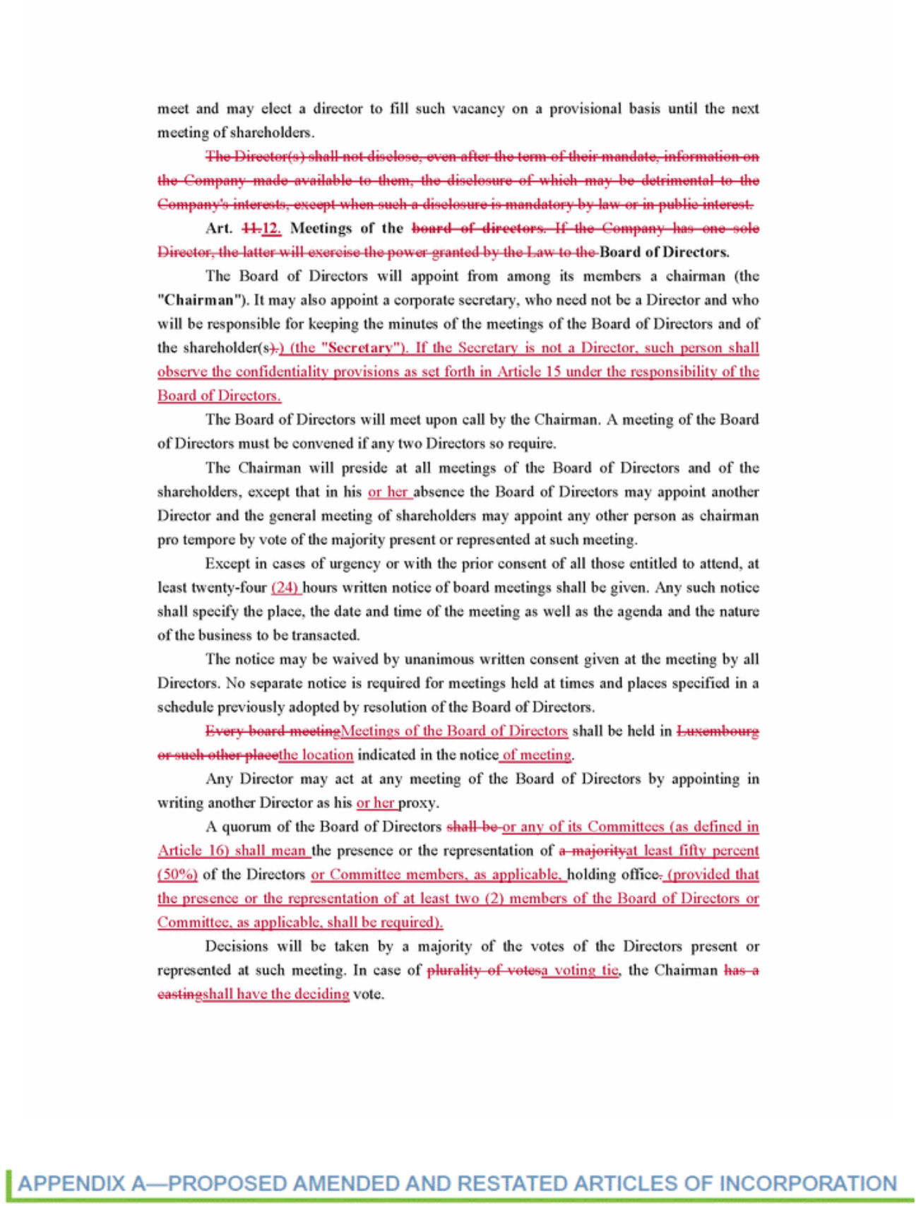

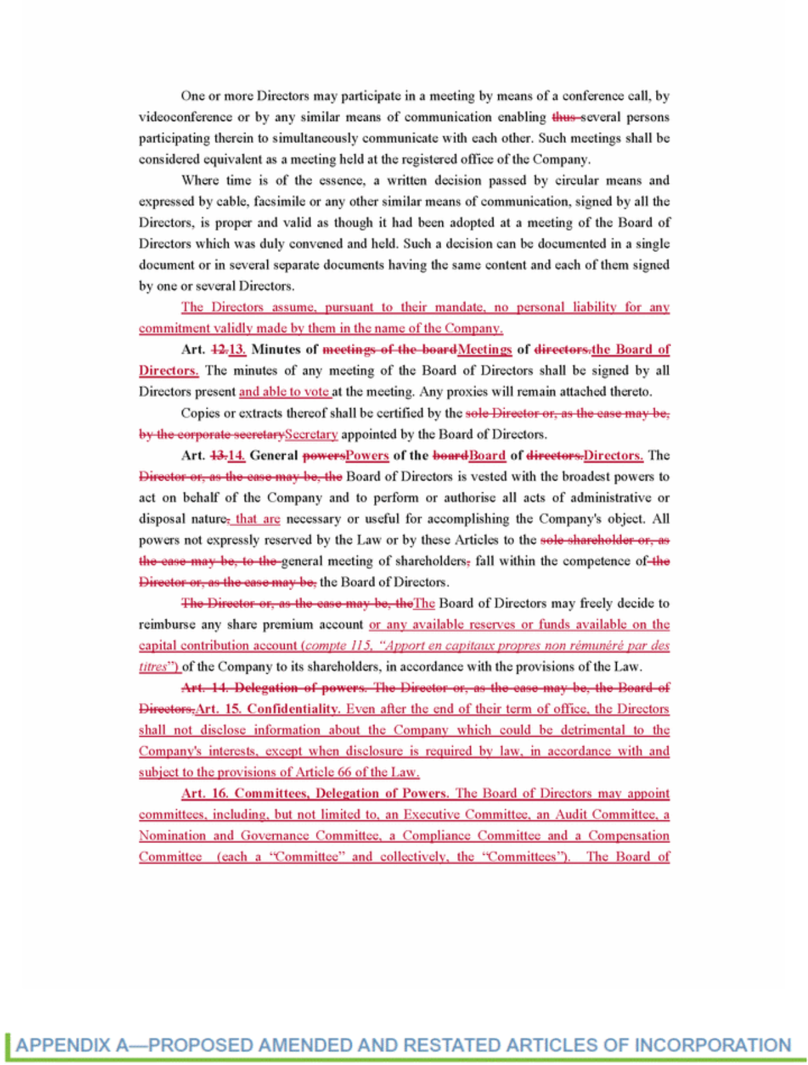

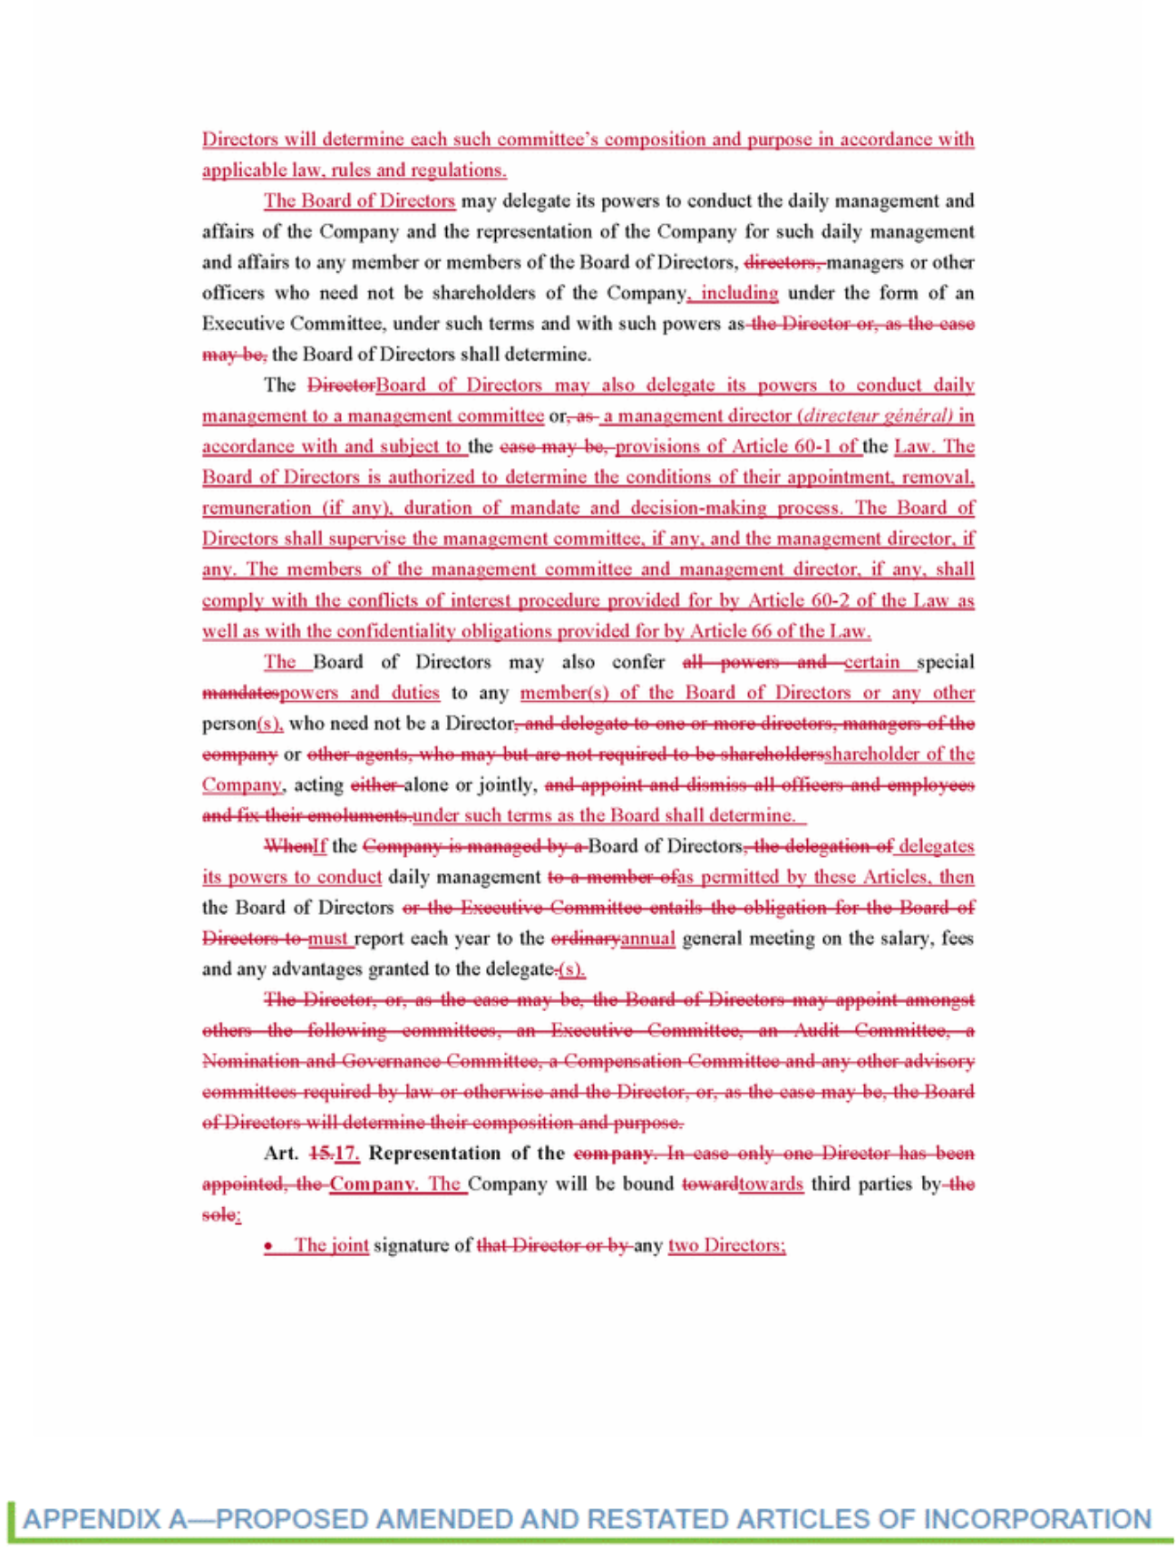

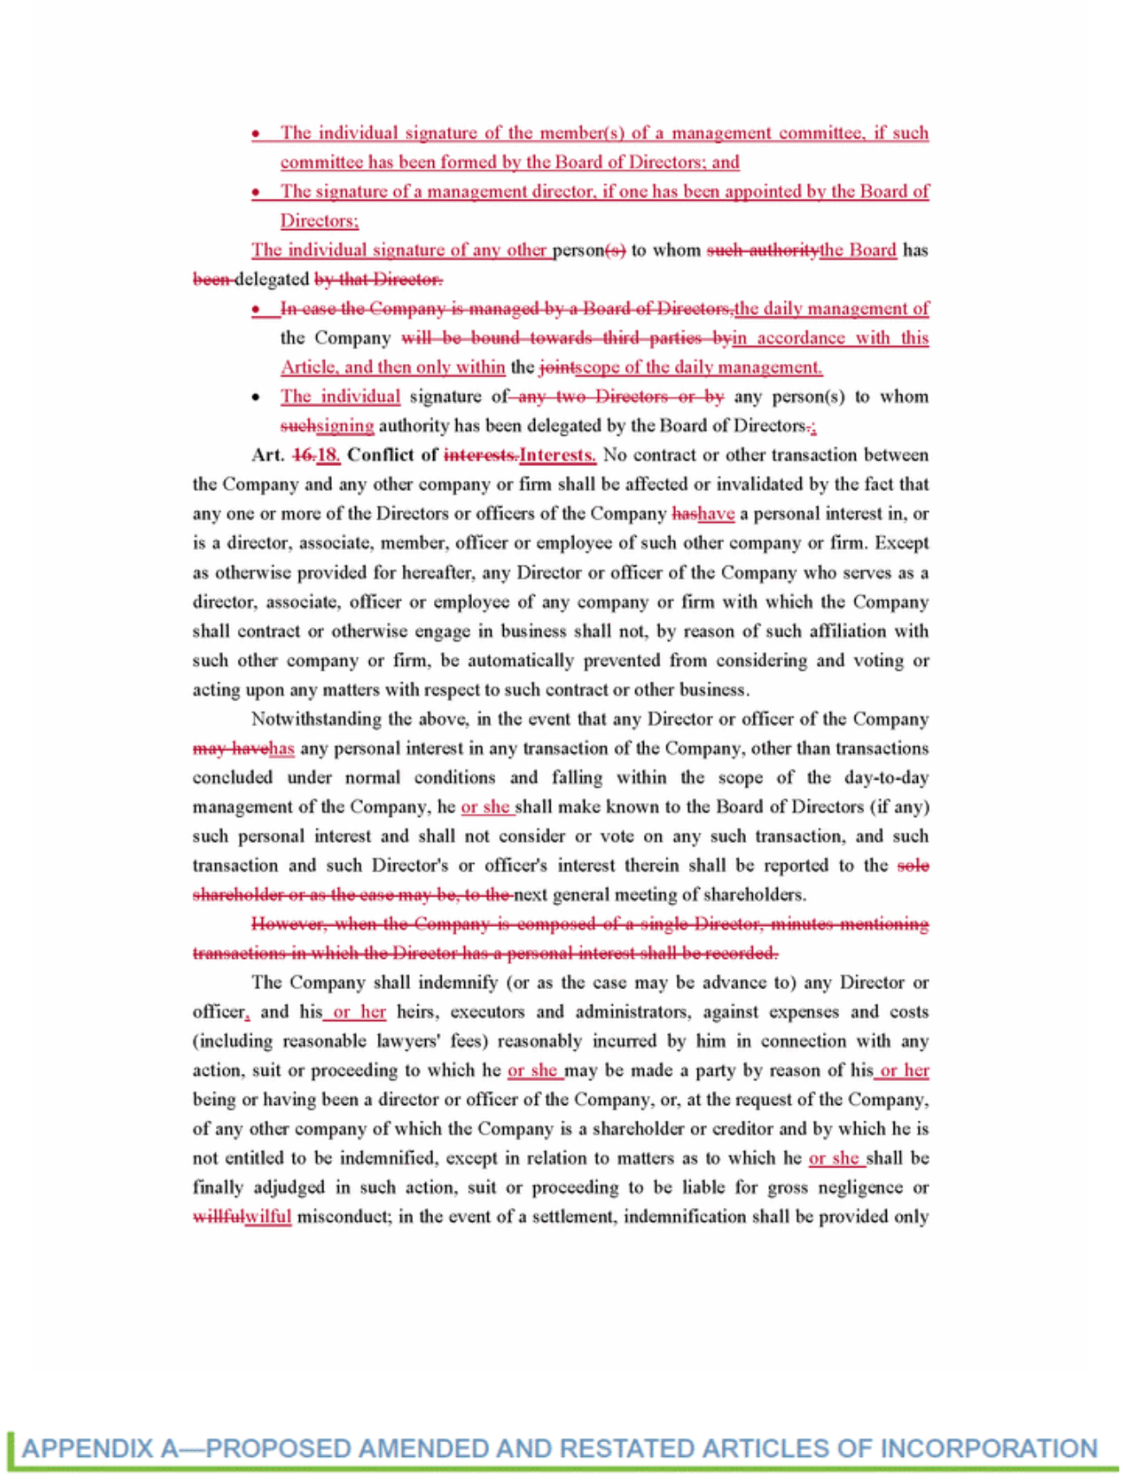

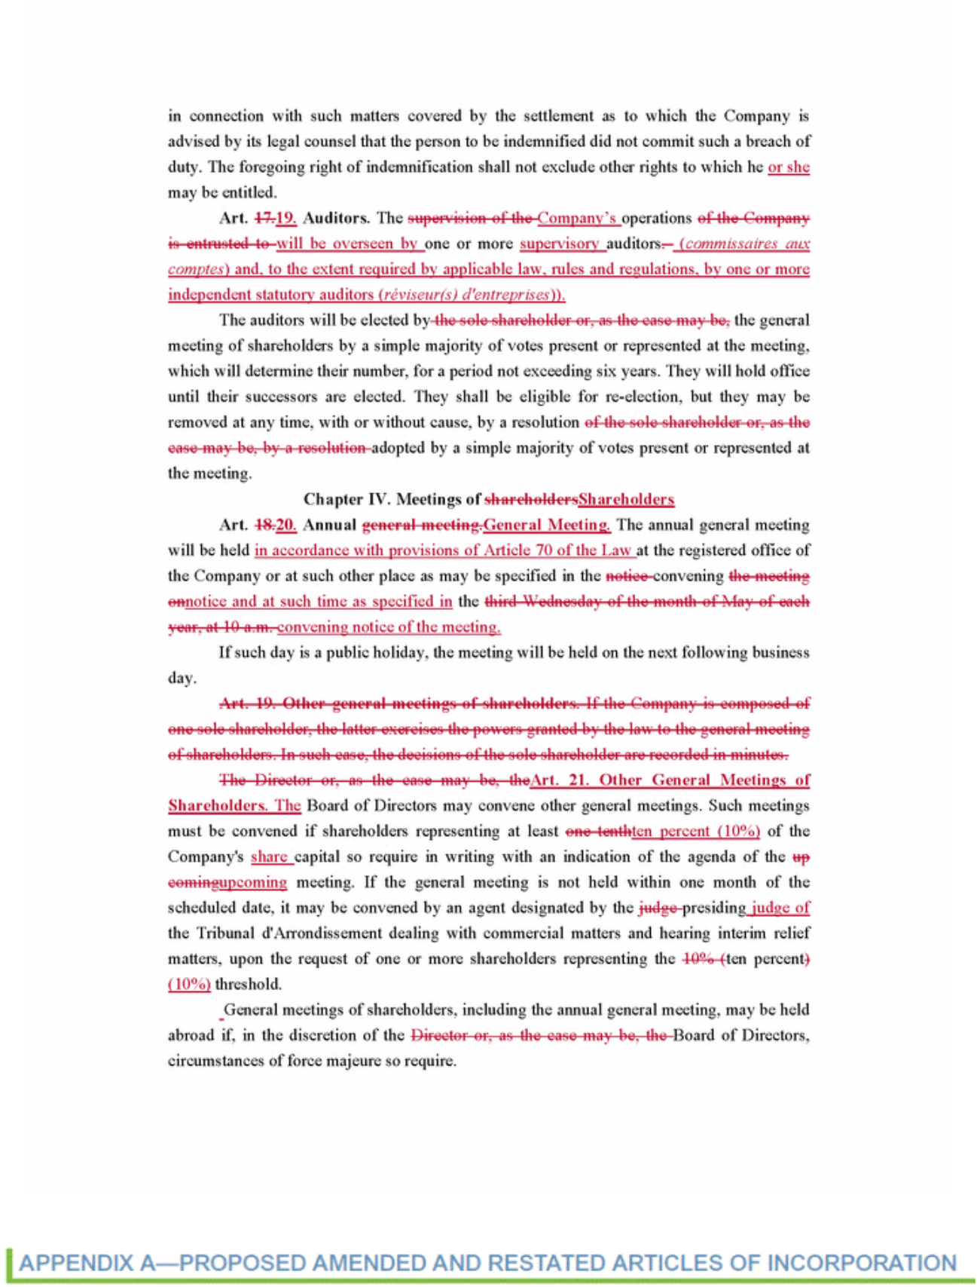

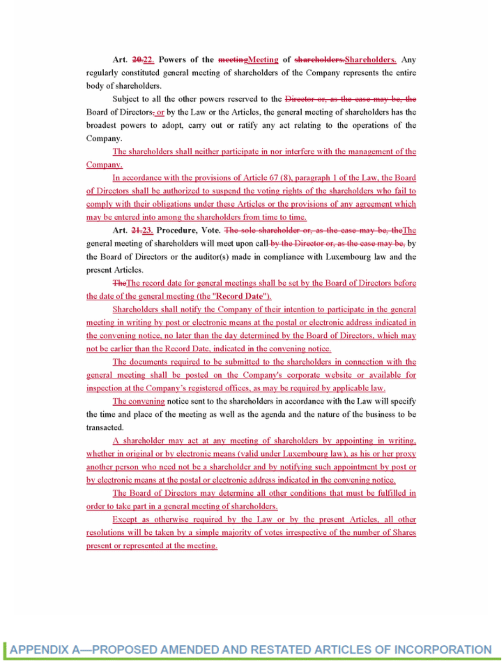

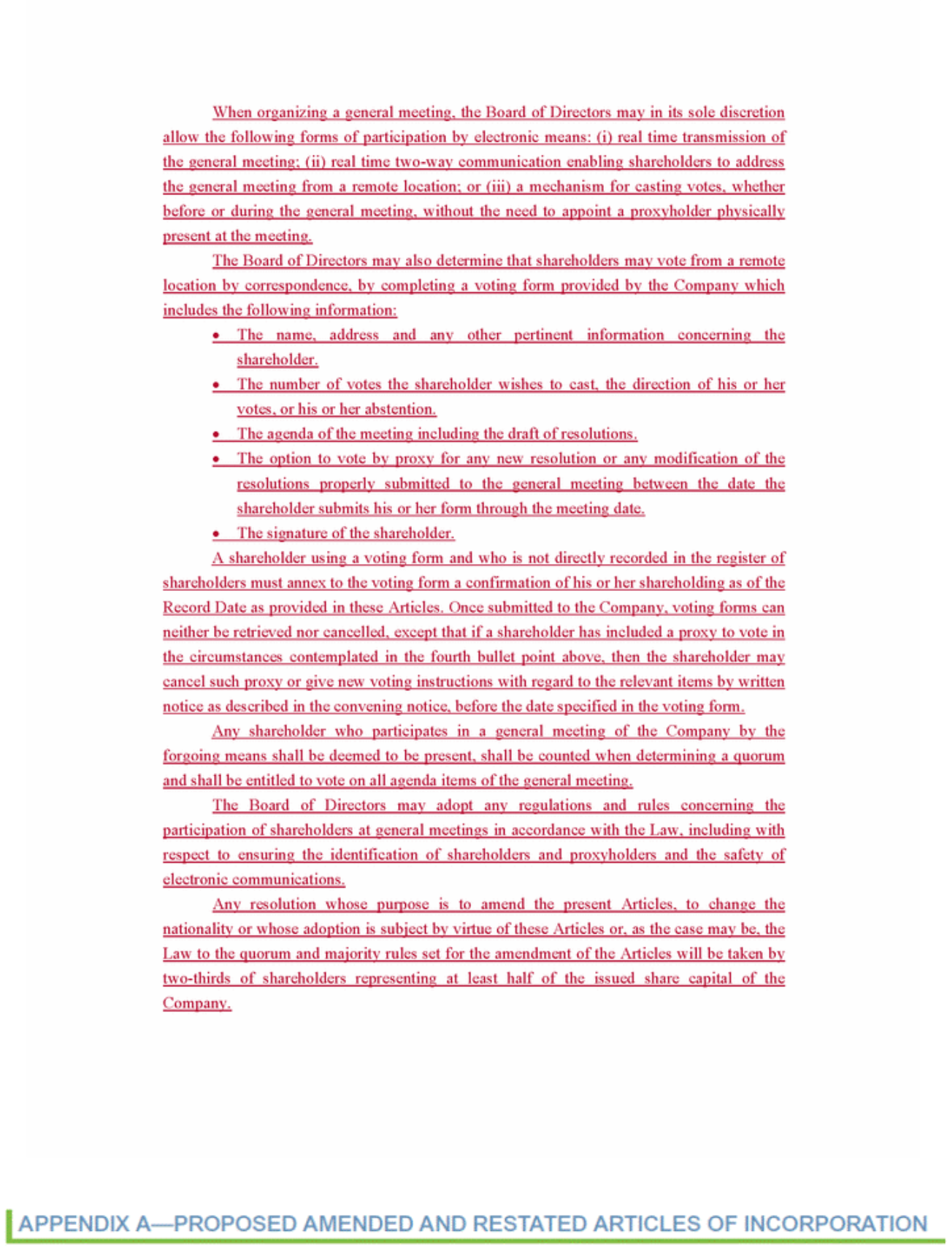

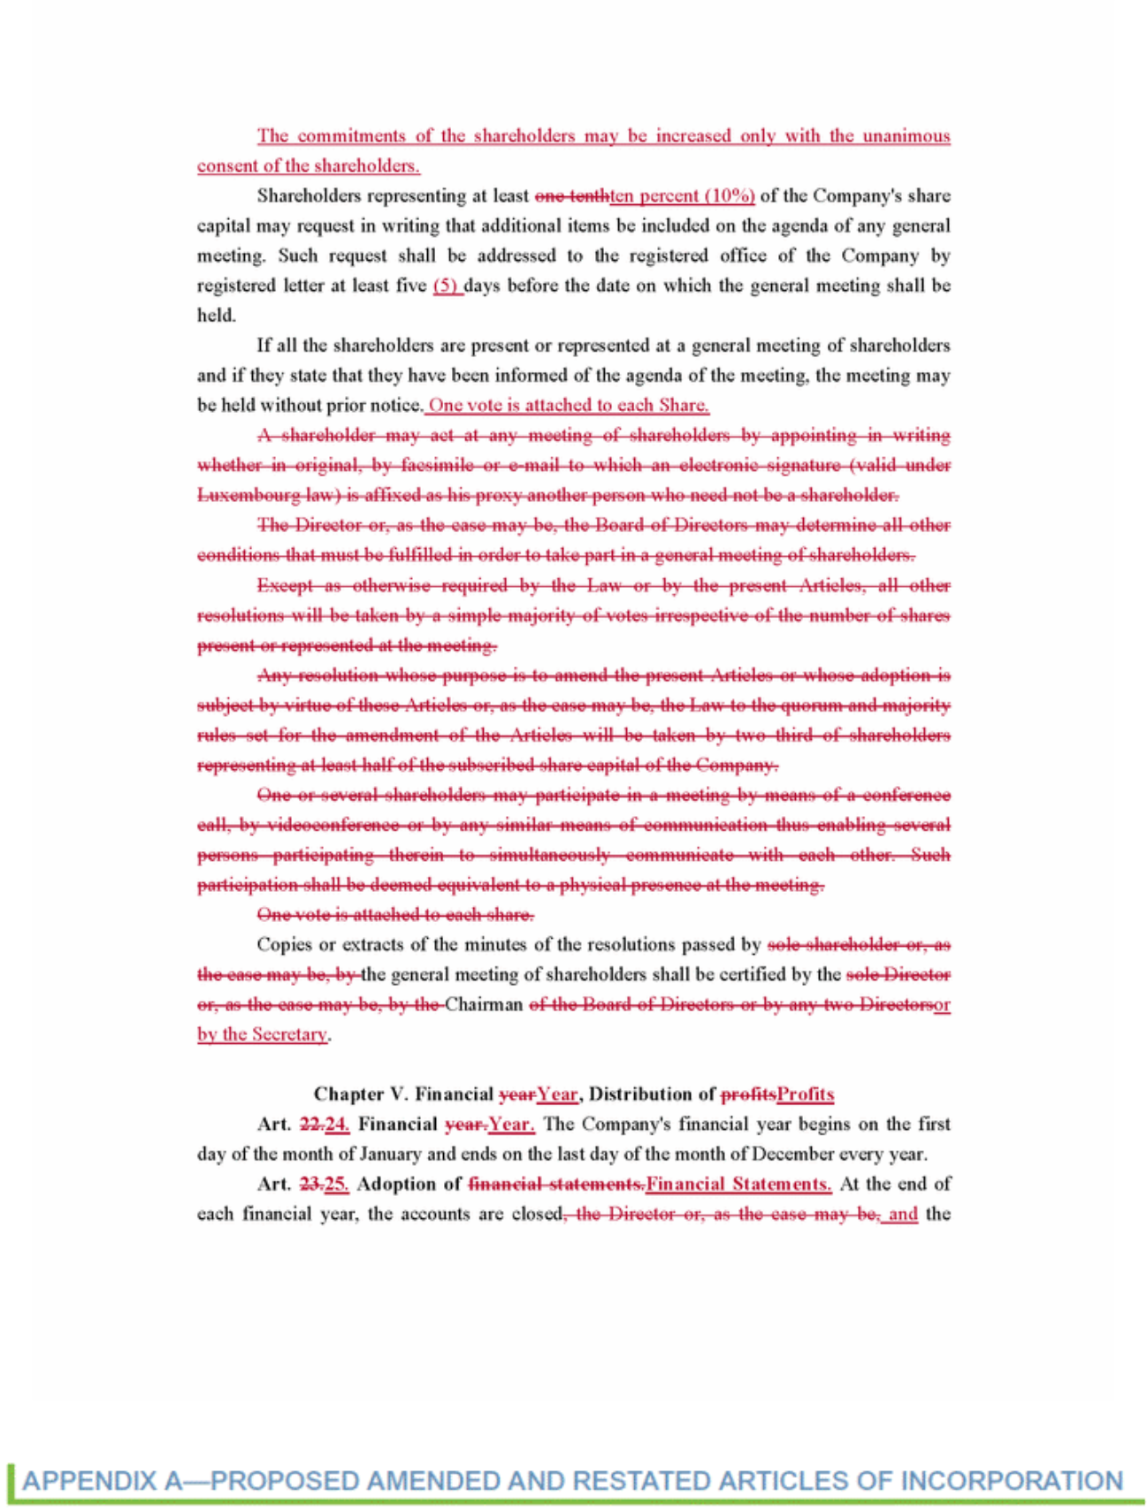

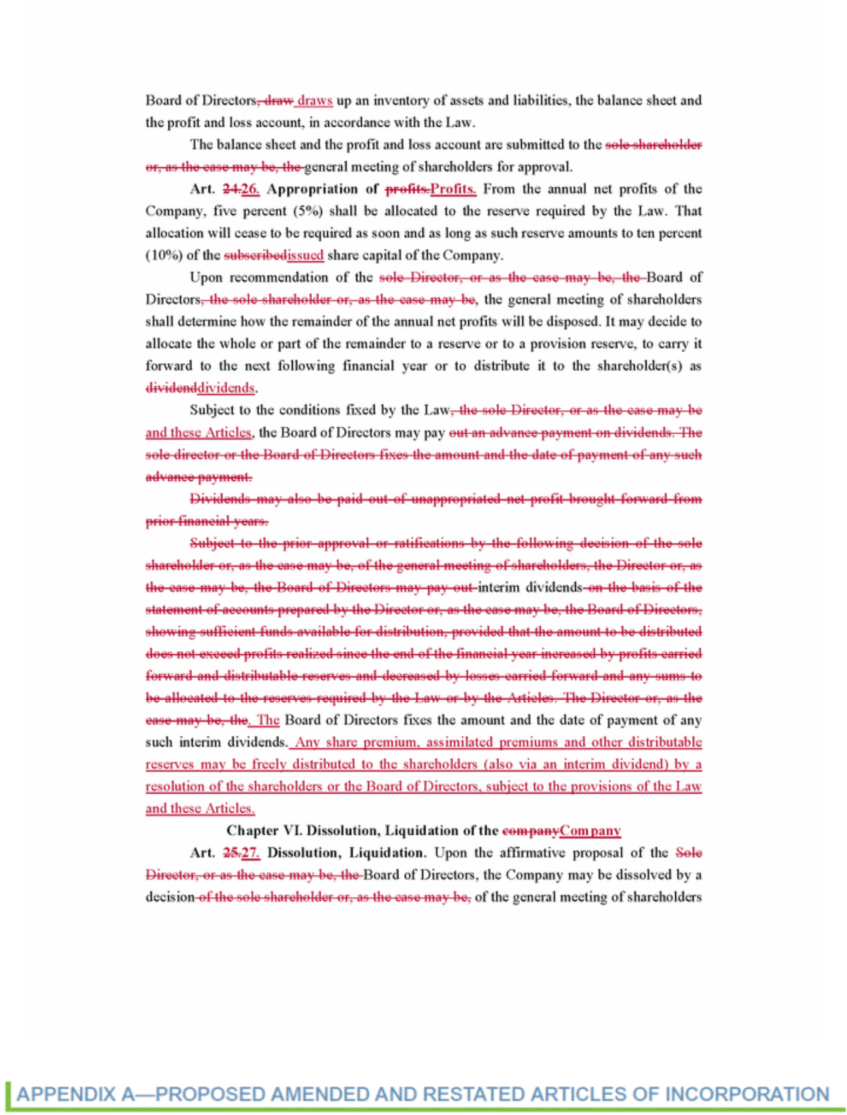

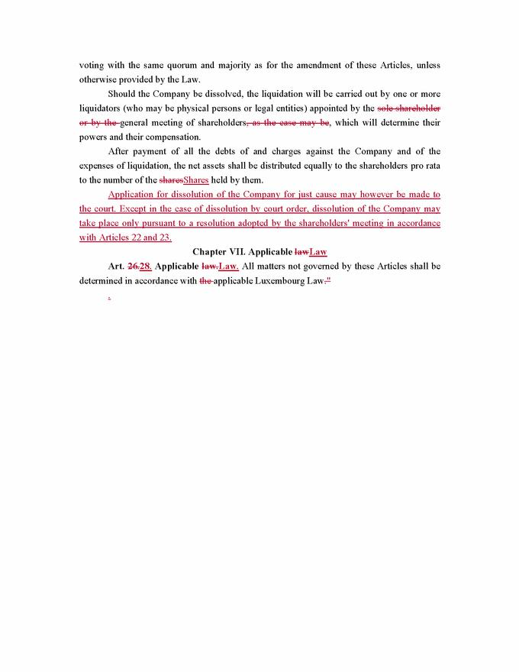

ALTISOURCE PORTFOLIO SOLUTIONS S.A.

C/O PROXY SERVICES

P.O. BOX 9142

FARMINGDALE, NY 11735

VOTE BY MAIL

Mark, sign and date your proxy card and return it in the postage-paid envelope we have provided or return it to Vote Processing, c/o Broadridge, 51 Mercedes Way, Edgewood, NY 11717

TO VOTE, MARK BLOCKS BELOW IN BLUE OR BLACK INK AS FOLLOWS:

KEEP THIS PORTION FOR YOUR RECORDS

THIS PROXY CARD IS VALID ONLY WHEN SIGNED AND DATED.

DETACH AND RETURN THIS PORTION ONLY

ALTISOURCE PORTFOLIO SOLUTIONS S.A.

The Board of Directors recommends you vote FOR the following:

1. | Election of Directors
Nominees: |  | For |  | Against |  | Abstain
01) | Orin S. Kramer | o |  | o |  | o
02) | W. Michael Linn | o |  | o |  | o
03) | Roland Müller-Ineichen | o |  | o |  | o
04) | William B. Shepro | o |  | o |  | o
05) | Timo Vättö | o |  | o |  | o
06) | Joseph L. Morettini | o |  | o |  | o

The Board of Directors recommends you vote FOR the following proposals: | For |  | Against |  | Abstain
2. Proposal to approve the appointment of Mayer Hoffman McCann P.C. to be our independent | o |  | o |  | o
registered certified public accounting firm for the year ending December 31, 2017 and the appointment
of Atwell S.à r.l. to be our certified auditor (Réviseur d’Entreprises) for the same period
3. Proposal to approve the appointment of Michelle D. Esterman, Chief Financial Officer of the | o |  | o |  | o
Company, to be our supervisory auditor (Commissaire aux Comptes) to report on Altisource Portfolio
Solutions S.A.’s unconsolidated annual accounts prepared in accordance with accounting principles
generally accepted in Luxembourg (the “Luxembourg Annual Accounts”) for the years ending
December 31, 2017 through December 31, 2022, or until her successor is duly elected and qualified,
and to ratify her appointment by the Board of Directors as our supervisory auditor to report on the
Luxembourg Annual Accounts for the years ended December 31, 2009 through December 31, 2016
4. Proposal to approve the Luxembourg Annual Accounts for the year ended December 31, 2016 and | o |  | o |  | o
Altisource Portfolio Solutions S.A.’s consolidated financial statements prepared in accordance with
accounting principles generally accepted in the United States including a footnote reconciliation of
equity and net income to International Financial Reporting Standards (the “Consolidated Accounts”
and, together with the Luxembourg Annual Accounts, the “Luxembourg Statutory Accounts”) as of and
for the year ended December 31, 2016
5. Proposal to receive and approve the Directors’ reports for the Luxembourg Statutory Accounts for the | o |  | o |  | o
year ended December 31, 2016 and to receive the reports of the supervisory auditor (Commissaire aux
Comptes) for the Luxembourg Annual Accounts for the years ended December 31, 2009 through
December 31, 2016
6. Proposal to allocate the results in the Luxembourg Annual Accounts for the year ended December 31, | o |  | o |  | o
2016
7. Proposal to discharge each of the Directors of Altisource Portfolio Solutions S.A. for the performance | o |  | o |  | o
of their mandates for the year ended December 31, 2016 and the supervisory auditor (Commissaire aux
Comptes) for the performance of her mandate for the years ended December 31, 2009 through
December 31, 2016
8. Proposal to renew our share repurchase program such that Altisource Portfolio Solutions S.A. is | o |  | o |  | o
authorized, for a period of five years from the date of the Annual Meeting, to repurchase up to twenty-
five percent (25%) of the outstanding shares of its common stock (as of the close of business on the date
of the Annual Meeting) at a minimum price of one dollar ($1.00) per share and a maximum price of five
hundred dollars ($500.00) per share

- Proposal to approve, on an advisory (non-binding) basis, the compensation of Altisource’s named executive officers as disclosed in the joint proxy statement (“Say-on-Pay”)

The Board of Directors recommends that you vote for “ONE YEAR” on the following proposal:

- Proposal to approve, on an advisory (non-binding) basis, the frequency of future shareholder advisory votes on executive compensation (“Say-on-Frequency”)

NOTE: Proxies will vote in their discretion upon such other matters that may properly come before the Annual Meeting or any adjournment or postponement thereof.

o o o

1 Year 2 Years 3 Years Abstain

o o o o

For address changes and/or comments, please check this box and write them on the back where indicated. o

Please indicate if you plan to attend this meeting. o o

Yes No

Signature [PLEASE SIGN WITHIN BOX] Date

Please sign exactly as your name(s) appear(s) hereon. When signing as attorney, executor, administrator or other fiduciary, please give full title as such. Joint owners should each sign personally. All holders must sign. If a corporation or partnership, please sign in full corporate or partnership name, by authorized officer.

Signature (Joint Owners) Date

Preliminary — Subject to change

Important Notice Regarding the Availability of Proxy Materials for the Annual Meeting of Shareholders:

The Notice and Proxy Statement are available at www.proxyvote.com.

ALTISOURCE PORTFOLIO SOLUTIONS S.A.

40, avenue Monterey, L-2163 Luxembourg City, Grand Duchy of Luxembourg

REVOCABLE PROXY

THIS PROXY IS SOLICITED ON BEHALF OF THE BOARD OF DIRECTORS OF ALTISOURCE PORTFOLIO SOLUTIONS S.A. FOR USE ONLY AT THE ANNUAL MEETING OF SHAREHOLDERS TO BE HELD ON MAY 17, 2017, AND AT ANY ADJOURNMENT OR POSTPONEMENT THEREOF.

The undersigned shareholder(s) hereby appoint(s) William B. Shepro and Kevin J. Wilcox, or either of them (the “Proxies”), as proxy, with full powers of substitution, and hereby authorizes them to represent and vote, as designated on the reverse side of this ballot, all of the shares of common stock (“Common Stock”) of Altisource Portfolio Solutions S.A. (the “Company”) that the shareholder(s) is/are entitled to vote at the Annual Meeting of Shareholders (the “Annual Meeting”) to be held at the offices of the Company located at 40, avenue Monterey L-2163 Luxembourg City, Grand Duchy of Luxembourg on Wednesday, May 17, 2017, at 9:00 a.m. Central European Time and at any adjournment or postponement thereof.

This proxy, when properly executed, will be voted in the manner directed herein. If no such direction is made, this proxy will be voted FOR the election of each of the Board of Directors’ nominees to the Board of Directors; FOR the approval of the appointment of Mayer Hoffman McCann P.C. to be our independent registered certified public accounting firm for the year ending December 31, 2017 and the appointment of Atwell S.à r.l. to be our certified auditor (Réviseur d’Entreprises) for the same period; FOR the approval of the appointment of Michelle D. Esterman, Chief Financial Officer of the Company, to be our supervisory auditor (Commissaire aux Comptes) to report on Altisource Portfolio Solutions S.A.’s unconsolidated annual accounts prepared in accordance with accounting principles generally accepted in Luxembourg (the “Luxembourg Annual Accounts”) for the years ending December 31, 2017 through December 31, 2022, or until her successor is duly elected and qualified, and to ratify her appointment by the Board of Directors as our supervisory auditor to report on the Luxembourg Annual Accounts for the years ended December 31, 2009 through December 31, 2016; FOR the approval of the Luxembourg Annual Accounts for the year ended December 31, 2016 and Altisource Portfolio Solutions S.A.’s consolidated financial statements prepared in accordance with accounting principles generally accepted in the United States including a footnote reconciliation of equity and net income to International Financial Reporting Standards (the “Consolidated Accounts” and, together with the Luxembourg Annual Accounts, the “Luxembourg Statutory Accounts”) as of and for the year ended December 31, 2016; FOR the receipt and approval of the Directors’ reports for the Luxembourg Statutory Accounts for the year ended December 31, 2016 and to receive the reports of the supervisory auditor (Commissaire aux Comptes) for the Luxembourg Annual Accounts for the years ended December 31, 2009 through December 31, 2016; FOR the allocation of the results in the Luxembourg Annual Accounts for the year ended December 31, 2016; FOR the discharge of each of the Directors of Altisource Portfolio Solutions S.A. for the performance of their mandates for the year ended December 31, 2016 and the supervisory auditor (Commissaire aux Comptes) for the performance of her mandate for the years ended December 31, 2009 through December 31, 2016; FOR the renewal

of our share repurchase program such that Altisource Portfolio Solutions S.A. is authorized, for a period of five years from the date of the Annual Meeting, to repurchase up to twenty-five percent (25%) of the outstanding shares of its common stock (as of the close of business on the date of the Annual Meeting) at a minimum price of one dollar ($1.00) per share and a maximum price of five hundred dollars ($500.00) per share; FOR the approval, on an advisory (non-binding) basis, of the compensation of Altisource’s named executive officers as disclosed in the joint proxy statement (“Say-on-Pay”); For the approval, on an advisory (non-binding) basis, of “ONE YEAR” as the frequency of future shareholder advisory votes on executive compensation (“Say-on-Frequency”); and in the discretion of the Proxies on any other matter that may properly come before the Annual Meeting or any adjournment or postponement thereof. This proxy may be revoked at any time prior to the time it is voted at the Annual Meeting.

The undersigned shareholder(s) hereby acknowledge(s) receipt of the Notice of Annual Meeting of Shareholders of Altisource Portfolio Solutions S.A. to be held on May 17, 2017, or any adjournment or postponement thereof and a Proxy Statement for the Annual Meeting prior to the signing of this proxy.

Address Changes/Comments:

(If any Address Changes/Comments are noted above, please mark the corresponding box on the reverse side.)

Continued and to be dated and signed on the reverse side

ALTISOURCE PORTFOLIO SOLUTIONS S.A.

C/O PROXY SERVICES

P.O. BOX 9142

FARMINGDALE, NY 11735

VOTE BY MAIL

Mark, sign and date your proxy card and return it in the postage-paid envelope we have provided or return it to Vote Processing, c/o Broadridge, 51 Mercedes Way, Edgewood, NY 11717

TO VOTE, MARK BLOCKS BELOW IN BLUE OR BLACK INK AS FOLLOWS:

KEEP THIS PORTION FOR YOUR RECORDS

THIS PROXY CARD IS VALID ONLY WHEN SIGNED AND DATED.

DETACH AND RETURN THIS PORTION ONLY

ALTISOURCE PORTFOLIO SOLUTIONS S.A.

The Board of Directors recommends you vote FOR the following proposals: |  |  |  |  |  | For |  | Against |  |  | Abstain
1. Proposal to approve the amendment of the Company’s Articles of Incorporation to (i) renew and extend the |  |  |  |  |  | o |  |  | o |  | o
 | authorization of the Board of Directors to issue shares of the Company’s common stock, within the limits of the
 | Company’s authorized share capital of one hundred million dollars ($100,000,000) and, in connection with any such
 | issuance, to limit or cancel the preferential subscription rights of shareholders, each for a period of five (5) years, as
 | set forth in the proposed Amended and Restated Articles of Incorporation and (ii) receive the report issued by the
 | Board of Directors pursuant to article 32 -3 (5) of the Luxembourg Law of 10 August 1915 on commercial
 | companies, as amended (the “Luxembourg Company Law”)
2. Proposal to approve the amendment of the Company’s Articles of Incorporation to effectuate recent changes in the |  |  |  |  |  | o |  |  | o |  | o
 | Luxembourg Company Law, as the Company is required to do pursuant to the Luxembourg Law of 10 August 2016
 | and to make certain other administrative changes as set forth in the proposed Amended and Restated Articles of
 | Incorporation
NOTE: |  | Proxies will vote in their discretion upon such other matters that may properly come before the Extraordinary Meeting or any adjournment or
 |  | postponement thereof.
For address changes and/or comments, please check this box and write them on the back where indicated. |  |  |  |  |  |  |  | o
Please indicate if you plan to attend this meeting. |  |  | o | o
 |  |  | Yes | No
 | Signature [PLEASE SIGN WITHIN BOX] |  |  |  | Date

Please sign exactly as your name(s) appear(s) hereon. When signing as attorney, executor, administrator or other fiduciary, please give full title as such. Joint owners should each sign personally. All holders must sign. If a corporation or partnership, please sign in full corporate or partnership name, by authorized officer.

Signature (Joint Owners) Date

Preliminary — Subject to change

Important Notice Regarding the Availability of Proxy Materials for the Extraordinary Meeting of Shareholders:

The Notice and Proxy Statement are available at www.proxyvote.com.

ALTISOURCE PORTFOLIO SOLUTIONS S.A.

40, avenue Monterey, L-2163 Luxembourg City, Grand Duchy of Luxembourg

REVOCABLE PROXY

THIS PROXY IS SOLICITED ON BEHALF OF THE BOARD OF DIRECTORS OF ALTISOURCE PORTFOLIO SOLUTIONS S.A. FOR USE ONLY AT THE EXTRAORDINARY MEETING OF SHAREHOLDERS TO BE HELD ON MAY 17, 2017, AND AT ANY ADJOURNMENT OR POSTPONEMENT THEREOF.

The undersigned shareholder(s) hereby appoint(s) William B. Shepro and Kevin J. Wilcox, or either of them (the “Proxies”), as proxy, with full powers of substitution, and hereby authorizes them to represent and vote, as designated on the reverse side of this ballot, all of the shares of common stock (“Common Stock”) of Altisource Portfolio Solutions S.A. (the “Company”) that the shareholder(s) is/are entitled to vote at the Extraordinary Meeting of Shareholders (the “Extraordinary Meeting”) to be held at the offices of the Company located at 40, avenue Monterey L-2163 Luxembourg City, Grand Duchy of Luxembourg on Wednesday, May 17, 2017, at 10:00 a.m. Central European Time and at any adjournment or postponement thereof.

This proxy, when properly executed, will be voted in the manner directed herein. If no such direction is made, this proxy will be voted FOR the approval of the amendment of the Company’s Articles of Incorporation to (i) renew and extend the authorization of the Board of Directors to issue shares of the Company’s common stock, within the limits of the Company’s authorized share capital of one hundred million dollars ($100,000,000) and, in connection with any such issuance, to limit or cancel the preferential subscription rights of shareholders, each for a period of five (5) years, as set forth in the proposed

Amended and Restated Articles of Incorporation and (ii) receive the report issued by the Board of Directors pursuant to article 32 -3 (5) of the Luxembourg Law of 10 August 1915 on commercial companies, as amended (the “Luxembourg Company Law”); FOR the approval of the amendment of the Company’s Articles of Incorporation to effectuate recent changes in the Luxembourg Company Law, as the Company is required to do pursuant to the Luxembourg Law of 10 August 2016 and to make certain other administrative changes as set forth in the proposed Amended and Restated Articles of Incorporation; and in the discretion of the Proxies on any other matter that may properly come before the Extraordinary Meeting or any adjournment or postponement thereof. This proxy may be revoked at any time prior to the time it is voted at the Extraordinary Meeting.

The undersigned shareholder(s) hereby acknowledge(s) receipt of the Notice of Extraordinary Meeting of Shareholders of Altisource Portfolio Solutions S.A. to be held on May 17, 2017, or any adjournment or postponement thereof and a Proxy Statement for the Extraordinary Meeting prior to the signing of this proxy.

Address Changes/Comments:

(If any Address Changes/Comments are noted above, please mark the corresponding box on the reverse side.)

Continued and to be dated and signed on the reverse side

