UNITED STATES

SECURITIES AND EXCHANGE COMMISSION
Washington, D.C. 20549

FORM 10-K

(Mark One)
- ANNUAL REPORT PURSUANT TO SECTION 13 OR 15(d) OF THE SECURITIES EXCHANGE ACT OF 1934

FOR THE FISCAL YEAR ENDED DECEMBER 31, 2015

o

OR

TRANSITION REPORT PURSUANT TO SECTION 13 OR 15(d) OF THE SECURITIES EXCHANGE ACT OF 1934 Commission File Number: 1-34354

ALTISOURCE PORTFOLIO SOLUTIONS S.A.

(Exact name of Registrant as specified in its Charter)

Luxembourg 98-0554932

(State or other jurisdiction of incorporation or organization) (I.R.S. Employer Identification No.)

40, avenue Monterey

L-2163 Luxembourg

Grand Duchy of Luxembourg
(352) 24 69 79 00
(Address and telephone number, including area code, of registrant’s principal executive offices)

 |  | Securities registered pursuant to Section 12(b) of the Act:
Title of each class |  |  |  | Name of each exchange on which registered
Common Stock, $1.00 par value |  |  |  |  | NASDAQ Global Select Market

Securities registered pursuant to Section 12(g) of the Act:

None

Indicate by check mark if the Registrant is a well-known seasoned issuer, as defined in Rule 405 of the Securities Act. Yes o No ☑ Indicate by check mark if the Registrant is not required to file reports pursuant to Section 13 or Section 15(d) of the Act. Yes o No ☑

Indicate by check mark whether the registrant (1) has filed all reports required to be filed by section 13 or 15(d) of the Securities Exchange Act of 1934 during the preceding 12 months (or for such shorter period that the registrant was required to file such reports), and (2) has been subject to such filing requirements for the past 90 days. Yes ☑ No o

Indicate by check mark whether the registrant has submitted electronically and posted on its corporate Web site, if any, every Interactive Data File required to be submitted and posted pursuant to Rule 405 of Regulation S-T (§232.405 of this chapter) during the preceding 12 months (or for such shorter period that the registrant was required to submit and post such files). Yes ☑ No o

Indicate by check mark if disclosure of delinquent filers pursuant to Item 405 of Regulation S-K (§229.405 of this chapter) is not contained herein and will not be contained, to the best of the Registrant’s knowledge, in the definitive proxy or information statements incorporated by reference in Part III of this Form 10-K or any amendment to this Form 10-K. ☑

Indicate by check mark whether the registrant is a large accelerated filer, an accelerated filer, a non-accelerated filer or a smaller reporting company (as defined in Rule 12b-2 of the Exchange Act):

Large accelerated filer ☑ Accelerated filer o

Non-accelerated filer o (Do not check if a smaller reporting company) Smaller reporting company o

Indicate by check mark whether the registrant is a shell company (as defined in Rule 12b-2 of the Exchange Act). Yes o No ☑

The aggregate market value of the voting stock held by non-affiliates of the registrant as of June 30, 2015 was $569,714,482 based on the closing share price as quoted on the NASDAQ Global Market on that day and the assumption that all directors and executive officers of the Company, and their families, are affiliates. This determination of affiliate status is not necessarily a conclusive determination for any other purpose.

As of February 22, 2016, there were 18,839,824 outstanding shares of the registrant’s shares of beneficial interest (excluding 6,572,924 shares held as treasury stock).

DOCUMENTS INCORPORATED BY REFERENCE

Portions of the registrant’s Definitive Proxy Statement to be filed subsequent to the date hereof with the Securities and Exchange Commission pursuant to Regulation 14A in connection with the registrant’s Annual Meeting of Shareholders to be held on May 18, 2016 are incorporated by reference into Part III of this Report. Such Definitive Proxy Statement will be filed with the Securities and Exchange Commission not later than 120 days after the conclusion of the registrant’s fiscal year ended December 31, 2015.

Table of Contents

TABLE OF CONTENTS

ALTISOURCE PORTFOLIO SOLUTIONS S.A.

FORM 10-K

 |  |  |  |  |  |  |  |  |  |  |  |  |  |  |  |  |  |  |  |  |  |  |  |  |  |  |  |  |  |  |  |  | Page
PART I
 | ITEM 1. |  |  |  |  |  |  |  |  | BUSINESS |  |  |  |  |  |  |  |  |  |  |  |  |  |  |  |  |  |  |  |  |  |  |  |  |  | 3
 | ITEM 1A. |  |  |  |  |  |  |  |  | RISK FACTORS |  |  |  |  |  |  |  |  |  |  |  |  |  |  |  |  |  |  |  |  |  |  | 9
 | ITEM 1B. |  |  |  |  |  |  |  |  | UNRESOLVED STAFF COMMENTS |  |  |  |  |  |  |  |  |  |  |  |  |  |  |  |  |  |  |  |  |  |  | 18
 | ITEM 2. |  |  |  |  |  |  |  |  | PROPERTIES |  |  |  |  |  |  |  |  |  |  |  |  |  |  |  |  |  |  |  |  |  |  | 19
 | ITEM 3. |  |  |  |  |  |  |  |  | LEGAL PROCEEDINGS |  |  |  |  |  |  |  |  |  |  |  |  |  |  |  |  |  |  |  |  |  |  | 19
 | ITEM 4. |  |  |  |  |  |  |  |  | MINE SAFETY DISCLOSURES |  |  |  |  |  |  |  |  |  |  |  |  |  |  |  |  |  |  |  |  |  |  | 20
PART II
 | ITEM 5. |  |  |  |  |  |  |  |  | MARKET FOR REGISTRANT’S COMMON EQUITY, RELATED STOCKHOLDER MATTERS AND ISSUER
 |  |  |  |  |  |  |  |  |  | PURCHASES OF EQUITY SECURITIES |  |  |  |  |  |  |  |  |  |  |  |  |  |  |  |  |  |  |  |  |  |  | 21
 | ITEM 6. |  |  |  |  |  |  |  |  | SELECTED FINANCIAL DATA |  |  |  |  |  |  |  |  |  |  |  |  |  |  |  |  |  |  |  |  |  |  | 24
 | ITEM 7. |  |  |  |  |  |  |  |  | MANAGEMENT’S DISCUSSION AND ANALYSIS OF FINANCIAL CONDITION AND RESULTS OF
 |  |  |  |  |  |  |  |  |  | OPERATIONS |  |  |  |  |  |  |  |  |  |  |  |  |  |  |  |  |  |  |  |  |  |  | 27
 | ITEM 7A. |  |  |  |  |  |  |  |  | QUANTITATIVE AND QUALITATIVE DISCLOSURES ABOUT MARKET RISK |  |  |  |  |  |  |  |  |  |  |  |  |  |  |  |  |  |  |  |  |  |  | 51
 | ITEM 8. |  |  |  |  |  |  |  |  | FINANCIAL STATEMENTS AND SUPPLEMENTARY DATA |  |  |  |  |  |  |  |  |  |  |  |  |  |  |  |  |  |  |  |  |  |  | 52
 | ITEM 9. |  |  |  |  |  |  |  |  | CHANGES IN AND DISAGREEMENTS WITH ACCOUNTANTS ON ACCOUNTING AND FINANCIAL
 |  |  |  |  |  |  |  |  |  | DISCLOSURE |  |  |  |  |  |  |  |  |  |  |  |  |  |  |  |  |  |  |  |  |  |  | 95
 | ITEM 9A. |  |  |  |  |  |  |  |  | CONTROLS AND PROCEDURES |  |  |  |  |  |  |  |  |  |  |  |  |  |  |  |  |  |  |  |  |  |  | 95
 | ITEM 9B. |  |  |  |  |  |  |  |  | OTHER INFORMATION |  |  |  |  |  |  |  |  |  |  |  |  |  |  |  |  |  |  |  |  |  |  | 96
PART III
 | ITEM 10. |  |  |  |  |  |  |  |  | DIRECTORS, EXECUTIVE OFFICERS AND CORPORATE GOVERNANCE |  |  |  |  |  |  |  |  |  |  |  |  |  |  |  |  |  |  |  |  |  |  | 97
 | ITEM 11. |  |  |  |  |  |  |  |  | EXECUTIVE COMPENSATION |  |  |  |  |  |  |  |  |  |  |  |  |  |  |  |  |  |  |  |  |  |  | 97
 | ITEM 12. |  |  |  |  |  |  |  |  | SECURITY OWNERSHIP OF CERTAIN BENEFICIAL OWNERS AND MANAGEMENT AND RELATED
 |  |  |  |  |  |  |  |  |  | STOCKHOLDER MATTERS |  |  |  |  |  |  |  |  |  |  |  |  |  |  |  |  |  |  |  |  |  |  | 97
 | ITEM 13. |  |  |  |  |  |  |  |  | CERTAIN RELATIONSHIPS AND RELATED TRANSACTIONS, AND DIRECTOR INDEPENDENCE |  |  |  |  |  |  |  |  |  |  |  |  |  |  |  |  |  |  |  |  |  |  | 97
 | ITEM 14. |  |  |  |  |  |  |  |  | PRINCIPAL ACCOUNTING FEES AND SERVICES |  |  |  |  |  |  |  |  |  |  |  |  |  |  |  |  |  |  |  |  |  |  | 97
PART IV
 | ITEM 15. |  |  |  |  |  |  |  |  | EXHIBITS, FINANCIAL STATEMENT SCHEDULES |  |  |  |  |  |  |  |  |  |  |  |  |  |  |  |  |  |  |  |  |  |  | 98
 | SCHEDULE II. |  |  |  |  |  |  |  |  | VALUATION AND QUALIFYING ACCOUNTS |  |  |  |  |  |  |  |  |  |  |  |  |  |  |  |  |  |  |  |  |  |  | 103
 | SIGNATURES |  |  |  |  |  |  |  |  |  |  |  |  |  |  |  |  |  |  |  |  |  |  |  |  |  |  |  |  |  |  |  |  | 104
 |  |  |  |  |  |  |  |  |  | 2

Table of Contents

FORWARD-LOOKING STATEMENTS

This Annual Report on Form 10-K and certain information incorporated herein by reference contain forward-looking statements within the safe harbor provisions of the Private Securities Litigation Reform Act of 1995. These statements may relate to, among other things, future events or our future performance or financial condition. Words such as “anticipate,” “intend,” “expect,” “may,” “could,” “should,” “would,” “plan,” “estimate,” “believe,” “predict,” “potential” or “continue” or the negative of these terms and comparable terminology are intended to identify such forward-looking statements. Such statements are based on expectations as to the future and are not statements of historical fact. Furthermore, forward-looking statements are not guarantees of future performance and involve a number of assumptions, risks and uncertainties that could cause actual results to differ materially. Important factors that could cause actual results to differ materially from those suggested by the forward-looking statements include, but are not limited to, the risks discussed in Item 1A of Part I “Risk Factors.” We caution you not to place undue reliance on these forward-looking statements which reflect our view only as of the date of this report. We are under no obligation (and expressly disclaim any obligation) to update or alter any forward-looking statements contained herein to reflect any change in our expectations with regard thereto or change in events, conditions or circumstances on which any such statement is based.

PART I

Except as otherwise indicated or unless the context requires otherwise “Altisource,” the “Company,” “we,” “us,” or “our” refer to Altisource Portfolio Solutions S.A., a Luxembourg société anonyme, or public limited company, and its wholly-owned subsidiaries.

ITEM 1. BUSINESS

The Company

Altisource® is a premier marketplace and transaction solutions provider for the real estate, mortgage and consumer debt industries. Altisource’s proprietary business processes, vendor and electronic payment management software and behavioral science-based analytics improve outcomes for marketplace participants.

We are publicly traded on the NASDAQ Global Select Market under the symbol “ASPS.” We are incorporated under the laws of the Grand Duchy of Luxembourg.

2015 Highlights

Our 2015 highlights and significant items include:

  - Recognized service revenue of $940.9 million, which increased slightly compared to the year ended December 31, 2014;

  - Recognized total revenue of $1,051.5 million, a 3% decrease compared to the year ended December 31, 2014;

  - Selected by two top ten banks to provide services for their portfolios, including the selection by a top four bank in the fourth quarter of 2015;

  - In the fourth quarter of 2015, recorded non-cash impairment losses of $71.8 million in our Technology Services segment primarily driven by the Company’s current projected Technology Services revenue from Ocwen and investment in technologies provided to Ocwen;
  - Recognized diluted earnings per share of $2.02, a 64% decrease compared to the year ended December 31, 2014;

  - Recognized adjusted diluted earnings per share⁽¹⁾ of $6.96, a 3% decrease compared to the year ended December 31, 2014;
  - Generated cash flows from operations of $195.4 million, a 1% decrease compared to the year ended December 31, 2014;

  - Repurchased 2.1 million shares of common stock at an average price of $27.60 per share;

  - Repurchased portions of our senior secured term loan with an aggregate par value of $49.0 million at a weighted average discount of 10.3%, resulting in net gains totaling $3.8 million on the early extinguishment of debt;
  - To strengthen the Real Estate Investor Solutions initiative, we acquired RentRange® and Investability™ for $24.8 million; and
  - On July 17, 2015, acquired CastleLine for $33.4 million.

- This is a non-GAAP measure that is defined and reconciled to the corresponding GAAP measure on page 26.

3

Table of Contents

Reportable Segments

We classify our businesses into the following three reportable segments:

Mortgage Services: Provides services that span the mortgage and real estate lifecycle and are typically outsourced by loan servicers, loan originators, home investors and other sellers and buyers of single family homes. We provide most of these services primarily for loan portfolios serviced by Ocwen Financial Corporation and its subsidiaries (“Ocwen”). We also have longstanding relationships with commercial banks, insurance companies, mortgage bankers and other companies involved in the mortgage industry. Within the Mortgage Services segment, we provide the following services:

Asset management services - Asset management services principally include property preservation, property inspection, real estate owned (“REO”) asset management, the Hubzu® and Owners.com® consumer real estate portals and real estate brokerage services. We also provide property management, lease management and renovation management services for single family rental properties. Through our recent acquisition of GoldenGator, LLC (doing business as RentRange), REIsmart, LLC (doing business as Investability) and Onit Solutions, LLC, a support company for RentRange and Investability (collectively, the “Acquired RentRange and Investability Businesses”), we provide rental home data and information to the financial services and real estate industries and an online residential real estate investor search and acquisition platform.

Insurance services - Insurance services include an array of insurance services including pre-foreclosure, REO and refinance title searches, title insurance agency services, settlement and escrow services and loss draft claims processing. Prior to the fourth quarter of 2014 discontinuation, we provided insurance program management and insurance brokerage services for REO and lender placed insurance companies. Through the recent acquisition of CastleLine Holdings, LLC and its subsidiaries (“CastleLine”), we provide financial products (including insurance) and services to parties involved in the origination, underwriting, purchase and securitization of residential mortgages.

Residential property valuation services - Residential property valuation services principally include traditional appraisal products through our licensed appraisal management company and alternative valuation products, some of which are provided through our network of real estate professionals. We generally provide these services for residential loan servicers, residential lenders and investors in single family homes.

Default management services - Default management services principally include foreclosure trustee services for loan servicers and non-legal processing and related services for and under the supervision of foreclosure, bankruptcy and eviction attorneys.

Origination management services - Origination management services include products, services and solutions utilized in the origination, underwriting and purchase of primarily residential mortgages. Through the Mortgage Partnership of America, L.L.C. (“MPA”) and our Altisource Origination Services business, which provides outsourced business services to mortgage market participants, including due diligence, fulfillment, contract underwriting and quality control services, we are focused largely on the residential mortgage market. MPA serves as the manager of Best Partners Mortgage Cooperative, Inc., doing business as the Lenders One® mortgage cooperative (“Lenders One”), a national end-to-end marketplace for mortgage bankers and other mortgage market participants that provides its members with opportunities to: (i) expand revenue, (ii) reduce loan underwriting costs, (iii) increase operational efficiency and (iv) receive critical education and training. We provide other origination related services in the residential property valuation business and insurance services businesses. In September 2014, we launched Best Partners Mortgage Brokers Cooperative, Inc., doing business as the Wholesale One® Mortgage Cooperative (“Wholesale One”) for the wholesale mortgage market. Wholesale One assists mortgage brokers and other third party originators with tools to improve their businesses and obtain better access to the capital markets. In April 2015, we launched Best Partners Residential Investor Cooperative, Inc., doing business as the Residential Investor One™ cooperative (“Residential Investor One”). Residential Investor One was formed to deliver savings and efficiencies to individual and institutional residential real estate investors.

Financial Services: Provides collection and customer relationship management services primarily to debt originators and servicers (e.g., credit card, auto lending, retail credit and mortgage) and the utility, insurance and hotel industries. Within the Financial Services segment, we provide the following services:

Asset recovery management - Asset recovery management principally includes post-charge-off debt collection services on a contingency fee basis.

4

Table of Contents

Customer relationship management - Customer relationship management principally includes customer care, technical support and early stage collections services as well as insurance call center services and administrative support.

Technology Services: Provides a portfolio of software, data analytics and infrastructure management services that support the efficient and compliant management of mortgage and real estate activities and marketplace transactions across the mortgage and real estate lifecycles. We currently provide our information technology (“IT”) infrastructure management services to Ocwen, Altisource Residential Corporation (“Residential”) and Altisource Asset Management Corporation (“AAMC”) through managed services agreements, and our other segments in a shared services model. Our software and analytics solutions primarily include the following software solutions, as described briefly below:

REALServicing® - An enterprise residential mortgage loan servicing platform that offers an efficient and compliant platform for loan servicing, including loss mitigation and loan modifications. This solution spans the loan servicing lifecycle from loan boarding to satisfaction including automation for collections, borrower communications, payment processing and reporting.

REALSynergy® - A commercial real estate and multi-family loan servicing application that provides servicing and asset management capabilities.

REALResolution™ - A technology platform that provides servicers with an automated default management and home retention solution for delinquent and defaulted loans.

REALTrans® - A patented electronic services marketplace platform that automates and simplifies vendor selection and the ordering, tracking and fulfilling of vendor provided services principally related to real estate and mortgage marketplaces. This technology solution, whether accessed through the web or integrated into existing business processing applications, connects to a marketplace of services through a single platform and delivers an efficient method for managing a large scale network of vendors.

REALRemit® - A patented electronic invoicing and payment system that provides vendors with the ability to submit invoices electronically, provides payors with the ability to automatically adjudicate invoices according to compliance rules and for electronic payments to be fulfilled subject to approval review rules and workflows.

REALDoc® - An automated document management platform that consists of three primary modules: REALDoc Capture, which converts document images into processable data, indexes documents and provides customizable workflows based on data attributes; REALDoc Correspondence, which provides a scalable correspondence generation, management and delivery platform; and REALDoc Vault, which provides a scalable and distributed storage platform and secure document viewer.

REALAnalytics™ - A data analytics and delivery platform that utilizes advanced econometric modeling and behavioral economics to assist mortgage and real estate service providers in optimizing risk management, value measurement, loss mitigation and consumer behavior outcomes across the mortgage and real estate lifecycle.

Equator® - An integrated real estate management platform consisting of the following modules: EQ Workstation®, EQ Marketplace®, EQ Midsource® and EQ Portal™ that can be used separately or together as an end-to-end solution. EQ Workstation provides comprehensive, end-to-end workflow and transaction services to manage real estate and foreclosure related activities. EQ Marketplace provides a coordinated means of purchasing a variety of real estate services from vendors including real estate brokerage, title, closing, inspection and valuation. EQ Midsource allows users of EQ Workstation to outsource all or specific components of real estate related activities. EQ Portal provides realtors direct access to process real estate transactions with secure exchange of data and documents along with realtor marketing, training and certification.

Mortgage Builder® - A loan origination platform consisting of the following modules: Architect®, Surveyance®, Colonnade® and LoanXEngine™ for mortgage banks, community banks, credit unions and other financial institutions. The Architect platform is a cloud-based, all-inclusive origination platform that manages loans from prequalification through interim servicing and delivery. The Surveyance platform is a mobile origination solution that provides originators with the ability to service their clients remotely. The Colonnade platform is a loan servicing solution and the LoanXEngine platform provides customer relationship management and product pricing and eligibility solutions.

Pointillist™ - A cloud-based customer intelligence platform that empowers marketers to identify critical customer paths to purchase, upsell and satisfaction. The Pointillist marketing analytics platform is designed to reveal how consumer

5

Table of Contents

experiences drive business outcomes and delivers a better understanding of how customer behavior drives key results across channels and over time.

Corporate Items and Eliminations: Includes interest expense and costs related to corporate support functions including executive, finance, law, compliance, human resources, vendor management, risk and sales and marketing costs not allocated to the business units, and also includes eliminations of transactions between the reportable segments. Corporate Items and Eliminations also include the cost of certain facilities.

We classify revenue in three categories: service revenue, revenue from reimbursable expenses and non-controlling interests. In evaluating our performance, we focus on service revenue. Service revenue consists of amounts attributable to our fee-based services. Reimbursable expenses and non-controlling interests are pass-through items for which we earn no margin. Reimbursable expenses consist of amounts we incur on behalf of our customers in performing our fee-based services, but we pass such costs directly on to our customers without any additional markup. Non-controlling interests represent the earnings of Lenders One, Wholesale One and Residential Investor One, consolidated entities not owned by Altisource, and are included in revenue and reduced from net income to arrive at net income attributable to Altisource.

Customers

Our customers include one of the largest servicers in the United States, a government-sponsored enterprise (“GSE”), utility companies, commercial banks, servicers, investors, non-bank originators and correspondent lenders, mortgage bankers and financial services companies. During 2015, we were selected by two top 10 banks to provide services for their portfolios in addition to several other key customer additions across our businesses as well in 2015. Our largest customer, Ocwen, accounted for 60% of our total revenue for the year ended December 31, 2015.

Revenue from Ocwen primarily consists of revenue earned directly from Ocwen and revenue earned from the loans serviced by Ocwen when Ocwen designates us as the service provider. Revenue from Ocwen as a percentage of segment and consolidated revenue was as follows for the years ended December 31:

 | 2015 |  | 2014 |  | 2013
Mortgage Services | 63% |  | 67% |  | 70%
Financial Services | 21% |  | 27% |  | 30%
Technology Services | 54% |  | 42% |  | 50%
Consolidated revenue | 60% |  | 60% |  | 65%

For the years ended December 31, 2015, 2014 and 2013, we generated revenue from Ocwen of $631.6 million, $650.7 million and $499.3 million, respectively. Services provided to Ocwen during such periods and reported in the Mortgage Services segment included real estate asset management and sales, residential property valuation, trustee management services, property inspection, property preservation and insurance services. Services provided to Ocwen and reported in the Financial Services segment included mortgage charge-off collections. Services provided to Ocwen and reported in the Technology Services segment included IT infrastructure management and software applications including our software platforms. As of December 31, 2015, accounts receivable from Ocwen totaled $38.2 million, $20.4 million of which was billed and $17.8 million of which was unbilled.

We record revenue we earn from Ocwen under service agreements at rates we believe to be comparable market rates as we believe they are consistent with the fees we charge to other customers and/or fees charged by our competitors for comparable services.

We earn additional revenue related to the portfolios serviced by Ocwen when a party other than Ocwen selects Altisource as the service provider. For the years ended December 31, 2015, 2014 and 2013, we recognized revenue of $216.9 million, $256.0 million and $161.9 million, respectively, related to the portfolios serviced by Ocwen when a party other than Ocwen selected Altisource as the service provider. These amounts are not included in deriving revenue from Ocwen as a percentage of revenue in the table above.

Our services are provided to customers primarily located in the United States. Financial information for our segments can be found in Note 25 to our consolidated financial statements.

6

Table of Contents

Sales and Marketing

We have experienced sales and marketing personnel and relationship managers with subject matter expertise. These individuals maintain relationships throughout the industry sectors we serve and play an important role in generating new client business as well as identifying opportunities to expand our services with existing clients. Additional opportunities are also generated through requests for proposal processes.

Our primary sales and marketing focus is developing new relationships and expanding existing relationships and services provided to financial institutions, residential home investors and loan originators, correspondents and brokers including members of Lenders One and Wholesale One. We are also focused on attracting customers to Owners.com and Investability.com. Given the highly diverse nature of the industries we serve, the time and effort we spend in expanding relationships or winning new relationships is significant.

Intellectual Property

We rely on a combination of contractual restrictions, internal security practices, patents, trademarks and copyrights to establish and protect our trade secrets, intellectual property, software, technology and expertise. We also own or, as necessary and appropriate, have obtained licenses from third parties to intellectual property relating to our services, processes and businesses. These intellectual property rights are important factors in the success of our businesses.

As of December 31, 2015, we have been awarded one patent that expires in 2023, four patents that expire in 2024, seven patents that expire in 2025, two patents that expire in 2026, one patent that expires in 2029 and one patent that expires in 2030. In addition, we have registered trademarks, or recently filed applications for the registration of trademarks, in a number of jurisdictions including the United States, the European Union (“EU”), India and nine other jurisdictions. These trademarks generally can be renewed indefinitely, provided they are being used in commerce.

We actively protect our rights and intend to continue our policy of taking all measures we deem reasonable and necessary to develop and protect our patents, trademarks, copyrights, trade secrets and other intellectual property rights.

Industry and Competition

The industry verticals in which we engage are highly competitive and generally consist of a few national companies as well as a large number of regional, local and in-house providers resulting in a fragmented market with disparate service offerings. Our Mortgage Services segment competes with national and regional third party service providers and in-house servicing operations of large mortgage lenders and servicers. We also compete with companies providing online real estate auction services and real estate brokerage firms. Our Financial Services segment competes with other large receivables management and customer care companies as well as a fragmented group of smaller companies and law firms focused on collections and customer care. Our Technology Services segment competes with data processing and software development companies and in-house technology and software operations of other loan servicers.

Given the diverse nature of services we and our competitors offer, we cannot determine our position in the market with certainty, but we believe we represent only a small portion of very large markets. Given our size, some of our competitors may offer more diversified services, operate in broader geographic markets or have greater financial resources than we do. In addition, some of our larger customers retain multiple providers and continuously evaluate our performance against our competitors.

Competitive factors in our Mortgage Services business include the compliance, quality and timeliness of our services, the size and competence of our network of vendors and the breadth of the services we offer. Competitive factors in our Financial Services business include the ability to achieve a collection rate comparable to our competitors; the compliance, quality, timeliness and personal nature of the service; the consistency and professionalism of the service; and the recruitment, training and retention of our workforce. Competitive factors in our Technology Services business include the quality of the technology-based applications or services; compliance; application features and functions; ease of delivery and integration; our ability to maintain, enhance and support the applications or services; our ability to recruit and retain software and other technical employees; and the cost of obtaining, maintaining and enforcing our patents.

7

Table of Contents

Employees

As of December 31, 2015, we had the following number of employees:

 | United |  | India |  | Philippines |  | Uruguay |  | Luxembourg |  | Consolidated
 | States |  |  |  |  |  |  |  |  |  | Altisource
Mortgage Services | 480 |  | 2,513 |  | 364 |  | 10 |  | 7 |  | 3,374
Financial Services | 678 |  | 2,105 |  | 335 |  | — |  | 2 |  | 3,120
Technology Services | 459 |  | 1,400 |  | 10 |  | — |  | 1 |  | 1,870
Corporate | 146 |  | 451 |  | 13 |  | 133 |  | 16 |  | 759
Total employees | 1,763 |  | 6,469 |  | 722 |  | 143 |  | 26 |  | 9,123

We have not experienced any work stoppages and we consider our relations with employees to be good. We believe our future success will depend, in part, on our continuing ability to attract, hire and retain skilled and experienced personnel.

Seasonality

Certain of our revenues are seasonal. More specifically, Mortgage Services’ revenue is impacted by REO sales and lawn maintenance, which tend to be at their lowest levels during fall and winter months and highest during spring and summer months. Financial Services’ asset recovery management revenue tends to be higher in the first quarter, as borrowers may utilize tax refunds and bonuses to pay debts, and generally declines throughout the rest of the year.

Government Regulation

Our business and the business of our customers are subject to extensive scrutiny and regulation by federal, state and local governmental authorities including the Federal Trade Commission (“FTC”), the Consumer Financial Protection Bureau (“CFPB”), the Securities and Exchange Commission (“SEC”), the Department of Housing and Urban Development (“HUD”) and the state and local agencies that license or oversee certain of our auction, real estate brokerage, mortgage and debt collection services, trustee services and insurance services. We also must comply with a number of federal, state and local consumer protection laws including, among others, the Gramm-Leach-Bliley Act (“GLBA”), the Fair Debt Collection Practices Act (“FDCPA”), Unfair, Deceptive or Abusive Acts and Practices statutes (“UDAAP”), the Real Estate Settlement Procedures Act (“RESPA”), the Truth in Lending Act (“TILA”), the Fair Credit Reporting Act (“FCRA”), the Telephone Consumer Protection Act (“TCPA”), the Homeowners Protection Act (“HPA”), the California Homeowner Bill of Rights (“CHBR”), the Fair Housing Act and the Secure and Fair Enforcement for Mortgage Licensing (“SAFE”) Act. We are also subject to the requirements of the Foreign Corrupt Practices Act (“FCPA”) and comparable foreign laws, due to our activities in foreign jurisdictions.

Requirements can and do change as statutes and regulations are enacted, promulgated or amended. One such enacted regulation is the Dodd-Frank Wall Street Reform and Consumer Protection Act (“Dodd-Frank Act”). The Dodd-Frank Act is extensive and includes reform of the regulation and supervision of financial institutions, as well as the regulation of derivatives, capital market activities and consumer financial services. The Dodd-Frank Act, among other things, created the CFPB, a federal entity responsible for regulating consumer financial services and products. Title XIV of the Dodd-Frank Act contains the Mortgage Reform and Anti-Predatory Lending Act (“Mortgage Act”). The Mortgage Act imposes a number of additional requirements on lenders and servicers of residential mortgage loans by amending and expanding certain existing regulations. Our failure to comply with applicable laws and regulations could subject the Company to significant penalties, fines, settlements, costs and consent orders affecting us or our customers that may curtail or restrict the business as it is currently conducted and could have an adverse effect on our financial condition or results of operations.

We are subject to licensing and regulation as a provider of certain services including, among others, services as a mortgage origination underwriter, valuation provider, appraisal management company, asset manager, property manager, title insurance agent, insurance broker and underwriter, real estate broker, auctioneer, foreclosure trustee and debt collector in a number of states. Our employees and subsidiaries may be required to be licensed by various state commissions for the particular type of service sold and to participate in regular continuing education programs. Periodically, we are subject to audits and examinations by federal, state and local governmental authorities and receive subpoenas, civil investigative demands or other requests for information from such governmental authorities in connection with their regulatory or investigative authority. We are currently responding to such inquiries from governmental authorities relating to certain aspects of our business. We believe it is premature to predict the potential outcome or to estimate any potential financial impact in connection with these inquiries.

8

Table of Contents

Available Information

We file Annual Reports on Form 10-K, Quarterly Reports on Form 10-Q, Current Reports on Form 8-K and other information with the SEC. These filings are available to the public over the Internet at the SEC’s website at http://www.sec.gov. You may also read and copy any document we file at the SEC’s public reference room located at 100 F Street, N.E., Washington, DC 20549. Please call the SEC at 1-800-SEC-0330 for further information on the public reference room.

Our principal internet address is www.altisource.com and we encourage investors to use it as a way of easily finding information about us. We promptly make the reports we file or furnish with the SEC, corporate governance information (including our Code of Business Conduct and Ethics), select press releases and other related information available on this website. The contents of our website are available for informational purposes only and shall not be deemed incorporated by reference in this report.

ITEM 1A. RISK FACTORS

The following risk factors and other information included in this Annual Report on Form 10-K should be carefully considered. The risks and uncertainties described below are not the only ones we face. Additional risks and uncertainties not presently known to us or that we presently deem less significant may also impair our business operations. If any of the following risks actually occur, our business, results of operations and financial condition could be adversely affected.

Risks Related to Our Business and Industry

Ocwen is our largest customer and the loss of Ocwen as a customer or a reduction in the size of Ocwen could adversely affect our business and results of operations.

For the year ended December 31, 2015, we generated approximately 60% of our revenue from Ocwen. Additionally, 21% of our 2015 revenue was earned related to the portfolios serviced by Ocwen when a party other than Ocwen selected Altisource as the service provider. Ocwen purchases certain services from our Mortgage Services, Financial Services and Technology Services segments under service agreements that extend through August 2025, subject to termination under certain conditions. In addition, Ocwen purchases certain origination services from Altisource under an agreement that extends through January 2017, subject to termination under certain conditions. During the fourth quarter of 2015, Altisource recorded an estimated loss in connection with an anticipated payment to Ocwen for obtaining a release of liability for Altisource related to Ocwen’s settlement of a particular case. While currently being negotiated, the ultimate resolution of the matter is not expected to result in a material loss in excess of the amount accrued.

Ocwen has been and is subject to a number of federal and state regulatory investigations, inquiries and requests for information that have or could result in adverse regulatory actions against Ocwen. For example, as a result of various regulatory actions, Ocwen is (i) subject to an independent auditor’s review of compliance with California servicing laws and has agreed not to obtain any new servicing rights in California until the regulator is satisfied with future document requests, (ii) operating under the oversight of an on-site operations monitor imposed by the New York Department of Financial Services (“NYDFS”), which is assessing the adequacy and effectiveness of Ocwen’s operations, including IT systems, (iii) required to perform benchmarking pricing studies for transactions with related parties (as that term is set forth in Ocwen’s consent order with the NYDFS), which are subject to periodic review by the monitor imposed by the NYDFS and (iv) subject to requirements under an agreement with the CFPB and various states attorneys general and agencies that imposed specific servicing guidelines and oversight by an independent national monitor. Additionally, as Ocwen has publicly disclosed, it has reached a resolution with the staff of the SEC related to an investigation of certain matters, including Ocwen’s business dealings with related party entities, including Altisource, and its amendments to its 2013 Annual Report on Form 10-K and Quarterly Report on Form 10-Q for the quarterly period ended March 31, 2014, pursuant to which it will pay a civil monetary penalty and consent to the entry of an administrative order requiring that it cease and desist from violations of certain provisions of the Securities Exchange Act of 1934. In addition to these matters, Ocwen continues to be subject to other regulatory investigations, inquiries and requests for information and pending legal proceedings, and Ocwen may become subject to future federal and state regulatory investigations, inquiries and requests for information, any of which could also result in adverse regulatory or other actions against Ocwen.

On April 6, 2015, Home Loan Servicing Solutions, Ltd. (“HLSS”) completed the sale of substantially all of its assets to New Residential Investment Corp. (“NRZ”). As a result, as of September 30, 2015, NRZ owns the rights to approximately 77% of Ocwen’s non-government-sponsored enterprise (“non-GSE”) servicing rights. In connection with the sale, Ocwen and HLSS/NRZ amended their agreement to, among other things, eliminate HLSS/NRZ’s ability to transfer servicing away from Ocwen for a servicer rating downgrade for two years (unless HLSS/NRZ determine in good faith that a trustee, or other party entitled to terminate, intends to terminate Ocwen as the servicer) and extend the term of the initial six-year agreements by up to an additional

9

Table of Contents

two years. Under the amended agreement, HLSS/NRZ has the right (not necessarily the ability) to transfer servicing away from Ocwen if, among other circumstances, Ocwen fails to maintain certain minimum servicer ratings on or after April 6, 2017. As of December 31, 2015, we believe Ocwen’s servicer ratings were below the minimum rating.

If Ocwen does not achieve the minimum required servicer ratings prior to April 6, 2017, HLSS/NRZ has the right to transfer certain of Ocwen’s servicing pursuant to its contract. Further, certain bondholders of Ocwen-serviced residential mortgage-backed securities (“RMBS”) have alleged that Ocwen, as servicer of certain mortgage-backed securities trusts, defaulted on these servicing agreements. Bondholders of RMBS may attempt to replace Ocwen as servicer as a result of such ratings downgrades or the alleged defaults.

Ocwen disclosed in its 2015 Annual Report on Form 10-K that it is facing certain challenges and uncertainties that could have significant adverse effects on its business, liquidity and financial activities.

The foregoing may have significant and varied effects on Ocwen’s business and our continuing relationships with Ocwen. For example, Ocwen may be required to alter the way it conducts business, including the parties it contracts with for services (including IT and software services), it may be required to seek changes to its existing pricing structure with us or otherwise, it may lose or sell some or all of its non-GSE servicing rights or subservicing arrangements or may lose one or more of its state servicing licenses. Additional regulatory actions may impose additional restrictions on or require changes in Ocwen’s business that would require it to sell assets or change its business operations. Any or all of these effects could result in our eventual loss of Ocwen as a customer or a reduction in the number and/or volume of services they purchase from us or the loss of other customers.

If any of the following events occurred, Altisource’s revenue would be significantly lower and our results of operations would be adversely affected, including from the impairment or write-off of goodwill, intangible assets, property and equipment, other assets and accounts receivable:

- Altisource loses Ocwen as a customer or there is a significant reduction in the volume of services they purchase from us

- Ocwen loses or sells a significant portion or all of its non-GSE servicing rights or subservicing arrangements and Altisource fails to be retained as a service provider
- Ocwen loses state servicing licenses in states with a significant number of loans in Ocwen’s servicing portfolio and Altisource fails to be retained as a service provider
- The contractual relationship between Ocwen and Altisource changes significantly or there are significant changes to our pricing to Ocwen for services from which we generate material revenue

Our continuing relationship with Ocwen may inhibit our ability to attract and retain other customers.

Given our close and continuing relationship with Ocwen and the regulatory scrutiny related to the way in which Ocwen does business with Altisource, we may encounter difficulties in attracting new customers and retaining existing customers. Should these and other potential customers view Altisource as part of Ocwen or as too closely related to or dependent upon Ocwen, they may be unwilling to utilize our services and our growth could be inhibited as a result.

We have key customer relationships, other than Ocwen, the loss of which could affect our business and results of operations.

While no individual client, other than Ocwen, represents more than 10% of our consolidated revenue, we are exposed to customer concentration. Most of our customers are not contractually obligated to continue to use our services at historical levels or at all. The loss of any of these key customers or their failure to pay us could reduce our revenue and adversely affect our results of operations.

The strength of the economy and the housing market can affect demand for our services.

The performance and growth of our origination services business is dependent on the volume of loan originations by third parties. In the event of an economic slowdown, increase in interest rates or any other factor that would likely lead to a decrease in the level of origination transactions, including refinancing transactions, our origination services growth prospects could be adversely affected. Also, in a strengthening economy and housing market, reduced delinquencies negatively impact our default business. Further, in the event that adverse economic conditions or other factors lead to a decline in levels of home ownership and a reduction in the aggregate number of United States mortgage loans outstanding, our revenues from our software applications could be adversely affected.

10

Table of Contents

Our business is subject to substantial competition.

The markets for our services are very competitive. Our competitors vary in size and in the scope and breadth of the services they offer. We compete for existing and new customers against both third parties and the in-house capabilities of our customers. Some of our competitors are more established, better known and have substantial resources, and some have widely-used technology platforms which they seek to use as a competitive advantage to drive sales of other products and services. In addition, we expect the markets in which we compete will continue to attract new competitors and new technologies. These new technologies may render our existing technologies obsolete, resulting in operating inefficiencies and increased competitive pressure. There can be no assurance we will be able to compete successfully against current or future competitors or that competitive pressures we face in the markets in which we operate will not adversely affect our business, financial condition and results of operations.

Our intellectual property rights are valuable and any inability to protect them or challenges to our right to use them could reduce the value of our services or increase our costs.

Our patents, trademarks, trade secrets, copyrights and other intellectual property rights are important assets. The efforts we have taken to protect these proprietary rights may not be sufficient or effective in every case. The unauthorized use of our intellectual property or significant impairment of our intellectual property rights could harm our business, make it more expensive to do business or hurt our ability to compete. Protecting our intellectual property rights is costly and time consuming.

Although we seek to obtain patent protection for certain of our innovations, it is possible we may not be able to protect all of the innovations for which we seek protection. Changes in patent law, such as changes in the law regarding patentable subject matter, can also impact our ability to obtain patent protection for our innovations. In addition, given the costs of obtaining patent protection, we may choose not to protect certain innovations that later turn out to be important. Furthermore, there is always the possibility, despite our efforts, that the scope of the protection gained will be insufficient or an issued patent may be deemed invalid or unenforceable.

Further, as our technology solutions and services develop, we may become increasingly subject to infringement claims by others. Any claims, whether with or without merit, could:

- be expensive and time-consuming to defend;

- cause us to cease making, licensing or using technology solutions that incorporate the challenged intellectual property;

- require us to redesign our technology solutions, if feasible;

- divert management’s attention and resources; and/or

- require us to enter into royalty or licensing agreements in order to obtain the right to use necessary technologies.

Technology failures, defects or inadequacies, development delays or installation difficulties, security breaches, acts of vandalism or the introduction of harmful code could damage our business operations and increase our costs.

Disruptions, failures, defects or inadequacies in our technology or software we purchase from third parties, delays in the development of, or installation difficulties with, our technology, or security breaches, acts of vandalism, system attacks or the introduction of malicious code to our technology, may interrupt or delay our ability to provide services to our customers. Any sustained and repeated disruptions in these services may have an adverse impact on our and our customers’ results of operations. Further, Ocwen or other of our customers may require changes and improvements to the systems we provide to them to manage the volume and complexity of their businesses, which changes and improvements may be costly and time consuming to implement and may create disruptions in our provision of services to customers, which may have an adverse impact on our business operations and financial condition, and increase our costs. Additionally, the improper implementation or use of Altisource technology by customers could impact the operation of that technology, and potentially cause harm to our reputation, loss of customers, negative publicity or exposure to liability claims.

The Company’s databases containing proprietary information and personal information of our customers, vendors and employees could be breached, which could subject us to adverse publicity, costly government enforcement actions or private litigation and expenses.

As part of our business and operation of our technology, we maintain proprietary information in tangible and electronic forms and electronically receive, process, store and transmit personally identifiable information (“PII”) and confidential and sensitive business information of our customers, vendors and employees. We rely on the security of our facilities, networks, databases, systems and processes and, in certain circumstances, those of third parties, such as vendors, to protect our proprietary information and PII in our possession and information about our customers, vendors and employees. Hackers, criminals and others are constantly devising

11

Table of Contents

schemes to circumvent security safeguards and other large companies have suffered serious data security breaches. If unauthorized parties gain access to our networks or databases, or those of our vendors, they may be able to steal, publish, delete, or modify our sensitive proprietary information and sensitive third party information, including PII. In addition, employees may intentionally or inadvertently cause data or security breaches that result in unauthorized release of such PII, proprietary or confidential information. In such circumstances, our business could suffer and we could be held liable to our customers, vendors, other parties or employees, as well as be subject to notification requirements or regulatory or other actions for breaching privacy laws or failing to adequately protect such information. This could result in costly investigations and litigation, civil or criminal penalties, large scale remediation requirements, operational changes or other response measures, significant penalties, fines, settlements, costs, consent orders, loss of consumer confidence in our security measures and negative publicity that could adversely affect our financial condition, results of operations and reputation. Furthermore, new laws or regulations could be implemented limiting our use of data or imposing new liabilities for data breaches that could have an adverse effect on us and our results of operations.

We have long development and sales cycles for many of our services, analytics and technology solutions and if we fail to close sales after expending significant time and resources to do so, our business, financial condition and results of operations may be adversely affected.

We have long development and sales cycles for many of our services, analytics and technology solutions. We may expend significant time and resources in pursuing a particular service, technology solution or customer that does not generate revenue. We may encounter delays when developing new services or technology solutions. We may experience difficulties in installing or integrating our technologies on platforms used by our customers. Further, defects in our technology solutions, errors or delays in the processing of electronic transactions or other difficulties could result in interruption of business operations, delay in market acceptance, additional development and remediation costs, loss of customers, negative publicity or exposure to liability claims.

Delays due to the length of our sales cycle or costs incurred that do not result in sales could have an adverse effect on our business, financial condition or results of operations.

The failure of any of the insurance underwriting loss limitation methods we use could have adverse effects on our results.

Altisource, through its subsidiary Association of Certified Mortgage Originators Risk Retention Group, Inc., provides certified loan insurance to CastleLine customers. Altisource reduces a portion of its insurance loss risk through third party reinsurance. The incidence and severity of claims against insurance policies are inherently unpredictable. Although we attempt to manage our exposure to insurance underwriting risk through the use of disciplined underwriting controls and the purchase of third party reinsurance, the frequency and severity of claims could be greater than contemplated in our pricing and risk management methods.

We also face counterparty risk when purchasing reinsurance from third party reinsurers. The insolvency or unwillingness of any of our present or future reinsurers to make timely payments to us under the terms of our reinsurance agreements could have an adverse effect on us. Further, there is no certainty that we will be able to purchase the reinsurance we desire in the future or the reinsurance we desire may not be on terms we consider acceptable or with reinsurers with whom we want to do business.

Our business and the business of our customers are subject to extensive scrutiny and regulation, and failure to comply with existing or new regulations may adversely impact us.

Our business and the business of our customers are subject to extensive scrutiny and regulation by federal, state and local governmental authorities including the FTC, the CFPB, the SEC, the HUD and the state and local agencies that license or oversee certain of our auction, real estate brokerage, mortgage and debt collection services, trustee services and insurance services. We also must comply with a number of federal, state and local consumer protection laws including, among others, the GLBA, the FDCPA, UDAAP, RESPA, TILA, the FCRA, the TCPA, the HPA, the CHBR, the Fair Housing Act, the SAFE Act, the Mortgage Act, the FCPA and the Dodd-Frank Act. These requirements can and do change as statutes and regulations are enacted, promulgated or amended. We are also subject to licensing and regulation as a provider of certain services including, among others, services as a mortgage origination underwriter, valuation provider, appraisal management company, asset manager, property manager, title insurance agent, insurance broker and underwriter, real estate broker, auctioneer, foreclosure trustee and debt collector in a number of states. Our employees and subsidiaries may be required to be licensed by various state commissions for the particular type of service sold and to participate in regular continuing education programs. We incur significant ongoing costs to comply with licensing requirements and governmental regulations and to respond to government and regulatory confidential inquiries, audits, regulatory examinations and other similar matters.

Participants in the industries in which we operate are subject to a high level of government and regulatory scrutiny. This scrutiny has included review by federal and state governmental authorities of all aspects of the mortgage servicing and lending industries and the debt collection industry, including an increased legislative and regulatory focus on consumer protection practices. Our

12

Table of Contents

failure to comply with applicable laws and regulations could subject the Company to significant penalties, fines, settlements, costs and consent orders against us or our customers that may curtail or restrict our business as it is currently conducted and could have an adverse effect on our financial condition or result of operations. If governmental authorities continue to impose new or more restrictive requirements, we may incur significant additional costs to comply with such requirements which could further adversely affect our results of operations or financial condition. In addition, our failure to comply with these laws and regulations can possibly lead to civil and criminal liability, loss of licensure, damage to our reputation in the industry, significant penalties, fines, settlements, costs, consent orders and litigation, including class action lawsuits or administrative enforcement actions. Any of these outcomes could have an adverse effect on our financial condition or results of operations. Furthermore, even if we believe we complied with such laws and regulations, we may choose to settle enforcement actions or lawsuits in order to avoid the potentially significant costs of defending such actions or lawsuits and to further avoid the risk of increased damages if we ultimately were to receive an unfavorable outcome.

Periodically, we are subject to audits and examinations by federal, state and local governmental authorities and receive subpoenas, civil investigative demands or other requests for information from such governmental authorities in connection with their regulatory or investigative authority. We are currently responding to such inquiries from governmental authorities relating to certain aspects of our business. Responding to such audits, examinations and inquiries will cause us to incur costs, including legal fees or other charges, which may be material in amount. If any such audits, examinations or inquiries result in allegations of noncompliance, we could incur significant penalties, fines, settlements, costs and consent orders that may curtail, restrict or otherwise have an adverse effect on our business and results of operations. Furthermore, even if we believe we complied with applicable laws and regulations, we may choose to settle such allegations with the governmental authorities in order to avoid the potentially significant costs of defending such allegations and to further avoid the risk of increased damages if we ultimately were to receive an unfavorable outcome.

National servicing standards and federal and state government scrutiny and regulation and other requirements require very specific loan modification and foreclosure procedures that have further reduced the number of loans entering the foreclosure process and have negatively impacted our default services revenue and profit. It is unclear when or if volumes will increase in the future.

Our customers are subject to government regulation, requiring our customers to, among other things, oversee their vendors and maintain documentation that demonstrates their oversight. If our performance does not meet such requirements, our results of operations could be adversely affected.

Our customers are subject to a variety of federal, state and local government regulations, including those promulgated by the CFPB. Certain regulations require our customers to oversee their vendors and document the procedures performed to demonstrate that oversight. Altisource, as a vendor, is subject to oversight by our customers. If we do not meet the standards established by our customers or if any other oversight procedures result in a negative outcome for Altisource, we may lose customers or may no longer be granted referrals for certain services, negatively impacting our business and results of operations. Even if Altisource satisfies its contractual obligations to its clients, regulators may allege that products or services provided by Altisource fail to meet applicable regulatory requirements.

We rely on third party vendors for many aspects of our business. If our vendor oversight activities are ineffective, we fail to meet customer or regulatory requirements or we face difficulties managing our relationships with third party vendors, our results of operations could be adversely affected.

We rely on third party vendors to provide goods and services in relation to many aspects of our operations. Our dependence on these vendors makes our operations vulnerable to such third parties’ failure to perform adequately under our agreements with them. In addition, where a vendor provides services that we are required to provide under a contract with a client, we are generally responsible for such performance and could be held accountable by the client for any failure of performance by our vendors. We evaluate the competency and solvency of our key third party vendors. We perform ongoing vendor oversight activities to identify any performance or other issues related to these vendors. If our vendor oversight activities are ineffective or if a vendor fails to provide the services that we require or expect, or fails to meet contractual requirements, such as service levels or compliance with applicable laws, the failure could negatively impact our business by adversely affecting our ability to serve our customers and/or subjecting us to litigation and regulatory risk for ineffective vendor oversight. In addition, Altisource may be required by its customers or by applicable regulations to oversee its vendors and document procedures performed to demonstrate that oversight. If we fail to meet such customer or regulatory requirements, or we face difficulties managing our relationships with third party vendors, we may lose customers or may no longer be granted referrals for certain services or could be subject to adverse regulatory action, negatively impacting our business and results of operations. Such failures could adversely affect the reliability and quality of the services we provide our customers and could adversely affect our results of operations.

13

Table of Contents

If financial institutions at which we hold cash and cash equivalents as well as escrow and trust funds fail, it could have an adverse impact on our Company.

We hold our cash and cash equivalents at various financial institutions. In addition, we hold customers’ assets in escrow and trust accounts at various financial institutions pending completion of certain real estate activities. We also hold cash in trust accounts at various financial institutions where contractual obligations mandate maintaining dedicated bank accounts. These amounts are held in escrow and trust accounts for limited periods of time and are not included in the accompanying consolidated balance sheets. We may become liable for funds owed to third parties as a result of the failure of one or more of these financial institutions, in addition to loss of our cash and cash equivalents, and there is no guarantee we would recover the funds deposited, whether through Federal Deposit Insurance Corporation coverage, private insurance or otherwise.

We may be subject to claims of legal violations or wrongful conduct which may cause us to pay unexpected litigation costs, damages or indemnifications, or modify our products or processes.

From time to time, we may be subject to costly and time-consuming legal proceedings that claim legal violations or wrongful conduct. These lawsuits may involve clients, our clients’ customers, vendors, competitors and/or other large groups of plaintiffs and, if resulting in findings of violations, could result in substantial damages or indemnification obligations. Additionally, we may be forced to settle some claims out of court and change existing company practices, services and processes that are currently revenue generating. This could lead to unexpected costs or a loss of revenue.

Our debt makes us more sensitive to the effects of economic change; our level of debt and provisions in our debt agreements could limit our ability to react to changes in the economy or our industry.

Our debt makes us more vulnerable to changes in our results of operations because a portion of our cash flows from operations is dedicated to servicing our debt and is not available for other purposes. Our debt is secured by virtually all of our assets and from time to time trades at a substantial discount to face value. Our ability to raise additional debt is largely limited and in many circumstances would be subject to lender approval and would require modification of our current debt agreements. Additionally, increases in interest rates will negatively impact our cash flows as the interest rate on our debt is variable. The provisions of our debt agreement could have other negative consequences to us including the following:

- limiting our ability to borrow money for our working capital, capital expenditures, debt service requirements or other general corporate purposes;

- limiting our flexibility in planning for, or reacting to, changes in our operations, our business or the industry in which we compete;

- requiring us to use a portion of our excess cash flow, as defined in the debt agreement, to repay debt in the event our debt to EBITDA ratios, as defined in the debt agreement, exceed certain thresholds; and
- placing us at a competitive disadvantage by limiting our ability to invest in the business.

Our ability to make payments on our indebtedness depends, in part, on our ability to generate cash in the future. If we do not generate sufficient cash flows and do not have sufficient cash on hand to meet our debt service and working capital requirements, we may need to seek additional financing, raise equity or sell assets. This may make it more difficult for us to obtain financing on terms that are acceptable to us, or at all. Without any such financing or equity issuance, we could be forced to sell assets to make up for any shortfall in our payment obligations under unfavorable circumstances. If necessary, we may not be able to sell assets quickly enough or for sufficient amounts to enable us to meet our obligations.

In addition, our debt agreement contains covenants that limit our flexibility in planning for, or reacting to changes in, our business and our industry, including limitations on incurring additional indebtedness, making investments, granting liens and merging or consolidating with other companies. Complying with these covenants may impair our ability to finance our future operations or capital needs or to engage in other favorable business activities.

Our failure to comply with the covenants contained in our debt agreement, including as a result of events beyond our control, could result in an event of default which could adversely affect our operating results and our financial condition.

Our debt agreement requires us to comply with various operational, reporting and other covenants that limit us from engaging in certain types of transactions. If there were an event of default under our debt agreement that was not cured or waived, the holders of the defaulted debt could cause all amounts outstanding with respect to that debt to be immediately due and payable. We cannot assure you that our assets or cash flows would be sufficient to fully repay borrowings under our outstanding debt instruments,

14

Table of Contents

either upon maturity or if accelerated, upon an event of default or that we would be able to refinance or restructure the payments on those debt instruments.

Our failure to maintain certain debt to EBITDA ratios contained in our debt agreement could result in required payments to the lenders of a percentage of our excess cash flows, which could adversely affect our ability to use our excess cash flows for other purposes.

Our debt agreement requires us to distribute to our lenders 50% of our consolidated excess cash flows, as defined in the debt agreement, if our net debt to EBITDA ratio, as defined in the debt agreement, exceeds 3.50 to 1.00 and 25% of our consolidated excess cash flows if our net debt to EBITDA ratio is 3.50 to 1.00 or less, but greater than 3.00 to 1.00. If we were required to distribute a portion of our excess cash flows to our lenders, we may be limited in our ability to grow our business through acquisitions or investments in technology and we may be limited in our ability to repurchase our common stock. We cannot assure you that we will maintain debt to EBITDA ratios at levels that will not require us to distribute a portion of our excess cash flows to lenders.

In preparing our fiscal 2015 financial statements, management identified a material weakness in our internal control over financial reporting related to the review of impairment indicators of long-lived assets, including premises and equipment and intangible assets, and the impairment analysis of indefinite-lived assets, primarily goodwill. If we fail to maintain proper and effective internal controls, our ability to prepare accurate and timely financial statements could be impaired, which could adversely affect investor confidence in our reported financial information.

As described under Part II. Item 9A. “Controls and Procedures” of this Annual Report, management determined that the Company has a material weakness in its internal controls over financial reporting related to the review of impairment indicators of long-lived assets, including premises and equipment and intangible assets, and the impairment analysis of indefinite-lived assets, primarily goodwill. A material weakness is a deficiency, or combination of deficiencies in internal controls over financial reporting that results in a reasonable possibility that a material misstatement of our annual or interim financial statements will not be prevented or detected on a timely basis. While the Company is developing a remediation plan, the material weakness will not be considered remediated until improvements have been fully implemented and have operated effectively for an adequate period of time. We cannot assure you that our efforts to fully remediate this internal control weakness will be successful or that similar material weaknesses will not recur.

In addition, we may in the future discover additional areas of our internal controls that need improvement. We cannot be certain that we will be successful in implementing or maintaining adequate internal control over our financial reporting and financial processes. Additionally, the existence of any additional material weaknesses could require management to devote significant time and incur significant expense to remediate any such material weakness, and management may not be able to remediate any such material weakness in a timely manner. The existence of any material weakness in our internal control over financial reporting could also result in errors in our financial statements that could require us to restate our financial statements, cause us to fail to meet our reporting obligations and cause stockholders to lose confidence in our reported financial information, all of which could materially and adversely affect us.

The existence of material weaknesses in our internal control over financial reporting may affect our ability to timely file periodic reports under the Securities Exchange Act of 1934. The inability to timely file periodic reports would constitute a failure to comply with the listing requirements of the NASDAQ Global Select Market, which could result in the delisting of our common stock or could result in the SEC revoking the registration of our common stock, which would prevent us from listing or having our stock quoted on the NASDAQ Global Select Market or any other United States stock exchange. This could have an adverse effect on our business and stock price by limiting access to publicly available information regarding us and greatly reducing the ability of our stockholders to sell or trade our common stock.

Risks Related to our Growth Strategy

Our ability to grow is affected by our ability to execute on our strategic initiatives, retain and expand our existing client relationships and our ability to attract new customers.

Our ability to retain existing customers and expand those relationships and attract new customers is subject to a number of risks including the risk that we do not:

- execute on our strategic initiatives;

- maintain or improve the quality and compliance of services we provide to our customers;

- meet or exceed the expectations of our customers;

15

Table of Contents

- successfully leverage our existing client relationships to sell additional services; and

- attract new customers.

If our efforts to execute on our strategic initiatives, retain and expand our client relationships and attract new customers do not prove effective, it could have an adverse effect on our business and results of operations and our ability to grow our operations.

Our ability to expand existing relationships and attract new customers is also affected by broader economic factors and the strength of the overall housing market, which can reduce demand for our services and increase competition for each customer’s business. See “The strength of the economy and the housing market can affect demand for our services.”

If we do not adapt our services to changes in technology or in the marketplace, changing requirements of governmental authorities, or if our ongoing efforts to upgrade our technology and particularly our efforts to complete development of our technology are not successful, we could lose customers and have difficulty attracting new customers for our services, which could have an adverse effect on our business and results of operations.

The markets for our services are characterized by constant technological change, our customers’ frequent introduction of new services and evolving industry standards and government regulation. We are currently in the process of, and from time to time will be, developing and introducing new technologies and improvements to existing technologies. Our future success will be significantly affected by our ability to complete our current efforts and in the future enhance, primarily through use of automation, econometrics and behavioral science principles, our services and develop and introduce new services that address the increasingly sophisticated needs of our customers and their customers. These initiatives carry the risks associated with any new service development effort, including cost overruns, delays in delivery and performance effectiveness. There can be no assurance that we will be successful in developing, marketing and selling new and improved technologies and services. In addition, we may experience difficulties that could delay or prevent the successful development, introduction and marketing of these services. Finally, our services and their enhancements may not adequately meet the demands of the marketplace or governmental authorities and achieve market acceptance. Any of these results could have a negative impact on our financial condition and results of operations and our ability to grow our operations.

Our technology services are provided at the direction and pursuant to the identified requirements of our customers. The failure of our customers to properly identify or account for regulatory requirements applicable to such technology services could expose us to significant penalties, fines, settlements, costs and consent orders that could have an adverse effect on our financial condition or results of operations.

Our growth objectives are dependent on the timing and market acceptance of our new service offerings.

Our ability to grow may be adversely affected by difficulties or delays in service development or the inability to gain market acceptance of new services to existing and new customers. There are no guarantees that new services will prove to be commercially successful.

Some of our businesses are dependent on the trend toward outsourcing.

Our continued growth at historical rates for some of our businesses is dependent on the industry trend toward outsourced services. There can be no assurance this trend will continue as organizations may elect to perform such services themselves or may be prevented from outsourcing services. A significant change in this trend could have an adverse effect on our continued growth.

Acquisitions to accelerate growth initiatives involve potential risks.

During 2015, we acquired CastleLine and the Acquired RentRange and Investability Businesses. During 2014, we acquired certain assets and assumed certain liabilities of Mortgage Builder Software, Inc. (“Mortgage Builder”) and acquired certain assets and assumed certain liabilities of Owners Advantage, LLC (“Owners”). During 2013, we acquired fee-based businesses from Ocwen and acquired Equator, LLC (“Equator”).

When we acquire new businesses, we may face a number of integration risks, including a loss of focus on our daily operations, the need for additional management, constraints on operating resources, constraints on financial resources from integration and system conversion costs and the inability to maintain key pre-acquisition relationships with customers, suppliers and employees. In addition, any acquisition may result in the incurrence of additional amortization expense of related intangible assets, which could reduce our profitability.

16

Table of Contents

In the future, we may consider acquisitions of other businesses that could complement our business, offer us greater access in our current markets or offer us greater access and expertise in other asset types and markets that are related to ours but we do not currently serve. Our ability to pursue additional acquisitions in the future is dependent on our access to sufficient capital (equity and/or debt) to fund the acquisition and subsequent integration. We may not be able to secure adequate capital as needed on terms that are acceptable to us, or at all, and our ability to secure such capital through debt financing is limited by our current debt agreements. Our failure to effectively pursue or integrate acquisitions, and such acquisitions themselves, may have an adverse effect on our financial condition or results of operations.

Risks Related to International Business

Our international operations subject us to additional risks which could have an adverse effect on our results of operations.

We have reduced our operating expenses by utilizing lower cost labor in foreign countries such as India, the Philippines and Uruguay. As of December 31, 2015, 7,334 of our employees were based in India, the Philippines and Uruguay. These countries are subject to relatively higher degrees of political and social instability and may lack the infrastructure to withstand political unrest or natural disasters. The occurrence of natural disasters or political or economic instability in these countries could interfere with work performed by these labor sources, or could result in our having to replace or reduce these labor sources. Such disruptions could decrease efficiency, increase our costs and have an adverse effect on our financial condition or results of operations. Furthermore, the practice of utilizing labor based in foreign countries has come under increased scrutiny in the United States and, as a result, some of our customers may require us to use labor based in the United States. We may not be able to pass on the increased costs of higher-priced United States-based labor to our customers, which ultimately could have an adverse effect on our results of operations.

The FCPA and other applicable anti-corruption laws and regulations prohibit certain types of payments by our employees, vendors and agents. Any violation of the applicable anti-corruption laws or regulations by us, our subsidiaries or our local agents, could expose us to significant penalties, fines, settlements, costs and consent orders that may curtail or restrict our business as it is currently conducted and could have an adverse effect on our financial condition or results of operations.

Weakness of the United States dollar in relation to the currencies used in these foreign countries may also reduce the savings achievable through this strategy and could have an adverse effect on our financial condition or our results of operations.

Altisource is a Luxembourg company and it may be difficult to obtain and enforce judgments against it or its directors and executive officers.

Altisource is a public limited liability company organized under the laws of, and headquartered in, Luxembourg. As a result, Luxembourg law and the articles of incorporation govern the rights of shareholders. The rights of shareholders under Luxembourg law may differ from the rights of shareholders of companies incorporated in other jurisdictions. A significant portion of the assets of Altisource are owned outside of the United States. It may be difficult for investors to obtain and enforce, in the United States, judgments obtained in United States courts against Altisource or its directors based on the civil liability provisions of the United States securities laws or to enforce, in Luxembourg, judgments obtained in other jurisdictions including the United States.

A significant change of the Luxembourg tax regime or of its interpretation by the Luxembourg tax authorities or others could adversely affect our results of operations.

Altisource has a lower effective tax rate than some of its competitors. The Company received a tax ruling from the Luxembourg tax authority, which expires in 2019 unless extended or renewed. It is possible that changes in Luxembourg’s administrative taxation practices or applicable regulations may cause an increase in our effective tax rate. In addition, the European Commission (“EC”) has initiated investigations into several EU member states, including Luxembourg, to determine whether these EU member states have provided tax advantages to companies on a basis not allowed by the EU. While the EC’s investigations continue, it has concluded that certain companies in certain EU member states, including Luxembourg, have been provided such tax advantages. The EC is requiring these EU member states to recover from certain companies the prior year tax benefits they received. These EU member states have the ability to appeal the decision. Changes in the manner in which we are taxed or a challenge in the manner in which we have been taxed could have an adverse effect on our financial condition and results of operations.

17

Table of Contents

Risks Related to Our Employees

Our success depends on our directors, executive officers and key personnel.

Our success is dependent on the efforts and abilities of our directors, executive officers and other key employees, many of whom have significant experience in the real estate and mortgage, financial services and technology industries. In particular, we are dependent on the services of our Board of Directors and key executives at our corporate headquarters and personnel at each of our segments. The loss of the services of any of these directors, executives or key personnel, for any reason, could have an adverse effect upon our business, financial condition and results of operations.

Our inability to attract and retain skilled employees may adversely impact our business.

Our business is labor intensive and places significant importance on our ability to recruit, train and retain skilled employees. Additionally, demand for qualified technical and software professionals conversant in certain technologies may exceed supply as new and additional skills are required to keep pace with evolving computer technology. Our ability to locate and train employees is critical to achieving our growth objective. Our inability to attract and retain skilled employees or an increase in wages or other costs of attracting, training or retaining skilled employees could have an adverse effect on our business, financial condition and results of operations.

Risks Related to Our Relationships

We could have conflicts of interest with Ocwen, Residential, AAMC and certain members of our management, which may be resolved in a manner adverse to us.

We have significant business relationships with and provide services to Ocwen and Residential. We also provide certain services to AAMC. Our largest shareholder, William C. Erbey, owns or controls common stock in each of Altisource, Ocwen, Residential and AAMC, Residential’s external manager. As of December 31, 2015, Mr. Erbey owned or controlled approximately 31% of the common stock of Altisource, approximately 14% of the common stock of Ocwen, approximately 4% of the common stock of Residential and approximately 31% of the common stock of AAMC. Certain members of our management have equity interests in Ocwen, Residential and/or AAMC. Each of the independent members of our Board of Directors also has immaterial equity interests in Residential and/or AAMC as a result of the distribution of shares of these companies to our shareholders at the time of their separation from Altisource. Such ownership interests could create, or appear to create, potential conflicts of interest with respect to matters potentially or actually involving or affecting us and Ocwen, Residential and AAMC, as the case may be.

We believe we are able to manage potential conflicts with respect to our dealings with Ocwen, Residential and AAMC through our policies, procedures and practices, including through a management review process of the terms of transactions with these companies and through review, approval and oversight of such transactions by our independent directors (independent directors constitute a majority of our Board of Directors and our current Chairman is an independent director). There can be no assurance that such measures will be effective, that we will be able to manage or resolve all potential conflicts with these companies, and, even if we do, that the resolution will be no less favorable to us than if we were dealing with a third party that has none of the connections we have with these companies.

ITEM 1B. UNRESOLVED STAFF COMMENTS

Not applicable.

18

Table of Contents

ITEM 2. PROPERTIES

Our principal executive offices are located in leased office space in Luxembourg, Grand Duchy of Luxembourg. A summary of our principal leased office space as of December 31, 2015 and the segments primarily occupying each location is as follows:

 |  |  |  | Mortgage Services |  | Financial Services |  | Technology Services |  | Corporate and Support
 |  |  |  |  |  |  |  |  |  | Services
Luxembourg |  |  |  | X |  | X |  | X |  | X
United States
 | Atlanta, GA |  |  | X |  | X |  | X |  | X
 | Boston, MA |  |  |  |  |  |  | X |  | X
 | Coppell, TX |  |  | X
 | Endicott, NY |  |  |  |  | X
 | Fort Washington, PA |  |  |  |  | X
 | Irvine, CA |  |  |  |  |  |  | X
 | Los Angeles, CA |  |  |  |  |  |  | X
 | Plano, TX |  |  |  |  |  |  | X
 | Sacramento, CA |  |  |  |  | X
 | Southfield, MI |  |  |  |  |  |  | X
 | St. Louis, MO |  |  | X
 | Tempe, AZ |  |  |  |  | X
Montevideo, Uruguay |  |  |  | X |  |  |  |  |  | X
Pasay City, Philippines |  |  |  | X |  | X |  |  |  | X
India
 | Bangalore |  |  | X |  | X |  | X |  | X
 | Mumbai |  |  | X |  | X |  | X |  | X

We do not own any real property. We consider these facilities to be suitable and currently adequate for the management and operations of our businesses.

ITEM 3. LEGAL PROCEEDINGS

From time to time, we are involved in legal and administrative proceedings arising in the course of our business. We record a liability for these matters if an unfavorable outcome is probable and the amount of loss can be reasonably estimated, including expected insurance coverage. For proceedings where the reasonable estimate of loss is a range, we record a best estimate of loss within the range.

On September 8, 2014, the West Palm Beach Firefighters’ Pension Fund filed a putative securities class action suit against Altisource Portfolio Solutions S.A. and certain of its current or former officers and directors in the United States District Court for the Southern District of Florida alleging violations of the Securities Exchange Act of 1934 and Rule 10b-5 with regard to disclosures concerning pricing and transactions with related parties that allegedly inflated Altisource Portfolio Solutions S.A. share prices. The Court subsequently appointed the Pension Fund for the International Union of Painters and Allied Trades District Council 35 and the Annuity Fund for the International Union of Painters and Allied Trades District Council 35 as Lead Plaintiffs. On January 30, 2015, Lead Plaintiffs filed an amended class action complaint which added Ocwen Financial Corporation as a defendant, and seeks a determination that the action may be maintained as a class action on behalf of purchasers of Altisource Portfolio Solutions S.A. securities between April 25, 2013 and December 21, 2014 and an unspecified amount of damages. Altisource Portfolio Solutions S.A. moved to dismiss the suit on March 23, 2015. On September 4, 2015, the Court granted the defendants’ motion to dismiss, finding that the Lead Plaintiffs’ amended complaint failed to state a claim as to any of the defendants, but permitting the Lead Plaintiffs to file another amended complaint. Lead Plaintiffs subsequently filed second and third amended complaints with substantially similar claims and theories. Altisource Portfolio Solutions S.A. moved to dismiss the third amended complaint on October 22, 2015. On December 22, 2015, the Court issued an order dismissing with prejudice all claims against Ocwen Financial Corporation and certain claims against Altisource Portfolio Solutions S.A. and the officer and director defendants, but denying the motion to dismiss as to other claims. Altisource Portfolio Solutions S.A. intends to continue to vigorously defend this suit.

19

Table of Contents

On February 11, 2015, W.A. Sokolowski, an alleged shareholder of Ocwen Financial Corporation, filed an amended shareholder derivative complaint in the United States District Court for the Southern District of Florida against Ocwen Financial Corporation (as a nominal defendant), certain of its current or former officers and directors, Altisource Portfolio Solutions S.A. and other companies. The suit seeks recovery of an unspecified amount of damages for alleged breaches of fiduciary duty by Ocwen Financial Corporation’s officers and directors, which were allegedly aided and abetted by Altisource Portfolio Solutions S.A. and other defendants. Altisource Portfolio Solutions S.A. filed a motion to dismiss the complaint on November 9, 2015. While that motion was pending, additional lawsuits alleging similar claims for alleged breaches of fiduciary duty by current or former Ocwen Financial Corporation’s officers and directors were filed in or transferred to the Court. The Court subsequently consolidated these actions and denied Altisource Portfolio Solutions S.A.’s motion to dismiss the Sokolowski complaint without prejudice to re-file following appointment of lead counsel for the consolidated action and the filing or designation of an operative complaint. Altisource Portfolio Solutions S.A. intends to vigorously defend the lawsuit and to move to dismiss all claims against it.

On March 26, 2015, Robert Moncavage, an alleged shareholder of Ocwen Financial Corporation, filed an amended shareholder derivative complaint in the Circuit Court of the Fifteenth Judicial Circuit in and for Palm Beach County, Florida against Ocwen Financial Corporation, certain of its current or former officers and directors, Altisource Portfolio Solutions S.A. and other companies. The suit seeks recovery of an unspecified amount of damages for alleged breaches of fiduciary duty by the current or former Ocwen Financial Corporation’s officers and directors, which were allegedly aided and abetted by Altisource Portfolio Solutions S.A. and other defendants. On November 9, 2015, the Court entered an order staying all proceedings in the case pending further order of the Court. If the litigation proceeds, Altisource Portfolio Solutions S.A. intends to vigorously defend the lawsuit and to move to dismiss all claims against it.

Altisource is unable to predict the outcomes of these lawsuits or reasonably estimate the potential loss, if any, arising from the suits, given the forthcoming motions to dismiss in the second and third cases have not yet been adjudicated, a stay has been entered in the third case, discovery has not occurred in any of the cases and significant legal and factual issues remain to be determined in all three cases.

In addition to the matters referenced above, we are involved in legal actions in the course of our business, some of which seek monetary damages. We do not believe that the outcome of these proceedings, both individually and in the aggregate, will have a material impact on our financial condition, results of operations or cash flows.

Our businesses are also subject to extensive regulation which may result in regulatory proceedings or actions against us. For further information, see Item 1A of Part I, “Risk Factors” above and Note 24 to the consolidated financial statements.

ITEM 4. MINE SAFETY DISCLOSURES

Not applicable.

20

Table of Contents

PART II — OTHER INFORMATION

ITEM 5. MARKET FOR REGISTRANT’S COMMON EQUITY, RELATED STOCKHOLDER MATTERS AND ISSUER PURCHASES OF EQUITY SECURITIES

Market Information

Our common stock is listed on the NASDAQ Global Select Market under the symbol “ASPS.” The following table sets forth the high and low close of day sales prices for our common stock, for the periods indicated, as reported by the NASDAQ Global Select Market:

 |  |  | 2015
Quarter ended |  | Low |  |  | High

March 31 |  | $ | 12.48 | $ |  |  | 34.17
June 30 |  |  | 13.26 |  |  |  | 32.15
September 30 |  |  | 23.33 |  |  |  | 39.54
December 31 |  |  | 22.93 |  |  |  | 33.08
 |  |  |  | 2014
Quarter ended |  |  | Low |  |  |  | High
March 31 |  | $ | 98.38 | $ |  |  | 164.48
June 30 |  |  | 95.36 |  |  |  | 125.84
September 30 |  |  | 83.98 |  |  |  | 119.95
December 31 |  |  | 29.44 |  |  |  | 101.99

The number of holders of record of our common stock as of February 22, 2016 was 69. The number of beneficial shareholders is substantially greater than the number of holders as a large portion of our common stock is held through brokerage firms.

Dividends

We have never declared or paid cash dividends on our common stock and we do not anticipate paying cash dividends in the foreseeable future. The provisions of our senior secured term loan agreement, as amended, limit, among other things, our ability to pay dividends. Luxembourg law also limits our ability to pay dividends, including statutory reporting requirements and dividend amount limitations based on annual net income and net income carried forward, less any amounts placed in reserve.

21

Table of Contents

Stock Performance Graph

The graph below compares the cumulative total stockholder return on our common stock with the cumulative total return on the S&P 500 Index and the NASDAQ Composite Index for the five year period ending on December 31, 2015. The graph assumes an investment of $100 at the beginning of this period and does not include the effects of the post-distribution values of Residential and AAMC, which were distributed to Altisource shareholders in December 2012. The comparisons in the graph below are based upon historical data and are not indicative of, nor intended to forecast, future performance of our common stock.
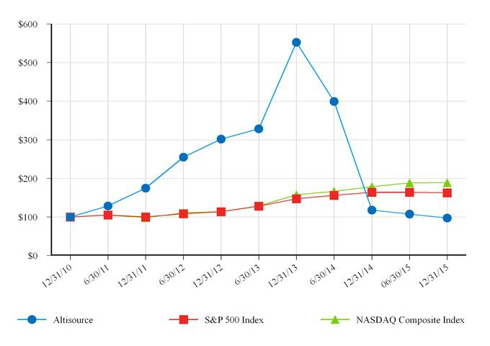

 | 12/31/10 |  | 6/30/11 |  | 12/31/11 |  | 6/30/12 |  | 12/31/12 |  | 6/30/13 |  | 12/31/13 |  | 6/30/14 |  | 12/31/14 |  | 06/30/15 |  | 12/31/15
Altisource | $ 100.00 |  | $ 128.18 |  | $ 174.78 |  | $ 255.07 |  | $ 301.81 |  | $ 328.46 |  | $ 552.53 |  | $ 399.09 |  | $ 117.69 |  | $ 107.24 |  | $ 96.87
S&P 500 Index | 100.00 |  | 105.01 |  | 100.00 |  | 108.31 |  | 113.40 |  | 127.72 |  | 146.97 |  | 155.87 |  | 163.71 |  | 164.05 |  | 162.52
NASDAQ Composite | 100.00 |  | 104.55 |  | 98.20 |  | 110.64 |  | 113.82 |  | 128.29 |  | 157.44 |  | 166.17 |  | 178.53 |  | 187.98 |  | 188.75
Index | 100.00 |  | 104.55 |  | 98.20 |  | 110.64 |  | 113.82 |  | 128.29 |  | 157.44 |  | 166.17 |  | 178.53 |  | 187.98 |  | 188.75

Securities Authorized for Issuance under Equity Compensation Plans

The information required by this item is incorporated herein by reference to our definitive proxy statement in connection with our 2016 annual meeting of shareholders to be filed pursuant to Regulation 14A under the Securities Exchange Act of 1934.

22

Table of Contents

Issuer Purchases of Equity Securities

On May 20, 2015, our shareholders approved a new share repurchase program, which replaced the previous share repurchase program. Under the new program, we are authorized to purchase up to 3.0 million shares of our common stock, based on a limit of 15% of the outstanding shares of common stock on the date of approval at a minimum price of $1.00 per share and a maximum price of $500.00 per share. This is in addition to amounts previously purchased under prior programs. Under the existing and prior programs, we purchased 2.1 million shares of common stock at an average price of $27.60 per share during the year ended December 31, 2015, 2.5 million shares at an average price of $103.67 per share during the year ended December 31, 2014 and 1.2 million shares at an average price of $116.99 per share during the year ended December 31, 2013. As of December 31, 2015, approximately 1.4 million shares of common stock remain available for repurchase under the new program. Our senior secured term loan limits the amount we can spend on share repurchases and may prevent repurchases in certain circumstances. As of December 31, 2015, approximately $360 million was available to repurchase shares of our common stock under our senior secured term loan.

The following table presents information related to the repurchases of our equity securities during the three months ended December 31, 2015:

 |  |  |  |  |  |  |  |  | Total number |  | Maximum number
 |  |  |  | Total |  |  | Weighted |  | of shares |  | Maximum number
 |  |  |  |  |  |  |  |  | purchased as |  | of shares that may
 |  |  |  | number of |  |  | average |  | part of publicly |  | yet be purchased
 | Period |  |  | shares |  |  | price paid |  | announced plans |  | under the
 |  |  |  | purchased(1) |  |  | per share |  | or programs(2) |  | plans or programs(2)
 | Common stock:
 | October 1 — 31, 2015 |  |  | — |  | $ | — |  | — |  | 1,811,525
 | November 1 — 30, 2015 |  |  | 178,000 |  |  | 27.56 |  | 178,000 |  | 1,633,525
 | December 1 — 31, 2015 |  |  | 201,945 |  |  | 25.06 |  | 201,945 |  | 1,431,580
 | Total shares of common stock |  |  | 379,945 |  | $ | 26.23 |  | 379,945 |  | 1,431,580

- May include shares withheld from employees to satisfy tax withholding obligations that arose from the exercise of stock options.

- On May 20, 2015, our shareholders authorized a new share repurchase program that replaced the prior program and authorized us to purchase up to 3.0 million shares of our common stock in the open market.

23

Table of Contents

ITEM 6. SELECTED FINANCIAL DATA

The following selected financial data as of and for the years ended December 31, 2015, 2014, 2013, 2012 and 2011 has been derived from our audited consolidated financial statements.

The historical results presented below may not be indicative of our future performance.

The selected consolidated financial data should be read in conjunction with the information contained in Item 7 of Part II, “Management’s Discussion and Analysis of Financial Condition and Results of Operations” and our consolidated financial statements and notes thereto in Item 8 of Part II, “Financial Statements and Supplementary Data.”

 |  |  |  |  |  | For the years ended December 31,
(in thousands, except per share data) |  |  | 2015 |  |  | 2014 |  |  | 2013 |  |  | 2012 |  |  | 2011
Revenue |  | $ | 1,051,466 |  | $ | 1,078,916 |  | $ | 768,357 |  | $ | 568,360 |  | $ | 423,687
Cost of revenue |  |  | 687,327 |  |  | 707,180 |  |  | 492,480 |  |  | 366,201 |  |  | 275,849
Gross profit |  |  | 364,139 |  |  | 371,736 |  |  | 275,877 |  |  | 202,159 |  |  | 147,838
Selling, general and administrative expenses |  |  | 220,868 |  |  | 201,733 |  |  | 113,810 |  |  | 74,712 |  |  | 62,131
Impairment losses |  |  | 71,785 |  |  | 37,473 |  |  | — |  |  | — |  |  | —
Change in the fair value of Equator earn out liability |  |  | (7,591) |  |  | (37,924) |  |  | — |  |  | — |  |  | —
Income from operations |  |  | 79,077 |  |  | 170,454 |  |  | 162,067 |  |  | 127,447 |  |  | 85,707
Other income (expense), net:
Interest expense |  |  | (28,208) |  |  | (23,363) |  |  | (20,291) |  |  | (1,210) |  |  | (85)
Loss on sale of HLSS equity securities, net of dividends
received |  |  | (1,854) |  |  | — |  |  | — |  |  | — |  |  | —
Other income (expense), net |  |  | 4,045 |  |  | 174 |  |  | 557 |  |  | (1,588) |  |  | 288
Total other income (expense), net |  |  | (26,017) |  |  | (23,189) |  |  | (19,734) |  |  | (2,798) |  |  | 203
Income before income taxes and non-controlling interests |  |  | 53,060 |  |  | 147,265 |  |  | 142,333 |  |  | 124,649 |  |  | 85,910
Income tax provision |  |  | (8,260) |  |  | (10,178) |  |  | (8,540) |  |  | (8,738) |  |  | (7,943)
Net income |  |  | 44,800 |  |  | 137,087 |  |  | 133,793 |  |  | 115,911 |  |  | 77,967
Net income attributable to non-controlling interests |  |  | (3,202) |  |  | (2,603) |  |  | (3,820) |  |  | (5,284) |  |  | (6,855)
Net income attributable to Altisource |  | $ | 41,598 |  | $ | 134,484 |  | $ | 129,973 |  | $ | 110,627 |  | $ | 71,112
Earnings per share:
Basic |  | $ | 2.13 |  | $ | 6.22 |  | $ | 5.63 |  | $ | 4.74 |  | $ | 2.92
Diluted |  | $ | 2.02 |  | $ | 5.69 |  | $ | 5.19 |  | $ | 4.43 |  | $ | 2.77
Transactions with related parties included above:
Revenue |  |  | N/A⁽¹⁾ |  | $ | 666,800 |  | $ | 502,087 |  | $ | 338,227 |  | $ | 245,262
Cost of revenue |  |  | N/A⁽¹⁾ |  |  | 38,610 |  |  | 19,983 |  |  | 13,469 |  |  | 5,180
Selling, general and administrative expenses |  |  | _{N/A}(1) |  |  | (268) |  |  | 569 |  |  | (542) |  |  | (166)
Other income |  |  | N/A⁽¹⁾ |  |  | — |  |  | 773 |  |  | 86 |  |  | —
Non-GAAP Financial Measures⁽²⁾
Adjusted net income attributable to Altisource |  | $ | 143,475 |  | $ | 169,141 |  | $ | 156,458 |  | $ | 115,304 |  | $ | 75,914
Adjusted diluted earnings per share |  | $ | 6.96 |  | $ | 7.16 |  | $ | 6.25 |  | $ | 4.62 |  | $ | 2.96

- Through January 16, 2015, William C. Erbey served as our Chairman as well as the Executive Chairman of Ocwen and Chairman of each of HLSS, Residential and AAMC. Effective January 16, 2015, Mr. Erbey stepped down as the Executive Chairman of Ocwen and Chairman of each of Altisource, HLSS, Residential and AAMC and is no longer a member of the Board of Directors for any of these companies. Consequently, these companies are no longer related parties of Altisource, as defined by Financial Accounting Standards Board’s Accounting Standards Codification (“ASC”) Topic 850, Related Party Disclosures. The disclosures in the table above are limited to the periods that each of Ocwen, HLSS, Residential and AAMC were related parties of Altisource and are not necessarily reflective of current activities with these former related parties. See Note 4 to the consolidated financial statements for more details.

- Theses are non-GAAP measures that are defined and reconciled to the corresponding GAAP measures on page 26.

24

Table of Contents

 |  |  |  |  |  |  |  |  | December 31,
(in thousands) |  |  | 2015 |  |  | 2014 |  |  | 2013 |  |  | 2012 |  |  | 2011
Cash and cash equivalents |  | $ | 179,327 |  | $ | 161,361 |  | $ | 130,324 |  | $ | 105,502 |  | $ | 32,125
Accounts receivable, net |  |  | 105,023 |  |  | 112,183 |  |  | 104,787 |  |  | 88,955 |  |  | 52,005
Premises and equipment, net |  |  | 119,121 |  |  | 127,759 |  |  | 87,252 |  |  | 50,399 |  |  | 25,600
Goodwill |  |  | 82,801 |  |  | 90,851 |  |  | 99,414 |  |  | 14,915 |  |  | 14,915
Intangible assets, net |  |  | 197,003 |  |  | 245,246 |  |  | 276,162 |  |  | 56,586 |  |  | 64,950
Loan to Ocwen |  |  | — |  |  | — |  |  | — |  |  | 75,000 |  |  | —
Total assets |  |  | 727,982 |  |  | 788,221 |  |  | 730,052 |  |  | 429,226 |  |  | 224,159
Long-term debt, net (including current portion) |  |  | 534,362 |  |  | 588,614 |  |  | 395,256 |  |  | 198,027 |  |  | —
Capital lease obligations |  |  | — |  |  | — |  |  | — |  |  | 233 |  |  | 836
Total liabilities |  |  | 675,712 |  |  | 746,778 |  |  | 572,311 |  |  | 269,397 |  |  | 58,216

Significant events affecting our historical earnings trends from 2013 through 2015, including acquisitions, are described in Item 7 of Part II, “Management’s Discussion and Analysis of Financial Condition and Results of Operations.”

25

Table of Contents

NON-GAAP MEASURES

Adjusted net income attributable to Altisource and adjusted diluted earnings per share are non-GAAP measures used by management, existing shareholders and potential shareholders to measure Altisource’s performance. Adjusted net income attributable to Altisource is calculated by adding intangible asset amortization expense (net of tax) and impairment losses (net of tax) and deducting gains associated with reductions of the Equator earn out liability (net of tax) to GAAP net income attributable to Altisource. Adjusted diluted earnings per share is calculated by dividing net income attributable to Altisource plus intangible asset amortization expense (net of tax) plus impairment losses (net of tax) less gains associated with reductions of the Equator earn out liability (net of tax) to GAAP net income attributable to Altisource by the weighted average number of diluted shares. Reconciliations of the non-GAAP measures to the corresponding GAAP measures are as follows:

 |  |  |  |  |  | For the years ended December 31,
(in thousands, except per share data) |  |  | 2015 |  |  | 2014 |  |  | 2013 |  |  | 2012 |  |  | 2011
Net income attributable to Altisource |  | $ | 41,598 |  | $ | 134,484 |  | $ | 129,973 |  | $ | 110,627 |  | $ | 71,112
Intangible amortization expense, net of tax |  |  | 38,187 |  |  | 35,076 |  |  | 26,485 |  |  | 4,677 |  |  | 4,802
Impairment loss, net of tax |  |  | 70,630 |  |  | 34,884 |  |  | — |  |  | — |  |  | —
Gain on Equator earn out liability, net of tax |  |  | (6,940) |  |  | (35,303) |  |  | — |  |  | — |  |  | —
Adjusted net income attributable to Altisource |  | $ | 143,475 |  | $ | 169,141 |  | $ | 156,458 |  | $ | 115,304 |  | $ | 75,914
Diluted earnings per share |  | $ | 2.02 |  | $ | 5.69 |  | $ | 5.19 |  | $ | 4.43 |  | $ | 2.77
Intangible amortization expense, net of tax, per diluted share |  |  | 1.85 |  |  | 1.48 |  |  | 1.06 |  |  | 0.19 |  |  | 0.19
Impairment loss, net of tax, per diluted share |  |  | 3.43 |  |  | 1.48 |  |  | — |  |  | — |  |  | —
Gain on Equator earn out liability, net of tax, per diluted share |  |  | (0.34) |  |  | (1.49) |  |  | — |  |  | — |  |  | —
Adjusted diluted earnings per share |  | $ | 6.96 |  | $ | 7.16 |  | $ | 6.25 |  | $ | 4.62 |  | $ | 2.96
Calculation of the impact of intangible amortization expense, net of tax
Intangible amortization expense |  | $ | 41,135 |  | $ | 37,680 |  | $ | 28,176 |  | $ | 5,030 |  | $ | 5,291
Tax benefit from intangible asset amortization |  |  | (2,948) |  |  | (2,604) |  |  | (1,691) |  |  | (353) |  |  | (489)
Intangible asset amortization expense, net of tax |  |  | 38,187 |  |  | 35,076 |  |  | 26,485 |  |  | 4,677 |  |  | 4,802
Diluted share count |  |  | 20,619 |  |  | 23,634 |  |  | 25,053 |  |  | 24,962 |  |  | 25,685
Intangible asset amortization expense, net of tax, per diluted share |  | $ | 1.85 |  | $ | 1.48 |  | $ | 1.06 |  | $ | 0.19 |  | $ | 0.19
Calculation of the impact of impairment loss, net of tax
Impairment loss |  | $ | 71,785 |  | $ | 37,473 |  | $ | — |  | $ | — |  | $ | —
Tax benefit from impairment loss |  |  | (1,155) |  |  | (2,589) |  |  | — |  |  | — |  |  | —
Impairment loss, net of tax |  |  | 70,630 |  |  | 34,884 |  |  | — |  |  | — |  |  | —
Diluted share count |  |  | 20,619 |  |  | 23,634 |  |  | 25,053 |  |  | 24,962 |  |  | 25,685
Impairment loss, net of tax, per diluted share |  | $ | 3.43 |  | $ | 1.48 |  | $ | — |  | $ | — |  | $ | —
Calculation of gain on Equator earn out liability, net of tax
Gain on Equator earn out liability |  | $ | (7,591) |  | $ | (37,924) |  | $ | — |  | $ | — |  | $ | —
Tax provision from the gain on Equator earn out liability |  |  | 651 |  |  | 2,621 |  |  | — |  |  | — |  |  | —
Gain on Equator earn out liability, net of tax |  |  | (6,940) |  |  | (35,303) |  |  | — |  |  | — |  |  | —
Diluted share count |  |  | 20,619 |  |  | 23,634 |  |  | 25,053 |  |  | 24,962 |  |  | 25,685
Gain on Equator earn out liability, net of tax, per diluted share |  | $ | (0.34) |  | $ | (1.49) |  | $ | — |  | $ | — |  | $ | —

26

Table of Contents

ITEM 7. MANAGEMENT’S DISCUSSION AND ANALYSIS OF FINANCIAL CONDITION AND RESULTS OF OPERATIONS

Management’s discussion and analysis of financial condition and results of operations (“MD&A”) is a supplement to the accompanying consolidated financial statements and is intended to provide a reader of our financial statements with a narrative from the perspective of management on our businesses, current developments, financial condition, results of operations and liquidity. Significant sections of the MD&A are as follows:

Overview. This section, beginning below, provides a description of recent developments we believe are important in understanding our results of operations and financial condition as well as understanding anticipated future trends. It also provides a brief description of significant transactions and events that affect the comparability of financial results and a discussion of the progress being made on our growth initiatives.

Consolidated Results of Operations. This section, beginning on page 31, provides an analysis of our consolidated results of operations for the three years ended December 31, 2015.

Segment Results of Operations. This section, beginning on page 35, provides an analysis of each business segment for the three years ended December 31, 2015 as well as Corporate Items and Eliminations. In addition, we discuss significant transactions, events and trends that may affect the comparability of the results being analyzed.

Liquidity and Capital Resources. This section, beginning on page 44, provides an analysis of our cash flows for the three years ended December 31, 2015. We also discuss restrictions on cash movements, future commitments and capital resources.

Critical Accounting Policies, Estimates and Recent Accounting Pronouncements. This section, beginning on page 47, identifies those accounting principles we believe are most important to our financial results and that require significant judgment and estimates on the part of management in application. We provide all of our significant accounting policies in Note 2 to the accompanying consolidated financial statements.

Other Matters. This section, beginning on page 50, provides a discussion of off-balance sheet arrangements to the extent they exist. In addition, we provide a tabular discussion of contractual obligations, discuss any significant commitments or contingencies and customer concentration.

OVERVIEW

Our Business

We are a premier marketplace and transaction solutions provider for the real estate, mortgage and consumer debt industries. Altisource’s proprietary business processes, vendor and electronic payment management software and behavioral science-based analytics improve outcomes for marketplace participants.

Our business segments are based upon our organizational structure, which focuses primarily on the services offered, and are consistent with the internal reporting used by our Chief Executive Officer to evaluate operating performance and to assess the allocation of our resources.

We classify our businesses into three reportable segments. The Mortgage Services segment provides services that span the mortgage and real estate lifecycle and are typically outsourced by loan servicers, loan originators, home investors and other sellers and buyers of single family homes. The Financial Services segment provides collection and customer relationship management services primarily to debt originators and servicers (e.g., credit card, auto lending, retail credit and mortgage) and the utility, insurance and hotel industries. The Technology Services segment provides a portfolio of software, data analytics and infrastructure management services that support the efficient and compliant management of mortgage and real estate activities and marketplace transactions across the mortgage and real estate lifecycles. In addition, Corporate Items and Eliminations include interest expense and costs related to corporate support functions including executive, finance, law, compliance, human resources, vendor management, risk, sales and marketing costs not allocated to the business units and eliminations of transactions between the reportable segments.

We classify revenue in three categories: service revenue, revenue from reimbursable expenses and non-controlling interests. In evaluating our performance, we focus on service revenue. Service revenue consists of amounts attributable to our fee-based services. Reimbursable expenses and non-controlling interests are pass-through items for which we earn no margin. Reimbursable expenses consist of amounts we incur on behalf of our customers in performing our fee-based services, but we pass such costs

27

Table of Contents

directly on to our customers without any additional markup. Non-controlling interests represent the earnings of Lenders One, Wholesale One and Residential Investor One, consolidated entities not owned by Altisource, and are included in revenue and reduced from net income to arrive at net income attributable to Altisource.

We have prepared our consolidated financial statements in accordance with accounting principles generally accepted in the United States of America (“GAAP”).

Altisource’s Vision and Growth Initiatives

Altisource provides a suite of mortgage, real estate and consumer debt services, leveraging our technology platform and global operations. Altisource is focused on becoming the premier provider of real estate and mortgage marketplaces and related services to a broad and diversified customer base. Within the real estate and mortgage markets, we facilitate transactions and provide products, solutions and services related to home sales, home purchases, home rentals, home maintenance, mortgage origination and mortgage servicing.

Strategically, we are focused on (1) our four key business initiatives, (2) continuing to strengthen our compliance management system and (3) maintaining strong performance and relationships with our strategic customers.

Each of our four key business initiatives position Altisource to grow and diversify our customer and revenue base. We believe these initiatives address very large markets and directly leverage our core competencies and distinct competitive advantages. Our four strategic growth initiatives and a brief description of each are as follows:

Mortgage market:

- Continue to grow our Servicer Solutions business (the products, services and technologies typically used or licensed by loan servicers): We are focused on growing our Servicer Solutions business by expanding services purchased by our existing customer base and attracting new customers. Even as delinquencies return to historical norms, we believe there is a very large addressable market for the services we provide, as well as a strong and increasing customer focus on regulatory compliance and operational quality. We are one of only a few service providers with a comprehensive offering of services and technologies on a national scale. We believe we are well positioned to gain market share as customers consolidate to larger, full-service vendors and continue to outsource services that have historically been performed in-house.

- Continue to grow our Origination Solutions business (the products, services and technologies typically used or licensed by participants in the loan origination market): We are focused on building an industry leading, integrated origination services platform that provides end-to-end solutions (products, services and technology) to our customers. We plan to grow our Origination Solutions business by expanding our product offerings to our existing client base and actively adding new customers. We are leveraging our enterprise wide sales organization to offer our origination services to larger bank and non-bank originators and correspondents and plan to expand our middle market sales organization to address other prospects. We believe we are well positioned to gain market share as customers consolidate to larger full-service vendors and by offering our existing customers (e.g., the members of Lenders One, the customers of Mortgage Builder and CastleLine and our preferred vendors and partners) an attractive suite of products and services that meet their growing needs.

Real estate market:

- Continue to grow Owners.com, our consumer real estate offering (the products, services and technologies typically used by self-directed home buyers and sellers): Owners.com provides self-directed consumers with a full suite of real estate services from which to choose. We are focused on growing Owners.com by building brand awareness, driving customer engagement and increasing consumer adoption of our buy side brokerage services. With a growing segment of the population demonstrating a desire to engage in self-directed transactions, we believe Owners.com is well positioned to become a market leader.

- Continue to grow our Real Estate Investor Solutions business (the products, services and technologies typically used by participants in residential real estate investments): We are focused on growing our Real Estate Investor Solutions business by supporting the growth of our existing customers, expanding services purchased by our existing customer base and attracting new customers. With our national real estate brokerage operation, vendor network, property management and renovation footprint, existing customer base and growing suite of technologies, we believe we are well positioned to grow.

28

Table of Contents

Share Repurchase Plan

On May 20, 2015, our shareholders approved a new share repurchase program, which replaced the previous share repurchase program. Under the new program, we are authorized to purchase up to 3.0 million shares of our common stock, based on a limit of 15% of the outstanding shares of common stock on the date of approval at a minimum price of $1.00 per share and a maximum price of $500.00 per share. This is in addition to amounts previously purchased under prior programs. Under the existing and prior programs, we purchased 2.1 million shares of common stock at an average price of $27.60 per share during the year ended December 31, 2015, 2.5 million shares at an average price of $103.67 per share during the year ended December 31, 2014 and 1.2 million shares at an average price of $116.99 per share during the year ended December 31, 2013. As of December 31, 2015, approximately 1.4 million shares of common stock remain available for repurchase under the new program. Our senior secured term loan limits the amount we can spend on share repurchases and may prevent repurchases in certain circumstances. As of December 31, 2015, approximately $360 million was available to repurchase shares of our common stock under our senior secured term loan.

Factors Affecting Comparability

The following items may impact the comparability of our results:

- The average number of loans serviced by Ocwen on REALServicing was 2.0 million for the year ended December 31, 2015 compared to 2.2 million and 1.2 million for the years ended December 31, 2014 and 2013, respectively. The average number of delinquent non-GSE loans serviced by Ocwen on REALServicing was 279 thousand for the year ended December 31, 2015 compared to 352 thousand and 296 thousand for the years ended December 31, 2014 and 2013, respectively;

- In the fourth quarter of 2015, we recorded non-cash impairment losses of $71.8 million in our Technology Services segment primarily driven by the Company’s current projected Technology Services revenue from Ocwen and investment in technologies provided to Ocwen;
- During the year ended December 31, 2015, we repurchased portions of our senior secured term loan with an aggregate par value of $49.0 million at a weighted average discount of 10.3%, resulting in net gains totaling $3.8 million on the early extinguishment of debt;
- On October 9, 2015, we acquired the Acquired RentRange and Investability Businesses for $24.8 million, composed of $17.5 million in cash and 247 thousand shares of restricted common stock of the Company with a value of $7.3 million as of the closing date;
- On July 17, 2015, we acquired CastleLine for $33.4 million. The purchase consideration was composed of $12.3 million of cash at closing, $10.5 million of cash payable over four years from the acquisition date and 495 thousand shares of restricted common stock of the Company with a value of $14.4 million as of the closing date. Of the cash payable following acquisition, $3.8 million is contingent on certain future employment conditions of certain of the sellers, and therefore excluded from the purchase price;

- Effective March 31, 2015, we terminated the Data Access and Services Agreement with Ocwen;

- On November 21, 2014, we acquired Owners for an initial purchase price of $19.8 million plus contingent earn out consideration of up to an additional $7.0 million over two years, subject to Owners achieving annual performance targets;
- In the fourth quarter of 2014, we discontinued our lender placed insurance brokerage line of business;

- On September 12, 2014, we acquired Mortgage Builder for an initial purchase price of $15.7 million plus contingent earn out consideration of up to an additional $7.0 million over three years, subject to Mortgage Builder achieving annual performance targets;
- Bad debt expense was higher in 2014, driven primarily from the default management services business. A change in many of our default management services customers’ business models and fourth quarter of 2014 discussions with these customers led us to believe that a portion of the accounts receivable balance was no longer collectible;

- On November 15, 2013, we acquired Equator for an initial purchase price of $63.4 million plus contingent earn out consideration of up to an additional $80 million over three years (“Equator Earn Out”), subject to Equator achieving annual performance targets. During 2014, the fair value of the Equator contingent consideration was reduced by $37.9 million with a corresponding increase in earnings. As a result of the adjustment in the fair value of the Equator contingent consideration, we determined that the Equator goodwill was impaired and recorded an estimated impairment loss of $37.5 million in 2014. In 2015, we paid the former owners of Equator $0.5 million to extinguish any liability for the Equator Earn Out. In connection with this settlement, we reduced the liability for the Equator Earn Out to $0 and recognized a $7.6 million increase in earnings;

- On April 12, 2013, we completed the Residential Capital, LLC (“ResCap”) fee-based business transaction with Ocwen for an aggregate purchase price of $128.8 million;

29

Table of Contents

- On March 29, 2013, we completed the acquisition of the Homeward Residential Capital, Inc. (“Homeward”) fee-based businesses from Ocwen for an aggregate purchase price of $75.8 million; and

- During 2013, we increased our borrowings under the senior secured term loan to $400.0 million and refinanced the loan which included, among other changes, lowering the interest rate of the term loans. On August 1, 2014, we amended our senior secured term loan agreement and increased our borrowings by $200.0 million to $594.5 million.

Material Weakness

In connection with the assessment and recording of the non-cash impairment losses described above, we identified a material weakness in our internal controls over the review of impairment indicators of long-lived assets, including premises and equipment and intangible assets, and the impairment analysis of indefinite-lived assets, primarily goodwill. We intend to implement remediation measures to address this material weakness, but currently do not have an expected timetable for the completion of the remediation. See Part II. Item 9A. “Controls and Procedures” of this Annual Report for additional information.

30

Table of Contents

CONSOLIDATED RESULTS OF OPERATIONS

Summary Consolidated Results

Following is a discussion of our consolidated results of operations for the years ended December 31, 2015, 2014 and 2013. For a more detailed discussion of the factors that affected the results of our business segments in these periods, see “Segment Results of Operations” below.

The following table sets forth information on our results of operations for the years ended December 31:

(in thousands, except per share data) |  |  | 2015 |  | % Increase |  |  | 2014 |  | % Increase |  |  | 2013
 |  |  | 2015 |  | (decrease) |  |  | 2014 |  | (decrease) |  |  | 2013
Service revenue
Mortgage Services |  | $ | 676,222 | 4 |  |  | $ | 653,093 | 32 |  |  | $ | 493,500
Financial Services |  |  | 88,328 | (10) |  |  |  | 98,312 | 6 |  |  |  | 92,479
Technology Services |  |  | 215,482 | (5) |  |  |  | 227,300 | 126 |  |  |  | 100,724
Eliminations |  |  | (39,112) | (2) |  |  |  | (40,026) | 62 |  |  |  | (24,644)
Total service revenue |  |  | 940,920 |  | — |  |  | 938,679 | 42 |  |  |  | 662,059
Reimbursable expenses |  |  | 107,344 | (22) |  |  |  | 137,634 | 34 |  |  |  | 102,478
Non-controlling interests |  |  | 3,202 | 23 |  |  |  | 2,603 | (32) |  |  |  | 3,820
Total revenue |  |  | 1,051,466 | (3) |  |  |  | 1,078,916 | 40 |  |  |  | 768,357
Cost of revenue |  |  | 687,327 | (3) |  |  |  | 707,180 | 44 |  |  |  | 492,480
Gross profit |  |  | 364,139 | (2) |  |  |  | 371,736 | 35 |  |  |  | 275,877
Selling, general and administrative expenses |  |  | 220,868 | 9 |  |  |  | 201,733 | 77 |  |  |  | 113,810
Impairment losses |  |  | 71,785 | 92 |  |  |  | 37,473 |  | N/M |  |  | —
Change in the fair value of Equator earn out liability |  |  | (7,591) | (80) |  |  |  | (37,924) |  | N/M |  |  | —
Income from operations |  |  | 79,077 | (54) |  |  |  | 170,454 | 5 |  |  |  | 162,067
Other income (expense), net:
Interest expense |  |  | (28,208) | 21 |  |  |  | (23,363) | 15 |  |  |  | (20,291)
Loss on sale of HLSS equity securities, net of dividends
received |  |  | (1,854) |  | N/M |  |  | — |  | N/M |  |  | —
Other income (expense), net |  |  | 4,045 |  | N/M |  |  | 174 | (69) |  |  |  | 557
Total other income (expense), net |  |  | (26,017) |  | 12 |  |  | (23,189) | 18 |  |  |  | (19,734)
Income before income taxes and non-controlling interests |  |  | 53,060 | (64) |  |  |  | 147,265 | 3 |  |  |  | 142,333
Income tax provision |  |  | (8,260) | (19) |  |  |  | (10,178) | 19 |  |  |  | (8,540)
Net income |  |  | 44,800 | (67) |  |  |  | 137,087 | 2 |  |  |  | 133,793
Net income attributable to non-controlling interests |  |  | (3,202) | 23 |  |  |  | (2,603) | (32) |  |  |  | (3,820)
Net income attributable to Altisource |  | $ | 41,598 | (69) |  |  | $ | 134,484 | 3 |  |  | $ | 129,973
Margins:
Gross profit/service revenue |  |  | 39% |  |  |  |  | 40% |  |  |  |  | 42%
Income from operations/service revenue |  |  | 8% |  |  |  |  | 18% |  |  |  |  | 24%
Earnings per share:
Basic |  | $ | 2.13 | (66) |  |  | $ | 6.22 | 10 |  |  | $ | 5.63
Diluted |  | $ | 2.02 | (64) |  |  | $ | 5.69 | 10 |  |  | $ | 5.19
Non-GAAP Financial Measures ⁽¹⁾
Adjusted net income attributable to Altisource |  | $ | 143,475 | (15) |  |  | $ | 169,141 | 8 |  |  | $ | 156,458
Adjusted diluted earnings per share |  | $ | 6.96 | (3) |  |  | $ | 7.16 | 15 |  |  | $ | 6.25

- These are non-GAAP measures that are defined and reconciled to the corresponding GAAP measures on page 26 N/M — not meaningful.

31

Table of Contents

Revenue

We recognized service revenue of $940.9 million, $938.7 million and $662.1 million for the years ended December 31, 2015, 2014 and 2013, respectively. The increase in service revenue for the year ended December 31, 2015 was primarily due to the revenue expansion in the asset management services businesses primarily from growth in both the number of non-Ocwen and Ocwen REO properties sold on Hubzu, increased volumes of property preservation services for Residential, higher revenue from software development and a full year of revenue from the September 2014 acquisition of Mortgage Builder. In addition, in early 2015, the pricing model to one of our customers for REO preservation services within asset management services changed. Historically, we billed (1) a fixed fee per REO asset (which was recognized as service revenue) and (2) actual vendor costs (which were recognized as reimbursable expenses revenue). For new REO referrals, effective early 2015, our pricing is on a per service basis (which is recognized as service revenue). This results in certain services that were historically reimbursable expense revenue becoming service revenue. As a result, asset management services revenue at Mortgage Services increased, partially offset by a decrease in reimbursable expenses revenue. These increases were largely offset by the discontinuation of the lender placed insurance brokerage line of business in the fourth quarter of 2014, lower Equator revenue from the full amortization of acquisition related deferred revenue in 2014, fewer property valuation services referrals, decreased property inspection volumes, lower mortgage charge-off collections and a decrease in IT infrastructure services. The growth in service revenue for the year ended December 31, 2014 was primarily driven by Ocwen’s growth, higher auction mix for houses sold on Hubzu, revenue from Equator, which we acquired in November 2013, and growth in our Financial Services business from new customers in our customer relationship management business. These increases were partially offset by a decline in the default management services business driven by lower levels of foreclosure starts and the fourth quarter of 2013 loss of an origination management services customer which eliminated its affinity relationship with Altisource and its other similar vendor partners.

Certain of our revenues are impacted by seasonality. More specifically, Mortgage Services’ revenue is impacted by REO sales and lawn maintenance, which tend to be at their lowest level during the fall and winter months and at their highest level during the spring and summer months. Financial Services’ asset recovery management revenue tends to be higher in the first quarter, as borrowers may utilize tax refunds and bonuses to pay debts, and generally declines throughout the rest of the year.

Cost of Revenue and Gross Profit

Cost of revenue principally includes payroll and employee benefits associated with personnel employed in customer service and operations roles, fees paid to external providers related to the provision of services, reimbursable expenses, technology and telecommunications costs, and depreciation and amortization of operating assets.

We recognized cost of revenue of $687.3 million, $707.2 million and $492.5 million for the years ended December 31, 2015, 2014 and 2013, respectively. The decrease in cost of revenue for the year ended December 31, 2015 was primarily attributable to the March 31, 2015 termination of the Data Access and Services Agreement with Ocwen in the Mortgage Services segment and lower technology and telecommunications costs, partially offset by an increase in compensation and benefits, outside fees and services and depreciation and amortization costs. Outside fees and services increased and reimbursable expenses declined as a result of the change in billing discussed in the revenue section above. Technology and telecommunications costs decreased due to cost savings initiatives implemented in 2015. Recognizing that our service revenue from Ocwen was not expected to grow in the near term due to challenges faced by Ocwen in late 2014 and early 2015, we developed and executed on a plan that included eliminating certain non-revenue generating businesses, reducing vendor costs and eliminating staff. Compensation and benefits costs were higher in 2015 compared to 2014 primarily due to increased United States headcount to support growth in certain of our Mortgage Services businesses. Additionally, severance costs of $4.3 million for the year ended December 31, 2015 were incurred in connection with the elimination of staff as a result of the cost reduction initiatives implemented during the first half of 2015. The increase in cost of revenue for the year ended December 31, 2014 was primarily attributable to revenue growth during the same period and the increased investment in the development of our technology.

Gross profit decreased to $364.1 million, representing 39% of service revenue, for the year ended December 31, 2015 compared to $371.7 million, representing 40% of service revenue, for the year ended December 31, 2014 and $275.9 million, representing 42% of service revenue, for the year ended December 31, 2013.

Gross profit as a percentage of service revenue declined slightly in 2015 compared to 2014 primarily due to service revenue growth in the higher margin Mortgage Services segment offset by a decline in gross profit as a percentage of service revenue in the Financial Services and Technology Services segments. Mortgage Services’ slight decline in gross profit margins was driven by service revenue growth of the lower margin property preservation and inspection business within asset management services and the November 2014 discontinuation of the higher margin lender placed insurance brokerage business within insurance services, partially offset by Hubzu revenue growth within asset management services and the March 31, 2015 termination of the Data Access

32

Table of Contents

and Services Agreement with Ocwen. The decline in gross profit as a percentage of service revenue in the Financial Services and Technology Services segments was from revenue mix and the full amortization of the Equator acquisition related deferred revenue within software services in November 2014.

Gross profit as a percentage of service revenue declined in 2014 compared to 2013 from a shift in revenue across segments with higher growth in the lower margin Technology Services segment. Margin expansion in the Mortgage Services segment was partially offset by margin decreases in the other segments. In the Mortgage Services segment, we expanded our gross profit margin by fully utilizing employees that we were carrying in 2013 in anticipation of new business and performing certain services with our employees that were previously performed by outside vendors. In the Financial Services segment, the gross profit margin decline was driven by revenue mix as the higher margin mortgage charge-off collections business within asset recovery management represented a lower percentage of revenue in the Financial Services segment in 2014. In the Technology Services segment, gross profit margin decreased primarily due to our continued investment in our technology to support our growth, partially offset by higher gross profit margin in the Equator business within software services.

Operating Expenses and Income from Operations

Operating expenses are composed of selling, general and administrative (“SG&A”) expenses, impairment losses and changes in the fair value of the Equator earn out liability. Selling, general and administration expenses include payroll for personnel employed in executive, finance, law, compliance, human resources, vendor management, risk, sales and marketing roles. This category also includes occupancy costs, professional fees and depreciation and amortization of intangible assets.

We recognized SG&A of $220.9 million, $201.7 million and $113.8 million for the years ended December 31, 2015, 2014 and 2013, respectively. The increase in SG&A in 2015 compared to 2014 was primarily driven by higher compensation and benefits costs from an expansion of certain support functions, severance costs incurred in connection with cost savings initiatives, higher legal costs related to legal and regulatory matters, increased corporate marketing expenses associated with our customer and revenue diversification initiatives, increased amortization of intangible assets related to the Homeward and ResCap fee-based business acquisitions and the Mortgage Builder acquisition and an estimated loss recorded in the fourth quarter of 2015 in connection with an anticipated payment to Ocwen for obtaining a release of liability for Altisource related to Ocwen’s settlement of a particular case. These increased costs were partially offset in 2015 by lower bad debt expense.

The increase in SG&A in 2014 compared to 2013 was primarily driven by higher marketing costs related to Hubzu within asset management services, higher compensation and benefits costs to support growth, higher occupancy costs from increased headcount to support growth and higher legal and compliance related costs. Increased amortization of intangible assets was primarily driven by the Homeward and ResCap fee-based business acquisitions and the Equator acquisition, which closed in March 2013, April 2013 and November 2013, respectively. Bad debt expense increased during 2014, driven primarily by the default management services business. A change in many of our default management services customers’ business models and fourth quarter 2014 discussions with these customers led us to believe that a portion of these accounts receivable were no longer collectible. Marketing costs were $24.1 million and $5.0 million for the years ended December 31, 2014 and 2013, respectively. Amortization expense was $37.7 million and $28.2 million for the years ended December 31, 2014 and 2013, respectively.

We recognized impairment losses of $71.8 million and $37.5 million for the years ended December 31, 2015 and 2014, respectively (no comparative amount in 2013). In the fourth quarter of 2015, we recorded non-cash impairment losses of $71.8 million in our Technology Services segment primarily driven by the Company’s current projected Technology Services revenue from Ocwen and investment in technologies provided to Ocwen. These losses are composed of an estimated $55.7 million impairment of goodwill, $11.9 million impairment of intangible assets from the 2013 Homeward and ResCap fee-based business acquisitions and $4.1 million impairment of software assets included in premises and equipment.

In 2014, as a result of the adjustment in the fair value of the Equator contingent consideration described below and based on our goodwill assessment in 2014, we determined that the Equator goodwill was impaired and recorded an impairment loss of $37.5 million for the year ended December 31, 2014.

We recognized gains on the change in the fair value of Equator earn out liability of $7.6 million and $37.9 million for the years ended December 31, 2015 and 2014, respectively (no comparative amount in 2013). The liability for contingent consideration is reflected at fair value and adjusted each reporting period with the change in fair value recognized in earnings. In 2015, we reached an agreement with the former owners of Equator to extinguish any liability for the Equator Earn Out. In connection with this settlement, we reduced the liability for the Equator Earn Out to $0 and recognized a $7.6 million increase in earnings. During 2014, the fair value of the contingent consideration related to the Equator acquisition was reduced by $37.9 million with a

33

Table of Contents

corresponding increase in earnings based on management’s revised estimates that expected earnings of Equator will be lower than projected at the time of acquisition.

Income from operations decreased to $79.1 million, representing 8% of service revenue, for the year ended December 31, 2015 compared to $170.5 million, representing 18% of service revenue, for the year ended December 31, 2014 and $162.1 million, representing 24% of service revenue, for the year ended December 31, 2013. The decrease in operating income margin is primarily driven by the non-cash impairment losses, lower gross profit margins and increases in SG&A, partially offset by gains on the change in fair value of Equator earn out liability, as discussed above.

Other Income (Expense), net

Other income (expense), net principally includes interest expense, interest income, loss on the sale of HLSS equity securities, net of dividends received, and gains on the early extinguishment of debt. Interest expense for the year ended December 31, 2015 was $28.2 million, an increase of $4.8 million compared to the year ended December 31, 2014, resulting from the additional $200.0 million senior secured term loan borrowings on August 1, 2014, partially offset by lower interest expense associated with the 2015 repurchases of a portion of our senior secured term loan with an aggregate par value of $49.0 million. Interest expense for the year ended December 31, 2014 was $23.4 million, an increase of $3.1 million compared to the year ended December 31, 2013, resulting from the additional $200.0 million senior secured term loan borrowings on August 1, 2014, and the additional $200.0 million senior secured term loan borrowings on May 7, 2013, partially offset by lower interest rates from the senior secured term loan refinancing on December 9, 2013. We recognized interest income of $0.1 million for each of the years ended December 31, 2015 and 2014. Additionally, we recognized interest income of $0.9 million for the year ended December 31, 2013, primarily from a $75.0 million loan to Ocwen, which was repaid in February 2013.

During 2015, we repurchased portions of our senior secured term loan with an aggregate par value of $49.0 million at a weighted average discount of 10.3%, resulting in net gains totaling $3.8 million on the early extinguishment of debt (no comparative amounts for 2014 and 2013).

During March 2015, we purchased 1.6 million shares of HLSS common stock in the open market for $30.0 million. On April 6, 2015, HLSS completed the sale of substantially all of its assets and adopted a plan of complete liquidation and dissolution. During 2015, we received liquidating dividends and other dividends from HLSS totaling $20.4 million and sold all of our 1.6 million shares of HLSS common stock in the open market for $7.7 million. As a result of these transactions, we recognized a net loss of $1.9 million for the year ended December 31, 2015 (no comparative amounts for 2014 and 2013) in connection with our investment in HLSS.

Income Tax Provision

We recognized an income tax provision of $8.3 million, $10.2 million and $8.5 million for the years ended December 31, 2015, 2014 and 2013, respectively. Our effective tax rate was 15.6%, 6.9% and 6.0% for the years ended December 31, 2015, 2014 and 2013, respectively. The effective tax rate in all three periods differs from the Luxembourg statutory tax rate of 29.2% primarily due to the effect of certain deductions allowed in Luxembourg pursuant to a tax ruling, which expires in 2019 unless extended or renewed, the mix of income and losses with varying tax rates in multiple taxing jurisdictions and the recognition of research and development tax credits. The higher 2015 effective tax rate is driven by impairment losses which resulted in a change in the jurisdictional mix of income. The impairment losses are related to assets owned by a subsidiary with a lower effective tax rate. Our consolidated effective income tax rate for financial reporting purposes may change periodically due to changes in enacted tax rates, fluctuations in the mix of income earned from our domestic and international operations and our ability to utilize net operating loss and tax credit carryforwards.

34

Table of Contents

SEGMENT RESULTS OF OPERATIONS

The following section provides a discussion of pre-tax results of operations of our business segments. Transactions between segments are accounted for as third party arrangements for purposes of presenting segment results of operations. Intercompany transactions primarily consist of IT infrastructure management services. We reflect these as service revenue in the Technology Services segment and technology and telecommunications costs within cost of revenue and SG&A in the segment receiving the services. Certain prior year amounts reported by the Mortgage Services and Technology Services segments have been reclassified to conform with the current year presentation.

Financial information for our segments is as follows:

 |  |  |  |  |  |  |  |  |  | For the year ended December 31, 2015
 |  |  |  |  | Mortgage |  |  |  |  | Financial |  |  |  |  | Technology |  |  | Corporate |  |  | Consolidated
(in thousands) |  |  |  |  |  |  |  |  |  |  |  |  |  |  |  |  |  | Items and |  |  | Consolidated
 |  |  |  |  | Services |  |  |  |  | Services |  |  |  |  | Services |  |  | Eliminations |  |  | Altisource
Revenue
Service revenue |  |  | $ |  | 676,222 |  |  | $ |  | 88,328 |  |  | $ |  | 215,482 |  | $ | (39,112) |  | $ | 940,920
Reimbursable expenses |  |  |  |  | 107,224 |  |  |  |  | 120 |  |  |  |  | — |  |  | — |  |  | 107,344
Non-controlling interests |  |  |  |  | 3,202 |  |  |  |  | — |  |  |  |  | — |  |  | — |  |  | 3,202
 |  |  |  |  | 786,648 |  |  |  |  | 88,448 |  |  |  |  | 215,482 |  |  | (39,112) |  |  | 1,051,466
Cost of revenue |  |  |  |  | 474,169 |  |  |  |  | 60,806 |  |  |  |  | 187,835 |  |  | (35,483) |  |  | 687,327
Gross profit (loss) |  |  |  |  | 312,479 |  |  |  |  | 27,642 |  |  |  |  | 27,647 |  |  | (3,629) |  |  | 364,139
Selling, general and administrative expenses |  |  |  |  | 105,153 |  |  |  |  | 18,707 |  |  |  |  | 29,902 |  |  | 67,106 |  |  | 220,868
Impairment losses |  |  |  |  | — |  |  |  |  | — |  |  |  |  | 71,785 |  |  | — |  |  | 71,785
Change in the fair value of Equator earn out liability |  |  |  |  | — |  |  |  |  | — |  |  |  |  | (7,591) |  |  | — |  |  | (7,591)
Income (loss) from operations |  |  |  |  | 207,326 |  |  |  |  | 8,935 |  |  |  |  | (66,449) |  |  | (70,735) |  |  | 79,077
Other income (expense), net |  |  |  |  | 506 |  |  |  |  | 58 |  |  |  |  | 61 |  |  | (26,642) |  |  | (26,017)
Income (loss) before income taxes and non-controlling |  |  | $ |  | 207,832 |  |  | $ |  | 8,993 |  |  | $ |  | (66,388) |  | $ | (97,377) |  | $ | 53,060
interests |  |  |  |  | 207,832 |  |  |  |  | 8,993 |  |  |  |  | (66,388) |  | $ | (97,377) |  | $ | 53,060
Margins:
Gross profit/service revenue |  |  |  |  | 46% |  |  |  |  | 31% |  |  |  |  | 13 % |  |  | N/M |  |  | 39%
Income (loss) from operations/service revenue |  |  |  |  | 31% |  |  |  |  | 10% |  |  |  |  | (31)% |  |  | N/M |  |  | 8%
N/M — not meaningful.
 |  |  |  |  |  |  |  |  |  | For the year ended December 31, 2014
 |  |  |  |  | Mortgage |  |  |  |  | Financial |  |  |  |  | Technology |  |  | Corporate |  |  | Consolidated
(in thousands) |  |  |  |  |  |  |  |  |  |  |  |  |  |  |  |  |  | Items and |  |  | Consolidated
 |  |  |  |  | Services |  |  |  |  | Services |  |  |  |  | Services |  |  | Eliminations |  |  | Altisource
Revenue
Service revenue |  |  | $ |  | 653,093 |  |  | $ |  | 98,312 |  |  | $ |  | 227,300 |  | $ | (40,026) |  | $ | 938,679
Reimbursable expenses |  |  |  |  | 137,447 |  |  |  |  | 187 |  |  |  |  | — |  |  | — |  |  | 137,634
Non-controlling interests |  |  |  |  | 2,603 |  |  |  |  | — |  |  |  |  | — |  |  | — |  |  | 2,603
 |  |  |  |  | 793,143 |  |  |  |  | 98,499 |  |  |  |  | 227,300 |  |  | (40,026) |  |  | 1,078,916
Cost of revenue |  |  |  |  | 486,387 |  |  |  |  | 64,338 |  |  |  |  | 192,426 |  |  | (35,971) |  |  | 707,180
Gross profit (loss) |  |  |  |  | 306,756 |  |  |  |  | 34,161 |  |  |  |  | 34,874 |  |  | (4,055) |  |  | 371,736
Selling, general and administrative expenses |  |  |  |  | 94,686 |  |  |  |  | 18,791 |  |  |  |  | 32,393 |  |  | 55,863 |  |  | 201,733
Impairment losses |  |  |  |  | — |  |  |  |  | — |  |  |  |  | 37,473 |  |  | — |  |  | 37,473
Change in the fair value of Equator earn out liability |  |  |  |  | — |  |  |  |  | — |  |  |  |  | (37,924) |  |  | — |  |  | (37,924)
Income (loss) from operations |  |  |  |  | 212,070 |  |  |  |  | 15,370 |  |  |  |  | 2,932 |  |  | (59,918) |  |  | 170,454
Other income (expense), net |  |  |  |  | 204 |  |  |  |  | 62 |  |  |  |  | (31) |  |  | (23,424) |  |  | (23,189)
Income (loss) before income taxes and non-controlling |  |  | $ |  | 212,274 |  |  | $ |  | 15,432 |  |  | $ |  | 2,901 |  | $ | (83,342) |  | $ | 147,265
interests |  |  |  |  | 212,274 |  |  |  |  | 15,432 |  |  |  |  | 2,901 |  | $ | (83,342) |  | $ | 147,265
Margins:
Gross profit/service revenue |  |  |  |  | 47% |  |  |  |  | 35% |  |  |  |  | 15% |  |  | N/M |  |  | 40%
Income from operations/service revenue |  |  |  |  | 32% |  |  |  |  | 16% |  |  |  |  | 1% |  |  | N/M |  |  | 18%

N/M — not meaningful.

35

Table of Contents

 |  |  |  |  |  | For the year ended December 31, 2013
 |  |  | Mortgage |  |  | Financial |  |  | Technology |  |  | Corporate |  |  | Consolidated
(in thousands) |  |  |  |  |  |  |  |  |  |  |  | Items and |  |  | Consolidated
 |  |  | Services |  |  | Services |  |  | Services |  |  | Eliminations |  |  | Altisource
Revenue
Service revenue |  | $ | 493,500 |  | $ | 92,479 |  | $ | 100,724 |  | $ | (24,644) |  | $ | 662,059
Reimbursable expenses |  |  | 101,999 |  |  | 479 |  |  | — |  |  | — |  |  | 102,478
Non-controlling interests |  |  | 3,820 |  |  | — |  |  | — |  |  | — |  |  | 3,820
 |  |  | 599,319 |  |  | 92,958 |  |  | 100,724 |  |  | (24,644) |  |  | 768,357
Cost of revenue |  |  | 376,639 |  |  | 55,328 |  |  | 82,612 |  |  | (22,099) |  |  | 492,480
Gross profit (loss) |  |  | 222,680 |  |  | 37,630 |  |  | 18,112 |  |  | (2,545) |  |  | 275,877
Selling, general and administrative expenses |  |  | 46,522 |  |  | 15,571 |  |  | 12,435 |  |  | 39,282 |  |  | 113,810
Income (loss) from operations |  |  | 176,158 |  |  | 22,059 |  |  | 5,677 |  |  | (41,827) |  |  | 162,067
Other income (expense), net |  |  | (136) |  |  | (10) |  |  | 7 |  |  | (19,595) |  |  | (19,734)
Income (loss) before income taxes and non-controlling |  | $ | 176,022 |  | $ | 22,049 |  | $ | 5,684 |  | $ | (61,422) |  | $ | 142,333
interests |  | $ | 176,022 |  | $ | 22,049 |  | $ | 5,684 |  | $ | (61,422) |  | $ | 142,333
Margins:
Gross profit/service revenue |  |  | 45% |  |  | 41% |  |  | 18% |  |  | N/M |  |  | 42%
Income from operations/service revenue |  |  | 36% |  |  | 24% |  |  | 6% |  |  | N/M |  |  | 24%

N/M — not meaningful.

36

Table of Contents

Mortgage Services

Revenue

Revenue by service line was as follows for the years ended December 31:

(in thousands) |  |  | 2015 |  | % Increase |  |  | 2014 |  | % Increase |  |  | 2013
 |  |  | 2015 |  | (decrease) |  |  | 2014 |  | (decrease) |  |  | 2013
Service revenue:
Asset management services |  | $ | 463,780 | 30 |  |  | $ | 356,433 | 80 |  |  | $ | 197,999
Insurance services |  |  | 96,688 | (38) |  |  |  | 154,830 | 29 |  |  |  | 119,835
Residential property valuation |  |  | 67,672 | (33) |  |  |  | 101,173 | (2) |  |  |  | 103,300
Default management services |  |  | 26,930 | 18 |  |  |  | 22,728 | (46) |  |  |  | 41,812
Origination management services |  |  | 21,152 | 18 |  |  |  | 17,929 | (41) |  |  |  | 30,554
Total service revenue |  |  | 676,222 | 4 |  |  |  | 653,093 | 32 |  |  |  | 493,500
Reimbursable expenses:
Asset management services |  |  | 96,761 | (26) |  |  |  | 130,864 | 35 |  |  |  | 96,944
Insurance services |  |  | 7,436 | 69 |  |  |  | 4,408 | 168 |  |  |  | 1,647
Default management services |  |  | 2,871 | 41 |  |  |  | 2,032 | (36) |  |  |  | 3,177
Origination management services |  |  | 156 | 9 |  |  |  | 143 | (38) |  |  |  | 231
Total reimbursable expenses |  |  | 107,224 | (22) |  |  |  | 137,447 | 35 |  |  |  | 101,999
Non-controlling interests |  |  | 3,202 | 23 |  |  |  | 2,603 | (32) |  |  |  | 3,820
Total revenue |  | $ | 786,648 | (1) |  |  | $ | 793,143 | 32 |  |  | $ | 599,319

We recognized service revenue of $676.2 million for the year ended December 31, 2015, a 4% increase compared to the year ended December 31, 2014. The increase was primarily due to revenue expansion in the asset management services businesses primarily from the growth in both the number of non-Ocwen and Ocwen REO properties sold on Hubzu and increased volumes of property preservation services for Residential, partially offset by a decrease in property inspection volumes, all within asset management services. In addition, in early 2015, the pricing model to one of our customers for REO preservation services within asset management services changed. Historically, we billed (1) a fixed fee per REO asset (which was recognized as service revenue) and (2) actual vendor costs (which were recognized as reimbursable expenses revenue). For new REO referrals, effective early 2015, our pricing is on a per service basis (which is recognized as service revenue). This results in certain services that were historically reimbursable expense revenue becoming service revenue. As a result, asset management service revenue increased, partially offset by a decrease in reimbursable expenses revenue. These increases were partially offset by a decrease in insurance services revenue from the discontinuation of the lender placed insurance brokerage line of business in the fourth quarter of 2014 and fewer referrals within residential property valuation.

We recognized service revenue of $653.1 million for the year ended December 31, 2014, a 32% increase compared to the year ended December 31, 2013. The growth in asset management services and insurance services was primarily due to Ocwen’s growth as loans from its servicing acquisitions are boarded on REALServicing. The growth in asset management services was also from the higher auction mix of houses sold on Hubzu. Growth in the insurance services business was partially offset by the discontinuation of the lender placed insurance brokerage line of business in the fourth quarter of 2014. The decline in default management services revenue was driven primarily by lower levels of foreclosure starts. The lower origination management services revenue was primarily due to the loss of a customer in the fourth quarter of 2013 who eliminated its affinity relationship with Altisource and its other similar vendor partners along with a close to 40% decline in U.S. origination volume.

Certain of our Mortgage Services businesses are impacted by seasonality. REO sales and lawn maintenance services within the asset management services business are generally lowest during the fall and winter months and highest during the spring and summer months.

37

Table of Contents

Cost of Revenue and Gross Profit

Cost of revenue consists of the following for the years ended December 31:

(in thousands) |  |  | 2015 |  | % Increase |  |  | 2014 |  | % Increase |  |  | 2013
 |  |  | 2015 |  | (decrease) |  |  | 2014 |  | (decrease) |  |  | 2013
Compensation and benefits |  | $ | 85,474 | 12 |  |  | $ | 76,125 | 18 |  |  | $ | 64,644
Outside fees and services |  |  | 245,739 | 2 |  |  |  | 240,070 | 27 |  |  |  | 189,065
Reimbursable expenses |  |  | 107,224 | (22) |  |  |  | 137,447 | 35 |  |  |  | 101,999
Technology and telecommunications |  |  | 32,122 | 6 |  |  |  | 30,305 | 58 |  |  |  | 19,150
Depreciation and amortization |  |  | 3,610 | 48 |  |  |  | 2,440 | 37 |  |  |  | 1,781
Cost of revenue |  | $ | 474,169 | (3) |  |  | $ | 486,387 | 29 |  |  | $ | 376,639

Cost of revenue for the year ended December 31, 2015 of $474.2 million decreased by 3% compared to the year ended December 31, 2014, primarily attributable to the termination of the Data Access and Services Agreement with Ocwen as of March 31, 2015 and non-recurring costs incurred in 2014 to build and develop our insurance services business. These reductions were partially offset by an increase in compensation and benefits costs from increased headcount in the United States. The decline in reimbursable expenses was from the change in billing discussed above and resulted in an increase in outside fees and services.

Cost of revenue for the year ended December 31, 2014 of $486.4 million increased by 29% compared to the year ended December 31, 2013, primarily driven by the growth of Ocwen’s loan servicing portfolio on REALServicing. The overall increase in cost of revenue was consistent with the increase in service revenue. However, compensation and benefits costs and outside fees and services expense as a percentage of service revenue decreased as we experienced the benefit of our workforce efficiency initiatives on higher referral volumes, transition of the performance of certain services to lower cost geographies and vendor cost reduction initiatives.

Gross profit increased to $312.5 million, representing 46% of service revenue, for the year ended December 31, 2015 compared to $306.8 million, representing 47% of service revenue, for the year ended December 31, 2014 and $222.7 million, representing 45% of service revenue, for the year ended December 31, 2013. Gross profit as a percentage of service revenue in 2015 decreased slightly compared to 2014 primarily due to service revenue growth of the lower margin property preservation and inspection business within asset management services and the November 2014 discontinuation of the higher margin lender placed insurance brokerage business within insurance services, partially offset by Hubzu revenue growth within asset management services and the March 31, 2015 termination of the Data Access and Services Agreement with Ocwen. We expanded our gross profit margin in 2014 by fully utilizing employees that we were carrying in 2013 in anticipation of new business and performing certain services with our employees that were previously performed by outside vendors. The increase in gross profit margin was also driven by the impact of revenue mix, partially offset by higher staff levels in our origination services and rental property management business within asset management services in preparation for anticipated growth.

Our margins can vary substantially depending upon service revenue mix.

Selling, General and Administrative Expenses and Income from Operations

SG&A expenses consist of the following for the years ended December 31:

(in thousands) |  |  | 2015 |  | % Increase |  |  | 2014 |  | % Increase |  |  | 2013
 |  |  | 2015 |  | (decrease) |  |  | 2014 |  | (decrease) |  |  | 2013
Compensation and benefits |  | $ | 4,168 | 141 |  |  | $ | 1,726 | 126 |  |  | $ | 765
Professional services |  |  | 11,344 | 37 |  |  |  | 8,295 |  | N/M |  |  | 1,661
Occupancy related costs |  |  | 11,789 | 17 |  |  |  | 10,085 | 8 |  |  |  | 9,304
Amortization of intangible assets |  |  | 31,601 | 14 |  |  |  | 27,770 | 32 |  |  |  | 21,058
Depreciation and amortization |  |  | 2,457 | 21 |  |  |  | 2,031 | 104 |  |  |  | 994
Marketing costs |  |  | 24,559 | 3 |  |  |  | 23,777 |  | N/M |  |  | 4,907
Other |  |  | 19,235 | (8) |  |  |  | 21,002 | 168 |  |  |  | 7,833
Selling, general and administrative expenses |  | $ | 105,153 | 11 |  |  | $ | 94,686 | 104 |  |  | $ | 46,522
N/M — not meaningful.

38

Table of Contents

SG&A for the year ended December 31, 2015 of $105.2 million increased by 11% compared to the year ended December 31, 2014, primarily due to an increase in professional services from higher legal and regulatory related costs. In addition, compensation and benefits costs increased primarily due to increased sales and marketing expenses to support our revenue and customer diversification initiatives and the amortization of intangible assets increased due to higher revenues from the Homeward and ResCap fee-based business acquisitions compared to projections. During the fourth quarter of 2015, Altisource recorded an estimated loss in connection with an anticipated payment to Ocwen for obtaining a release of liability for Altisource related to Ocwen’s settlement of a particular case. While currently being negotiated, the ultimate resolution of the matter is not expected to result in a material loss in excess of the amount accrued. These increases were partially offset by lower bad debt expense, primarily as a result of the prior year default management services expense recorded in the fourth quarter of 2014 from a change in many of our default management services customers’ business models, with no corresponding change in 2015.

SG&A for the year ended December 31, 2014 of $94.7 million increased by 104% compared to the year ended December 31, 2013, primarily driven by marketing costs largely related to Hubzu within asset management services, higher legal costs, an increase in the allocation of costs incurred at certain corporate support groups and bad debt expense in 2014, and increased amortization of intangible assets recorded in connection with the acquisition of the Homeward and ResCap fee-based businesses. Bad debt expense increased in 2014 by $12.0 million, driven primarily from the default management services business. A change in many of our default management services customers’ business models and fourth quarter 2014 discussions with these customers led us to believe that a portion of the accounts receivable balance was no longer collectible.

Income from operations decreased to $207.3 million, representing 31% of service revenue, for the year ended December 31, 2015 compared to $212.1 million, representing 32% of service revenue, for the year ended December 31, 2014 and $176.2 million, representing 36% of service revenue, for the year ended December 31, 2013. In 2015, the operating income margin decreased primarily due to decreased gross profit margin and an increase in SG&A, as discussed above. In 2014, the decrease in operating income margin was primarily driven by higher Hubzu marketing costs within asset management services, increased amortization of intangible assets recorded in connection with the Homeward and ResCap fee-based business acquisitions and the other increases in SG&A, as discussed above, partially offset by the higher gross profit margin.

Financial Services

Revenue

Revenue by service line was as follows for the years ended December 31:

(in thousands) |  |  | 2015 |  | % Increase |  |  | 2014 |  | % Increase |  |  | 2013
 |  |  | 2015 |  | (decrease) |  |  | 2014 |  | (decrease) |  |  | 2013
Service revenue:
Customer relationship management |  | $ | 50,294 | (2) |  |  | $ | 51,411 | 13 |  |  | $ | 45,680
Asset recovery management |  |  | 38,034 | (19) |  |  |  | 46,901 |  | — |  |  | 46,799
Total service revenue |  |  | 88,328 | (10) |  |  |  | 98,312 | 6 |  |  |  | 92,479
Reimbursable expenses:
Asset recovery management |  |  | 120 | (36) |  |  |  | 187 | (61) |  |  |  | 479
Total reimbursable expenses |  |  | 120 | (36) |  |  |  | 187 | (61) |  |  |  | 479
Total revenue |  | $ | 88,448 | (10) |  |  | $ | 98,499 | 6 |  |  | $ | 92,958

We recognized service revenue of $88.3 million for the year ended December 31, 2015, a 10% decrease compared to the year ended December 31, 2014, primarily due to lower referrals of mortgage charge-off collections in the asset recovery management business. The customer relationship management business revenue declined modestly with one client’s referral reduction largely offset by other customer growth.

We recognized service revenue of $98.3 million for the year ended December 31, 2014, a 6% increase compared to the year ended December 31, 2013, primarily due to growth in the customer relationship management business from the addition of new clients and expansion of services provided to existing clients.

Certain of our Financial Services businesses are impacted by seasonality. Revenue in the asset recovery management business tends to be higher in the first quarter, as borrowers may utilize tax refunds and bonuses to pay debts, and generally declines throughout the rest of the year.

39

Table of Contents

Cost of Revenue and Gross Profit

Cost of revenue consists of the following for the years ended December 31:

(in thousands) |  |  | 2015 |  | % Increase |  |  | 2014 |  | % Increase |  |  | 2013
 |  |  | 2015 |  | (decrease) |  |  | 2014 |  | (decrease) |  |  | 2013
Compensation and benefits |  | $ | 46,086 | (2) |  |  | $ | 47,063 | 13 |  |  | $ | 41,800
Outside fees and services |  |  | 2,703 | (20) |  |  |  | 3,361 | (24) |  |  |  | 4,401
Reimbursable expenses |  |  | 120 | (36) |  |  |  | 187 | (61) |  |  |  | 479
Technology and telecommunications |  |  | 10,033 | (18) |  |  |  | 12,277 | 59 |  |  |  | 7,704
Depreciation and amortization |  |  | 1,864 | 29 |  |  |  | 1,450 | 54 |  |  |  | 944
Cost of revenue |  | $ | 60,806 | (5) |  |  | $ | 64,338 | 16 |  |  | $ | 55,328

Cost of revenue for the year ended December 31, 2015 of $60.8 million decreased by 5% compared to the year ended December 31, 2014, primarily due to lower technology and telecommunications costs as a result of the implementation of cost savings initiatives in 2015. Cost of revenue for the year ended December 31, 2014 of $64.3 million increased by 16% compared to the year ended December 31, 2013, primarily due to higher compensation and benefits costs and higher technology and telecommunications costs from investments in our IT infrastructure to support revenue growth.

Gross profit decreased to $27.6 million, representing 31% of service revenue, for the year ended December 31, 2015 compared to $34.2 million, representing 35% of service revenue, for the year ended December 31, 2014 and $37.6 million, representing 41% of service revenue, for the year ended December 31, 2013. In 2015, gross profit margin decreased due to a change in revenue mix as revenue declined in the higher margin mortgage charge-off business. In 2014, gross profit margin decreased due to higher technology and telecommunications costs from investments in our IT infrastructure and an increase in employee costs due to increases in headcount to support revenue growth and a slight shift in revenue mix.

Selling, General and Administrative Expenses and Income from Operations

SG&A expenses consist of the following for the years ended December 31:

(in thousands) |  |  | 2015 |  | % Increase |  |  | 2014 |  | % Increase |  |  | 2013
 |  |  | 2015 |  | (decrease) |  |  | 2014 |  | (decrease) |  |  | 2013
Compensation and benefits |  | $ | 819 | 22 |  |  | $ | 672 | (38) |  |  | $ | 1,078
Professional services |  |  | 1,245 | 26 |  |  |  | 988 |  | N/M |  |  | 273
Occupancy related costs |  |  | 7,420 | 3 |  |  |  | 7,193 | 38 |  |  |  | 5,220
Amortization of intangible assets |  |  | 4,056 | (24) |  |  |  | 5,355 | (9) |  |  |  | 5,889
Depreciation and amortization |  |  | 2,427 | 30 |  |  |  | 1,870 | 126 |  |  |  | 826
Other |  |  | 2,740 | 1 |  |  |  | 2,713 | 19 |  |  |  | 2,285
Selling, general and administrative expenses |  | $ | 18,707 |  | — |  | $ | 18,791 | 21 |  |  | $ | 15,571
N/M — not meaningful.

SG&A for the year ended December 31, 2015 of $18.7 million remained flat compared to the year ended December 31, 2014, primarily due to a decrease in amortization of intangible assets driven by lower service revenue from the related mortgage charge-off services, largely offset by an increase in depreciation and amortization expenses from 2014 leasehold improvements in connection with facility relocations and an increase in legal and regulatory related costs. SG&A for the year ended December 31, 2014 of $18.8 million increased by 21% compared to the year ended December 31, 2013, principally from higher occupancy related costs driven by higher headcount and facility relocations.

Income from operations was $8.9 million, representing 10% of service revenue, for the year ended December 31, 2015 compared to $15.4 million, representing 16% of service revenue, for the year ended December 31, 2014 and $22.1 million, representing 24% of service revenue, for the year ended December 31, 2013. The decrease in operating income as a percentage of service revenue in 2015 was primarily due to the decrease in gross profit margin, as discussed above. The decrease in operating income as a percentage of service revenue in 2014 was the result of lower gross profit margins and an increase in SG&A as a percentage of service revenue, as discussed above.

40

Table of Contents

Technology Services

Revenue

Revenue by service line was as follows for the years ended December 31:

(in thousands) |  |  | 2015 |  | % Increase |  |  | 2014 |  | % Increase |  |  | 2013
 |  |  | 2015 |  | (decrease) |  |  | 2014 |  | (decrease) |  |  | 2013
Service revenue:
Software services |  | $ | 149,291 | (1) |  |  | $ | 151,335 | 136 |  |  | $ | 64,152
IT infrastructure services |  |  | 66,191 | (13) |  |  |  | 75,965 | 108 |  |  |  | 36,572
Total revenue |  | $ | 215,482 | (5) |  |  | $ | 227,300 | 126 |  |  | $ | 100,724

We recognized service revenue of $215.5 million for the year ended December 31, 2015, a 5% decrease compared to the year ended December 31, 2014, primarily driven by a decrease in IT infrastructure services, which are typically billed on a cost plus basis, and were lower from reduced investment in infrastructure to better align our costs with revenue. In addition, during the fourth quarter of 2015, we began transitioning resources supporting technology infrastructure to Ocwen as a part of our previously announced separation of technology infrastructure. Software services decreased slightly, primarily at Equator from the full amortization of acquisition related deferred revenue in 2014, partially offset by an increase in software development revenue and increased revenue in connection with the acquisition of Mortgage Builder in September 2014.

We recognized service revenue of $227.3 million for the year ended December 31, 2014, a 126% increase compared to the year ended December 31, 2013, primarily driven by increases in software services as a result of the acquisition of Equator in November 2013, including recognition of acquisition related deferred revenues, increased licensing revenue from REALDoc and growth in Ocwen’s residential loan servicing portfolio on REALServicing. IT infrastructure services revenue also increased in 2014 due to an increase in headcount and costs at both Ocwen and Altisource, which are typically billed on a cost plus basis.

For segment presentation purposes, revenue from services provided by Technology Services to our other reportable segments is eliminated in consolidation. This intercompany revenue is included as revenue in the Technology Services segment and as technology and telecommunications costs, a component of cost of revenue and SG&A, in our other reportable segments.

Cost of Revenue and Gross Profit

Cost of revenue consists of the following for the years ended December 31:

(in thousands) |  |  | 2015 |  | % Increase |  |  | 2014 |  | % Increase |  |  | 2013
 |  |  | 2015 |  | (decrease) |  |  | 2014 |  | (decrease) |  |  | 2013
Compensation and benefits |  | $ | 130,279 | (2) |  |  | $ | 132,701 | 163 |  |  | $ | 50,368
Outside fees and services |  |  | 23 |  | N/M |  |  | — |  | N/M |  |  | —
Technology and telecommunications |  |  | 36,318 | (14) |  |  |  | 42,117 | 105 |  |  |  | 20,546
Depreciation and amortization |  |  | 21,215 | 20 |  |  |  | 17,608 | 51 |  |  |  | 11,698
Cost of revenue |  | $ | 187,835 | (2) |  |  | $ | 192,426 | 133 |  |  | $ | 82,612
N/M — not meaningful.

Cost of revenue for the year ended December 31, 2015 of $187.8 million decreased by 2% compared to the year ended December 31, 2014, primarily due to a decrease in technology and telecommunications costs and compensation and benefits costs in connection with the implementation of cost savings initiatives in 2015, partially offset by an increase in depreciation and amortization expense driven by capital expenditures and compensation and benefits cost increases as a result of the acquisition of Mortgage Builder in September 2014. Recognizing that our service revenue from Ocwen was not expected to grow in the near term due to challenges faced by Ocwen, in late 2014 and early 2015, we developed and executed on a plan that included eliminating certain non-revenue generating businesses, reducing vendor costs and eliminating staff. We recognized $3.2 million of severance expense in the Technology Services segment for the year ended December 31, 2015 in connection with the elimination of staff.

Cost of revenue for the year ended December 31, 2014 of $192.4 million increased by 133% compared to the year ended December 31, 2013, primarily due to the acquisition of Equator in November 2013 and the hiring of more and higher cost personnel

41

Table of Contents

to support the development of our next generation technologies. Technology and telecommunications costs were higher primarily as a result of the acquisition of Equator, the increase in employee headcount and the expansion of facilities. Depreciation and amortization increased as a result of deploying new hardware and software applications as well as the acquisition of Equator.

Gross profit was $27.6 million, representing 13% of service revenue, for the year ended December 31, 2015 compared to $34.9 million, representing 15% of service revenue, for the year ended December 31, 2014 and $18.1 million, representing 18% of service revenue, for the year ended December 31, 2013. In 2015, gross profit margin as a percentage of service revenue decreased primarily due to lower Equator revenue from the full amortization of acquisition related deferred revenue in 2014. Higher depreciation and amortization costs also contributed to the reduction in gross profit. In 2014, gross profit as a percentage of service revenue decreased due to our continued investment in our next generation technology, partially offset by the acquisition of the higher margin Equator business.

Operating Expenses and Income from Operations

SG&A expenses consist of the following for the years ended December 31:

(in thousands) |  |  | 2015 |  | % Increase |  |  | 2014 |  | % Increase |  |  | 2013
 |  |  | 2015 |  | (decrease) |  |  | 2014 |  | (decrease) |  |  | 2013
Compensation and benefits |  | $ | 3,259 | (45) |  |  | $ | 5,938 |  | N/M |  | $ | 1,871
Professional services |  |  | 1,484 | 116 |  |  |  | 686 | 70 |  |  |  | 404
Occupancy related costs |  |  | 13,325 | 9 |  |  |  | 12,250 | 118 |  |  |  | 5,610
Amortization of intangible assets |  |  | 5,478 | 20 |  |  |  | 4,555 |  | N/M |  |  | 1,229
Depreciation and amortization |  |  | 2,188 | 82 |  |  |  | 1,205 | 58 |  |  |  | 763
Other |  |  | 4,168 | (46) |  |  |  | 7,759 |  | N/M |  |  | 2,558
Selling, general and administrative expenses |  | $ | 29,902 | (8) |  |  | $ | 32,393 | 160 |  |  | $ | 12,435
N/M — not meaningful.

SG&A for the year ended December 31, 2015 of $29.9 million decreased by 8% compared to the year ended December 31, 2014, primarily due to lower compensation and benefits costs in connection with cost savings initiatives and lower bad debt expense, partially offset by an increase in occupancy related costs driven by facility expansions and relocations and higher amortization of intangible assets, primarily due to the Mortgage Builder acquisition in September 2014.

SG&A for the year ended December 31, 2014 of $32.4 million increased by 160% compared to the year ended December 31, 2013, primarily due to higher administrative employee costs, increased occupancy related costs driven by higher headcount and facility relocations and higher intangible asset amortization related to the Homeward and ResCap fee-based business acquisitions and the Equator acquisition.

We recognized impairment losses of $71.8 million and $37.5 million for the years ended December 31, 2015 and 2014, respectively (no comparative amount in 2013). In the fourth quarter of 2015, we recorded non-cash impairment losses of $71.8 million primarily driven by the Company’s current projected Technology Services revenue from Ocwen and investment in technologies provided to Ocwen. These losses are composed of an estimated $55.7 million impairment of goodwill, $11.9 million impairment of intangible assets from the 2013 Homeward and ResCap fee-based business acquisitions and $4.1 million impairment of software assets included in premises and equipment.

In 2014, as a result of the adjustment in the fair value of the Equator contingent consideration described below and based on our goodwill assessment in 2014, we determined that the Equator goodwill was impaired and recorded an impairment loss of $37.5 million for the year ended December 31, 2014.

We recognized gains on the change in fair value of the Equator earn out liability of $7.6 million and $37.9 million for the years ended December 31, 2015 and 2014, respectively (no comparative amount in 2013). The liability for contingent consideration is reflected at fair value and adjusted each reporting period with the change in fair value recognized in earnings. In 2015, we reached an agreement with the former owners of Equator to extinguish any liability for the Equator Earn Out. In connection with this settlement, we reduced the liability for the Equator Earn Out to $0 and recognized a $7.6 million increase in earnings. During 2014, the fair value of the contingent consideration related to the Equator acquisition was reduced by $37.9 million with a corresponding increase in earnings based on management’s revised estimates that expected earnings of Equator will be lower than projected at the time of acquisition.

42

Table of Contents

Loss from operations was $(66.4) million, representing (31)% of service revenue, for the year ended December 31, 2015 compared to income from operations of $2.9 million, representing 1% of service revenue, for the year ended December 31, 2014 and income from operations of $5.7 million, representing 6% of service revenue, for the year ended December 31, 2013. The 2015 loss from operations was primarily due to the non-cash impairment losses and the decline in gross profit margin, partially offset by the settlement of the Equator Earn Out and other net reductions in SG&A, as discussed above. Income from operations as a percentage of service revenue decreased in 2014 due to increased employee and occupancy related costs and intangible asset amortization related to the Homeward and ResCap fee-based business acquisitions and the Equator acquisition and the impact of the decline in gross profit margin, as discussed above.

Corporate Items and Eliminations

Corporate Items and Eliminations include interest expense, loss on sale of HLSS equity securities, net of dividends received, gain on the early extinguishment of debt and costs related to corporate support functions including executive, finance, law, compliance, human resources, vendor management, risk, sales and marketing costs not allocated to the business units. It also includes eliminations of transactions between the reportable segments.

Corporate costs consist of the following for the years ended December 31:

(in thousands) |  |  | 2015 |  | % Increase |  |  | 2014 |  | % Increase |  |  | 2013
 |  |  | 2015 |  | (decrease) |  |  | 2014 |  | (decrease) |  |  | 2013
Compensation and benefits |  | $ | 46,651 | 27 |  |  | $ | 36,762 | 52 |  |  | $ | 24,150
Professional services |  |  | 9,110 | 6 |  |  |  | 8,629 | 52 |  |  |  | 5,684
Occupancy related costs |  |  | 7,383 | (15) |  |  |  | 8,734 | 5 |  |  |  | 8,290
Depreciation and amortization |  |  | 2,709 | 11 |  |  |  | 2,442 | 19 |  |  |  | 2,050
Marketing costs |  |  | 1,499 |  | N/M |  |  | 33 |  | N/M |  |  | —
Other |  |  | (246) | (67) |  |  |  | (737) | (17) |  |  |  | (892)
Selling, general and administrative expenses |  |  | 67,106 | 20 |  |  |  | 55,863 | 42 |  |  |  | 39,282
Other expense, net |  |  | 26,642 | 14 |  |  |  | 23,424 | 20 |  |  |  | 19,595
Total corporate costs |  | $ | 93,748 | 18 |  |  | $ | 79,287 | 35 |  |  | $ | 58,877
N/M — not meaningful.

Corporate costs for the year ended December 31, 2015 of $93.7 million increased by 18% compared to the year ended December 31, 2014, primarily due to higher compensation and benefit costs as we expanded certain corporate functions, expanded the sales and marketing functions, increased marketing costs incurred in connection with our rebranding initiatives, higher interest expense and a loss on the sale of HLSS equity securities, net of dividends received, partially offset by gains totaling $3.8 million recognized on the early extinguishment of a portion of our senior secured term loan.

Corporate costs for the year ended December 31, 2014 of $79.3 million increased by 35% compared to the year ended December 31, 2013, primarily due to higher compensation and employee related costs, legal and compliance related costs and interest expense. We incurred higher compensation and employee related costs as we were expanding certain corporate functions to support our continued growth.

Interest expense for the year ended December 31, 2015 was $28.2 million, an increase of $4.8 million compared to the year ended December 31, 2014, resulting from the additional $200.0 million senior secured term loan borrowings on August 1, 2014, partially offset by lower interest expense associated with repurchases in 2015 of a portion of our senior secured term loan with an aggregate par value of $49.0 million. Interest expense for the year ended December 31, 2014 was $23.4 million, an increase of $3.1 million compared to the year ended December 31, 2013, resulting from the additional $200.0 million senior secured term loan borrowings on August 1, 2014 and the additional $200.0 million senior secured term loan borrowings on May 7, 2013, partially offset by lower interest rates from the senior secured term loan refinancing on December 9, 2013. We recognized interest income of $0.1 million for each of the years ended December 31, 2015 and 2014. Additionally, we recognized interest income of $0.9 million for the year ended December 31, 2013, primarily from a $75.0 million loan to Ocwen, which was repaid in February 2013.

43

Table of Contents

During 2015, we repurchased portions of our senior secured term loan with an aggregate par value of $49.0 million at a weighted average discount of 10.3%, resulting in net gains totaling $3.8 million on the early extinguishment of debt. These net gains are included in other income (expense), net in the consolidated statements of operations.

During March 2015, we purchased 1.6 million shares of HLSS common stock in the open market for $30.0 million. On April 6, 2015, HLSS completed the sale of substantially all of its assets and adopted a plan of complete liquidation and dissolution. During 2015, we received liquidating dividends and other dividends from HLSS totaling $20.4 million and sold all of our 1.6 million shares of HLSS common stock in the open market for $7.7 million. As a result of these transactions, we recognized a net loss of $1.9 million for the year ended December 31, 2015 (no comparative amounts for 2014 and 2013) in connection with our investment in HLSS.

Intercompany revenue is eliminated in consolidation. Intercompany transactions are primarily related to IT infrastructure services provided by Technology Services to the other segments. Service revenue is reflected in Technology Services and technology and telecommunications costs within cost of revenue and SG&A in the segment receiving the services. The elimination of the service revenue and expenses is reflected in Corporate Items and Eliminations.

Intercompany revenue eliminations were $39.1 million, $40.0 million and $24.6 million for the years ended December 31, 2015, 2014 and 2013, respectively. Intercompany revenue decreased for the year ended December 31, 2015 compared to the year ended December 31, 2014 and intercompany revenue increased for the year ended December 31, 2014 compared to the year ended December 31, 2013, consistent with changes in IT infrastructure services revenue described in the Technology Services revenue discussion above.

LIQUIDITY AND CAPITAL RESOURCES

Liquidity

Our primary source of liquidity is cash flows from operations. We seek to deploy excess cash generated in a disciplined manner. Principally, we intend to use excess cash to develop complementary services and businesses that we believe will generate attractive margins in line with our core capabilities and strategy. We also use cash to repurchase and repay our senior secured term loan and repurchase shares of our common stock when we believe our shares are attractively priced. We also consider and evaluate business acquisitions that may arise from time to time that are aligned with our strategy.

For the year ended December 31, 2015, we used $28.7 million, net of cash acquired, to acquire CastleLine and the Acquired RentRange and Investability Businesses. For the year ended December 31, 2015, we used $109.3 million to repurchase shares of our common stock, repurchase portions of the senior secured term loan and make contractual repayments of our senior secured term loan.

Senior Secured Term Loan

On November 27, 2012, Altisource Solutions S.à r.l., a wholly-owned subsidiary of Altisource Portfolio Solutions S.A., entered into a senior secured term loan agreement with Bank of America, N.A., as administrative agent, and certain lenders. Altisource Portfolio Solutions S.A. and certain wholly-owned subsidiaries are guarantors of the term loan. We subsequently amended the senior secured term loan agreement to increase the principal amount of the senior secured term loan and, among other changes, re-establish the $200.0 million incremental term loan facility accordion, lower the interest rate, extend the maturity date by approximately one year and increase the maximum amount of Restricted Junior Payments (as defined in the senior secured term loan agreement; other capitalized terms, unless defined herein, are defined in the senior secured term loan agreement). The lenders of the senior secured term loan, as amended, have no obligation to provide any such additional debt under the accordion provision. As of December 31, 2015, $534.4 million, net of unamortized discount of $2.2 million, was outstanding under the senior secured term loan agreement, as amended, compared to $588.6 million, net of unamortized discount of $2.9 million, as of December 31, 2014.

After giving effect to the third amendment entered into on August 1, 2014, the term loan must be repaid in equal consecutive quarterly principal installments of $1.5 million, which commenced on September 30, 2014, with the balance due at maturity. All amounts outstanding under the senior secured term loan agreement will become due on the earlier of (i) December 9, 2020 and (ii) the date on which the loans are declared to be due and owing by the administrative agent at the request (or with the consent) of the Required Lenders or as otherwise provided in the loan agreement upon the occurrence of any event of default under the senior secured term loan agreement. However, if the leverage ratio exceeds 3.00 to 1.00, as calculated in accordance with the provisions of the senior secured term loan agreement, a percentage of cash flows must be used to repay principal (the percentage

44

Table of Contents

increases if the leverage ratio exceeds 3.50 to 1.00). No mandatory prepayments were required during the year ended December 31, 2015. The interest rate as of December 31, 2015 was 4.50%.

During 2015, we repurchased portions of our senior secured term loan with an aggregate par value of $49.0 million at a weighted average discount of 10.3%, resulting in net gains totaling $3.8 million on the early extinguishment of debt. These net gains are included in other income (expense), net in the consolidated statements of operations.

The debt covenants in the senior secured term loan agreement limit, among other things, our ability to incur additional debt, pay dividends and repurchase shares of our common stock. In the event we require additional liquidity, our ability to obtain it may be limited by the senior secured term loan.

Cash Flows

The following table presents our cash flows for the years ended December 31:

(in thousands) |  |  | 2015 |  | % Increase |  |  | 2014 |  | % Increase |  |  | 2013
 |  |  | 2015 |  | (decrease) |  |  | 2014 |  | (decrease) |  |  | 2013
Net income adjusted for non-cash items |  | $ | 195,922 | (13) |  |  | $ | 224,673 | 18 |  |  | $ | 190,655
Changes in operating assets and liabilities |  |  | (570) | 98 |  |  |  | (27,180) |  | N/M |  |  | (5,181)
Net cash flows provided by operating activities |  |  | 195,352 | (1) |  |  |  | 197,493 | 6 |  |  |  | 185,474
Net cash flows used in investing activities |  |  | (65,995) | 35 |  |  |  | (101,268) | 53 |  |  |  | (215,944)
Net cash flows (used in) provided by financing activities |  |  | (111,391) | (71) |  |  |  | (65,188) | (218) |  |  |  | 55,292
Net increase in cash and cash equivalents |  |  | 17,966 | (42) |  |  |  | 31,037 | 25 |  |  |  | 24,822
Cash and cash equivalents at the beginning of the period |  |  | 161,361 | 24 |  |  |  | 130,324 | 24 |  |  |  | 105,502
Cash and cash equivalents at the end of the period |  | $ | 179,327 | 11 |  |  | $ | 161,361 | 24 |  |  | $ | 130,324
N/M — not meaningful.

Cash Flows from Operating Activities

Cash flows from operating activities generally consist of the cash effects of transactions and events that enter into the determination of net income. For the year ended December 31, 2015, we generated cash flows from operating activities of $195.4 million, or approximately $0.21 for every dollar of service revenue compared to cash flows from operating activities of $197.5 million, or approximately $0.21 for every dollar of service revenue for the year ended December 31, 2014 and $185.5 million of cash flows from operating activities, or approximately $0.28 per dollar of service revenue for the year ended December 31, 2013. The decrease in cash flows from operating activities during 2015 compared to 2014 was principally driven by the decrease in net income after adding back depreciation and amortization and amortization of intangible assets, largely offset by lower unfavorable working capital changes in 2015. Changes in working capital were principally driven by improved timing of collections of accounts receivable in 2015, partially offset by a net decrease in accounts payable and accrued expenses in 2015 largely due to the timing of payments across the relative time periods. Cash flows from operating activities per dollar of service revenue remained flat compared to 2014. The increase in cash flows from operating activities during 2014 compared to 2013 was primarily due to the increase in net income, after adding back depreciation and amortization and amortization of intangible assets, partially offset by unfavorable working capital changes. Changes in working capital in 2014 compared to 2013 were principally due to higher accounts receivable from revenue growth and the timing of collections. The decrease in cash flows from operating activities per dollar of service revenue in 2014 compared to 2013 was primarily the result of lower operating income as a percentage of service revenue and, to a lesser extent, timing differences in converting accounts receivable to cash.

Operating cash flows per service revenue dollar can be negatively impacted because of the nature of some of our services. Certain services are performed immediately following or shortly after the referral, but the collection of the receivable does not occur until a specific event occurs (e.g., the foreclosure is complete, the REO asset is sold, etc.) and our cash flows from operations may be negatively impacted when comparing one period to another.

Cash Flows from Investing Activities

Cash flows from investing activities included capital expenditures of $36.2 million, $64.8 million and $34.1 million for the years ended December 31, 2015, 2014 and 2013, respectively, primarily related to facility build-outs, investments in IT infrastructure,

45

Table of Contents

the Equator integration and the development of certain software applications. Capital expenditures were higher in 2014 compared to 2013 primarily as a result of increased facility build-outs and office relocations to support growth.

On October 9, 2015, we acquired the Acquired RentRange and Investability Businesses for $24.8 million. The purchase price was composed of $17.5 million in cash and $7.3 million of restricted common stock of the Company. On July 17, 2015, we acquired CastleLine for $33.4 million. This was composed of $11.2 million of cash at closing, excluding cash balances acquired of $1.1 million. Additionally, the acquisition includes $10.5 million of cash that is payable over four years from the acquisition date and $14.4 million of restricted common stock of the Company. Of the cash payable following acquisition, $3.8 million is contingent on certain future employment conditions of certain of the sellers, and therefore excluded from the purchase price.

During 2015, we purchased 1.6 million shares of HLSS common stock in the open market for $30.0 million. Also during 2015, we received liquidating dividends and other dividends from HLSS totaling $20.4 million and we sold all of our 1.6 million shares of HLSS common stock in the open market for $7.7 million.

On November 21, 2014, we acquired Owners for $19.8 million plus contingent consideration of up to $7.0 million. On September 12, 2014, we acquired Mortgage Builder for $14.9 million, net of acquired cash of $0.7 million, and contingent consideration of up to $7.0 million.

On November 15, 2013, we acquired Equator for initial consideration of $63.4 million, before a working capital adjustment payment made by us to the sellers in 2014. On March 31, 2013, we sold our 49% interest in Correspondent One S.A. to Ocwen for $12.6 million. On February 15, 2013, Ocwen repaid a $75.0 million loan that it borrowed from us in December 2012.

On March 29, 2013, we acquired the Homeward fee-based business from Ocwen for $75.8 million, after a working capital and pre-acquisition net income adjustment payment by Ocwen totaling $11.1 million, which we received in September 2013. On April 12, 2013, we entered into an agreement with Ocwen to establish additional terms related to the existing servicing arrangements between Altisource and Ocwen in connection with Ocwen’s acquisition of certain mortgage service platform assets of ResCap. The cash consideration paid by Altisource to Ocwen under the ResCap agreements totaled $128.8 million.

Cash Flows from Financing Activities

Cash flows from financing activities for the year ended December 31, 2015 primarily included activity associated with share repurchases, debt repurchases and repayments, stock option exercises and payments to non-controlling interests. For the year ended December 31, 2015, we spent $58.9 million to repurchase shares of our common stock and used $50.4 million to repurchase and repay the senior secured term loan. This includes the repurchases of portions of our senior secured term loan with an aggregate par value of $49.0 million at a weighted average discount of 10.3%. For the year ended December 31, 2015, stock option exercises provided proceeds of $1.4 million and we distributed $3.0 million to non-controlling interests.

Cash flows from financing activities for the year ended December 31, 2014 primarily included activity associated with debt proceeds, share repurchases, stock option exercises and payments to non-controlling interests. On August 1, 2014, we borrowed $200.0 million in connection with amending our senior secured term loan agreement, and received $198.0 million of cash proceeds net of a $2.0 million original issue discount. For the year ended December 31, 2014, we incurred debt issuance costs of $2.6 million, in connection with the debt issuances. For the year ended December 31, 2014, we spent $255.7 million to repurchase shares of our common stock, we repaid $5.0 million of the borrowings under the senior secured term loan and distributed $2.6 million to non-controlling interests. Stock option exercises provided proceeds of $2.7 million.

Cash flows from financing activities for the year ended December 31, 2013 primarily included activity associated with debt proceeds, debt issuance costs, share repurchases, stock option exercises and payments to non-controlling interests. On May 7, 2013, we amended our senior secure term loan agreement to increase the principal amount of the senior secured term loan by $200.0 million and received $201.0 million, including a $1.0 million original issue premium. We also incurred debt issuance costs of $2.4 million in connection with the amendment. On December 9, 2013, we entered into the Second Amendment, the proceeds of which were used to refinance, in full, the $397.5 million of term loans outstanding and included an original issue discount of $0.5 million. We incurred an additional $0.8 million of debt issuance costs in connection with the Second Amendment. In 2013, we spent $141.0 million to repurchase shares of our common stock and stock option exercises provided proceeds of $6.9 million. Also during 2013, we repaid $3.5 million of the borrowings under the senior secured term loan and $0.2 million of capital lease obligations and distributed $4.2 million to non-controlling interests.

46

Table of Contents

Liquidity Requirements after December 31, 2015

On September 12, 2014, we acquired Mortgage Builder. The Mortgage Builder purchase agreement provides for the payment of up to $7.0 million in potential additional consideration based on Adjusted Revenue (as defined in the purchase agreement). We have estimated the fair value of the Mortgage Builder potential additional consideration to be $1.7 million as of December 31, 2015. The amount ultimately paid will depend on Mortgage Builder’s Adjusted Revenue in the three consecutive 12-month periods following closing.

On November 21, 2014, we acquired Owners. The Owners purchase agreement provides for a payment of up to $7.0 million of potential additional consideration based on Adjusted Revenue (as defined in the purchase agreement) earned in the two consecutive 12-month periods following closing. We estimated the fair value of the Owners contingent consideration to be $2.2 million as of December 31, 2015. The amount ultimately paid will depend on Owners’ Adjusted Revenue earned in the two consecutive 12-month periods following closing.

On July 17, 2015, we acquired CastleLine. A portion of the purchase consideration totaling $10.5 million is payable to the sellers over four years from the acquisition date, including $3.8 million to be paid to certain of the sellers that is contingent on future employment.

During the first quarter of 2016, we expect to distribute $0.7 million to the Lenders One members representing non-controlling interests, repay $1.5 million of the senior secured term loan and pay $6.0 million of interest expense under the senior secured term loan agreement.

We believe that we will generate sufficient cash flows from operating activities to fund capital expenditures and required debt and interest payments for the next 12 months.

CRITICAL ACCOUNTING POLICIES, ESTIMATES AND RECENT ACCOUNTING PRONOUNCEMENTS

We prepare our consolidated financial statements in accordance with GAAP. In applying many of these accounting principles, we need to make assumptions, estimates and judgments that affect the reported amounts of assets, liabilities, revenue and expenses in our consolidated financial statements. We base our estimates and judgments on historical experience and other assumptions that we believe are reasonable under the circumstances. These assumptions, estimates and judgments, however, are often subjective. Actual results may be negatively affected based on changing circumstances. If actual amounts are ultimately different from our estimates, the revisions are included in our results of operations for the period in which the actual amounts become known.

We have identified the critical accounting policies and estimates addressed below. We also have other key accounting policies, which involve the use of assumptions, estimates and judgments that are significant to understanding our results. For additional information, see Note 2 to the consolidated financial statements. Although we believe that our assumptions, estimates and judgments are reasonable, they are based upon information presently available. Actual results may differ significantly from these estimates under different assumptions, judgments or conditions.

Revenue Recognition

We recognize revenue from the services we provide in accordance with ASC Topic 605, Revenue Recognition (“ASC Topic 605”). ASC Topic 605 sets forth guidance as to when revenue is realized or realizable and earned which is generally when all of the following criteria are met: (1) persuasive evidence of an arrangement exists; (2) delivery has occurred or services have been performed; (3) the seller’s price to the buyer is fixed or determinable; and (4) collectability is reasonably assured. Generally, the contract terms for these services are relatively short in duration, and we recognize revenue as the services are performed either on a per unit or a fixed price basis.

In the Mortgage Services segment, we recognize revenue for the majority of the services we provide when the services have been performed. For default processing services and certain property preservation services, we recognize revenue over the period during which we perform the related services, with full recognition upon recording the related foreclosure deed or on closing of the related real estate transaction. We record revenue associated with real estate sales on a net basis as we perform services as an agent without assuming the risks and rewards of ownership of the asset and the commission earned on the sale is a fixed percentage.

In the Financial Services segment, we generally earn our fees for asset recovery management services as a percentage of the amount we collect on delinquent consumer receivables and charged-off mortgages on behalf of our clients and recognize revenue upon collection from the debtors. We also earn fees for packaging and selling charged-off mortgages and recognize revenue after the

47

Table of Contents

sale of the notes and once the risks and rewards of the mortgage notes are transferred to the purchasers. In addition, we provide customer relationship management services for which we earn and recognize revenue on a per-person, per-call or per-minute basis as the related services are performed.

In the Technology Services segment, we charge fees for our software services based on the number of loans on the system or on a per-transaction basis. We record transactional revenue when the service is provided and other revenue monthly based on the number of loans processed or services provided. In addition, we charge fees for professional services engagements, which consist primarily of time and materials agreements with customers that are generally billed and recognized as the hours are worked. For Equator’s software applications, we recognize revenue from arrangements with multiple deliverables in accordance with ASC Subtopic 605-25, Revenue Recognition: Multiple-Element Arrangements (“ASC 605-25”), and Securities and Exchange Commission Staff Accounting Bulletin Topic 13, Revenue Recognition (“SAB Topic 13”). ASC 605-25 and SAB Topic 13 require each deliverable within a multiple-deliverable revenue arrangement to be accounted for as a separate unit if both of the following criteria are met: (1) the delivered item or items have value to the customer on a standalone basis and (2) for an arrangement that includes a general right of return relative to the delivered item(s), delivery or performance of the undelivered item(s) is considered probable and substantially in the seller’s control. Deliverables not meeting the criteria for accounting treatment as a separate unit are combined with a deliverable that meets that criterion. Equator derives its revenue from platform services fees, professional services fees and other services. Equator does not begin to recognize revenue for platform services fees until these fees become billable, as the services fees are not fixed and determinable until such time. Platform services fees are recognized ratably over the shorter of the term of the contract with the customer or the minimum cancellation period. Professional services fees consist primarily of configuration services related to customizing the platform for individual customers and are generally billed as the hours are worked. Due to the essential and specialized nature of the configuration services, these services do not qualify as separate units of accounting separate from the platform services as the delivered services do not have value to the customer on a standalone basis. Therefore, the related fees are recorded as deferred revenue until the project configuration is complete and then recognized ratably over the longer of the term of the agreement or the estimated expected customer life. Other services consist primarily of training, including agent certification and consulting services. These services are generally sold separately and are recognized as revenue as the services are performed and earned. For Mortgage Builder software applications, we recognize subscription revenues ratably over the contract term, beginning on the commencement date of each contract. Revenues for usage-based transactions are generally recognized as the usage occurs, as that is the point when the fee becomes fixed or determinable. Mortgage Builder generally invoices customers on a monthly basis. We also provide IT infrastructure services and charge for these services primarily on a cost plus basis, based on the number of employees that are using the applicable systems and the number and type of licensed platforms used. We record revenue associated with implementation services upon completion of the services and we record revenue from maintenance activity ratably over the related service period.

Significant areas of judgment include the period over which we recognize property preservation revenue and certain default management services revenue.

Goodwill and Identifiable Intangible Assets

Goodwill

We evaluate goodwill for impairment annually during the fourth quarter or more frequently when an event occurs or circumstances change in a manner that indicates the carrying value may not be recoverable. During 2015, we changed the measurement date of our annual goodwill impairment test from November 30th to December 31st in order to better align our measurement date with our financial projections. There was no impact of this change. We first assess qualitative factors to determine whether it is more likely than not that the fair value of a reporting unit is less than its carrying value as a basis for determining whether we need to perform the quantitative two-step goodwill impairment test. Only if we determine, based on a qualitative assessment, that it is more likely than not that a reporting unit’s fair value is less than its carrying value will we calculate the fair value of the reporting unit. We would then test goodwill for impairment by first comparing the book value of net assets to the fair value of the reporting units. If the fair value is determined to be less than the book value, a second step is performed to compute the amount of impairment as the difference between the estimated fair value of goodwill and the carrying value. We estimate the fair value of the reporting units using discounted cash flows. The discounted cash flow method is based on the present value of projected cash flows. Forecasts of future cash flows are based on our estimate of future sales and operating expenses, based primarily on estimated pricing, sales volumes, market segment share, cost trends and general economic conditions. Certain estimates of discounted cash flows involve businesses with limited financial history and developing revenue models. The estimated cash flows are discounted using a rate that represents our weighted average cost of capital.

In the second quarter of 2014, management determined that Equator goodwill should be tested for impairment as a result of the decline in the fair value of the Equator Earn Out (see Note 15 to the consolidated financial statements). Consequently, we initiated

48

Table of Contents

a quantitative two-step goodwill impairment test by comparing the carrying value of the net assets of Equator to its fair value based on a discounted cash flow analysis. Based on this goodwill assessment, we determined that the fair value of Equator was less than its carrying value and goodwill was impaired. Consequently, we recorded an impairment loss of $37.5 million.

During our fourth quarter 2014 and 2015 annual goodwill assessments, we elected to bypass the initial analysis of qualitative factors and perform a quantitative two-step goodwill impairment test of all of our reporting units as a result of an impairment of goodwill recorded in an interim period in 2014. We calculated the fair value of each of our reporting units by using a discounted cash flow analysis and concluded that the fair values of the Mortgage Services, Financial Services and Technology Services reporting units exceeded their carrying values by a significant margin in 2014 and that the Mortgage Services and Financial Services reporting units exceeded their carrying values by a significant margin in 2015. In 2015, the fair value of the Technology Services reporting unit was less than its carrying value. Accordingly, we performed step two of the impairment test for the Technology Services reporting unit and determined that an estimated $55.7 million of goodwill was impaired. This goodwill impairment was primarily driven by the Company’s current projected Technology Services revenue from Ocwen and investment in technologies provided to Ocwen. There were no additional goodwill impairments as of December 31, 2015 and 2014, and there was no goodwill impairment in 2013.

Identifiable Intangible Assets

Identified intangible assets consist primarily of customer related intangible assets, operating agreements, trade names and trademarks and other intangible assets. We perform tests for impairment if conditions exist that indicate the carrying value may not be recoverable. When facts and circumstances indicate that the carrying value of intangible assets determined to have definite lives may not be recoverable, management assesses the recoverability of the carrying value by preparing estimates of cash flows of discrete intangible assets consistent with models utilized for internal planning purposes. If the sum of the undiscounted expected future cash flows is less than the carrying value, we would recognize an impairment to the extent the carrying amount exceeds fair value. In the fourth quarter of 2015, we recorded a non-cash impairment loss of $11.9 million in our Technology Services segment related to customer relationship intangible assets from the 2013 Homeward and ResCap fee-based business acquisitions. These impairments of intangible assets were primarily driven by the Company’s current projected Technology Services revenue from Ocwen and investment in technologies provided to Ocwen. There were no impairments of intangible assets for the years ended December 31, 2014 and 2013.

Acquisitions

For those acquisitions that meet the definition of a business combination, we allocate the purchase price, including any contingent consideration, to the assets acquired and the liabilities assumed at their estimated fair values as of the date of the acquisition with any excess of the purchase price paid over the estimated fair value of net assets acquired recorded as goodwill. The fair value of the assets acquired and liabilities assumed is typically determined by using either estimates of replacement costs or discounted cash flow valuation methods. When determining the fair value of tangible assets acquired, we estimate the cost to replace the asset with a new asset taking into consideration such factors as age, condition and the economic useful life of the asset. When determining the fair value of intangible assets acquired, we estimate the applicable discount rate and the timing and amount of future cash flows, including rate and terms of renewal and attrition. The determination of the final purchase price and the fair values on the acquisition date of the identifiable assets acquired and liabilities assumed may extend over more than one period and result in adjustments to the preliminary estimate recognized.

Accounting for Income Taxes

We are subject to income taxes principally in Luxembourg, the United States, India, Uruguay and the Philippines. Significant judgment is required in evaluating our tax positions and determining our provision for income taxes. During the ordinary course of business, there are many transactions and estimates for which the ultimate tax determination may vary from year to year. For example, our effective tax rates could be adversely affected by lower than anticipated earnings in countries where we have lower effective tax rates and higher than anticipated earnings in countries where we have higher effective tax rates, by changes in foreign currency exchange rates or by changes in the relevant tax rate, accounting and other laws, regulations, principles and interpretations. We are subject to audits in various taxing jurisdictions, and such jurisdictions may assess additional income tax during an examination. Although we believe our recorded tax liabilities are sufficient to support our future tax liabilities, the final determination of tax audits and any related litigation could differ from the balances we have accrued.

Future Adoption of New Accounting Pronouncements

See Note 2 to the consolidated financial statements for a discussion of the future adoption of new accounting pronouncements.

49

Table of Contents

OTHER MATTERS

Off-Balance Sheet Arrangements

Our off-balance sheet arrangements consist of escrow and trust arrangements and operating leases.

We hold customers’ assets in escrow and trust accounts at various financial institutions pending completion of certain real estate activities. We also hold cash in trust accounts at various financial institutions where contractual obligations mandate maintaining dedicated bank accounts for Financial Services collections. These amounts are held in escrow and trust accounts for limited periods of time and are not included in the accompanying consolidated balance sheets. Amounts held in escrow and trust accounts were $66.6 million and $62.5 million at December 31, 2015 and 2014, respectively.

Contractual Obligations, Commitments and Contingencies

Our long-term contractual obligations generally include our long-term debt and operating lease payments on certain of our property and equipment. The following table sets forth information relating to our contractual obligations as of December 31, 2015:

 |  |  |  |  |  |  |  | Payments due by period
(in thousands) |  |  |  | Total |  |  | Less than |  |  |  | 1-3 years |  |  | 3-5 years |  |  | More than
 |  |  |  |  |  |  | 1 year |  |  |  |  |  |  |  |  |  | 5 years
Non-cancelable operating lease obligations |  |  | $ | 59,341 |  | $ | 17,308 | $ |  |  | 26,068 |  | $ | 11,105 |  | $ | 4,860
Long-term debt |  |  |  | 536,598 |  |  | 5,945 |  |  |  | 11,890 |  |  | 518,763 |  |  | —
Contractual interest payments⁽¹⁾ |  |  |  | 116,229 |  |  | 24,052 |  |  |  | 47,291 |  |  | 44,886 |  |  | —
Unrecognized tax benefit |  |  |  | 1,461 |  |  | 1,461 |  |  |  | — |  |  | — |  |  | —
Total |  |  | $ | 713,629 |  | $ | 48,766 | $ |  |  | 85,249 |  | $ | 574,754 |  | $ | 4,860

- Represents estimated future interest payments on our senior secured term loan based on applicable interest rates as of December 31, 2015. For further information, see Notes 14, 22 and 24 to the consolidated financial statements.

Customer Concentration

Revenue from Ocwen primarily consists of revenue earned directly from Ocwen and revenue earned from the loans serviced by Ocwen when Ocwen designates us as the service provider. Revenue from Ocwen as a percentage of segment and consolidated revenue was as follows for the years ended December 31:

 | 2015 |  | 2014 |  | 2013
Mortgage Services | 63% |  | 67% |  | 70%
Financial Services | 21% |  | 27% |  | 30%
Technology Services | 54% |  | 42% |  | 50%
Consolidated revenue | 60% |  | 60% |  | 65%

For the years ended December 31, 2015, 2014 and 2013, we generated revenue from Ocwen of $631.6 million, $650.7 million and $499.3 million, respectively. Services provided to Ocwen during such periods and reported in the Mortgage Services segment included real estate asset management and sales, residential property valuation, trustee management services, property inspection, property preservation and insurance services. Services provided to Ocwen and reported in the Financial Services segment included mortgage charge-off collections. Services provided to Ocwen and reported in the Technology Services segment included IT infrastructure management and software applications including our software platforms.

We record revenue we earn from Ocwen under the Service Agreements at rates we believe to be comparable market rates as we believe they are consistent with the fees we charge to other customers and/or fees charged by our competitors for comparable services.

50

Table of Contents

We earn additional revenue related to the portfolios serviced by Ocwen when a party other than Ocwen selects Altisource as the service provider. For the years ended December 31, 2015, 2014 and 2013, we recognized revenue of $216.9 million, $256.0 million and $161.9 million, respectively, related to the portfolios serviced by Ocwen when a party other than Ocwen selected Altisource as the service provider. These amounts are not included in deriving revenue from Ocwen as a percentage of revenue in the table above.

ITEM 7A. QUANTITATIVE AND QUALITATIVE DISCLOSURES ABOUT MARKET RISK

Market Risk

Our financial market risk consists primarily of interest rate and foreign currency exchange risk.

Interest Rate Risk

As of December 31, 2015, the interest rate charged on the senior secured term loan was 4.50%. The interest rate is calculated based on the Adjusted Eurodollar Rate (as defined in the senior secured term loan agreement) with a minimum floor of 1.00% plus 3.50%.

Based on the principal amount outstanding at December 31, 2015, a one percentage point increase in the Eurodollar rate would increase our annual interest expense by approximately $2.3 million, based on the December 31, 2015 Adjusted Eurodollar Rate. There would be no change in our annual interest expense if there was a one percentage point decrease in the Eurodollar Rate.

Foreign Currency Exchange Risk

We are exposed to currency risk from potential changes in currency values of our foreign currency denominated expenses, assets, liabilities and cash flows. Our most significant foreign currency exposure relates to the Indian rupee. Based on expenses incurred in Indian rupees during 2015, a one percentage point increase or decrease in value of the Indian rupee in relation to the United States dollar would increase or decrease our annual expenses by $1.2 million.

51

Table of Contents

ITEM 8. FINANCIAL STATEMENTS AND SUPPLEMENTARY DATA

INDEX TO CONSOLIDATED FINANCIAL STATEMENTS

 |  |  |  |  |  |  | Page
Reports of Independent Registered Public Accounting Firm |  |  |  |  |  |  | 53
Consolidated Balance Sheets as of December 31, 2015 and 2014 |  |  |  |  |  |  | 56
Consolidated Statements of Operations for the years ended December 31, 2015, 2014 and 2013 |  |  |  |  |  |  | 57
Consolidated Statements of Equity for the years ended December 31, 2015, 2014 and 2013 |  |  |  |  |  |  | 58
Consolidated Statements of Cash Flows for the years ended December 31, 2015, 2014 and 2013 |  |  |  |  |  |  | 59
Notes to Consolidated Financial Statements |  |  |  |  |  |  | 60

52

Table of Contents

REPORT OF INDEPENDENT REGISTERED PUBLIC ACCOUNTING FIRM

To the Board of Directors and Shareholders of Altisource Portfolio Solutions S.A.:

We have audited the accompanying consolidated balance sheets of Altisource Portfolio Solutions S.A. and subsidiaries (the “Company”) as of December 31, 2015 and 2014, and the related consolidated statements of operations, consolidated statements of equity, and cash flows for each of the three years in the period ended December 31, 2015. Our audits also included the financial statement schedule listed in the Index at Item 15. These financial statements and financial statement schedule are the responsibility of the Company’s management. Our responsibility is to express an opinion on the financial statements and financial statement schedule based on our audits.

We conducted our audits in accordance with the standards of the Public Company Accounting Oversight Board (United States). Those standards require that we plan and perform the audit to obtain reasonable assurance about whether the financial statements are free of material misstatement. An audit includes examining, on a test basis, evidence supporting the amounts and disclosures in the financial statements. An audit also includes assessing the accounting principles used and significant estimates made by management, as well as evaluating the overall financial statement presentation. We believe that our audits provide a reasonable basis for our opinion.

In our opinion, such consolidated financial statements referred to above present fairly, in all material respects, the financial position of Altisource Portfolio Solutions S.A. and subsidiaries as of December 31, 2015 and 2014, and the results of their operations and their cash flows for each of the three years in the period ended December 31, 2015, in conformity with accounting principles generally accepted in the United States of America. Also, in our opinion, such financial statement schedule, when considered in relation to the basic consolidated financial statements taken as a whole, presents fairly, in all material respects, the information set forth therein.

As discussed in Note 3 to the consolidated financial statements, Ocwen Financial Corporation (“Ocwen”), is the Company’s largest customer. As discussed in Note 24 to the consolidated financial statements, Ocwen has been and is subject to a number of federal and state regulatory matters and is subject to other challenges and uncertainties that could have significant adverse effects on Ocwen’s business. Note 24 also discusses the potential implications of these uncertainties to the Company including the loss of Ocwen as a customer or a reduction in the number or volume of services Ocwen purchases from the Company.

We have also audited, in accordance with the standards of the Public Company Accounting Oversight Board (United States), the Company’s internal control over financial reporting as of December 31, 2015, based on the criteria established in Internal Control— Integrated Framework (2013) issued by the Committee of Sponsoring Organizations of the Treadway Commission and our report dated March 15, 2016 expressed an adverse opinion on the Company’s internal control over financial reporting because of a material weakness.

/s/ Deloitte & Touche LLP

Atlanta, Georgia

March 15, 2016

53

Table of Contents

REPORT OF INDEPENDENT REGISTERED PUBLIC ACCOUNTING FIRM

To the Board of Directors and Shareholders of Altisource Portfolio Solutions S.A.:

We have audited the internal control over financial reporting of Altisource Portfolio Solutions S.A. and subsidiaries (the “Company”) as of December 31, 2015, based on criteria established in Internal Control — Integrated Framework (2013) issued by the Committee of Sponsoring Organizations of the Treadway Commission. As described in Management’s Report on Internal Control over Financial Reporting, management excluded from its assessment the internal control over financial reporting for the businesses and certain assets acquired and certain liabilities assumed of CastleLine Holdings, LLC, acquired on July 17, 2015, and GoldenGator, LLC, REIsmart, LLC and Onit Solutions, LLC, acquired on October 9, 2015, and whose combined financial statements constitute 7% of total assets and less than 1% of revenues and net income attributable to Altisource as reflected in the consolidated financial statement amounts as of and for the year ended December 31, 2015. Accordingly, our audit did not include the internal control over financial reporting for the businesses and certain assets acquired and certain liabilities assumed of CastleLine Holdings, LLC and GoldenGator, LLC, REIsmart, LLC and Onit Solutions, LLC. The Company’s management is responsible for maintaining effective internal control over financial reporting and for its assessment of the effectiveness of internal control over financial reporting, included in the accompanying Management’s Report on Internal Control over Financial Reporting. Our responsibility is to express an opinion on the Company’s internal control over financial reporting based on our audit.

We conducted our audit in accordance with the standards of the Public Company Accounting Oversight Board (United States). Those standards require that we plan and perform the audit to obtain reasonable assurance about whether effective internal control over financial reporting was maintained in all material respects. Our audit included obtaining an understanding of internal control over financial reporting, assessing the risk that a material weakness exists, testing and evaluating the design and operating effectiveness of internal control based on the assessed risk, and performing such other procedures as we considered necessary in the circumstances. We believe that our audit provides a reasonable basis for our opinion.

A company’s internal control over financial reporting is a process designed by, or under the supervision of, the company’s principal executive and principal financial officers, or persons performing similar functions, and effected by the company’s board of directors, management, and other personnel to provide reasonable assurance regarding the reliability of financial reporting and the preparation of financial statements for external purposes in accordance with generally accepted accounting principles. A company’s internal control over financial reporting includes those policies and procedures that (1) pertain to the maintenance of records that, in reasonable detail, accurately and fairly reflect the transactions and dispositions of the assets of the company; (2) provide reasonable assurance that transactions are recorded as necessary to permit preparation of financial statements in accordance with generally accepted accounting principles, and that receipts and expenditures of the company are being made only in accordance with authorizations of management and directors of the company; and (3) provide reasonable assurance regarding prevention or timely detection of unauthorized acquisition, use, or disposition of the company’s assets that could have a material effect on the consolidated financial statements.

Because of the inherent limitations of internal control over financial reporting, including the possibility of collusion or improper management override of controls, material misstatements due to error or fraud may not be prevented or detected on a timely basis. Also, projections of any evaluation of the effectiveness of the internal control over financial reporting to future periods are subject to the risk that the controls may become inadequate because of changes in conditions, or that the degree of compliance with the policies or procedures may deteriorate.

A material weakness is a deficiency, or a combination of deficiencies, in internal control over financial reporting, such that there is a reasonable possibility that a material misstatement of a company’s annual or interim financial statements will not be prevented or detected on a timely basis. The following material weakness has been identified and included in management’s assessment: the Company did not maintain effective internal controls over the review of impairment indicators of long-lived assets, including premises and equipment and intangible assets, and the impairment analysis of indefinite-lived assets, primarily goodwill. This material weakness was considered in determining the nature, timing and extent of audit tests applied in our audit of the consolidated financial statements and financial statement schedule as of and for the year ended December 31, 2015 of the Company and this report does not affect our report on such financial statements and financial statement schedule.

In our opinion, because of the effect of the material weakness identified above on the achievement of the objectives of the control criteria, the Company has not maintained effective internal control over financial reporting as of December 31, 2015, based on the criteria established in Internal Control — Integrated Framework (2013) issued by the Committee of Sponsoring Organizations of the Treadway Commission.

54

Table of Contents

We have also audited, in accordance with the standards of the Public Company Accounting Oversight Board (United States), the consolidated financial statements and financial statement schedule as of and for the year ended December 31, 2015 of the Company and our report dated March 15, 2016 expressed an unqualified opinion on those financial statements and included an explanatory paragraph regarding concentration of revenue with Ocwen Financial Corporation (“Ocwen”), and an emphasis of a matter paragraph related to uncertainties faced by Ocwen.

/s/ Deloitte & Touche LLP

Atlanta, Georgia

March 15, 2016

55

Table of Contents

ALTISOURCE PORTFOLIO SOLUTIONS S.A.

Consolidated Balance Sheets

(in thousands, except per share data)

 |  | December 31,
 |  | 2015 |  |  | 2014
ASSETS
Current assets:
Cash and cash equivalents | $ | 179,327 |  | $ | 161,361
Accounts receivable, net |  | 105,023 |  |  | 112,183
Prepaid expenses and other current assets |  | 21,751 |  |  | 23,567
Deferred tax assets, net |  | — |  |  | 4,987
Total current assets |  | 306,101 |  |  | 302,098
Premises and equipment, net |  | 119,121 |  |  | 127,759
Goodwill |  | 82,801 |  |  | 90,851
Intangible assets, net |  | 197,003 |  |  | 245,246
Deferred tax assets, net |  | 3,619 |  |  | —
Other assets |  | 19,337 |  |  | 22,267
Total assets | $ | 727,982 |  | $ | 788,221
LIABILITIES AND EQUITY
Current liabilities:
Accounts payable and accrued expenses | $ | 91,871 |  | $ | 111,766
Current portion of long-term debt |  | 5,945 |  |  | 5,945
Deferred revenue |  | 15,060 |  |  | 9,829
Other current liabilities |  | 16,266 |  |  | 13,227
Total current liabilities |  | 129,142 |  |  | 140,767
Long-term debt, less current portion |  | 528,417 |  |  | 582,669
Deferred tax liabilities, net |  | — |  |  | 2,694
Other non-current liabilities |  | 18,153 |  |  | 20,648
Commitments, contingencies and regulatory matters (Note 24)
Equity:
Common stock ($1.00 par value; 25,413 shares authorized and issued and 19,021 outstanding as of December
31, 2015; 25,413 shares authorized and issued and 20,279 outstanding as of December 31, 2014) |  | 25,413 |  |  | 25,413
Additional paid-in capital |  | 96,321 |  |  | 91,509
Retained earnings |  | 369,270 |  |  | 367,967
Treasury stock, at cost (6,392 shares as of December 31, 2015 and 5,134 shares as of December 31, 2014) |  | (440,026) |  |  | (444,495)
Altisource equity |  | 50,978 |  |  | 40,394
Non-controlling interests |  | 1,292 |  |  | 1,049
Total equity |  | 52,270 |  |  | 41,443
Total liabilities and equity | $ | 727,982 |  | $ | 788,221
See accompanying notes to consolidated financial statements.

56

Table of Contents

ALTISOURCE PORTFOLIO SOLUTIONS S.A.

Consolidated Statements of Operations

(in thousands, except per share data)

 |  | For the years ended December 31,
 |  | 2015 |  |  | 2014 |  |  | 2013
Revenue | $ | 1,051,466 |  | $ | 1,078,916 |  | $ | 768,357
Cost of revenue |  | 687,327 |  |  | 707,180 |  |  | 492,480
Gross profit |  | 364,139 |  |  | 371,736 |  |  | 275,877
Selling, general and administrative expenses |  | 220,868 |  |  | 201,733 |  |  | 113,810
Impairment losses |  | 71,785 |  |  | 37,473 |  |  | —
Change in the fair value of Equator earn out liability |  | (7,591) |  |  | (37,924) |  |  | —
Income from operations |  | 79,077 |  |  | 170,454 |  |  | 162,067
Other income (expense), net:
Interest expense |  | (28,208) |  |  | (23,363) |  |  | (20,291)
Loss on sale of HLSS equity securities, net of dividends received |  | (1,854) |  |  | — |  |  | —
Other income (expense), net |  | 4,045 |  |  | 174 |  |  | 557
Total other income (expense), net |  | (26,017) |  |  | (23,189) |  |  | (19,734)
Income before income taxes and non-controlling interests |  | 53,060 |  |  | 147,265 |  |  | 142,333
Income tax provision |  | (8,260) |  |  | (10,178) |  |  | (8,540)
Net income |  | 44,800 |  |  | 137,087 |  |  | 133,793
Net income attributable to non-controlling interests |  | (3,202) |  |  | (2,603) |  |  | (3,820)
Net income attributable to Altisource | $ | 41,598 |  | $ | 134,484 |  | $ | 129,973
Earnings per share:
Basic | $ | 2.13 |  | $ | 6.22 |  | $ | 5.63
Diluted | $ | 2.02 |  | $ | 5.69 |  | $ | 5.19
Weighted average shares outstanding:
Basic |  | 19,504 |  |  | 21,625 |  |  | 23,072
Diluted |  | 20,619 |  |  | 23,634 |  |  | 25,053
Transactions with related parties included above:
Revenue |  | See Note 4 |  | $ | 666,800 |  | $ | 502,087
Cost of revenue |  | See Note 4 |  |  | 38,610 |  |  | 19,983
Selling, general and administrative expenses |  | See Note 4 |  |  | (268) |  |  | 569
Other income |  | See Note 4 |  |  | — |  |  | 773

See accompanying notes to consolidated financial statements.

57

Table of Contents

ALTISOURCE PORTFOLIO SOLUTIONS S.A.

Consolidated Statements of Equity

(in thousands)

 |  |  |  |  |  |  | Altisource Equity
 |  |  |  |  |  |  |  |  | Additional |  |  | Retained |  |  | Treasury |  |  | Non-
 |  | Common stock |  |  |  |  |  |  |  |  |  |  |  |  | stock, |  |  | controlling |  |  | Total
 |  |  |  |  |  |  |  | paid-in capital |  |  |  | earnings |  |  | at cost |  |  | interests |  |  | Total
 |  | Shares
Balance, January 1, 2013 | 25,413 |  |  | $ | 25,413 |  | $ |  | 86,873 |  | $ | 124,127 |  | $ | (77,954) |  | $ | 1,370 |  | $ | 159,829
Net income |  | — |  |  | — |  |  |  | — |  |  | 129,973 |  |  | — |  |  | 3,820 |  |  | 133,793
Contributions from non-controlling interest
holders |  | — |  |  | — |  |  |  | — |  |  | — |  |  | — |  |  | 28 |  |  | 28
Distributions to non-controlling interest holders |  | — |  |  | — |  |  |  | — |  |  | — |  |  | — |  |  | (4,176) |  |  | (4,176)
Share-based compensation expense |  | — |  |  | — |  |  |  | 2,400 |  |  | — |  |  | — |  |  | — |  |  | 2,400
Exercise of stock options |  | — |  |  | — |  |  |  | — |  |  | (14,539) |  |  | 21,424 |  |  | — |  |  | 6,885
Repurchase of shares |  | — |  |  | — |  |  |  | — |  |  | — |  |  | (141,018) |  |  | — |  |  | (141,018)
Balance, December 31, 2013 | 25,413 |  |  |  | 25,413 |  |  |  | 89,273 |  |  | 239,561 |  |  | (197,548) |  |  | 1,042 |  |  | 157,741
Net income |  | — |  |  | — |  |  |  | — |  |  | 134,484 |  |  | — |  |  | 2,603 |  |  | 137,087
Distributions to non-controlling interest holders |  | — |  |  | — |  |  |  | — |  |  | — |  |  | — |  |  | (2,596) |  |  | (2,596)
Share-based compensation expense |  | — |  |  | — |  |  |  | 2,236 |  |  | — |  |  | — |  |  | — |  |  | 2,236
Exercise of stock options |  | — |  |  | — |  |  |  | — |  |  | (6,078) |  |  | 8,766 |  |  | — |  |  | 2,688
Repurchase of shares |  | — |  |  | — |  |  |  | — |  |  | — |  |  | (255,713) |  |  | — |  |  | (255,713)
Balance, December 31, 2014 | 25,413 |  |  |  | 25,413 |  |  |  | 91,509 |  |  | 367,967 |  |  | (444,495) |  |  | 1,049 |  |  | 41,443
Net income |  | — |  |  | — |  |  |  | — |  |  | 41,598 |  |  | — |  |  | 3,202 |  |  | 44,800
Distributions to non-controlling interest holders |  | — |  |  | — |  |  |  | — |  |  | — |  |  | — |  |  | (2,959) |  |  | (2,959)
Share-based compensation expense |  | — |  |  | — |  |  |  | 4,812 |  |  | — |  |  | — |  |  | — |  |  | 4,812
Exercise of stock options |  | — |  |  | — |  |  |  | — |  |  | (8,292) |  |  | 9,682 |  |  | — |  |  | 1,390
Issuance of restricted shares for acquisitions |  | — |  |  | — |  |  |  | — |  |  | (32,003) |  |  | 53,736 |  |  | — |  |  | 21,733
Repurchase of shares |  | — |  |  | — |  |  |  | — |  |  | — |  |  | (58,949) |  |  | — |  |  | (58,949)
Balance, December 31, 2015 |  | 25,413 |  | $ | 25,413 |  |  | $ | 96,321 |  | $ | 369,270 |  | $ | (440,026) |  | $ | 1,292 |  | $ | 52,270
 | See accompanying notes to consolidated financial statements.
 |  |  |  |  | 58

Table of Contents

ALTISOURCE PORTFOLIO SOLUTIONS S.A.

Consolidated Statements of Cash Flows

(in thousands)

 |  | For the years ended December 31,
 |  | 2015 |  |  | 2014 |  |  | 2013
Cash flows from operating activities:
Net income | $ | 44,800 |  | $ | 137,087 |  | $ | 133,793
Adjustments to reconcile net income to net cash provided by operating activities:
Depreciation and amortization |  | 36,470 |  |  | 29,046 |  |  | 19,056
Amortization of intangible assets |  | 41,135 |  |  | 37,680 |  |  | 28,176
Loss on sale of HLSS equity securities, net of dividends received |  | 1,854 |  |  | — |  |  | —
Change in the fair value of acquisition related contingent consideration |  | (7,184) |  |  | (37,924) |  |  | —
Impairment losses |  | 71,785 |  |  | 37,473 |  |  | —
Share-based compensation expense |  | 4,812 |  |  | 2,236 |  |  | 2,400
Equity in losses of investment in affiliate |  | — |  |  | — |  |  | 176
Bad debt expense |  | 5,514 |  |  | 16,257 |  |  | 2,549
Gain on early extinguishment of debt |  | (3,836) |  |  | — |  |  | —
Amortization of debt discount |  | 498 |  |  | 317 |  |  | 223
Amortization of debt issuance costs |  | 1,374 |  |  | 1,151 |  |  | 958
Deferred income taxes |  | (1,326) |  |  | 1,166 |  |  | 2,015
Loss on disposal of fixed assets |  | 26 |  |  | 184 |  |  | 1,309
Changes in operating assets and liabilities, net of effects of acquisitions:
Accounts receivable |  | 2,401 |  |  | (22,492) |  |  | (5,602)
Prepaid expenses and other current assets |  | 1,883 |  |  | (12,501) |  |  | (2,817)
Other assets |  | 2,993 |  |  | (1,750) |  |  | (1,586)
Accounts payable and accrued expenses |  | (14,483) |  |  | 24,285 |  |  | 7,381
Other current and non-current liabilities |  | 6,636 |  |  | (14,722) |  |  | (2,557)
Net cash provided by operating activities |  | 195,352 |  |  | 197,493 |  |  | 185,474
Cash flows from investing activities:
Additions to premises and equipment |  | (36,188) |  |  | (64,846) |  |  | (34,134)
Acquisition of businesses, net of cash acquired |  | (28,675) |  |  | (34,720) |  |  | (267,946)
Purchase of HLSS equity securities |  | (29,966) |  |  | — |  |  | —
Proceeds received from sale of and dividends from HLSS equity securities |  | 28,112 |  |  | — |  |  | —
Proceeds from loan to Ocwen |  | — |  |  | — |  |  | 75,000
Proceeds from sale of equity affiliate |  | — |  |  | — |  |  | 12,648
Change in restricted cash |  | 722 |  |  | (1,402) |  |  | (1,462)
Other investing activities |  | — |  |  | (300) |  |  | (50)
Net cash used in investing activities |  | (65,995) |  |  | (101,268) |  |  | (215,944)
Cash flows from financing activities:
Proceeds from issuance of long-term debt |  | — |  |  | 198,000 |  |  | 200,502
Repurchases and repayment of long-term debt and payments on capital lease obligations |  | (50,373) |  |  | (4,959) |  |  | (3,729)
Debt issuance costs |  | — |  |  | (2,608) |  |  | (3,200)
Proceeds from stock option exercises |  | 1,390 |  |  | 2,688 |  |  | 6,885
Purchase of treasury stock |  | (58,949) |  |  | (255,713) |  |  | (141,018)
Contributions from non-controlling interests |  | — |  |  | — |  |  | 28
Distributions to non-controlling interests |  | (2,959) |  |  | (2,596) |  |  | (4,176)
Other financing activities |  | (500) |  |  | — |  |  | —
Net cash (used in) provided by financing activities |  | (111,391) |  |  | (65,188) |  |  | 55,292
Net increase in cash and cash equivalents |  | 17,966 |  |  | 31,037 |  |  | 24,822
Cash and cash equivalents at the beginning of the period |  | 161,361 |  |  | 130,324 |  |  | 105,502
Cash and cash equivalents at the end of the period | $ | 179,327 |  | $ | 161,361 |  | $ | 130,324
Supplemental cash flow information:
Interest paid | $ | 26,274 |  | $ | 21,829 |  | $ | 19,325
Income taxes paid, net |  | 9,725 |  |  | 13,340 |  |  | 3,671

Non-cash investing and financing activities:
Acquisition of businesses with restricted shares | $ | 21,733 | $ | — $ | —
(Decrease) increase in payables for purchases of premises and equipment |  | (6,679) |  | (2,328) | 4,552
Decrease in acquisition of businesses from subsequent working capital true-ups |  | — |  | (3,711) | (2,039)

See accompanying notes to consolidated financial statements.

59

Table of Contents

ALTISOURCE PORTFOLIO SOLUTIONS S.A.

Notes to Consolidated Financial Statements

NOTE 1 — ORGANIZATION

Description of Business

Altisource Portfolio Solutions S.A., together with its subsidiaries (which may be referred to as “Altisource,” the “Company,” “we,” “us” or “our”), is a premier marketplace and transaction solutions provider for the real estate, mortgage and consumer debt industries. Altisource’s proprietary business processes, vendor and electronic payment management software and behavioral science-based analytics improve outcomes for marketplace participants.

We conduct our operations through three reportable segments: Mortgage Services, Financial Services and Technology Services. In addition, we report our corporate related expenditures and eliminations separately (see Note 25 for a description of our business segments).

NOTE 2 — BASIS OF PRESENTATION AND SUMMARY OF SIGNIFICANT ACCOUNTING POLICIES

Basis of Accounting and Presentation - The consolidated financial statements are prepared in accordance with accounting principles generally accepted in the United States of America (“GAAP”). Intercompany transactions and accounts have been eliminated in consolidation. Certain prior year amounts reported by the Mortgage Services and Technology Services segments have been reclassified to conform with the current year presentation.

Principles of Consolidation - The financial statements include the accounts of the Company, its wholly-owned subsidiaries and those entities in which we have a variable interest and are the primary beneficiary.

The Mortgage Partnership of America, L.L.C. (“MPA”), a wholly-owned subsidiary of Altisource, serves as the manager of Best Partners Mortgage Cooperative, Inc., doing business as the Lenders One® mortgage cooperative (“Lenders One”). MPA provides services to Lenders One under a management agreement that ends on December 31, 2025. MPA acts on behalf of Lenders One and its members principally to provide its members with opportunities to: (i) expand revenue, (ii) reduce loan underwriting costs, (iii) increase operational efficiency and (iv) receive critical education and training. For providing these services, MPA receives payments from Lenders One, and in some instances the vendors, based primarily upon the benefits achieved for the members. The management agreement provides MPA with broad powers such as recruiting members for Lenders One, collection of fees and other obligations from members of Lenders One, processing of all rebates owed to Lenders One and negotiating and executing contracts with vendors including executing contracts on behalf of Lenders One.

In September 2014, we launched Best Partners Mortgage Brokers Cooperative, Inc., doing business as the Wholesale One® Mortgage Cooperative (“Wholesale One”), for the wholesale mortgage market. Wholesale One assists mortgage brokers and wholesale lenders with tools to improve their businesses and obtain better access to the capital markets. In April 2015, we launched Best Partners Residential Investor Cooperative, Inc., doing business as the Residential Investor One™ cooperative (“Residential Investor One”). Residential Investor One was formed to deliver savings and efficiencies to individual and institutional residential real estate investors. MPA provides services to both Wholesale One and Residential Investor One under management agreements that end on July 8, 2039 (with automatic renewals for three successive five-year periods) and March 12, 2040 (with automatic renewals for three successive five-year periods), respectively. The management agreements provide MPA with broad powers such as recruiting members for Wholesale One and Residential Investor One, collection of fees and other obligations from members of Wholesale One and Residential Investor One, processing of all fees owed to Wholesale One and Residential Investor One and negotiating and executing contracts with vendors including executing contracts on behalf of Wholesale One and Residential Investor One.

The management agreements between MPA and Lenders One, Wholesale One and Residential Investor One, pursuant to which MPA is the management company of each of these cooperatives, represent variable interests in variable interest entities. MPA is the primary beneficiary of Lenders One, Wholesale One and Residential Investor One as it has the power to direct the activities that most significantly impact each of these cooperatives’ economic performance and the right to receive benefits from each of these cooperatives. As a result, Lenders One, Wholesale One and Residential Investor One are presented in the accompanying consolidated financial statements on a consolidated basis with the interests of the members reflected as non-controlling interests. As of December 31, 2015, Lenders One had total assets of $4.9 million and total liabilities of $3.7 million. As of December 31, 2014, Lenders One had total assets of $7.7 million and total liabilities of $6.7 million. As of December 31, 2015, Wholesale One and Residential Investor One each had less than $0.1 million in total assets and less than $0.1 million in total liabilities (no comparative amounts for 2014).

60

Table of Contents

ALTISOURCE PORTFOLIO SOLUTIONS S.A.

Notes to Consolidated Financial Statements (Continued)

Use of Estimates - The preparation of financial statements in conformity with GAAP requires estimates and assumptions that affect the reported amounts of assets and liabilities, revenue and expenses and related disclosures of contingent liabilities in the consolidated financial statements and accompanying notes. Estimates are used for, but not limited to, determining share-based compensation, income taxes, collectability of receivables, valuation of acquired intangibles and goodwill, depreciable lives of fixed assets and contingencies. Actual results could differ materially from those estimates.

Cash and Cash Equivalents - We classify all highly liquid instruments with an original maturity of three months or less at the time of purchase as cash equivalents.

Accounts Receivable, Net - Accounts receivable are presented net of an allowance for doubtful accounts that represents an amount that we estimate to be uncollectible. We have estimated the allowance for doubtful accounts based on our historical write-offs, our analysis of past due accounts based on the contractual terms of the receivables and our assessment of the economic status of our customers, if known. The carrying value of accounts receivable, net, approximates fair value.

Premises and Equipment, Net - We report premises and equipment, net at cost or estimated fair value at acquisition for premises and equipment recorded in connection with a business combination and depreciate these assets over their estimated useful lives using the straight-line method as follows:

Furniture and fixtures | 5 years
Office equipment | 5 years
Computer hardware | 5 years
Computer software | 3-7 years
Leasehold improvements | Shorter of useful life, 10 years or the term of the lease

Maintenance and repair costs are expensed as incurred. We capitalize expenditures for significant improvements and new equipment and depreciate the assets over the shorter of the capitalized asset’s life or the life of the lease.

We review premises and equipment for impairment whenever events or changes in circumstances indicate that the carrying amount of an asset or asset group may not be recoverable. We measure recoverability of assets to be held and used by comparing the carrying amount of an asset or asset group to estimated undiscounted future cash flows expected to be generated by the asset or asset group. If the carrying amount of an asset or asset group exceeds its estimated future cash flows, we recognize an impairment charge for the amount that the carrying value of the asset or asset group exceeds the fair value of the asset or asset group. For the year ended December 31, 2015, we recognized a $4.1 million premises and equipment impairment loss. See Note 9 for additional information. There were no impairments of premises and equipment for the years ended December 31, 2014 and 2013.

Computer software includes the fair value of software acquired in business combinations, capitalized software development costs and purchased software.

Capitalized software development and purchased software are recorded at cost and amortized using the straight-line method over its estimated useful life.

Software acquired in business combinations is recorded at its fair value and amortized using the straight-line method over its estimated useful life.

Business Combinations - We account for acquisitions using the purchase method of accounting in accordance with Financial Accounting Standards Board (“FASB”) Accounting Standards Codification (“ASC”) Topic 805, Business Combinations. The purchase price of an acquisition is allocated to the assets acquired and liabilities assumed using their fair value as of the acquisition date.

Goodwill - Goodwill represents the excess cost of an acquired business over the fair value of the identifiable tangible and intangible assets acquired and liabilities assumed in a business combination. We evaluate goodwill for impairment annually during the fourth quarter or more frequently when an event occurs or circumstances change in a manner that indicates the carrying value may not be recoverable. During 2015, we changed the measurement date of our annual goodwill impairment test from November 30th to December 31st in order to better align our measurement date with our financial projections. There was no impact of this change. We first assess qualitative factors to determine whether it is more likely than not that the fair value of a reporting unit is less than its carrying value as a basis for determining whether we need to perform the quantitative two-step goodwill impairment test. Only if we determine, based on qualitative assessment, that it is more likely than not that a reporting unit’s fair value is less than its carrying value will we calculate the fair value of the reporting unit. We would then test goodwill for impairment by first comparing the book value of net assets to the fair value of the reporting units. If the fair value is determined to be less than the book value, a second step is performed to compute the amount of impairment as the difference between the estimated fair value of goodwill and the carrying value. We estimate the fair value of the reporting units using discounted cash flows. The discounted cash flow method is based on the present value of projected cash flows. Forecasts of future cash flows are based on our estimate of future

61

Table of Contents

ALTISOURCE PORTFOLIO SOLUTIONS S.A.

Notes to Consolidated Financial Statements (Continued)

sales and operating expenses, based primarily on estimated pricing, sales volumes, market segment share, cost trends and general economic conditions. Certain estimates of discounted cash flows involve businesses with limited financial history and developing revenue models. The estimated cash flows are discounted using a rate that represents our weighted average cost of capital. For the years ended December 31, 2015 and 2014, we recognized goodwill impairment losses of $55.7 million and $37.5 million, respectively (no comparative amount in 2013). See Note 10 for additional information.

Intangible Assets, Net - Identified intangible assets consist primarily of customer related intangible assets, operating agreements, trademarks and trade names and other intangible assets. Identifiable intangible assets acquired in business combinations are recorded based on their fair values at the date of acquisition. We determine the useful lives of our identifiable intangible assets after considering the specific facts and circumstances related to each intangible asset. Factors we consider when determining useful lives include the contractual term of any arrangements, the history of the asset, our long-term strategy for use of the asset and other economic factors. We amortize intangible assets that we deem to have definite lives in proportion to actual and expected customer revenues or on a straight-line basis over their useful lives, generally ranging from 4 to 20 years.

We perform tests for impairment if conditions exist that indicate the carrying value may not be recoverable. When facts and circumstances indicate that the carrying value of intangible assets determined to have definite lives may not be recoverable, management assesses the recoverability of the carrying value by preparing estimates of cash flows of discrete intangible assets consistent with models utilized for internal planning purposes. If the sum of the undiscounted expected future cash flows is less than the carrying value, we would recognize an impairment to the extent the carrying amount exceeds fair value. For the year ended December 31, 2015, we recognized impairments of intangible assets of $11.9 million (no comparative amounts in 2014 and 2013). See Note 10 for additional information on impairments.

Debt Issuance Costs - Debt issuance costs are capitalized and amortized to interest expense through maturity of the related debt using the effective interest method.

Long-Term Debt - Long-term debt is reported net of applicable discount or premium. The debt discount or premium is amortized to interest expense through maturity of the related debt using the effective interest method.

Fair Value Measurements - Fair value is defined as an exit price, representing the amount that would be received for an asset or paid to transfer a liability in an orderly transaction between market participants at the measurement date. The three-tier hierarchy for inputs used in measuring fair value, which prioritizes the inputs used in the methodologies of measuring fair value for assets and liabilities, is as follows:

Level 1 — Quoted prices in active markets for identical assets and liabilities

Level 2 — Observable inputs other than quoted prices included in Level 1

Level 3 — Unobservable inputs that are supported by little or no market activity and that are significant to the fair value of assets or liabilities.

Financial assets and financial liabilities are classified based on the lowest level of input that is significant to the fair value measurements. Our assessment of the significance of a particular input to the fair value measurements requires judgment and may affect the valuation of the assets and liabilities being measured and their placement within the fair value hierarchy.

Functional Currency - The currency of the primary economic environment in which our operations are conducted is the United States dollar. Therefore, the United States dollar has been determined to be our functional and reporting currency. Non-United States dollar transactions and balances have been measured in United States dollars in accordance with ASC Topic 830, Foreign Currency Matters. All transaction gains and losses from the measurement of monetary balance sheet items denominated in non-United States dollar currencies are reflected in the consolidated statements of operations as income or expenses, as appropriate.

Defined Contribution 401(k) Plan - Some of our employees currently participate in a defined contribution 401(k) plan under which we may make matching contributions equal to a discretionary percentage determined by us. We recorded expenses of $1.0 million, $0.9 million and $0.4 million for the years ended December 31, 2015, 2014 and 2013, respectively, related to our discretionary amounts contributed.

Share-Based Compensation - Share-based compensation is accounted for under the provisions of ASC Topic 718, Compensation - Stock Compensation. Under ASC Topic 718, the cost of employee services received in exchange for an award of equity instruments is generally measured based on the grant date fair value of the award. Share-based awards that do not require future service are expensed immediately. Share-based employee awards that require future service are recognized over the relevant service period. Further, as required under ASC Topic 718, we estimate forfeitures for share-based awards that are not expected to vest.

62

Table of Contents

ALTISOURCE PORTFOLIO SOLUTIONS S.A.

Notes to Consolidated Financial Statements (Continued)

Earnings Per Share - We compute earnings per share (“EPS”) in accordance with ASC Topic 260, Earnings Per Share. Basic net income per share is computed by dividing net income attributable to Altisource by the weighted average number of shares of common stock outstanding for the period. Diluted net income per share reflects the assumed conversion of all dilutive securities.

Revenue Recognition - We recognize revenue from the services we provide in accordance with ASC Topic 605, Revenue Recognition. ASC Topic 605 sets forth guidance as to when revenue is realized or realizable and earned, which is generally when all of the following criteria are met: (1) persuasive evidence of an arrangement exists; (2) delivery has occurred or services have been performed; (3) the seller’s price to the buyer is fixed or determinable; and (4) collectability is reasonably assured. Generally, the contract terms for these services are relatively short in duration, and we recognize revenue as the services are performed either on a per unit or a fixed price basis. Specific policies for each of our reportable segments are as follows:

Mortgage Services segment: We recognize revenue for the majority of the services we provide when the services have been performed. For default processing services and certain property preservation services, we recognize revenue over the period during which we perform the related services, with full recognition upon recording the related foreclosure deed or on closing of the related real estate transaction. We record revenue associated with real estate sales on a net basis as we perform services as an agent without assuming the risks and rewards of ownership of the asset and the commission earned on the sale is a fixed percentage. Reimbursable expenses of $107.2 million, $137.4 million and $102.0 million incurred for the years ended December 31, 2015, 2014 and 2013, respectively, are included in revenue with an equal offsetting expense included in cost of revenue primarily related to our property preservation and default processing services. These amounts are recognized on a gross basis, principally because we have complete control over selection of vendors and the vendor relationship is with us, rather than with our customers.

Financial Services segment: We generally earn our fees for asset recovery management services as a percentage of the amount we collect on delinquent consumer receivables and charged-off mortgages on behalf of our clients and recognize revenue upon collection from the debtors. We also earn fees for packaging and selling charged-off mortgages and recognize revenue after the sale of the notes and once the risks and rewards of the mortgage notes are transferred to the purchasers. In addition, we provide customer relationship management services for which we earn and recognize revenue on a per-person, per-call or per-minute basis as the related services are performed.

Technology Services segment: For our software services, we charge based on the number of loans on the system or on a per-transaction basis. We record transactional revenue when the service is provided and other revenue monthly based on the number of loans processed or services provided. In addition, we charge fees for professional services engagements, which consist primarily of time and materials agreements with customers that are generally billed and recognized as the hours are worked.

For Equator software applications, we recognize revenue from arrangements with multiple deliverables in accordance with ASC Subtopic 605-25, Revenue Recognition: Multiple-Element Arrangements (“ASC 605-25”), and Securities and Exchange Commission (“SEC”) Staff Accounting Bulletin Topic 13, Revenue Recognition (“SAB Topic 13”). ASC 605-25 and SAB Topic 13 require each deliverable within a multiple-deliverable revenue arrangement to be accounted for as a separate unit if both of the following criteria are met: (1) the delivered item or items have value to the customer on a standalone basis and (2) for an arrangement that includes a general right of return relative to the delivered item(s), delivery or performance of the undelivered item(s) is considered probable and substantially in the seller’s control. Deliverables not meeting the criteria for accounting treatment as a separate unit are combined with a deliverable that meets that criterion. We derive revenue from platform services fees, professional services fees and other services. We do not begin to recognize revenue for platform services fees until these fees become billable, as the services fees are not fixed and determinable until such time. Platform services fees are recognized ratably over the shorter of the term of the contract with the customer or the minimum cancellation period. Professional services fees consist primarily of configuration services related to customizing the platform for individual customers and are generally billed as the hours are worked. Due to the essential and specialized nature of the configuration services, these services do not qualify as separate units of accounting separate from the platform services as the delivered services do not have value to the customer on a standalone basis. Therefore, the related fees are recorded as deferred revenue until the project configuration is complete and then recognized ratably over the longer of the term of the agreement or the estimated expected customer life. Other services consist primarily of training, including agent certification, and consulting services. These services are generally sold separately and are recognized as revenue as the services are performed and earned.

For Mortgage Builder software applications, we recognize subscription revenues ratably over the contract term, beginning on the commencement date of each contract. Revenues for usage-based transactions are generally recognized as the usage occurs, as that is the point when the fee becomes fixed or determinable. We generally invoice customers on a monthly basis.

63

Table of Contents

ALTISOURCE PORTFOLIO SOLUTIONS S.A.

Notes to Consolidated Financial Statements (Continued)

We provide information technology infrastructure services to Ocwen Financial Corporation and its subsidiaries (“Ocwen”), Altisource Residential Corporation (“Residential”) and Altisource Asset Management Corporation (“AAMC”) and charge for these services primarily based on the number of employees that are using the applicable systems and the number and type of licensed platforms used by Ocwen, Residential and AAMC. We record revenue associated with implementation services upon completion and maintenance ratably over the related service period.

Significant areas of judgment include the period over which we recognize property preservation revenue and certain default management services revenue.

Income Taxes - We account for certain income and expense items differently for financial reporting purposes and income tax purposes. We recognize deferred income tax assets and liabilities for these differences between the financial reporting basis and the tax basis of our assets and liabilities as well as expected benefits of utilizing net operating loss and credit carryforwards. The most significant temporary differences relate to accrued compensation, amortization and loss and credit carryforwards. We measure deferred income tax assets and liabilities using enacted tax rates expected to apply to taxable income in the years in which we anticipate recovery or settlement of those temporary differences. The effect on deferred tax assets and liabilities of a change in tax rates is recognized in income in the period when the change is enacted. Deferred tax assets are reduced by a valuation allowance when it is more likely than not that some portion or all of the deferred tax assets will not be realized.

In 2015, the Company early-adopted FASB Accounting Standards Update (“ASU”) No. 2015-17, Income Taxes (Topic 740): Balance Sheet Classification of Deferred Taxes. This standard simplifies the presentation of deferred taxes by requiring that deferred tax assets and deferred tax liabilities be classified as non-current in an entity’s balance sheet. We have adopted this standard prospectively. Accordingly, prior periods were not retrospectively adjusted.

Tax laws are complex and subject to different interpretations by the taxpayer and respective governmental taxing authorities. Significant judgment is required in determining tax expense and in evaluating tax positions including evaluating uncertainties under ASC Topic 740, Income Taxes (“ASC Topic 740”). We recognize tax benefits from uncertain tax positions only if it is more likely than not that the tax position will be sustained on examination by the taxing authorities, based on the technical merits of the position. The tax benefits recognized in the financial statements from such positions are then measured based on the largest benefit that has a greater than 50% likelihood of being realized upon ultimate settlement. Resolution of these uncertainties in a manner inconsistent with management’s expectations could have a material impact on our results of operations.

Future Adoption of New Accounting Pronouncements

In May 2014, FASB issued ASU No. 2014-09, Revenue from Contracts with Customers (Topic 606). This standard establishes a single comprehensive model for entities to use in accounting for revenue arising from contracts with customers and supersedes most current revenue recognition guidance. The core principle of the new standard is an entity should recognize revenue to depict the transfer of promised goods or services to customers in an amount that reflects the consideration to which the entity expects to be entitled in exchange for those goods or services. In August 2015, in response to stakeholders’ requests to defer the effective date of ASU 2014-09 and in consideration of feedback received through extensive outreach with preparers, practitioners and users of financial statements, the FASB deferred the effective date for all entities by one year. This new standard will be effective for annual reporting periods beginning after December 15, 2017, including interim periods within that reporting period. Early adoption is permitted, although not prior to annual reporting periods beginning after December 15, 2016. The Company is currently evaluating the impact this new guidance may have on its results of operations and financial position.

In February 2015, FASB issued ASU No. 2015-02, Consolidation (Topic 810): Amendments to the Consolidation Analysis. This standard addresses the consolidation of certain legal entities relative to current requirements under GAAP of a reporting entity to consolidate another legal entity in situations in which the reporting entity’s contractual rights do not give it the ability to act primarily on its own behalf, the reporting entity does not hold a majority of the legal entity’s voting rights or the reporting entity is not exposed to a majority of the legal entity’s economic benefits or obligations. This standard will be effective for annual reporting periods beginning after December 15, 2015, including interim periods within that reporting period. Early adoption is permitted, including adoption in an interim period. If an entity early adopts the standard in an interim period, any adjustments should be reflected as of the beginning of the year that includes that interim period. The Company does not expect the adoption of this standard to have a material impact on its results of operations or financial position.

In April 2015, FASB issued ASU No. 2015-03, Interest-Imputation of Interest (Subtopic 835-30): Simplifying the Presentation of Debt Issuance Costs. This standard changes the presentation of debt issuance costs in financial statements. Under the ASU, an entity presents such costs in the balance sheet as a direct deduction from the related debt liability rather than as an asset. This standard will be effective for annual reporting periods beginning after December 15, 2015, including interim periods within that

64

Table of Contents

ALTISOURCE PORTFOLIO SOLUTIONS S.A.

Notes to Consolidated Financial Statements (Continued)

reporting period. Early adoption is permitted for financial statements that have not been previously issued. As of December 31, 2015, the Company’s total non-current assets were $421.9 million (including other assets of $19.3 million), net long-term debt (including current portion) was $534.4 million and debt issuance costs, net of amortization, were $6.2 million (included in other assets). As of December 31, 2015, adoption of this ASU would have reduced other assets and net long-term debt by $6.2 million. Consequently, the Company does not expect the adoption of this standard to have a material impact on its results of operations or financial position.

In September 2015, FASB issued ASU No. 2015-16, Business Combinations (Topic 805): Simplifying the Accounting for Measurement-Period Adjustments. This standard requires that adjustments to provisional amounts that are identified during the measurement period are recognized in the reporting period in which the adjustment amounts are determined rather than recognizing the adjustments retrospectively. The standard also requires that the acquirer records, in the same period’s financial statements, the effect on earnings of changes in depreciation, amortization or other income effects, if any, as a result of the change to the provisional amounts, calculated as if the accounting had been completed at the acquisition date. This standard will be effective for annual reporting periods beginning after December 15, 2015, including interim periods within that reporting period. Early adoption is permitted for financial statements that have not been previously issued. The Company does not expect the adoption of this standard to have a material impact on its results of operations or financial position.

In January 2016, FASB issued ASU No. 2016-01, Financial Instruments - Overall (Subtopic 825-10): Recognition and Measurement of Financial Assets and Financial Liabilities. This standard will require equity investments (except those accounted for under the equity method of accounting or those that result in consolidation of the investee) to be measured at fair value with changes in fair value recognized in net income. The standard also simplifies the impairment assessment of equity investments without readily determinable fair values by requiring a qualitative assessment to identify impairment. When a qualitative assessment indicates that impairment exists, an entity is required to measure the investment at fair value. It also amends certain financial statement presentation and disclosure requirements associated with the fair value of financial instruments. This standard will be effective for annual periods beginning after December 15, 2017, including interim periods within that reporting period. Early adoption is not permitted. The Company is currently evaluating the impact this new guidance may have on its results of operations and financial position.

In February 2016, FASB issued ASU No. 2016-02, Leases (Topic 842). This new standard introduces a new lessee model that brings substantially all leases on the balance sheet. The standard will require companies to recognize lease assets and lease liabilities on their balance sheets and disclose key information about leasing arrangements in their financial statements. This standard will be effective for annual periods beginning after December 15, 2018, including interim periods within that reporting period. Early application of this standard is permitted. The Company is currently evaluating the impact this new guidance may have on its results of operations and financial position.

NOTE 3 — CUSTOMER CONCENTRATION

Ocwen is our largest customer. Ocwen purchases certain mortgage services and technology services from us under the terms of master services agreements and amendments to master services agreements (collectively, the “Service Agreements”) with terms extending through August 2025. Certain of the Service Agreements, among other things, contain a “most favored nation” provision and the parties to the Service Agreements have the right to renegotiate pricing. Ocwen has also agreed not to develop similar fee-based businesses that would directly or indirectly compete with the services provided by Altisource to Ocwen with respect to the Homeward Residential, Inc. (“Homeward”) and Residential Capital, LLC (“ResCap”) portfolios. In addition, Ocwen purchases certain origination services from Altisource under an agreement that extends through January 2017.

Revenue from Ocwen primarily consists of revenue earned directly from Ocwen and revenue earned from the loans serviced by Ocwen when Ocwen designates us as the service provider. Revenue from Ocwen as a percentage of segment and consolidated revenue was as follows for the years ended December 31:

 | 2015 |  | 2014 |  | 2013
Mortgage Services | 63% |  | 67% |  | 70%
Financial Services | 21% |  | 27% |  | 30%
Technology Services | 54% |  | 42% |  | 50%
Consolidated revenue | 60% |  | 60% |  | 65%

For the years ended December 31, 2015, 2014 and 2013, we generated revenue from Ocwen of $631.6 million, $650.7 million and $499.3 million, respectively. Services provided to Ocwen during such periods and reported in the Mortgage Services segment

65

Table of Contents

ALTISOURCE PORTFOLIO SOLUTIONS S.A.

Notes to Consolidated Financial Statements (Continued)

included real estate asset management and sales, residential property valuation, trustee management services, property inspection, property preservation and insurance services. Services provided to Ocwen and reported in the Financial Services segment included mortgage charge-off collections. Services provided to Ocwen and reported in the Technology Services segment included information technology infrastructure management and software applications including our software platforms. As of December 31, 2015, accounts receivable from Ocwen totaled $38.2 million, $20.4 million of which was billed and $17.8 million of which was unbilled (see Note 7 for additional information on billed and unbilled accounts receivable).

We earn additional revenue related to the portfolios serviced by Ocwen when a party other than Ocwen selects Altisource as the service provider. For the years ended December 31, 2015, 2014 and 2013, we recognized revenue of $216.9 million, $256.0 million and $161.9 million, respectively, related to the portfolios serviced by Ocwen when a party other than Ocwen selected Altisource as the service provider. These amounts are not included in deriving revenue from Ocwen as a percentage of revenue in the table above.

NOTE 4 — TRANSACTIONS WITH RELATED PARTIES

Through January 16, 2015, William C. Erbey served as our Chairman as well as the Executive Chairman of Ocwen and Chairman of each of Home Loan Servicing Solutions, Ltd. (“HLSS”), Residential and AAMC. Effective January 16, 2015, Mr. Erbey stepped down as the Executive Chairman of Ocwen and Chairman of each of Altisource, HLSS, Residential and AAMC and is no longer a member of the Board of Directors for any of these companies. Consequently, these companies are no longer related parties of Altisource, as defined by FASB ASC Topic 850, Related Party Disclosures. The disclosures in this note are limited to the periods that each of Ocwen, HLSS, Residential and AAMC were related parties of Altisource and are not necessarily reflective of current activities with these former related parties.

Ocwen

Revenue

For the years ended December 31, 2014 and 2013, we generated revenue from Ocwen of $650.7 million and $499.3 million, respectively. For the period from January 1, 2015 through January 16, 2015, we estimated that we generated revenue from Ocwen of $22.9 million. Services provided to Ocwen during such periods included real estate asset management and sales, residential property valuation, trustee management services, property inspection and preservation, insurance services, mortgage charge-off collections, information technology infrastructure management and software applications including our software platforms. As of December 31, 2014, accounts receivable from Ocwen totaled $37.4 million, $22.8 million of which was billed and $14.6 million of which was unbilled (see Note 7 for additional information on billed and unbilled accounts receivable).

We record revenue we earn from Ocwen under the Service Agreements at rates we believe to be comparable market rates as we believe they are consistent with the fees we charge to other customers and/or fees charged by our competitors for comparable services.

Cost of Revenue and Selling, General and Administrative Expenses

At times, we have used Ocwen’s contractors and/or employees to support Altisource related services. Ocwen generally bills us for these contractors and/or employees based on their fully-allocated cost. Additionally, through March 31, 2015, we purchased certain data relating to Ocwen’s servicing portfolio in connection with a Data Access and Services Agreement. Based upon our previously provided notice, the Data Access and Services Agreement was terminated effective March 31, 2015. For the years ended December 31, 2014 and 2013, Ocwen billed us $38.6 million and $20.0 million, respectively, for these items. For the period from January 1, 2015 through January 16, 2015, we estimated that we incurred $1.9 million of expenses related to these items. These amounts are reflected as a component of cost of revenue in the consolidated statements of operations.

We provide certain other services to Ocwen and Ocwen provides certain other services to us in connection with Support Services Agreements. These services included such areas as human resources, vendor management, vendor oversight, corporate services, facilities related services, quality assurance, quantitative analytics, tax and treasury. Billings for these services were generally based on the fully-allocated cost of providing the service based on an estimate of the time and expense of providing the service or estimates thereof. For the years ended December 31, 2014 and 2013, we billed Ocwen $4.5 million and $2.8 million, respectively, for these items. For the years ended December 31, 2014 and 2013, Ocwen billed us $6.1 million and $4.6 million, respectively, for these items. Of the January 2015 billings to Ocwen, we estimated that $0.1 million related to the period from January 1, 2015 through January 16, 2015. Of the January 2015 billings from Ocwen, we estimated that $0.3 million related to

66

Table of Contents

ALTISOURCE PORTFOLIO SOLUTIONS S.A.

Notes to Consolidated Financial Statements (Continued)

the period from January 1, 2015 through January 16, 2015. These amounts are reflected as a component of selling, general and administrative expenses in the consolidated statements of operations.

As of December 31, 2014, accounts payable and accrued expenses payable to Ocwen totaled $11.6 million (see Note 13).

Unsecured Term Loan

On December 27, 2012, we entered into a senior unsecured term loan agreement with Ocwen under which we loaned $75.0 million to Ocwen. Payments of interest were due quarterly at a rate per annum equal to the Eurodollar Rate (as defined in the agreement) plus 6.75%, provided that the Eurodollar Rate was not less than 1.50%. On February 15, 2013, Ocwen repaid the outstanding principal amount of this loan and all accrued and unpaid interest and the term loan was terminated. Interest income related to this loan was $0.8 million for the year ended December 31, 2013 (no comparative amounts for 2015 and 2014).

Transactions Related to Fee-Based Businesses

On January 31, 2013, we entered into non-binding letters of intent with Ocwen to acquire certain fee-based businesses associated with Ocwen’s acquisitions of the Homeward and ResCap servicing portfolios. Ocwen acquired the Homeward servicing portfolio on December 27, 2012 and the ResCap servicing portfolio on February 15, 2013. Altisource acquired the Homeward fee-based businesses from Ocwen on March 29, 2013 (see Note 5). Altisource entered into an agreement with Ocwen on April 12, 2013 to establish additional terms related to our services in connection with the ResCap fee-based businesses (see Note 5).

Correspondent One and HLSS

In July 2011, we acquired an equity interest in Correspondent One S.A. (“Correspondent One”). Correspondent One purchased closed conforming and government guaranteed residential mortgages from approved mortgage bankers. On March 31, 2013, we sold our 49% interest in Correspondent One to Ocwen for $12.6 million. Prior to the sale to Ocwen, we provided Correspondent One certain finance, human resources, legal support, facilities, technology, vendor management and insurance risk management services under a support services agreement. For the year ended December 31, 2013, we billed Correspondent One less than $0.1 million (no comparative amounts for 2015 and 2014). This amount is reflected as a component of selling, general and administrative expenses in the consolidated statements of operations. We also provided certain origination related services to Correspondent One. We earned revenue of $0.1 million for the year ended December 31, 2013 for these services (no comparative amounts for 2015 and 2014).

Prior to April 2015, HLSS was a publicly traded company whose primary objective was the acquisition of mortgage servicing rights and related servicing advances, loans held for investment and other residential mortgage related assets. We provided HLSS certain finance, human resources, tax and facilities services and sold information technology services to HLSS under a support services agreement. For the years ended December 31, 2014 and 2013, we billed HLSS $0.9 million and $0.7 million, respectively. For the period from January 1, 2015 through January 16, 2015, our billings to HLSS were immaterial. These amounts are reflected as a reduction of selling, general and administrative expenses in the consolidated statements of operations. As of December 31, 2014, accounts receivable from HLSS was $0.1 million (see Note 7 for additional information on billed accounts receivable).

Residential and AAMC

Residential and AAMC were separated from Altisource on December 21, 2012, their equity was distributed to our shareholders on December 24, 2012 and they are each separate publicly traded companies. Residential is focused on acquiring and managing single family rental properties throughout the United States. Residential has historically acquired its rental properties primarily through the acquisition of sub-performing and non-performing mortgage loan portfolios. However, given evolving market conditions, commencing in 2015, Residential expanded its acquisition strategy to opportunistically acquire portfolios of single family rental properties. Residential also commenced a program to begin purchasing properties on a one-by-one basis sourcing listed properties from the Multiple Listing Service and alternative listing sources. AAMC’s primary business is to provide portfolio management and corporate governance services to investment vehicles that own real estate assets. Currently, AAMC’s primary client is Residential.

For purposes of governing certain ongoing relationships between Altisource, Residential and AAMC, we entered into certain agreements with Residential and AAMC. We have agreements, which extend through 2027, to provide Residential with renovation management, lease management, property management and real estate owned asset management services. In addition, we have agreements with Residential and AAMC pursuant to which we may provide services such as finance, human resources, facilities,

67

Table of Contents

ALTISOURCE PORTFOLIO SOLUTIONS S.A.

Notes to Consolidated Financial Statements (Continued)

technology and insurance risk management. Further, we have separate agreements for certain services related to income tax matters, trademark licenses and technology products and services.

For the years ended December 31, 2014 and 2013, we generated revenue from Residential of $16.0 million and $2.6 million, respectively, under these services agreement. For the period from January 1, 2015 through January 16, 2015, we estimated that we generated revenue from Residential of $1.0 million. These amounts are reflected in revenue in the consolidated statements of operations. This excludes revenue from services we provided to Residential’s loans serviced by Ocwen or other loan servicers where we were retained by Ocwen or Residential’s other loan servicers. The revenue associated with Residential’s loans serviced by Ocwen is included in Ocwen related party revenue for the years ended December 31, 2014 and 2013. As of December 31, 2014, accounts receivable from Residential was $11.3 million (see Note 7 for additional information on billed accounts receivable).

For the year ended December 31, 2014, we billed AAMC $1.0 million under these services agreements, $0.1 million of which is reflected in revenue and $0.9 million of which is reflected as a component of selling, general and administrative expenses in the consolidated statements of operations. For the year ended December 31, 2013, we billed AAMC $0.5 million under these services agreements, less than $0.1 million of which is reflected in revenue and $0.5 million of which is reflected as a component of selling, general and administrative expenses in the consolidated statements of operations. For the period from January 1, 2015 through January 16, 2015, our billings to AAMC were immaterial. As of December 31, 2014, accounts receivable from AAMC was $0.1 million (see Note 7 for additional information on billed accounts receivable).

NOTE 5 — ACQUISITIONS

RentRange, Investability and Onit Solutions Acquisitions

On October 9, 2015, we acquired GoldenGator, LLC (doing business as RentRange®), REIsmart, LLC (doing business as Investability™) and Onit Solutions, LLC, a support company for RentRange and Investability (collectively, the “Acquired RentRange and Investability Businesses”). RentRange is a leading provider of rental home data and information to the financial services and real estate industries, delivering a wide assortment of address and geography level data, analytics, and rent-based valuation solutions for single and multi-family properties. Investability is an online residential real estate search and acquisition platform that utilizes data and analytics to allow real estate investors to access the estimated cash flow, capitalization rate, net yield and market value of properties for sale in the United States. The purchase price of $24.8 million was composed of $17.5 million in cash and 247 thousand shares of restricted common stock of the Company with a value of $7.3 million as of the closing date. The restricted stock is subject to transfer restrictions and potential forfeiture provisions upon issuance. These restrictions and forfeiture provisions will be removed over a four year period, subject to meeting certain continued employment conditions with the Company and meeting certain acquisition related escrow release conditions. The Acquired RentRange and Investability Businesses are not material in relation to the Company’s results of operations or financial position.

The preliminary allocation of the purchase price is as follows:

(in thousands)
Cash |  | $ | 3
Accounts receivable, net |  |  | 245
Premises and equipment, net |  |  | 1,206
Other assets |  |  | 199
Software |  |  | 1,265
Trademarks and trade names |  |  | 1,205
Databases/other |  |  | 910
Non-compete agreements |  |  | 330
Customer relationships |  |  | 255
Goodwill |  |  | 19,565
 |  |  | 25,183
Accounts payable and accrued expenses |  |  | (391)
Purchase price |  | $ | 24,792

68

Table of Contents

ALTISOURCE PORTFOLIO SOLUTIONS S.A.

Notes to Consolidated Financial Statements (Continued)

CastleLine Acquisition

On July 17, 2015, we acquired CastleLine Holdings, LLC and its subsidiaries (“CastleLine”), a specialty risk management and insurance services firm. CastleLine provides financial products and services to parties involved in the origination, underwriting, purchase and securitization of residential mortgages. The purchase consideration was composed of $12.3 million of cash at closing, $10.5 million of cash payable over four years from the acquisition date and 495 thousand shares of restricted common stock of the Company with a value of $14.4 million as of the closing date. Of the cash payable following acquisition, $3.8 million is contingent on certain future employment conditions of certain of the sellers, and therefore excluded from the purchase price. The CastleLine acquisition is not material in relation to the Company’s results of operations or financial position.

The preliminary allocation of the purchase price is as follows:

(in thousands)
Cash |  | $ | 1,088
Accounts receivable, net |  |  | 510
Prepaid expenses |  |  | 66
Restricted cash |  |  | 2,501
Non-compete agreements |  |  | 1,105
Databases/other |  |  | 465
Customer relationships |  |  | 395
Trademarks and trade names |  |  | 150
Goodwill |  |  | 28,125
 |  |  | 34,405
Accounts payable and accrued expenses |  |  | (875)
Deferred revenue |  |  | (87)
Purchase price |  | $ | 33,443

Owners Acquisition

On November 21, 2014, we acquired certain assets and assumed certain liabilities of Owners Advantage, LLC (“Owners”). Owners is a self-directed online real estate marketplace. We paid $19.8 million at closing in cash and agreed to pay additional contingent consideration of up to an additional $7.0 million over two years following the closing (“Owners Earn Out”), based on Adjusted Revenue (as defined in the purchase agreement). At closing, we estimated the fair value of the Owners Earn Out to be $1.9 million determined based on the present value of future estimated Owners Earn Out payments. After the acquisition date, the allocation of the purchase price was adjusted based upon information that subsequently became available relating to acquisition date working capital, resulting in a payment to the sellers of less than $0.1 million. The Owners acquisition and the adjustment to the preliminary allocation of the purchase price are not material in relation to the Company’s results of operations or financial position.

The final allocation of the purchase price is as follows:

(in thousands)
Accounts receivable, net |  | $ | 32
Prepaid expenses |  |  | 28
Software |  |  | 501
Trademarks and trade names |  |  | 1,431
Goodwill |  |  | 19,775
 |  |  | 21,767
Accounts payable |  |  | (22)
Purchase price |  | $ | 21,745

Mortgage Builder Acquisition

On September 12, 2014, we acquired certain assets and assumed certain liabilities of Mortgage Builder Software, Inc. (“Mortgage Builder”) pursuant to a Purchase and Sale Agreement dated July 18, 2014 (the “Purchase and Sale Agreement”). Mortgage Builder is a provider of residential mortgage loan origination and servicing software systems. Pursuant to the terms of the Purchase and Sale Agreement, we paid $15.7 million at closing in cash (net of closing working capital adjustments). Additionally, the Purchase

69

Table of Contents

ALTISOURCE PORTFOLIO SOLUTIONS S.A.

Notes to Consolidated Financial Statements (Continued)

and Sale Agreement provides for the payment of up to $7.0 million in potential additional consideration (the “MB Earn-Out”) based on Adjusted Revenue (as defined in the Purchase and Sale Agreement) in the three consecutive 12-month periods following closing. At closing, we estimated the fair value of the MB Earn-Out to be $1.6 million determined based on the present value of future estimated MB Earn-Out payments. After the acquisition date, the allocation of the purchase price was adjusted based upon information that subsequently became available relating to acquisition date working capital, resulting in an obligation of the sellers to pay the Company $0.2 million. The Mortgage Builder acquisition and the adjustment to the preliminary allocation of the purchase price are not material in relation to the Company’s results of operations or financial position.

The final adjusted allocation of the purchase price is as follows:

(in thousands)
Cash |  | $ | 668
Accounts receivable, net |  |  | 1,102
Prepaid expenses |  |  | 38
Premises and equipment, net |  |  | 553
Software |  |  | 1,509
Trademarks and trade names |  |  | 209
Customer relationships |  |  | 4,824
Goodwill |  |  | 9,135
 |  |  | 18,038
Accounts payable and accrued expenses |  |  | (950)
Purchase price |  | $ | 17,088

See Note 10 for additional information on the impairment of Technology Services goodwill for the year ended December 31, 2015, which includes Mortgage Builder goodwill.

Equator Acquisition

On November 15, 2013, we completed the acquisition of all of the outstanding limited liability company interests of Equator, LLC (“Equator”) pursuant to a Purchase and Sale Agreement dated August 19, 2013 (the “Purchase Agreement”). Pursuant to the terms of the Purchase Agreement, we paid $63.4 million at closing in cash (net of closing working capital adjustments), subject to certain post-closing adjustments based on current assets and current liabilities of Equator at closing. After the acquisition date, management adjusted the purchase price allocation based upon information that has subsequently become available relating to acquisition date working capital, resulting in an obligation of the Company to pay the sellers an additional $3.7 million. Consequently, the Company retrospectively adjusted the fair value of the assets acquired and liabilities assumed in the consolidated balance sheet as of December 31, 2013 as well as disclosed the corresponding amount of non-cash investing and financing activities in the consolidated statement of cash flows for the year ended December 31, 2014.

The Purchase Agreement also provided for the payment of up to $80 million in potential additional consideration (“Equator Earn Out”). The Equator Earn Out was determined based on Equator’s Adjusted EBITA (as defined in the Purchase Agreement) in the three consecutive 12-month periods following closing. Up to $22.5 million of the Equator Earn Out could be earned in each of the first two 12-month periods and up to $35.0 million could be earned in the third 12-month period. Any amounts earned upon the achievement of Adjusted EBITA thresholds would be payable through 2017. We could have, at our discretion, paid up to 20% of each payment of any of the Equator Earn Out in shares of Company restricted stock, with the balance paid in cash. As of the closing date, we estimated the fair value of the Equator Earn Out to be $46.0 million, determined based on the present value of future estimated Equator Earn Out payments at such date, which has subsequently been reduced to $0 with a settlement payment of $0.5 million, as further described below and in Note 6. The acquisition date fair value of the Equator Earn Out is included as a component of the purchase price of Equator.

70

Table of Contents

(in thousands)

ALTISOURCE PORTFOLIO SOLUTIONS S.A.

Notes to Consolidated Financial Statements (Continued)

Initial purchase price |  | Adjustments |  | Adjusted purchase price
allocation |  | Adjustments |  | allocation

Accounts receivable | $ | 9,293 |  | $ | 3,490 |  | $ |  | 12,783
Prepaid expenses and other current assets |  | 954 |  |  | (393) |  |  |  | 561
Premises and equipment |  | 16,974 |  |  | — |  |  |  | 16,974
Customer relationships, trademarks and trade names |  | 43,393 |  |  | — |  |  |  | 43,393
Goodwill |  | 82,460 |  |  | — |  |  |  | 82,460
Other non-current assets |  | 242 |  |  | 78 |  |  |  | 320
Assets acquired |  | 153,316 |  |  | 3,175 |  |  |  | 156,491
Accounts payable and accrued expenses |  | (7,232) |  |  | 536 |  |  |  | (6,696)
Deferred revenue |  | (36,689) |  |  | — |  |  |  | (36,689)
Liabilities assumed |  | (43,921) |  |  | 536 |  |  |  | (43,385)
Purchase price | $ | 109,395 |  | $ | 3,711 |  | $ |  | 113,106
 |  |  |  |  |  |  |  |  | Estimated life
 |  |  |  |  |  |  |  |  | (in years)
Premises and equipment (excluding internally developed software) |  |  |  |  |  |  |  |  | 3 - 5
Internally developed software (included in premises and equipment) |  |  |  |  |  |  |  |  | 7
Customer relationships (weighted average) |  |  |  |  |  |  |  |  | 15
Trade names |  |  |  |  |  |  |  |  | 4

In accordance with ASC Topic 805, Business Combinations, the liability for contingent consideration is reflected at fair value and adjusted each reporting period with the change in fair value recognized in earnings. During 2014, the fair value of the contingent consideration related to the Equator acquisition was reduced by $37.9 million with a corresponding increase in earnings based on management’s revised estimates that expected earnings of Equator would be lower than projected at the time of acquisition. The reduction in fair value was recorded in 2014 and is reflected as a reduction of selling, general and administrative expenses in the consolidated statements of operations (see Note 19).

See Note 10 for additional information on the impairment of Technology Services goodwill for the years ended December 31, 2015 and 2014, which includes Equator goodwill.

ResCap Fee-Based Businesses

On April 12, 2013, we entered into an agreement with Ocwen to establish additional terms related to the existing servicing arrangements between Altisource and Ocwen in connection with certain mortgage servicing platform assets of ResCap (the “ResCap Business”). The agreement provides that (i) Altisource will be a provider to Ocwen of certain services related to the ResCap Business, (ii) Ocwen will not establish similar fee-based businesses that would directly or indirectly compete with Altisource’s services as they relate to the ResCap Business and (iii) Ocwen will market and promote the utilization of Altisource’s services to their various third party relationships. Additionally, the parties agreed to use commercially reasonable best efforts to ensure that the loans associated with the ResCap Business are boarded onto Altisource’s mortgage servicing platform. We paid $128.8 million to Ocwen in connection with the ResCap fee-based businesses agreement.

We acquired no tangible assets and assumed no liabilities in connection with the ResCap transaction. However, certain employees as well as practices and processes developed to support the ResCap servicing portfolio were components of the transaction. We accounted for this transaction as a business combination in accordance with ASC Topic 805, Business Combinations.

Management prepared a final purchase price allocation and assigned associated asset lives based upon available information at the time of the agreement and until finalized as of December 31, 2013. The agreement consideration of $128.8 million was fully allocated to the customer relationship intangible asset with an estimated average useful life of 7 years.

See Note 10 for additional information on the impairment of a portion of the ResCap customer relationship intangible asset for the year ended December 31, 2015.

71

Table of Contents

ALTISOURCE PORTFOLIO SOLUTIONS S.A.

Notes to Consolidated Financial Statements (Continued)

Homeward Fee-Based Businesses

On March 29, 2013, we acquired certain fee-based businesses associated with Ocwen’s acquisition of Homeward. As part of the acquisition, Ocwen agreed not to develop similar fee-based businesses that would directly or indirectly compete with services provided by Altisource to Ocwen with respect to the Homeward servicing portfolio. Additionally, the terms of our Service Agreements with Ocwen were amended to extend the term from 2020 to 2025 (see Note 3). We paid $75.8 million, after a working capital and pre-acquisition net income adjustment payment by Ocwen of $11.1 million, which we received in September 2013.

Since the acquisition date, management adjusted the purchase price allocation and assigned associated asset lives based upon information that has become available. In addition to the working capital adjustment, we also reduced premises and equipment by $1.2 million based on a post-acquisition detailed analysis of software licenses received and increased current liabilities by $2.0 million based on a subsequent detailed analysis of obligations payable as of the closing date, which we paid in 2014. Consequently, the Company disclosed the corresponding amount of non-cash investing and financing activities in the consolidated statement of cash flows for the year ended December 31, 2013.

The final adjusted allocation of the purchase price is as follows:

(in thousands)
Premises and equipment |  | $ | 1,559
Customer relationship |  |  | 75,609
Goodwill |  |  | 2,039
 |  |  | 79,207
Accounts payable and accrued expenses |  |  | (3,390)
Purchase price |  | $ | 75,817
 |  |  | Estimated life
 |  |  | (in years)
Premises and equipment |  |  | 3 - 5
Customer relationships |  |  | 7

See Note 10 for additional information on the impairment of a portion of the Homeward customer relationship intangible asset for the year ended December 31, 2015.

The following table presents the unaudited pro forma consolidated results of operations for the year ended December 31, 2013 as if the Equator, ResCap and Homeward transactions had occurred at the beginning of the period presented.

 |  |  | Year ended
 |  |  | December 31, 2013
(in thousands, except per share amounts) |  |  | As reported |  |  | Pro forma
Revenue |  | $ | 768,357 |  | $ | 854,098
Net income attributable to Altisource |  |  | 129,973 |  |  | 132,907
Earnings per share — diluted |  |  | 5.19 |  |  | 5.31

The unaudited pro forma information presents the combined operating results of Altisource and the Homeward fee-based business, ResCap fee-based business and Equator. The Homeward fee-based business, ResCap fee-based business and Equator operating results were derived from their historical financial statements for the most comparable periods available. The results prior to the acquisition dates have been adjusted to include the pro forma impact of the adjustment of amortization of the acquired intangible assets based on the purchase price allocations, the adjustment of interest expense reflecting the portion of our senior secured term loan used in the Homeward fee-based business, ResCap fee-based business and Equator transactions and to reflect the impact of income taxes on the pro forma adjustments utilizing Altisource’s effective income tax rate.

The unaudited pro forma results are presented for illustrative purposes only and do not reflect additional revenue opportunities, the realization of any potential cost savings and any related integration costs. Certain revenue opportunities and cost savings may result from the transactions and the conversion to the Altisource model; however, there can be no assurance that these revenue

72

Table of Contents

ALTISOURCE PORTFOLIO SOLUTIONS S.A.

Notes to Consolidated Financial Statements (Continued)

opportunities and cost savings will be achieved. These pro forma results do not purport to be indicative of the results that would have actually been obtained if the transactions occurred as of the beginning of the period presented, nor is the pro forma data intended to be a projection of results that may be obtained in the future.

NOTE 6 — FAIR VALUE

Fair Value Measurements on a Recurring Basis

In accordance with ASC Topic 805, Business Combinations, liabilities for contingent consideration are reflected at fair value and adjusted each reporting period with the change in fair value recognized in earnings. Liabilities for acquisition related contingent consideration were recorded in connection with the acquisitions of Equator in 2013 and Mortgage Builder and Owners in 2014. The fair value of the liabilities for acquisition related contingent consideration were $3.9 million and $11.6 million as of December 31, 2015 and 2014, respectively. We measure the liabilities for acquisition related contingent consideration using Level 3 inputs as they are determined based on the present value of future estimated payments, which include sensitivities pertaining to discount rates and financial projections. There were no transfers between different levels during the periods presented.

During 2015, we reached an agreement with the former owners of Equator to extinguish any liability for the Equator Earn Out in exchange for $0.5 million. In connection with this settlement, we reduced the liability for the Equator Earn Out to $0 and recognized a $7.6 million increase in earnings. In 2014, the Company recorded a change in the fair value of the Equator Earn Out of $37.9 million (see Note 5). These transactions are reflected as a reduction in selling, general and administrative expenses in the consolidated statements of operations (see Note 19).

Fair Value Measurements on a Nonrecurring Basis

The Company recorded goodwill impairment losses of $55.7 million and $37.5 million for the years ended December 31, 2015 and 2014, respectively, based on fair value measurements. In addition, the Company recorded an intangible asset impairment losses of $11.9 million and a premises and equipment impairment loss of $4.1 million for the year ended December 31, 2015, based on fair value measurements. These fair value measurements were based on inputs classified as Level 3 in the valuation hierarchy (see Notes 9 and 10).

Fair Value of Financial Instruments

The following table presents the carrying amount and estimated fair value of financial instruments held by the Company at December 31, 2015 and 2014 that are not carried at fair value. The fair values are estimated using market information and what the Company believes to be appropriate valuation methodologies under GAAP:

 |  |  |  |  |  | December 31, 2015 |  |  |  |  |  |  |  |  |  |  |  | December 31, 2014
(in thousands) |  | Carrying Amount |  |  |  |  |  |  | Fair Value |  |  |  |  | Carrying |  |  |  |  |  |  | Fair Value
 |  |  |  |  |  |  |  |  |  |  |  |  |  | Amount
 |  |  |  |  |  | Level 1 |  |  | Level 2 |  |  | Level 3 |  |  |  |  |  | Level 1 |  |  | Level 2 |  |  | Level 3
Cash and cash
equivalents |  | $ | 179,327 |  | $ | 179,327 |  | $ | — $ |  |  | — | $ |  | 161,361 |  | $ | 161,361 |  | $ | — $ |  |  | —
Restricted cash |  |  | 4,801 |  |  | 4,801 |  |  | — |  |  | — |  |  | 3,022 |  |  | 3,022 |  |  | — |  |  | —
Long-term debt |  |  | 536,598 |  |  | — |  |  | 469,523 |  |  | — |  |  | 591,543 |  |  | — |  |  | 467,319 |  |  | —

Our financial assets and financial liabilities primarily include cash and cash equivalents, restricted cash and long-term debt. Cash and cash equivalents and restricted cash are carried at amounts that approximate their fair value due to the short-term nature of these instruments and were measured using Level 1 inputs. The fair value of our long-term debt is based on quoted market prices. Based on the frequency of trading, we do not believe that there is an active market for our debt. Therefore, the quoted prices are considered Level 2 inputs.

73

Table of Contents

ALTISOURCE PORTFOLIO SOLUTIONS S.A.

Notes to Consolidated Financial Statements (Continued)

NOTE 7 — ACCOUNTS RECEIVABLE, NET

Accounts receivable, net consists of the following as of December 31:

(in thousands) |  |  | 2015 |  |  | 2014
Billed |  | $ | 67,021 |  | $ | 73,532
Unbilled |  |  | 56,458 |  |  | 61,326
 |  |  | 123,479 |  |  | 134,858
Less: allowance for doubtful accounts |  |  | (18,456) |  |  | (22,675)
Total |  | $ | 105,023 |  | $ | 112,183

Unbilled receivables consist primarily of certain asset management and default management services for which we generally recognize revenues over the service delivery period but bill following completion of the service. We also include in unbilled receivables amounts that are earned during a month and billed in the following month.

Bad debt expense amounted to $5.5 million, $16.3 million and $2.5 million for the years ended December 31, 2015, 2014 and 2013, respectively, and is included in selling, general and administrative expenses in the consolidated statements of operations. Bad debt expense increased during 2014 primarily driven by the default management services business. A change in many of our default management services customers’ business models and fourth quarter 2014 discussions with those customers led us to believe that a portion of the accounts receivable balance was no longer collectible.

NOTE 8 — PREPAID EXPENSES AND OTHER CURRENT ASSETS

Prepaid expenses and other current assets consist of the following as of December 31:

(in thousands) |  |  | 2015 |  |  | 2014
Maintenance agreements, current portion |  | $ | 7,000 |  | $ | 6,367
Income taxes receivable |  |  | 633 |  |  | 5,258
Prepaid expenses |  |  | 7,873 |  |  | 6,989
Other current assets |  |  | 6,245 |  |  | 4,953
Total |  | $ | 21,751 |  | $ | 23,567
NOTE 9 — PREMISES AND EQUIPMENT, NET
Premises and equipment, net consists of the following as of December 31:
(in thousands) |  |  | 2015 |  |  | 2014
Computer hardware and software |  | $ | 177,010 |  | $ | 140,799
Office equipment and other |  |  | 21,720 |  |  | 36,032
Furniture and fixtures |  |  | 14,443 |  |  | 12,231
Leasehold improvements |  |  | 35,503 |  |  | 34,069
 |  |  | 248,676 |  |  | 223,131
Less: accumulated depreciation and amortization |  |  | (129,555) |  |  | (95,372)
Total |  | $ | 119,121 |  | $ | 127,759

Depreciation and amortization expense amounted to $36.5 million, $29.0 million and $19.1 million for the years ended December 31, 2015, 2014 and 2013, respectively, and is included in cost of revenue for operating assets and in selling, general and administrative expenses for non-operating assets in the consolidated statements of operations.

In the fourth quarter of 2015, we recognized a $4.1 million premises and equipment impairment loss in our Technology Services segment primarily driven by the Company’s current projected Technology Services revenue from Ocwen and investment in

74

Table of Contents

ALTISOURCE PORTFOLIO SOLUTIONS S.A.

Notes to Consolidated Financial Statements (Continued)

technologies provided to Ocwen. There were no impairments of premises and equipment for the years ended December 31, 2014 and 2013.

NOTE 10 — GOODWILL AND INTANGIBLE ASSETS, NET

Goodwill

Goodwill was recorded primarily in connection with the 2015 acquisitions of CastleLine and the Acquired RentRange and Investability Businesses, the 2014 acquisitions of Mortgage Builder and Owners, the 2013 acquisitions of Homeward and Equator, the 2011 acquisitions of Springhouse, LLC and Tracmail and the 2010 acquisition of MPA. Note 5 discusses 2015, 2014 and 2013 acquisitions. Changes in goodwill during the years ended December 31, 2015 and 2014 are summarized below:

(in thousands) |  |  | Mortgage |  |  | Financial |  |  | Technology |  |  | Total
 |  |  | Services |  |  | Services |  |  | Services |  |  | Total
Balance January 1, 2014 |  | $ | 12,958 |  | $ | 2,378 |  | $ | 84,078 |  | $ | 99,414
Acquisition of Mortgage Builder |  |  | — |  |  | — |  |  | 9,135 |  |  | 9,135
Acquisition of Owners |  |  | 19,775 |  |  | — |  |  | — |  |  | 19,775
Impairment of Equator goodwill |  |  | — |  |  | — |  |  | (37,473) |  |  | (37,473)
Balance, December 31, 2014 |  |  | 32,733 |  |  | 2,378 |  |  | 55,740 |  |  | 90,851
Acquisition of CastleLine |  |  | 28,125 |  |  | — |  |  | — |  |  | 28,125
Acquisition of Acquired RentRange and Investability
Businesses |  |  | 19,565 |  |  | — |  |  | — |  |  | 19,565
Impairment of Technology Services goodwill |  |  | — |  |  | — |  |  | (55,740) |  |  | (55,740)
Balance, December 31, 2015 |  | $ | 80,423 |  | $ | 2,378 |  | $ | — |  | $ | 82,801

In the second quarter of 2014, management determined that Equator goodwill should be tested for impairment as a result of the decline in fair value of the Equator Earn Out (see Note 15). Consequently, we initiated a quantitative two-step goodwill impairment test by comparing the carrying value of the net assets of Equator to its fair value based on a discounted cash flow analysis. Based on this goodwill assessment, we determined that the fair value of Equator was less than its carrying value and goodwill was impaired. As a result, we recorded an impairment loss of $37.5 million.

During our fourth quarter 2014 and 2015 annual goodwill assessments, we elected to bypass the initial analysis of qualitative factors and perform a quantitative two-step goodwill impairment test of all of our reporting units as a result of the goodwill impairment recorded in the second quarter of 2014. We calculated the fair value of each of our reporting units by using a discounted cash flow analysis and concluded that the fair values of the Mortgage Services, Financial Services and Technology Services reporting units exceeded their carrying values by a significant margin in 2014 and that the fair values of the Mortgage Services and Financial Services reporting units exceeded their carrying values by a significant margin in 2015. In 2015, the fair value of the Technology Services reporting unit was less than its carrying value. Accordingly, we performed step two of the impairment test for the Technology Services reporting unit and determined that the remaining $55.7 million of goodwill was impaired. As a result, we recorded an estimated $55.7 million impairment loss in the fourth quarter of 2015. This goodwill impairment was primarily driven by the Company’s current projected Technology Services revenue from Ocwen and investment in technologies provided to Ocwen. There were no additional goodwill impairments as of December 31, 2015 and 2014, and there was no goodwill impairment in 2013.

75

Table of Contents

ALTISOURCE PORTFOLIO SOLUTIONS S.A.

Notes to Consolidated Financial Statements (Continued)

Intangible Assets, Net

Intangible assets, net consist of the following as of December 31:

 |  | Weighted
 |  | average |  |  | Gross carrying amount |  |  |  |  |  | Accumulated amortization |  |  |  |  |  | Net book value
 |  | estimated
(in thousands) |  | useful life (in |  |  | 2015 |  |  | 2014 |  |  | 2015 |  |  | 2014 |  |  | 2015 |  |  | 2014
(in thousands) |  | years) |  |  | 2015 |  |  | 2014 |  |  | 2015 |  |  | 2014 |  |  | 2015 |  |  | 2014
Definite lived intangible assets:
Trademarks and trade names | 13 |  |  | $ | 15,244 |  | $ | 13,889 |  | $ | (6,491) |  | $ | (5,016) |  | $ | 8,753 |  | $ | 8,873
Customer related intangible assets | 10 |  |  |  | 274,428 |  |  | 289,308 |  |  | (113,725) |  |  | (79,606) |  |  | 160,703 |  |  | 209,702
Operating agreement | 20 |  |  |  | 35,000 |  |  | 35,000 |  |  | (10,354) |  |  | (8,604) |  |  | 24,646 |  |  | 26,396
Non-compete agreements | 4 |  |  |  | 1,435 |  |  | — |  |  | (115) |  |  | — |  |  | 1,320 |  |  | —
Intellectual property | 10 |  |  |  | 300 |  |  | 300 |  |  | (55) |  |  | (25) |  |  | 245 |  |  | 275
Other intangible assets | 5 |  |  |  | 1,375 |  |  | — |  |  | (39) |  |  | — |  |  | 1,336 |  |  | —
Total |  |  |  | $ | 327,782 |  | $ | 338,497 |  | $ | (130,779) |  | $ | (93,251) |  | $ | 197,003 |  | $ | 245,246

Amortization expense for definite lived intangible assets was $41.1 million, $37.7 million and $28.2 million for the years ended December 31, 2015, 2014 and 2013, respectively. Expected annual definite lived intangible asset amortization expense for 2016 through 2020 is $32.3 million, $26.7 million, $23.6 million, $21.4 million and $19.5 million, respectively.

In the fourth quarter of 2015, we recorded an impairment loss of $11.9 million in our Technology Services segment related to customer relationship intangible assets from the 2013 Homeward and ResCap fee-based business acquisitions. These impairments of intangible assets were primarily driven by the Company’s current projected Technology Services revenue from Ocwen and investment in technologies provided to Ocwen. There were no impairments of intangible assets for the years ended December 31, 2014 and 2013.

NOTE 11 — INVESTMENT IN EQUITY AFFILIATE

Correspondent One purchased closed conforming residential mortgages from approved mortgage bankers. Prior to the sale of our interest in Correspondent One to Ocwen on March 31, 2013 (see Note 4), we had significant influence over the general operations of Correspondent One consistent with our 49% ownership level, and therefore, accounted for our investment under the equity method. On March 31, 2013, we sold our 49% interest in Correspondent One to Ocwen for $12.6 million.

Our net loss on this investment using the equity method was $0.2 million for the year ended December 31, 2013 (no comparative amounts for 2015 and 2014).

NOTE 12 — OTHER ASSETS

Other assets consist of the following as of December 31:

(in thousands) |  |  | 2015 |  |  | 2014
Security deposits, net |  | $ | 5,341 |  | $ | 7,277
Debt issuance costs, net |  |  | 6,184 |  |  | 8,099
Maintenance agreements, non-current portion |  |  | 1,570 |  |  | 3,324
Restricted cash |  |  | 4,801 |  |  | 3,022
Other |  |  | 1,441 |  |  | 545
Total |  | $ | 19,337 |  | $ | 22,267

76

Table of Contents

ALTISOURCE PORTFOLIO SOLUTIONS S.A.

Notes to Consolidated Financial Statements (Continued)

NOTE 13 — ACCOUNTS PAYABLE, ACCRUED EXPENSES AND OTHER CURRENT LIABILITIES

Accounts payable and accrued expenses consist of the following as of December 31:

(in thousands) |  |  | 2015 |  |  | 2014
Accounts payable |  | $ | 11,644 |  | $ | 28,280
Accrued expenses - general |  |  | 30,347 |  |  | 31,693
Accrued salaries and benefits |  |  | 46,564 |  |  | 44,150
Income taxes payable |  |  | 3,316 |  |  | 7,643
Total |  | $ | 91,871 |  | $ | 111,766
Other current liabilities consist of the following as of December 31:
(in thousands) |  |  | 2015 |  |  | 2014
Unfunded cash account balances |  | $ | 6,395 |  | $ | 4,788
Other |  |  | 9,871 |  |  | 8,439
Total |  | $ | 16,266 |  | $ | 13,227
NOTE 14 — LONG-TERM DEBT
Long-term debt consists of the following as of December 31:
(in thousands) |  |  | 2015 |  |  | 2014
Senior secured term loan |  | $ | 536,598 |  | $ | 591,543
Less: unamortized discount, net |  |  | (2,236) |  |  | (2,929)
Net long-term debt |  |  | 534,362 |  |  | 588,614
Less: current portion |  |  | (5,945) |  |  | (5,945)
Long-term debt, less current portion |  | $ | 528,417 |  | $ | 582,669

On November 27, 2012, Altisource Solutions S.à r.l., a wholly-owned subsidiary of Altisource Portfolio Solutions S.A., entered into a senior secured term loan agreement with Bank of America, N.A., as administrative agent, and certain lenders. Altisource Portfolio Solutions S.A. and certain wholly-owned subsidiaries are guarantors of the term loan (collectively, the “Guarantors”). We subsequently amended the senior secured term loan agreement to increase the principal amount of the senior secured term loan and, among other changes, re-establish the $200.0 million incremental term loan facility accordion, lower the interest rate, extend the maturity date by approximately one year and increase the maximum amount of Restricted Junior Payments (as defined in the senior secured term loan agreement; other capitalized terms, unless defined herein, are defined in the senior secured term loan agreement).

After giving effect to the third amendment entered into on August 1, 2014, the term loan must be repaid in equal consecutive quarterly principal installments of $1.5 million, which commenced on September 30, 2014, with the balance due at maturity. All amounts outstanding under the senior secured term loan agreement will become due on the earlier of (i) December 9, 2020, and (ii) the date on which the loans are declared to be due and owing by the administrative agent at the request (or with the consent) of the Required Lenders or as otherwise provided in the loan agreement upon the occurrence of any event of default under the senior secured term loan agreement.

In addition to the scheduled principal payments, subject to certain exceptions, the term loan is subject to mandatory prepayment upon issuances of debt, casualty and condemnation events and sales of assets, as well as from a percentage of Consolidated Excess Cash Flow if the leverage ratio is greater than 3.00 to 1.00, as calculated in accordance with the provisions of the senior secured term loan (the percentage increases if the leverage ratio exceeds 3.50 to 1.00). No mandatory prepayments were owed for the year ended December 31, 2015.

77

Table of Contents

ALTISOURCE PORTFOLIO SOLUTIONS S.A.

Notes to Consolidated Financial Statements (Continued)

During 2015, we repurchased portions of our senior secured term loan with an aggregate par value of $49.0 million at a weighted average discount of 10.3%, resulting in net gains totaling $3.8 million on the early extinguishment of debt. These net gains are included in other income (expense), net in the consolidated statements of operations (see Note 21).

The term loan bears interest at rates based upon, at our option, the Adjusted Eurodollar Rate or the Base Rate. Adjusted Eurodollar Rate loans bear interest at a rate per annum equal to the sum of (i) the greater of (x) the Adjusted Eurodollar Rate for the applicable interest period and (y) 1.00% plus (ii) a 3.50% margin. Base Rate loans bear interest at a rate per annum equal to the sum of (i) the greater of (x) the Base Rate and (y) 2.00% plus (ii) a 2.50% margin. The interest rate at December 31, 2015 was 4.50%.

Term loan payments are guaranteed by the Guarantors and are secured by a pledge of all equity interests of certain subsidiaries as well as a lien on substantially all of the assets of Altisource Solutions S.à r.l. and the Guarantors, subject to certain exceptions.

The senior secured term loan agreement includes covenants that restrict or limit, among other things, our ability to: create liens and encumbrances; incur additional indebtedness; sell, transfer or dispose of assets; make Restricted Junior Payments including share repurchases, dividends and repayment of junior indebtedness; change lines of business; amend material debt agreements or other material contracts; engage in certain transactions with affiliates; enter into sale/leaseback transactions; grant negative pledges or agree to such other restrictions relating to subsidiary dividends and distributions; make changes to our fiscal year and engage in mergers and consolidations.

The senior secured term loan agreement contains certain events of default, including (i) failure to pay principal when due or interest or any other amount owing on any other obligation under the senior secured term loan agreement within five days of becoming due, (ii) material incorrectness of representations and warranties when made, (iii) breach of covenants, (iv) failure to pay principal or interest on any other debt that equals or exceeds $40.0 million when due,
- default on any other debt that equals or exceeds $40.0 million that causes, or gives the holder or holders of such debt the ability to cause, an acceleration of such debt, (vi) occurrence of a Change of Control, (vii) bankruptcy and insolvency events, (viii) entry by a court of one or more judgments against us in an amount in excess of $40.0 million that remain unbonded, undischarged or unstayed for a certain number of days after the entry thereof, (ix) the occurrence of certain ERISA events and (x) the failure of certain Loan Documents to be in full force and effect. If any event of default occurs and is not cured within applicable grace periods set forth in the senior secured term loan agreement or waived, all loans and other obligations could become due and immediately payable and the facility could be terminated.

At December 31, 2015, debt issuance costs were $6.2 million, net of $4.1 million of accumulated amortization. At December 31, 2014, debt issuance costs were $8.1 million, net of $2.2 million of accumulated amortization. Debt issuance costs are included in other assets in the accompanying consolidated balance sheets.

Interest expense on the term loans, including amortization of debt issuance costs and the net debt discount, totaled $28.2 million, $23.4 million and $20.3 million for the years ended December 31, 2015, 2014 and 2013, respectively.

Maturities of our long-term debt are as follows:

(in thousands)
2016 | $ |  |  | 5,945
2017 |  |  |  | 5,945
2018 |  |  |  | 5,945
2019 |  |  |  | 5,945
2020 |  |  |  | 512,818
 | $ |  |  | 536,598
 | 78

Table of Contents

ALTISOURCE PORTFOLIO SOLUTIONS S.A.

Notes to Consolidated Financial Statements (Continued)

NOTE 15 — OTHER NON-CURRENT LIABILITIES

Other non-current liabilities consist of the following as of December 31:

(in thousands) |  |  | 2015 |  |  | 2014
Acquisition related contingent consideration |  | $ | 3,932 |  | $ | 11,616
Other non-current liabilities |  |  | 14,221 |  |  | 9,032
Total |  | $ | 18,153 |  | $ | 20,648

We recognized gains on the change in the fair value of Equator earn out liability of $7.6 million and $37.9 million for the years ended December 31, 2015 and 2014, respectively (no comparative amount in 2013). The liability for contingent consideration is reflected at fair value and adjusted each reporting period with the change in fair value recognized in earnings. In 2015, we reached an agreement with the former owners of Equator to extinguish any liability for the Equator Earn Out. In connection with this settlement, we reduced the liability for the Equator Earn Out to $0 and recognized a $7.6 million increase in earnings. During 2014, the fair value of the contingent consideration related to the Equator acquisition was reduced by $37.9 million with a corresponding increase in earnings based on management’s revised estimates that expected earnings of Equator will be lower than projected at the time of acquisition.

NOTE 16 — SHAREHOLDERS’ EQUITY AND SHARE-BASED COMPENSATION

Common Stock

At December 31, 2015, we had 25.4 million shares authorized and issued, and 19.0 million shares of common stock outstanding. At December 31, 2014, we had 25.4 million shares authorized and issued, and 20.3 million shares of common stock outstanding. The holders of shares of Altisource common stock generally are entitled to one vote for each share on all matters voted on by shareholders, and the holders of such shares generally will possess all voting power.

On October 9, 2015, we acquired the Acquired RentRange and Investability Businesses for $24.8 million, which included a cash component and the issuance of 247 thousand shares of restricted common stock of the Company with a value of $7.3 million as of the closing date. The restricted stock is subject to transfer restrictions and potential forfeiture provisions. These restrictions and forfeiture provisions will be removed over a four year period, subject to meeting certain continued employment conditions with the Company and meeting certain acquisition related escrow release conditions. In addition, on July 17, 2015, we acquired CastleLine for $33.4 million, which included a cash component and the issuance of 495 thousand shares of restricted common stock of the Company with a value of $14.4 million as of the closing date. The restrictions related to the common stock issued in connections with the CastleLine acquisition were removed on January 20, 2016. See Note 5 for additional information about these acquisitions.

Equity Incentive Plan

Our 2009 Equity Incentive Plan (the “Plan”) provides for various types of equity awards, including stock options, stock appreciation rights, stock purchase rights, restricted shares and other awards, or a combination of any of the above. Under the Plan, we may grant up to 6.7 million Altisource share-based awards to officers, directors, key employees and to employees of our affiliates. As of December 31, 2015, 1.6 million share-based awards were available for future grant under the Plan. Expired and forfeited awards are available for reissuance. Vesting and exercise of share-based awards are generally contingent on continued employment.

Share Repurchase Plan

On May 20, 2015, our shareholders approved a new share repurchase program, which replaced the previous share repurchase program. Under the new program, we are authorized to purchase up to 3.0 million shares of our common stock, based on a limit of 15% of the outstanding shares of common stock on the date of approval at a minimum price of $1.00 per share and a maximum price of $500.00 per share. This is in addition to amounts previously purchased under prior programs. Under the existing and prior programs, we purchased 2.1 million shares of common stock at an average price of $27.60 per share during the year ended December 31, 2015, 2.5 million shares at an average price of $103.67 per share during the year ended December 31, 2014 and 1.2 million shares at an average price of $116.99 per share during the year ended December 31, 2013. As of December 31, 2015, approximately 1.4 million shares of common stock remain available for repurchase under the new program. Our senior secured

79

Table of Contents

ALTISOURCE PORTFOLIO SOLUTIONS S.A.

Notes to Consolidated Financial Statements (Continued)

term loan limits the amount we can spend on share repurchases and may prevent repurchases in certain circumstances. As of December 31, 2015, approximately $360 million was available to repurchase shares of our common stock under our senior secured term loan.

Share-Based Compensation

We issue share-based awards in the form of stock options and certain other equity-based awards for certain employees and officers. We recorded share-based compensation expense of $4.8 million, $2.2 million and $2.4 million for the years ended December 31, 2015, 2014 and 2013, respectively. As of December 31, 2015, estimated unrecognized compensation costs related to share-based awards amounted to $11.4 million, which we expect to recognize over a weighted average remaining requisite service period of approximately 2.65 years.

Stock Options

Stock option grants are composed primarily of a combination of service-based and market-based options.

Service-Based Options. These options generally vest over three years or four years with equal annual cliff-vesting and expire on the earlier of ten years after the date of grant or following termination of service. A total of 1.2 million service-based awards were outstanding at December 31, 2015.

Market-Based Options. These option grants generally have two components, each of which vests only upon the achievement of certain criteria. The first component, which we refer to internally as “ordinary performance” grants, consists of two-thirds of the market-based grant and begins to vest if the stock price is at least double the exercise price, as long as the stock price realizes a compounded annual gain of at least 20% over the exercise price. The remaining third of the market-based options, which we refer to internally as “extraordinary performance” grants, begins to vest if the stock price is at least triple the exercise price, as long as the stock price realizes a compounded annual gain of at least 25% over the exercise price. The vesting schedule for substantially all market-based awards is 25% upon achievement of the criteria and thereafter the remaining 75% in three equal annual installments. Market-based options generally expire on the earlier of ten years after the date of grant or following termination of service, unless the performance criteria is met prior to termination of service or in the final three years of the option term, in which case vesting will continue in accordance with the provisions of the award agreement. A total of 2.0 million market-based awards were outstanding at December 31, 2015.

The Company granted 0.9 million stock options (at a weighted average exercise price of $24.21 per share), 0.1 million stock options (at a weighted average exercise price $84.61 per share) and less than 0.1 million stock options (at a weighted average exercise price of $104.84 per share) during the years ended December 31, 2015, 2014 and 2013, respectively.

The fair value of the service-based options was determined using the Black-Scholes option pricing model and the fair value of the market-based options was determined using a lattice (binomial) model. The following assumptions were used to determine the fair value as of the grant date:

 |  |  | 2015 |  |  |  |  | 2014 |  |  |  |  | 2013
 |  | Black-Scholes |  |  | Binomial |  | Black-Scholes |  |  | Binomial |  | Black-Scholes |  |  | Binomial
Risk-free interest rate (%) |  | 1.50 – 1.91 |  |  | 0.02 – 2.34 |  | 1.80 – 1.91 |  |  | 0.01 – 2.49 |  | 1.02 – 1.81 |  |  | 0.01 – 2.71
Expected stock price
volatility (%) |  | 55.06 – 59.73 |  |  | 55.06 – 59.73 |  | 37.57 – 45.15 |  |  | 38.38 – 45.15 |  | 36.35 – 36.76 |  |  | 36.40 – 36.80
Expected dividend yield |  | — |  |  | — |  | — |  |  | — |  | — |  |  | —
Expected option life (in
years) |  | 6.00 – 6.25 |  |  | 4.08 – 4.92 |  | 6.25 |  |  | 4.36 – 5.83 |  | 6.25 |  |  | 4.20 – 6.50
Fair value |  | $10.01 – $17.66 |  |  | $9.91 – $18.05 |  | $15.54 – $41.79 |  |  | $12.66 – $33.62 |  | $31.33 – $49.14 |  |  | $16.12 – $41.72

We determined the expected option life of all service-based stock option grants using the simplified method. We use the simplified method because we believe that our historical data does not provide a reasonable basis upon which to estimate expected option life.

80

Table of Contents

ALTISOURCE PORTFOLIO SOLUTIONS S.A.

Notes to Consolidated Financial Statements (Continued)

The following table summarizes the weighted average grant date fair value of stock options granted per share, the total intrinsic value of stock options exercised and the grant date fair value of stock options vested during the years ended December 31:

(in thousands, except per share amounts) |  | 2015 |  | 2014 |  | 2013

Weighted average grant date fair value of stock options granted per share |  |  |  |  | $ | 13.20 |  |  | $ | 26.92 |  | $ | 32.59
Intrinsic value of stock options exercised |  |  |  |  |  | 1,998 |  |  |  | 10,250 |  |  | 40,761
Grant date fair value of stock options that vested during the period |  |  |  |  |  | 1,616 |  |  |  | 2,641 |  |  | 3,156
The following table summarizes the activity related to our stock options:
 |  |  |  |  |  | Weighted |  |  |  | Weighted
 |  |  |  |  |  |  |  |  |  | average |  |  | Aggregate
 |  | Number of |  |  |  | average |  |  |  | contractual |  |  | Aggregate
 |  | Number of |  |  |  | exercise |  |  |  | term |  |  | intrinsic value
 |  | options |  |  |  | price |  |  |  | (in years) |  |  | (in thousands)
Outstanding at December 31, 2014 |  | 2,601,892 | $ |  |  | 21.21 |  |  |  | 4.44 |  | $ | 47,805
Granted |  | 853,510 |  |  |  | 24.21
Exercised |  | (130,682) |  |  |  | 10.64
Forfeited |  | (161,595) |  |  |  | 66.72
Outstanding at December 31, 2015 |  | 3,163,125 |  |  |  | 20.13 |  |  |  | 4.94 |  |  | 35,842
Exercisable at December 31, 2015 |  | 2,214,051 |  |  |  | 14.43 |  |  |  | 3.12 |  |  | 32,395

The following table summarizes information about stock options outstanding and exercisable at December 31, 2015:

 |  |  |  |  | Options outstanding |  |  |  |  |  |  | Options exercisable
 |  |  |  |  | Weighted |  |  |  |  |  |  | Weighted
 |  |  |  |  | average |  |  | Weighted |  |  |  | average |  |  | Weighted
 |  |  |  |  | remaining |  |  |  |  |  |  | remaining |  |  | Weighted
 |  |  |  |  | contractual |  |  | average |  |  |  | contractual |  |  | average
Exercise price range |  |  | Number |  | life |  |  | exercise |  | Number |  | life |  |  | exercise
 |  |  | Number |  | (in years) |  |  | price |  | Number |  | (in years) |  |  | price
Up to $10.00^{(a)} |  |  | 1,575,003 | 2.54 |  |  | $ | 9.14 |  | 1,575,003 | 2.54 |  |  | $ | 9.14
$10.01 | — $20.00^{(a)} |  | 427,781 | 8.44 |  |  |  | 18.23 |  | 64,729 | 3.66 |  |  |  | 15.08
$20.01 | — $30.00^{(a)} |  | 881,711 | 6.73 |  |  |  | 25.68 |  | 470,311 | 4.32 |  |  |  | 23.21
$30.01 | — $40.00^{(a)} |  | 63,880 | 7.02 |  |  |  | 32.26 |  | 39,880 | 5.43 |  |  |  | 33.05
$40.01 | — $50.00^{(a)} |  | 5,000 | 8.94 |  |  |  | 49.06 |  | 313 | 8.94 |  |  |  | 49.06
$60.01 | — $70.00^{(a)} |  | 71,000 | 6.19 |  |  |  | 60.73 |  | 46,469 | 6.19 |  |  |  | 60.74
$70.01 | — $80.00^{(a)} |  | 25,000 | 8.87 |  |  |  | 72.78 |  | 1,563 | 8.87 |  |  |  | 72.78
$80.01 | — $90.00^{(a)} |  | 40,000 | 8.04 |  |  |  | 85.63 |  | 9,063 | 7.37 |  |  |  | 84.35
$90.01 | — $100.00^{(a)} |  | 71,875 | 8.33 |  |  |  | 94.31 |  | 6,251 | 8.01 |  |  |  | 94.26
$100.01 — $110.00^{(a)} |  |  | 1,875 | 8.37 |  |  |  | 105.11 |  | 469 | 8.37 |  |  |  | 105.11
 |  |  | 3,163,125 |  |  |  |  |  |  | 2,214,051

- These options contain market-based components as described above.

81

Table of Contents

ALTISOURCE PORTFOLIO SOLUTIONS S.A.

Notes to Consolidated Financial Statements (Continued)

The following table summarizes the market prices necessary in order for the market performance options to begin to vest:

 |  |  | Market-based options
Vesting price |  |  | Ordinary |  |  | Extraordinary
 |  |  | performance |  |  | performance
$170.01 — $180.00 |  |  | 12,500 |  |  | —
$180.01 — $190.00 |  |  | 12,500 |  |  | 25,875
Over $190.00 |  |  | 22,500 |  |  | 30,000
Total |  |  | 47,500 |  |  | 55,875
Weighted average share price |  | $ | 92.29 |  | $ | 77.03
Other Share-Based Awards

The Company’s other share-based and similar types of awards are composed of restricted shares and Equity Appreciation Rights (“EARs”).

The restricted shares are service-based awards that vest over one to four years with either annual cliff vesting, vesting of all of the restricted shares at the end of the vesting period or vesting beginning after two years of service. The Company granted 0.3 million restricted shares (at a weighted average price of $19.25 per share) during the year ended December 31, 2015. A total of 0.3 million restricted shares were outstanding at December 31, 2015.

The following table summarizes the activity related to our restricted shares:

 | Number of
 | restricted shares
Outstanding at December 31, 2014 | 26,224
Granted | 251,938
Issued | (2,836)
Forfeited | (3,000)
Outstanding at December 31, 2015 | 272,326

EARs provide participating employees of certain divisions of the Company with the potential to receive a percentage of the increase in the value of the applicable division during the term of the EARs. The Company has established EAR plans for three divisions: Consumer Analytics, Document Solutions and Marketplace Solutions. These EAR plans allow for the issuance of EARs representing up to 15% of each of these divisions. The EARs consist of service-based awards and performance-based awards. Service-based EARs generally vest in equal installments on the first, second, third and fourth anniversaries of the grant date. Performance-based EARs generally begin to vest on the date certain performance criteria are achieved by the applicable division of the Company.

The participating employee will have the opportunity at certain times specified in the award agreement to exercise EARs that have vested and in exchange will receive share equivalency units, the number of which will be based on the increase in value of the division and the amount of EARs awarded to the participating employee. After a holding period of six months and one day, the Company, the applicable division or an affiliate of the Company may redeem the share equivalency units for a payment equal to the then fair market value of the share equivalency units. At the Company’s option, the share equivalency units may be redeemed for cash, shares of Altisource’s common stock under its shareholder approved equity incentive plan, a subordinated note payable or, under certain circumstances where the division has been converted into a company form, shares of that company. Upon the occurrence of certain corporate transactions, including the sale of the division, a qualified initial public offering of the equity of the division or a spin-off of the division, the Company will have the right to repurchase and cancel any outstanding share equivalency units or shares of the division that have been issued in payment of redeemed share equivalency units, and the applicable plan administrator will have the discretion to adjust the terms of the applicable division EAR plan and any outstanding EARs.

The Company granted EARs with a total grant date fair value of $1.1 million during the year ended December 31, 2015 related to the Company’s Consumer Analytics, Document Solutions and Marketplace Solutions divisions. Generally, 25% of these EARs are service-based and 75% of these EARs are performance-based.

82

Table of Contents

ALTISOURCE PORTFOLIO SOLUTIONS S.A.

Notes to Consolidated Financial Statements (Continued)

The following table summarizes the activity related to our EARs (expressed as a percentage of each of the divisions):

 |  | Consumer |  | Document |  | Marketplace
 |  | Analytics |  | Solutions |  | Solutions
 | Outstanding at December 31, 2014 | — |  | — |  | —
 | Granted | 5.6% |  | 5.8 % |  | 5.3%
 | Forfeited | — |  | (0.2) |  | —
 | Outstanding at December 31, 2015 | 5.6% |  | 5.6 % |  | 5.3%
The Company intends to issue additional EARs to employees.

Share-based compensation expense for stock options, restricted shares and EARs is recorded net of estimated forfeiture rates ranging from 0% to 40%.

NOTE 17 — REVENUE

Revenue includes service revenue, reimbursable expenses and non-controlling interests. Service revenue consists of amounts attributable to our fee-based services. Reimbursable expenses and non-controlling interests are pass-through items for which we earn no margin. Reimbursable expenses consist of amounts we incur on behalf of our customers in performing our fee-based services, but we pass such costs directly on to our customers without any additional markup. Non-controlling interests represent the earnings of Lenders One, Wholesale One and Residential Investor One, consolidated entities not owned by Altisource, and are included in revenue and reduced from net income to arrive at net income attributable to Altisource (see Note 2). The components of revenue were as follows for the years ended December 31:

(in thousands) |  |  | 2015 |  |  | 2014 |  |  | 2013
Service revenue |  | $ | 940,920 |  | $ | 938,679 |  | $ | 662,059
Reimbursable expenses |  |  | 107,344 |  |  | 137,634 |  |  | 102,478
Non-controlling interests |  |  | 3,202 |  |  | 2,603 |  |  | 3,820
Total |  | $ | 1,051,466 |  | $ | 1,078,916 |  | $ | 768,357

NOTE 18 — COST OF REVENUE

Cost of revenue principally includes payroll and employee benefits associated with personnel employed in customer service and operations roles, fees paid to external providers related to the provision of services, reimbursable expenses, technology and telecommunications costs as well as depreciation and amortization of operating assets. The components of cost of revenue were as follows for the years ended December 31:

(in thousands) |  |  |  | 2015 |  |  | 2014 |  |  | 2013
Compensation and benefits | $ |  |  | 261,839 |  | $ | 255,889 |  | $ | 156,812
Outside fees and services |  |  |  | 248,278 |  |  | 243,325 |  |  | 193,233
Reimbursable expenses |  |  |  | 107,344 |  |  | 137,634 |  |  | 102,478
Technology and telecommunications |  |  |  | 43,177 |  |  | 48,834 |  |  | 25,534
Depreciation and amortization |  |  |  | 26,689 |  |  | 21,498 |  |  | 14,423
Total | $ |  |  | 687,327 |  | $ | 707,180 |  | $ | 492,480
 | 83

Table of Contents

ALTISOURCE PORTFOLIO SOLUTIONS S.A.

Notes to Consolidated Financial Statements (Continued)

NOTE 19 — SELLING, GENERAL AND ADMINISTRATIVE EXPENSES

Selling, general and administrative expenses include payroll and employee benefits associated with personnel employed in executive, finance, law, compliance, human resources, vendor management, risk, sales and marketing roles. This category also includes occupancy costs, professional fees, marketing costs, depreciation and amortization of non-operating assets and other expenses. The components of selling, general and administrative expenses were as follows for the years ended December 31:

(in thousands) |  |  | 2015 |  |  | 2014 |  |  | 2013
Compensation and benefits |  | $ | 54,897 |  | $ | 45,098 |  | $ | 27,864
Professional services |  |  | 23,183 |  |  | 18,598 |  |  | 8,022
Occupancy related costs |  |  | 39,917 |  |  | 38,262 |  |  | 28,424
Amortization of intangible assets |  |  | 41,135 |  |  | 37,680 |  |  | 28,176
Depreciation and amortization |  |  | 9,781 |  |  | 7,548 |  |  | 4,633
Marketing costs |  |  | 27,499 |  |  | 24,130 |  |  | 5,028
Other |  |  | 24,456 |  |  | 30,417 |  |  | 11,663
Total |  | $ | 220,868 |  | $ | 201,733 |  | $ | 113,810

NOTE 20 — LOSS ON SALE OF HLSS EQUITY SECURITIES, NET OF DIVIDENDS RECEIVED

During March 2015, we purchased 1.6 million shares of HLSS common stock in the open market for $30.0 million. This investment was classified as available for sale. On April 6, 2015, HLSS completed the sale of substantially all of its assets to New Residential Investment Corp. (“NRZ”) and adopted a plan of complete liquidation and dissolution. During April 2015, we received liquidating dividends and other dividends from HLSS totaling $20.4 million and we sold all of our 1.6 million shares of HLSS common stock in the open market for $7.7 million. As a result of these transactions, we recognized a net loss of $1.9 million for the year ended December 31, 2015 (no comparative amounts for 2014 and 2013) in connection with our investment in HLSS.

NOTE 21 — OTHER INCOME (EXPENSE), NET

Other income (expense), net consists of the following for the years ended December 31:

(in thousands) |  |  | 2015 |  |  | 2014 |  |  | 2013
Gain on early extinguishment of debt |  | $ | 3,836 |  | $ | — |  | $ | —
Loss in equity affiliate, including impairment loss |  |  | — |  |  | — |  |  | (176)
Interest income |  |  | 133 |  |  | 103 |  |  | 899
Other, net |  |  | 76 |  |  | 71 |  |  | (166)
Total |  | $ | 4,045 |  | $ | 174 |  | $ | 557
NOTE 22 — INCOME TAXES

The components of income before income taxes and non-controlling interests consist of the following for the years ended December 31:

(in thousands) |  |  | 2015 |  |  | 2014 |  |  | 2013
Domestic - Luxembourg |  | $ | 27,884 |  | $ | 124,181 |  | $ | 122,722
Foreign - U.S. |  |  | 5,944 |  |  | 9,575 |  |  | 11,125
Foreign - Non-U.S. |  |  | 19,232 |  |  | 13,509 |  |  | 8,486
Total |  | $ | 53,060 |  | $ | 147,265 |  | $ | 142,333

84

Table of Contents

ALTISOURCE PORTFOLIO SOLUTIONS S.A.

Notes to Consolidated Financial Statements (Continued)

The income tax provision consists of the following for the years ended December 31:

(in thousands) |  |  | 2015 |  |  | 2014 |  |  | 2013
Current:
Domestic - Luxembourg |  | $ | 1,787 |  | $ | 4,415 |  | $ | 2,516
Foreign - U.S. Federal |  |  | 539 |  |  | 75 |  |  | 6
Foreign - U.S. State |  |  | 855 |  |  | 476 |  |  | 403
Foreign - Non-U.S. |  |  | 6,405 |  |  | 4,046 |  |  | 3,600
 |  | $ | 9,586 |  | $ | 9,012 |  | $ | 6,525
Deferred:
Foreign - U.S. Federal |  | $ | (108) |  | $ | 1,756 |  | $ | 2,506
Foreign - U.S. State |  |  | (526) |  |  | (281) |  |  | 84
Foreign - Non-U.S. |  |  | (692) |  |  | (309) |  |  | (575)
 |  | $ | (1,326) |  | $ | 1,166 |  | $ | 2,015
Total |  | $ | 8,260 |  | $ | 10,178 |  | $ | 8,540

We received a tax ruling in June 2010 regarding the treatment of certain intangibles that exist for purposes of determining the Company’s taxable income, which expires in 2019 unless extended or renewed. This ruling does not have a material impact on our deferred tax assets or liabilities. Income tax computed by applying the Luxembourg statutory income tax rate of 29.2% differs from income tax computed at the effective tax rate primarily because of the effect of the tax ruling and differing tax rates in multiple jurisdictions.

We operate under tax holidays in certain geographies in India, the Philippines and Uruguay. The India tax holidays are effective through 2020, and may be extended if certain additional requirements are satisfied. The Philippines tax holiday is effective through 2016, and may also be extended. We operate in a Uruguay free trade zone that provides an indefinite future tax benefit. The tax holidays are conditional upon our meeting certain employment and investment thresholds. The impact of these tax holidays decreased foreign taxes by $0.8 million ($0.04 per diluted share), $0.9 million ($0.04 per diluted share) and $0.2 million ($0.01 per diluted share) for the years ended December 31, 2015, 2014 and 2013, respectively.

The Company accounts for certain income and expense items differently for financial reporting purposes and income tax purposes. We recognize deferred income tax assets and liabilities for these differences between the financial reporting basis and the tax basis of our assets and liabilities as well as expected benefits of utilizing net operating loss and credit carryforwards. We measure deferred income tax assets and liabilities using enacted tax rates expected to apply to taxable income in the years in which we expect to recover or settle those temporary differences.

85

Table of Contents

ALTISOURCE PORTFOLIO SOLUTIONS S.A.

Notes to Consolidated Financial Statements (Continued)

A summary of the tax effects of the temporary differences is as follows for the years ended December 31:

(in thousands) |  |  | 2015 |  |  | 2014
Current deferred tax assets:
Allowance for doubtful accounts and other reserves |  | $ | — |  | $ | 72
Accrued expenses |  |  | — |  |  | 5,165
Current deferred tax liabilities:
Prepaid expenses |  |  | — |  |  | (250)
Current deferred tax assets, net |  | $ | — |  | $ | 4,987
Non-current deferred tax assets:
Net operating loss carryforwards |  | $ | 5,417 |  | $ | 13,940
U.S. federal and state tax credits |  |  | 2,577 |  |  | 1,202
Non-U.S. deferred tax assets |  |  | 2,472 |  |  | 1,780
Share-based compensation |  |  | 1,750 |  |  | 856
Accrued expenses |  |  | 7,730 |  |  | —
Non-current deferred tax liabilities:
Intangible assets |  |  | (4,508) |  |  | (5,302)
Depreciation |  |  | (7,446) |  |  | (11,878)
Other |  |  | (815) |  |  | (177)
 |  |  | 7,177 |  |  | 421
Valuation allowance |  |  | (3,558) |  |  | (3,115)
Non-current deferred tax assets, net |  | $ | 3,619 |  | $ | —
Non-current deferred tax liabilities, net |  | $ | — |  | $ | (2,694)
Net deferred tax assets |  | $ | 3,619 |  | $ | 2,293

A valuation allowance is provided when it is deemed more likely than not that some portion or all of a deferred tax asset will not be realized. In determining whether a valuation allowance is needed, we considered estimates of future taxable income, future reversals of temporary differences, the tax character of gains and losses and the impact of tax planning strategies that can be implemented, if warranted. The net increase in valuation allowance of $0.4 million during 2015 relates to an increase in foreign losses generated in the current year that the Company believes will more likely than not be realized.

We have not provided Luxembourg deferred taxes on cumulative earnings of non-Luxembourg affiliates as we have chosen to indefinitely reinvest these earnings. The earnings reinvested as of December 31, 2015 were approximately $63.5 million, which if distributed would result in additional tax due totaling approximately $12.5 million.

The Company had a deferred tax asset of $5.4 million as of December 31, 2015 relating to the U.S. federal, state and foreign net operating losses compared to $13.9 million as of December 31, 2014. Of this amount, $1.6 million as of December 31, 2015 related to state net operating losses subject to a valuation allowance compared to $1.8 million as of December 31, 2014, and $2.3 million as of December 31, 2015 related to Luxembourg net operating losses subject to a valuation allowance compared to $1.7 million as of December 31, 2014. The Company has not recognized the U.S. federal net operating loss carryforwards of $13.6 million as of December 31, 2015 related to stock options exercised compared to $13.6 million as of December 31, 2014. If realized, the benefit would be an increase to additional paid-in capital. The gross amount of net operating losses available for carryover to future years is approximately $14.8 million as of December 31, 2015 compared to $35.7 million as of December 31, 2014. Of this amount, $10.1 million as of December 31, 2015 compared to $12.2 million as of December 31, 2014 relates to Nationwide Credit, Inc. (“NCI”) for periods prior to our acquisition of NCI and is subject to Section 382 of the Internal Revenue Code (the “Code”) which limits their use to approximately $1.3 million per year. These losses are scheduled to expire between the years 2022 and 2029.

In addition, the Company had a deferred tax asset of $2.6 million and $1.2 million as of December 31, 2015 and 2014, respectively, relating to the U.S. federal and state tax credits. The U.S. federal credit carryforward is scheduled to expire between 2032 and 2035. The state tax credit carryforwards are scheduled to expire between 2017 and 2025.

86

Table of Contents

ALTISOURCE PORTFOLIO SOLUTIONS S.A.

Notes to Consolidated Financial Statements (Continued)

The distribution of the Company in connection with the separation from Ocwen during 2009 was intended to be a tax-free transaction under Section 355 of the Code. To the extent Ocwen does recognize tax under Section 355 of the Code, Altisource has agreed to indemnify Ocwen. In addition, we have agreed to indemnify Ocwen should the expected tax treatments not be upheld upon review or audit to the extent related to our operating results. The Company does not anticipate a material obligation under this indemnity.

The following table reconciles the Luxembourg statutory tax rate to our effective tax rate for the years ended December 31:

2015 |  |  |  | 2014 |  | 2013
Statutory tax rate |  | 29.22 % |  | 29.22 % |  | 29.22 %
Permanent difference related to Luxembourg intangible assets |  | (13.56) |  | (22.60) |  | (23.59)
Change in valuation allowance |  | 0.83 |  | (0.05) |  | 0.76
State tax expense |  | 0.29 |  | 0.03 |  | 0.24
Tax credits |  | (2.34) |  | (0.71) |  | —
Uncertain taxes |  | 1.39 |  | 0.88 |  | —
Other |  | (0.26) |  | 0.14 |  | (0.63)
Effective tax rate |  | 15.57 % |  | 6.91 % |  | 6.00 %

The Company follows ASC Topic 740 which clarifies the accounting and disclosure for uncertainty in tax positions. We analyzed our tax filing positions in all of the domestic and foreign tax jurisdictions where we are required to file income tax returns as well as for all open tax years in these jurisdictions. The Company has open tax years in the United States (2011 through 2014), India (2010 through 2015) and Luxembourg (2010 through 2013).

The following table reconciles the amount of unrecognized tax benefits for the years ended December 31:

(in thousands) |  |  | 2015 |  |  | 2014
Amount of unrecognized tax benefits as of the beginning of the year |  | $ | 1,153 |  | $ | —
Increases as a result of tax positions taken in a prior period |  |  | 638 |  |  | 1,153
Increases as a result of tax positions taken in the current period |  |  | 214 |  |  | —
Amount of unrecognized tax benefits as of the end of the year |  | $ | 2,005 |  | $ | 1,153

The total amount of unrecognized tax benefits including interest and penalties that, if recognized, would affect the effective tax rate is $2.1 million and $1.3 million as of December 31, 2015 and 2014, respectively. The Company recognizes interest, if any, related to unrecognized tax benefits as a component of income tax expense. As of December 31, 2015 and 2014, the Company had recorded accrued interest and penalties related to unrecognized tax benefits of $0.2 million and $0.1 million, respectively.

Due to an expected settlement within the next twelve months, an estimated $1.5 million of unrecognized tax benefits may be recognized during that twelve month period.

NOTE 23 — EARNINGS PER SHARE

Basic EPS is computed by dividing income available to common shareholders by the weighted average number of common shares outstanding for the period.

Diluted EPS reflects the assumed conversion of all dilutive securities using the treasury stock method.

87

Table of Contents

ALTISOURCE PORTFOLIO SOLUTIONS S.A.

Notes to Consolidated Financial Statements (Continued)

Basic and diluted EPS are calculated as follows for the years ended December 31:

(in thousands, except per share data) |  |  | 2015 |  |  | 2014 |  |  | 2013
Net income attributable to Altisource |  | $ | 41,598 |  | $ | 134,484 |  | $ | 129,973
Weighted average common shares outstanding, basic |  |  | 19,504 |  |  | 21,625 |  |  | 23,072
Dilutive effect of stock options and restricted shares |  |  | 1,115 |  |  | 2,009 |  |  | 1,981
Weighted average common shares outstanding, diluted |  |  | 20,619 |  |  | 23,634 |  |  | 25,053
Earnings per share:
Basic |  | $ | 2.13 |  | $ | 6.22 |  | $ | 5.63
Diluted |  | $ | 2.02 |  | $ | 5.69 |  | $ | 5.19

For the years ended December 31, 2015, 2014 and 2013, 0.6 million options, less than 0.1 million options and less than 0.1 million options, respectively, that were anti-dilutive have been excluded from the computation of diluted EPS. These options were anti-dilutive and excluded from the computation of diluted EPS because their exercise price was greater than the average market price of our common stock. Also excluded from the computation of diluted EPS are 0.3 million options, 0.1 million options and 0.1 million options for the years ended December 31, 2015, 2014 and 2013, respectively, granted for shares that are issuable upon the achievement of certain market and performance criteria related to our common stock price and an annualized rate of return to investors that have not yet been met.

NOTE 24 — COMMITMENTS, CONTINGENCIES AND REGULATORY MATTERS

Litigation

From time to time, we are involved in legal and administrative proceedings arising in the course of our business. We record a liability for these matters if an unfavorable outcome is probable and the amount of loss can be reasonably estimated, including expected insurance coverage. For proceedings where the reasonable estimate of loss is a range, we record a best estimate of loss within the range.

On September 8, 2014, the West Palm Beach Firefighters’ Pension Fund filed a putative securities class action suit against Altisource Portfolio Solutions S.A. and certain of its current or former officers and directors in the United States District Court for the Southern District of Florida alleging violations of the Securities Exchange Act of 1934 and Rule 10b-5 with regard to disclosures concerning pricing and transactions with related parties that allegedly inflated Altisource Portfolio Solutions S.A. share prices. The Court subsequently appointed the Pension Fund for the International Union of Painters and Allied Trades District Council 35 and the Annuity Fund for the International Union of Painters and Allied Trades District Council 35 as Lead Plaintiffs. On January 30, 2015, Lead Plaintiffs filed an amended class action complaint which added Ocwen Financial Corporation as a defendant, and seeks a determination that the action may be maintained as a class action on behalf of purchasers of Altisource Portfolio Solutions S.A. securities between April 25, 2013 and December 21, 2014 and an unspecified amount of damages. Altisource Portfolio Solutions S.A. moved to dismiss the suit on March 23, 2015. On September 4, 2015, the Court granted the defendants’ motion to dismiss, finding that the Lead Plaintiffs’ amended complaint failed to state a claim as to any of the defendants, but permitting the Lead Plaintiffs to file another amended complaint. Lead Plaintiffs subsequently filed second and third amended complaints with substantially similar claims and theories. Altisource Portfolio Solutions S.A. moved to dismiss the third amended complaint on October 22, 2015. On December 22, 2015, the Court issued an order dismissing with prejudice all claims against Ocwen Financial Corporation and certain claims against Altisource Portfolio Solutions S.A. and the officer and director defendants, but denying the motion to dismiss as to other claims. Altisource Portfolio Solutions S.A. intends to continue to vigorously defend this suit.

On February 11, 2015, W.A. Sokolowski, an alleged shareholder of Ocwen Financial Corporation, filed an amended shareholder derivative complaint in the United States District Court for the Southern District of Florida against Ocwen Financial Corporation (as a nominal defendant), certain of its current or former officers and directors, Altisource Portfolio Solutions S.A. and other companies. The suit seeks recovery of an unspecified amount of damages for alleged breaches of fiduciary duty by Ocwen Financial Corporation’s officers and directors, which were allegedly aided and abetted by Altisource Portfolio Solutions S.A. and other defendants. Altisource Portfolio Solutions S.A. filed a motion to dismiss the complaint on November 9, 2015. While that motion was pending, additional lawsuits alleging similar claims for alleged breaches of fiduciary duty by current or former Ocwen Financial Corporation’s officers and directors were filed in or transferred to the Court. The Court subsequently consolidated these actions

88

Table of Contents

ALTISOURCE PORTFOLIO SOLUTIONS S.A.

Notes to Consolidated Financial Statements (Continued)

and denied Altisource Portfolio Solutions S.A.’s motion to dismiss the Sokolowski complaint without prejudice to re-file following appointment of lead counsel for the consolidated action and the filing or designation of an operative complaint. Altisource Portfolio Solutions S.A. intends to vigorously defend the lawsuit and to move to dismiss all claims against it.

On March 26, 2015, Robert Moncavage, an alleged shareholder of Ocwen Financial Corporation, filed an amended shareholder derivative complaint in the Circuit Court of the Fifteenth Judicial Circuit in and for Palm Beach County, Florida against Ocwen Financial Corporation, certain of its current or former officers and directors, Altisource Portfolio Solutions S.A. and other companies. The suit seeks recovery of an unspecified amount of damages for alleged breaches of fiduciary duty by the current or former Ocwen Financial Corporation’s officers and directors, which were allegedly aided and abetted by Altisource Portfolio Solutions S.A. and other defendants. On November 9, 2015, the Court entered an order staying all proceedings in the case pending further order of the Court. If the litigation proceeds, Altisource Portfolio Solutions S.A. intends to vigorously defend the lawsuit and to move to dismiss all claims against it.

Altisource is unable to predict the outcomes of these lawsuits or reasonably estimate the potential loss, if any, arising from the suits, given the forthcoming motions to dismiss in the second and third cases have not yet been adjudicated, a stay has been entered in the third case, discovery has not occurred in any of the cases and significant legal and factual issues remain to be determined in all three cases.

In addition to the matters referenced above, we are involved in legal actions in the course of our business, some of which seek monetary damages. We do not believe that the outcome of these proceedings, both individually and in the aggregate, will have a material impact on our financial condition, results of operations or cash flows.

Regulatory Matters

Periodically, we are subject to audits and examinations by federal, state and local governmental authorities and receive subpoenas, civil investigative demands or other requests for information from such governmental authorities in connection with their regulatory or investigative authority. We are currently responding to such inquiries from governmental authorities relating to certain aspects of our business. We believe it is premature to predict the potential outcome or to estimate any potential financial impact in connection with these inquiries.

Ocwen Related Matters

Ocwen is our largest customer and 60% of our 2015 revenue was from Ocwen. Additionally, 21% of our 2015 revenue was earned on the portfolios serviced by Ocwen, when a party other than Ocwen selected Altisource as the service provider. During the fourth quarter of 2015, Altisource recorded an estimated loss in connection with an anticipated payment to Ocwen for obtaining a release of liability for Altisource related to Ocwen’s settlement of a particular case. While currently being negotiated, the ultimate resolution of the matter is not expected to result in a material loss in excess of the amount accrued.

Ocwen has been and is subject to a number of federal and state regulatory investigations, inquiries and requests for information that have or could result in adverse regulatory actions against Ocwen. For example, as a result of various regulatory actions, Ocwen is (i) subject to an independent auditor’s review of compliance with California servicing laws and has agreed not to obtain any new servicing rights in California until the regulator is satisfied with future document requests, (ii) operating under the oversight of an on-site operations monitor imposed by the New York Department of Financial Services (“NYDFS”), which is assessing the adequacy and effectiveness of Ocwen’s operations, including information technology systems, (iii) required to perform benchmarking pricing studies for transactions with related parties (as that term is set forth in Ocwen’s consent order with the NYDFS), which are subject to periodic review by the monitor imposed by the NYDFS and (iv) subject to requirements under an agreement with the Consumer Finance Protection Bureau and various states attorneys general and agencies that imposed specific servicing guidelines and oversight by an independent national monitor. Additionally, as Ocwen has publicly disclosed, it has reached a resolution with the staff of the SEC related to an investigation of certain matters, including Ocwen’s business dealings with related party entities, including Altisource, and its amendments to its 2013 Annual Report on Form 10-K and Quarterly Report on Form 10-Q for the quarterly period ended March 31, 2014, pursuant to which it will pay a civil monetary penalty and consent to the entry of an administrative order requiring that it cease and desist from violations of certain provisions of the Securities Exchange Act of 1934. In addition to these matters, Ocwen continues to be subject to other regulatory investigations, inquiries and requests for information and pending legal proceedings, and Ocwen may become subject to future federal and state regulatory investigations, inquiries and requests for information, any of which could also result in adverse regulatory or other actions against Ocwen.

89

Table of Contents

ALTISOURCE PORTFOLIO SOLUTIONS S.A.

Notes to Consolidated Financial Statements (Continued)

On April 6, 2015, HLSS completed the sale of substantially all of its assets to NRZ. As a result, as of September 30, 2015, NRZ owns the rights to approximately 77% of Ocwen’s non-government-sponsored enterprise (“non-GSE”) servicing rights. In connection with the sale, Ocwen and HLSS/NRZ amended their agreement to, among other things, eliminate HLSS/NRZ’s ability to transfer servicing away from Ocwen for a servicer rating downgrade for two years (unless HLSS/NRZ determine in good faith that a trustee, or other party entitled to terminate, intends to terminate Ocwen as the servicer) and extend the term of the initial six-year agreements by up to an additional two years. Under the amended agreement, HLSS/NRZ has the right (not necessarily the ability) to transfer servicing away from Ocwen if, among other circumstances, Ocwen fails to maintain certain minimum servicer ratings on or after April 6, 2017. As of December 31, 2015, we believe Ocwen’s servicer ratings were below the minimum rating.

If Ocwen does not achieve the minimum required servicer ratings prior to April 6, 2017, HLSS/NRZ has the right to transfer certain of Ocwen’s servicing pursuant to its contract. Further, certain bondholders of Ocwen-serviced residential mortgage-backed securities (“RMBS”) have alleged that Ocwen, as servicer of certain mortgage-backed securities trusts, defaulted on these servicing agreements. Bondholders of RMBS may attempt to replace Ocwen as servicer as a result of such ratings downgrades or the alleged defaults.

The foregoing may have significant and varied effects on Ocwen’s business and our continuing relationships with Ocwen. For example, Ocwen may be required to alter the way it conducts business, including the parties it contracts with for services (including information technology and software services), it may be required to seek changes to its existing pricing structure with us or otherwise, it may lose or sell some or all of its non-GSE servicing rights or subservicing arrangements or may lose one or more of its state servicing licenses. Additional regulatory actions may impose additional restrictions on or require changes in Ocwen’s business that would require it to sell assets or change its business operations. Any or all of these effects could result in our eventual loss of Ocwen as a customer or a reduction in the number and/or volume of services they purchase from us or the loss of other customers.

If any of the following events occurred, Altisource’s revenue would be significantly lower and our results of operations would be materially adversely affected, including from the impairment or write-off of goodwill, intangible assets, property and equipment, other assets and accounts receivable:

- Altisource loses Ocwen as a customer or there is a significant reduction in the volume of services they purchase from us

- Ocwen loses or sells a significant portion or all of its non-GSE servicing rights or subservicing arrangements and Altisource fails to be retained as a service provider
- Ocwen loses state servicing licenses in states with a significant number of loans in Ocwen’s servicing portfolio and Altisource fails to be retained as a service provider
- The contractual relationship between Ocwen and Altisource changes significantly or there are significant changes to our pricing to Ocwen for services from which we generate material revenue

Management cannot predict the outcome of the Ocwen related matters or the impact they may have on Altisource. However, in the event these Ocwen related matters materially negatively impact Altisource, we believe the impact to Altisource would occur over an extended period of time and the variable nature of our cost structure would allow us to realign our cost structure in line with remaining revenue.

In this regard, we have a plan that allows us to efficiently execute on this realignment. We believe that transfers of Ocwen’s servicing rights to a successor servicer(s) would take an extended period of time because of the approval required from many parties, including regulators, rating agencies, RMBS trustees, lenders and others. During this period of time, we believe we would continue to generate revenue from the services we provide to the portfolio. Additionally, we have several growth initiatives that focus on diversifying and growing our revenue and customer base. Our major growth initiatives include:

- Continue to grow our Servicer Solutions business

- Continue to grow our Origination Solutions business

- Continue to grow Owners.com, our consumer real estate offering

- Continue to grow our Real Estate Investor Solutions business

We have an established sales and marketing strategy to support each of these initiatives.

Management believes our plans, together with current liquidity and cash flows from operations will be sufficient to meet working capital, capital expenditures, debt service and other cash needs. However, there can be no assurance that our plans would be successful or our operations would be profitable.

90

Table of Contents

ALTISOURCE PORTFOLIO SOLUTIONS S.A.

Notes to Consolidated Financial Statements (Continued)

Leases

We lease certain premises and equipment under various operating lease agreements. Future minimum lease payments at December 31, 2015 under non-cancelable operating leases with an original term exceeding one year are as follows:

(in thousands) |  |  | Operating lease
 |  |  | obligations
2016 |  | $ | 17,308
2017 |  |  | 15,085
2018 |  |  | 10,983
2019 |  |  | 7,451
2020 |  |  | 3,654
Thereafter |  |  | 4,860
 |  | $ | 59,341

Total operating lease expense, net of sublease income, was $20.0 million, $20.1 million and $12.8 million for the years ended December 31, 2015, 2014 and 2013, respectively. The operating leases generally relate to office locations and reflect customary lease terms which range from 1 to 7 years in duration.

In connection with the acquisition of Equator (see Note 5), we executed a standby letter of credit in the amount of $0.7 million related to an office lease, secured by a restricted cash balance. In addition, we executed standby letters of credit totaling $1.7 million for three other office leases.

Escrow and Trust Balances

We hold customers’ assets in escrow and trust accounts at various financial institutions pending completion of certain real estate activities. We also hold cash in trust accounts at various financial institutions where contractual obligations mandate maintaining dedicated bank accounts for Financial Services collections. These amounts are held in escrow and trust accounts for limited periods of time and are not included in the consolidated balance sheets. Amounts held in escrow and trust accounts were $66.6 million and $62.5 million at December 31, 2015 and 2014, respectively.

NOTE 25 — SEGMENT REPORTING

Our business segments are based upon our organizational structure, which focuses primarily on the services offered, and are consistent with the internal reporting used by our Chief Executive Officer (our Chief Operating Decision Maker) to evaluate operating performance and to assess the allocation of our resources.

We classify our businesses into three reportable segments. The Mortgage Services segment provides services that span the mortgage and real estate lifecycle and are typically outsourced by loan servicers, loan originators, home investors and other sellers and buyers of single family homes. The Financial Services segment provides collection and customer relationship management services primarily to debt originators and servicers (e.g., credit card, auto lending, retail credit and mortgage) and the utility, insurance and hotel industries. The Technology Services segment provides a portfolio of software, data analytics and information technology infrastructure management services that support the efficient and compliant management of mortgage and real estate activities and marketplace transactions across the lifecycle. In addition, Corporate Items and Eliminations include eliminations of transactions between the reportable segments, interest expense and costs related to corporate support functions including executive, finance, law, compliance, human resources, vendor management, risk and sales and marketing costs not allocated to the business units. Intercompany transactions primarily consist of information technology infrastructure management services.

91

Table of Contents

ALTISOURCE PORTFOLIO SOLUTIONS S.A.

Notes to Consolidated Financial Statements (Continued)

Financial information for our segments is as follows:

 |  |  |  |  |  |  |  |  |  |  |  |  | For the year ended December 31, 2015
 |  |  |  |  |  | Mortgage |  |  |  |  |  |  | Financial |  |  |  |  |  |  | Technology |  |  |  |  |  |  | Corporate |  |  |  |  |  |  | Consolidated
(in thousands) |  |  |  |  |  |  |  |  |  |  |  |  |  |  |  |  |  |  |  |  |  |  |  |  |  |  | Items and
 |  |  |  |  |  | Services |  |  |  |  |  |  | Services |  |  |  |  |  |  | Services |  |  |  |  |  |  | Eliminations |  |  |  |  |  |  | Altisource
Revenue |  |  | $ |  |  | 786,648 |  |  | $ |  |  |  | 88,448 |  |  | $ |  |  |  | 215,482 |  |  | $ |  |  |  | (39,112) |  |  | $ |  |  |  | 1,051,466
Cost of revenue |  |  |  |  |  | 474,169 |  |  |  |  |  |  | 60,806 |  |  |  |  |  |  | 187,835 |  |  |  |  |  |  | (35,483) |  |  |  |  |  |  | 687,327
Gross profit (loss) |  |  |  |  |  | 312,479 |  |  |  |  |  |  | 27,642 |  |  |  |  |  |  | 27,647 |  |  |  |  |  |  | (3,629) |  |  |  |  |  |  | 364,139
Selling, general and administrative expenses |  |  |  |  |  | 105,153 |  |  |  |  |  |  | 18,707 |  |  |  |  |  |  | 29,902 |  |  |  |  |  |  | 67,106 |  |  |  |  |  |  | 220,868
Impairment losses |  |  |  |  |  | — |  |  |  |  |  |  | — |  |  |  |  |  |  | 71,785 |  |  |  |  |  |  | — |  |  |  |  |  |  | 71,785
Change in the fair value of Equator earn out liability |  |  |  |  |  | — |  |  |  |  |  |  | — |  |  |  |  |  |  | (7,591) |  |  |  |  |  |  | — |  |  |  |  |  |  | (7,591)
Income (loss) from operations |  |  |  |  |  | 207,326 |  |  |  |  |  |  | 8,935 |  |  |  |  |  |  | (66,449) |  |  |  |  |  |  | (70,735) |  |  |  |  |  |  | 79,077
Other income (expense), net |  |  |  |  |  | 506 |  |  |  |  |  |  | 58 |  |  |  |  |  |  | 61 |  |  |  |  |  |  | (26,642) |  |  |  |  |  |  | (26,017)
Income (loss) before income taxes and non- |  |  | $ |  |  | 207,832 |  |  |  |  | $ |  | 8,993 |  |  |  |  | $ |  | (66,388) |  |  |  |  |  | $ | (97,377) |  |  |  |  |  | $ | 53,060
 | controlling interests |  |  |  |  | 207,832 |  |  |  |  |  |  | 8,993 |  |  |  |  |  |  |  |  |  |  |  |  | $ |  |  |  |  |  |  | $ | 53,060
 |  |  |  |  |  |  |  |  |  |  |  |  | For the year ended December 31, 2014
 |  |  |  |  |  | Mortgage |  |  |  |  |  |  | Financial |  |  |  |  |  |  | Technology |  |  |  |  |  |  | Corporate |  |  |  |  |  |  | Consolidated
(in thousands) |  |  |  |  |  |  |  |  |  |  |  |  |  |  |  |  |  |  |  |  |  |  |  |  |  |  | Items and
 |  |  |  |  |  | Services |  |  |  |  |  |  | Services |  |  |  |  |  |  | Services |  |  |  |  |  |  | Eliminations |  |  |  |  |  |  | Altisource
Revenue |  |  | $ |  |  | 793,143 |  |  | $ |  |  |  | 98,499 |  |  | $ |  |  |  | 227,300 |  |  | $ |  |  |  | (40,026) |  |  | $ |  |  |  | 1,078,916
Cost of revenue |  |  |  |  |  | 486,387 |  |  |  |  |  |  | 64,338 |  |  |  |  |  |  | 192,426 |  |  |  |  |  |  | (35,971) |  |  |  |  |  |  | 707,180
Gross profit (loss) |  |  |  |  |  | 306,756 |  |  |  |  |  |  | 34,161 |  |  |  |  |  |  | 34,874 |  |  |  |  |  |  | (4,055) |  |  |  |  |  |  | 371,736
Selling, general and administrative expenses |  |  |  |  |  | 94,686 |  |  |  |  |  |  | 18,791 |  |  |  |  |  |  | 32,393 |  |  |  |  |  |  | 55,863 |  |  |  |  |  |  | 201,733
Impairment losses |  |  |  |  |  | — |  |  |  |  |  |  | — |  |  |  |  |  |  | 37,473 |  |  |  |  |  |  | — |  |  |  |  |  |  | 37,473
Change in the fair value of Equator earn out liability |  |  |  |  |  | — |  |  |  |  |  |  | — |  |  |  |  |  |  | (37,924) |  |  |  |  |  |  | — |  |  |  |  |  |  | (37,924)
Income (loss) from operations |  |  |  |  |  | 212,070 |  |  |  |  |  |  | 15,370 |  |  |  |  |  |  | 2,932 |  |  |  |  |  |  | (59,918) |  |  |  |  |  |  | 170,454
Other income (expense), net |  |  |  |  |  | 204 |  |  |  |  |  |  | 62 |  |  |  |  |  |  | (31) |  |  |  |  |  |  | (23,424) |  |  |  |  |  |  | (23,189)
Income (loss) before income taxes and non- |  |  | $ |  |  | 212,274 |  |  |  |  | $ |  | 15,432 |  |  |  |  | $ |  | 2,901 |  |  |  |  |  | $ | (83,342) |  |  |  |  |  | $ | 147,265
 | controlling interests |  |  |  |  | 212,274 |  |  |  |  |  |  | 15,432 |  |  |  |  |  |  | 2,901 |  |  |  |  |  | $ |  |  |  |  |  |  | $ | 147,265
 |  |  |  |  |  |  |  |  |  |  |  |  | For the year ended December 31, 2013
 |  |  |  |  |  | Mortgage |  |  |  |  |  |  | Financial |  |  |  |  |  |  | Technology |  |  |  |  |  |  | Corporate |  |  |  |  |  |  | Consolidated
 | (in thousands) |  |  |  |  |  |  |  |  |  |  |  |  |  |  |  |  |  |  |  |  |  |  |  |  |  | Items and
 |  |  |  |  |  | Services |  |  |  |  |  |  | Services |  |  |  |  |  |  | Services |  |  |  |  |  |  | Eliminations |  |  |  |  |  |  | Altisource
 | Revenue |  | $ |  |  | 599,319 |  |  | $ |  |  |  | 92,958 |  |  | $ |  |  |  | 100,724 |  |  | $ |  |  |  | (24,644) |  |  | $ |  |  |  | 768,357
 | Cost of revenue |  |  |  |  | 376,639 |  |  |  |  |  |  | 55,328 |  |  |  |  |  |  | 82,612 |  |  |  |  |  |  | (22,099) |  |  |  |  |  |  | 492,480
 | Gross profit (loss) |  |  |  |  | 222,680 |  |  |  |  |  |  | 37,630 |  |  |  |  |  |  | 18,112 |  |  |  |  |  |  | (2,545) |  |  |  |  |  |  | 275,877
 | Selling, general and administrative expenses |  |  |  |  | 46,522 |  |  |  |  |  |  | 15,571 |  |  |  |  |  |  | 12,435 |  |  |  |  |  |  | 39,282 |  |  |  |  |  |  | 113,810
 | Income (loss) from operations |  |  |  |  | 176,158 |  |  |  |  |  |  | 22,059 |  |  |  |  |  |  | 5,677 |  |  |  |  |  |  | (41,827) |  |  |  |  |  |  | 162,067
 | Other income (expense), net |  |  |  |  | (136) |  |  |  |  |  |  | (10) |  |  |  |  |  |  | 7 |  |  |  |  |  |  | (19,595) |  |  |  |  |  |  | (19,734)
 | Income (loss) before income taxes and non-controlling |  | $ |  |  | 176,022 |  |  | $ |  |  |  | 22,049 |  |  | $ |  |  |  | 5,684 |  |  | $ |  |  |  | (61,422) |  |  | $ |  |  |  | 142,333
 | interests |  |  |  |  |  |  |  |  |  |  |  |  |  |  |  |  |  |  | 5,684 |  |  |  |  |  |  | (61,422) |  |  |  |  |  |  | 142,333
 |  |  |  |  |  | Mortgage |  |  |  |  |  |  | Financial |  |  |  |  |  |  | Technology |  |  |  |  |  |  | Corporate |  |  |  |  |  |  | Consolidated
(in thousands) |  |  |  |  |  |  |  |  |  |  |  |  |  |  |  |  |  |  |  |  |  |  |  |  |  |  | Items and
 |  |  |  |  |  | Services |  |  |  |  |  |  | Services |  |  |  |  |  |  | Services |  |  |  |  |  |  | Eliminations |  |  |  |  |  |  | Altisource
Total assets:
 | December 31, 2015 |  | $ |  |  | 325,461 |  |  | $ |  |  |  | 53,757 |  |  | $ |  |  |  | 165,778 |  |  | $ |  |  |  | 182,986 |  |  | $ |  |  |  | 727,982
 | December 31, 2014 |  |  |  |  | 313,550 |  |  |  |  |  |  | 56,096 |  |  |  |  |  |  | 250,059 |  |  |  |  |  |  | 168,516 |  |  |  |  |  |  | 788,221

92

Table of Contents

ALTISOURCE PORTFOLIO SOLUTIONS S.A.

Notes to Consolidated Financial Statements (Continued)

Our services are provided to customers primarily located in the United States. Premises and equipment, net consist of the following, by country:

(in thousands) |  |  | December 31, |  |  | December 31,
 |  |  | 2015 |  |  | 2014
United States |  | $ | 85,021 |  | $ | 88,274
India |  |  | 21,187 |  |  | 27,082
Luxembourg |  |  | 9,944 |  |  | 9,059
Philippines |  |  | 2,664 |  |  | 3,344
Uruguay |  |  | 305 |  |  | —
Total |  | $ | 119,121 |  | $ | 127,759

NOTE 26 — QUARTERLY FINANCIAL DATA (UNAUDITED)

The following tables contain selected unaudited statement of operations information for each quarter of 2015 and 2014. The following information reflects all normal recurring adjustments necessary for a fair presentation of the information for the periods presented. The operating results for any quarter are not necessarily indicative of results for any future period. Our business is affected by seasonality.

 |  |  |  |  |  |  | 2015 quarter ended (1)(2)(3)(4)
 | (in thousands, except per share data) |  |  | March 31, |  |  | June 30, |  |  | September 30, |  |  | December 31,
 | Revenue |  | $ | 240,482 |  | $ | 268,321 |  | $ | 272,776 |  | $ | 269,887
 | Gross profit |  |  | 67,656 |  |  | 100,162 |  |  | 98,926 |  |  | 97,395
 | Income (loss) before income taxes and non-controlling interests |  |  | 4,808 |  |  | 51,244 |  |  | 41,200 |  |  | (44,192)
 | Net income (loss) |  |  | 4,408 |  |  | 46,846 |  |  | 37,897 |  |  | (44,351)
 | Net income (loss) attributable to Altisource |  |  | 3,698 |  |  | 45,950 |  |  | 37,046 |  |  | (45,096)
 | Earnings (loss) per share:
 | Basic |  | $ | 0.18 |  | $ | 2.35 |  | $ | 1.94 |  | $ | (2.35)
 | Diluted |  | $ | 0.18 |  | $ | 2.22 |  | $ | 1.82 |  | $ | (2.35)
 | Weighted average shares outstanding:
 | Basic |  |  | 20,172 |  |  | 19,571 |  |  | 19,091 |  |  | 19,196
 | Diluted |  |  | 20,995 |  |  | 20,669 |  |  | 20,411 |  |  | 19,196
 |  |  |  |  |  |  | 2014 quarter ended (1)(5)
 | (in thousands, except per share data) |  |  | March 31, |  |  | June 30, |  |  | September 30, |  |  | December 31,
 | Revenue |  | $ | 239,269 |  | $ | 296,072 |  | $ | 287,688 |  | $ | 255,887
 | Gross profit |  |  | 91,464 |  |  | 112,073 |  |  | 98,964 |  |  | 69,235
 | Income (loss) before income taxes and non-controlling interests |  |  | 43,201 |  |  | 58,225 |  |  | 45,867 |  |  | (28)
 | Net income (loss) |  |  | 40,146 |  |  | 54,732 |  |  | 43,115 |  |  | (906)
 | Net income (loss) attributable to Altisource |  |  | 39,631 |  |  | 54,101 |  |  | 42,287 |  |  | (1,535)
 | Earnings (loss) per share:
 | Basic |  | $ | 1.76 |  | $ | 2.45 |  | $ | 1.96 |  | $ | (0.08)
 | Diluted |  | $ | 1.61 |  | $ | 2.24 |  | $ | 1.79 |  | $ | (0.08)
 | Weighted average shares outstanding:
 | Basic |  |  | 22,509 |  |  | 22,089 |  |  | 21,626 |  |  | 20,306
 | Diluted |  |  | 24,662 |  |  | 24,166 |  |  | 23,640 |  |  | 20,306
 | ___________________________________________________

- The sum of quarterly amounts, including per share amounts, may not equal amounts reported for year-to-date periods. This is due to the effects of rounding and changes in the number of weighted average shares outstanding for each period.

- We acquired CastleLine on July 17, 2015 and the Acquired RentRange and Investability Businesses on October 9, 2015 (see Note 5).

93

Table of Contents

ALTISOURCE PORTFOLIO SOLUTIONS S.A.

Notes to Consolidated Financial Statements (Continued)

- During the fourth quarter of 2015, Altisource recorded an estimated loss in connection with an anticipated payment to Ocwen for obtaining a release of liability for Altisource related to Ocwen’s settlement of a particular case. While currently being negotiated, the ultimate resolution of the matter is not expected to result in a material loss in excess of the amount accrued.

- In the fourth quarter of 2015, we recorded impairment losses of $71.8 million in our Technology Services segment primarily driven by the Company’s current projected Technology Services revenue from Ocwen and investment in technologies provided to Ocwen (see Notes 9 and 10).
- We acquired Mortgage Builder on September 12, 2014 and Owners on November 21, 2014 (see Note 5).

94

Table of Contents

ITEM 9. CHANGES IN AND DISAGREEMENTS WITH ACCOUNTANTS ON ACCOUNTING AND FINANCIAL DISCLOSURE

None.

ITEM 9A. CONTROLS AND PROCEDURES

Evaluation of Disclosure Controls and Procedures

Our disclosure controls and procedures are designed to ensure that information required to be disclosed by us in the reports that we file or submit under the Securities Exchange Act of 1934, as amended (the “Exchange Act”), is recorded, processed, summarized and reported within the time periods specified in the SEC’s rules and forms. Disclosure controls and procedures include, without limitation, controls and procedures designed to ensure that information required to be disclosed by us in reports we file or submit under the Exchange Act is accumulated and communicated to our management, including the Chief Executive Officer and Chief Financial Officer, as appropriate, to allow timely decisions regarding required disclosure.

As of December 31, 2015, an evaluation was conducted under the supervision and with the participation of our management, including our Chief Executive Officer and Chief Financial Officer, of the effectiveness of our disclosure controls and procedures (as defined in Rule 13a-15(e) and Rule 15d-15(e) of the Exchange Act). Based on this evaluation, such officers have concluded that our disclosure controls and procedures were not effective as of December 31, 2015, solely because of the material weakness in our internal control over financial reporting described below.

Management’s Report on Internal Control over Financial Reporting

Management is responsible for establishing and maintaining adequate internal control over financial reporting, as defined in Rules 13a-15(f) and 15d-15(f) of the Exchange Act. Management has assessed the effectiveness of our internal control over financial reporting as of December 31, 2015 based on criteria established in Internal Control-Integrated Framework (2013) issued by the Committee of Sponsoring Organizations of the Treadway Commission. The scope of management’s assessment of the effectiveness of internal control over financial reporting includes all of our businesses except for the businesses of CastleLine Holdings, LLC, acquired on July 17, 2015 and GoldenGator, LLC, REIsmart, LLC and Onit Solutions, LLC, acquired on October 9, 2015, and whose combined financial statements represent 7% of total assets and less than 1% of revenues and net income attributable to Altisource of the consolidated financial statement amounts as of and for the year ended December 31, 2015. See Note 5 to the accompanying consolidated financial statements for further discussion of these acquisitions. As a result of this assessment, management concluded that our internal control over financial reporting was not effective as of December 31, 2015, solely because of a material weakness in our internal control over financial reporting described below. A material weakness is defined as a deficiency, or a combination of deficiencies, in internal control over financial reporting, such that there is a reasonable possibility that a material misstatement of a company’s annual or interim financial statements will not be prevented or detected on a timely basis.

Ineffective Controls Over Goodwill Impairment Testing

We did not maintain effective internal controls over the review of impairment indicators of long-lived assets, including premises and equipment and intangible assets, and the impairment analysis of indefinite-lived assets, primarily goodwill. As a result, we initially failed to identify a $71.8 million before-tax impairment of long-lived and indefinite-lived assets in the Technology Services segment. These impairment losses were recorded prior to issuing our consolidated financial statements for the year ended December 31, 2015 and are reflected in the financial results for the fourth quarter of 2015. Based on the materiality of the impairment losses that were detected after the completion of the review, we concluded that a material weakness exists in the effectiveness of internal controls over the reviews of impairment indicators of long-lived assets and the impairment analysis of indefinite-lived assets.

95

Table of Contents

Remediation of the Material Weakness in Internal Control Over Financial Reporting

We will implement remediation measures to address the above-described material weakness and enhance the Company’s internal control over financial reporting related to the review of impairment indicators of long-lived assets and the impairment analysis of indefinite-lived assets by taking the following actions:

- Review the processes related to the impairment assessment of long-lived and indefinite-lived assets

- Enhance review controls relating to the review of impairment indicators of long-lived assets and the impairment analysis of indefinite-lived assets

- Test and evaluate the design and operating effectiveness of the control procedures

- Assess the effectiveness of the remediation plan

We currently do not have an expected timetable for the execution and completion of the remediation but believe the remediation measures will strengthen the Company’s internal control over financial reporting related to the review of impairment indicators of long-lived assets and the impairment analysis of indefinite-lived assets and remediate the material weakness identified. We will continue to monitor the effectiveness of these remediation measures and will make any changes and take such other actions that we deem appropriate given the circumstances.

Deloitte & Touche LLP has independently assessed the effectiveness of our internal control over financial reporting and its report is included herein.

Changes in Internal Control Over Financial Reporting

There were no changes in our internal control over financial reporting (as defined in the Exchange Act Rules 13a-15(f) and 15d-15(f)) that occurred during the quarter ended December 31, 2015, that have materially affected, or are reasonably likely to materially affect, our internal control over financial reporting.

Limitations on Controls

Our disclosure controls and procedures and internal control over financial reporting are designed to provide reasonable assurance of achieving their objectives as specified above. Management does not expect, however, that our disclosure controls and procedures or our internal control over financial reporting will prevent or detect all error and fraud. Any control system, no matter how well designed and operated, is based upon certain assumptions and can provide only reasonable, not absolute, assurance that its objectives will be met. Further, no evaluation of controls can provide absolute assurance that misstatements due to error or fraud will not occur or that all control issues and instances of fraud, if any, within the Company have been detected.

ITEM 9B. OTHER INFORMATION

On April 30, 2013, the Company entered into an employment agreement with Vivek Bhandari, who became an executive officer of the Company on May 21, 2014.

On June 17, 2011, the Company entered into an employment agreement with Joseph A. Davila, who became an executive officer of the Company on May 21, 2014.

On December 31, 2013, the Company entered into an employment agreement with Mark J. Hynes, who became an executive officer of the Company on May 21, 2014.

Effective as of October 1, 2014, the Company entered into an employment agreement with Gregory J, Ritts, who became an executive officer of the Company on October 1, 2014.

96

Table of Contents

PART III

ITEM 10. DIRECTORS, EXECUTIVE OFFICERS AND CORPORATE GOVERNANCE

The information required by this item is incorporated herein by reference to our definitive proxy statement in connection with our 2016 annual meeting of shareholders to be filed pursuant to Regulation 14A under the Exchange Act.

ITEM 11. EXECUTIVE COMPENSATION

The information required by this item is incorporated herein by reference to our definitive proxy statement in connection with our 2016 annual meeting of shareholders to be filed pursuant to Regulation 14A under the Exchange Act.

ITEM 12. SECURITY OWNERSHIP OF CERTAIN BENEFICIAL OWNERS AND MANAGEMENT AND RELATED STOCKHOLDER MATTERS

The information required by this item is incorporated herein by reference to our definitive proxy statement in connection with our 2016 annual meeting of shareholders to be filed pursuant to Regulation 14A under the Exchange Act.

ITEM 13. CERTAIN RELATIONSHIPS AND RELATED TRANSACTIONS AND DIRECTOR INDEPENDENCE

The information required by this item is incorporated herein by reference to our definitive proxy statement in connection with our 2016 annual meeting of shareholders to be filed pursuant to Regulation 14A under the Exchange Act.

ITEM 14. PRINCIPAL ACCOUNTING FEES AND SERVICES

The information required by this item is incorporated herein by reference to our definitive proxy statement in connection with our 2016 annual meeting of shareholders to be filed pursuant to Regulation 14A under the Exchange Act.

97

Table of Contents

PART IV

ITEM 15. EXHIBITS, FINANCIAL STATEMENT SCHEDULES

- The following documents are filed as part of this annual report.

- Financial Statements See Item 8 above.

- Financial Statement Schedules:

Schedule II - Valuation and Qualifying Accounts - included below.

- Exhibits:

Exhibit
Number |  | Exhibit Description
2.1 |  | Form of Separation Agreement between Altisource Portfolio Solutions S.A. and Ocwen Financial Corporation (incorporated by
 |  | reference to Exhibit 2.1 of the Registrant’s Form 10-12B/A — Amendment No. 1 to Form 10 as filed with the Commission on June
 |  | 29, 2009)
2.2 |  | Separation Agreement, dated as of December 21, 2012, between Altisource Residential Corporation and Altisource Portfolio
 |  | Solutions S.A. (incorporated by reference to Exhibit 2.1 to the Company’s Form 8-K filed on December 28, 2012)
2.3 |  | Separation Agreement, dated as of December 21, 2012, between Altisource Asset Management Corporation and Altisource Portfolio
 |  | Solutions S.A. (incorporated by reference to Exhibit 2.2 to the Company’s Form 8-K filed on December 28, 2012)
2.4 |  | Purchase and Sale Agreement, dated as of March 29, 2013, by and among Altisource Portfolio Solutions, Inc., Altisource Solutions
 |  | S.à r.l., Ocwen Financial Corporation, Homeward Residential, Inc. and Power Valuation Services, Inc. (incorporated by reference to
 |  | Exhibit 2.1 to the Company’s Form 8-K filed on April 4, 2013)
2.5 |  | Purchase and Sale Agreement, dated as of August 19, 2013, by and among Altisource Portfolio Solutions S.A., Altisource Solutions
 |  | S.à r.l. and the Equity Interestholders of Equator, LLC (incorporated by reference to Exhibit 2.1 to the Company’s Form 8-K filed on
 |  | August 21, 2013)
3.1 |  | Articles of Incorporation of Altisource Portfolio Solutions S.A. (incorporated by reference to Exhibit 3.1 to the Company’s Form 10-
 |  | K filed on February 13, 2014)
10.1 |  | Separation Agreement, dated as of August 10, 2009, by and between Altisource Portfolio Solutions S.A. and Ocwen Financial
 |  | Corporation (incorporated by reference to Exhibit 10.1 of the Registrant’s Current Report on Form 8-K as filed with the Commission
 |  | on August 13, 2009)
10.2 |  | Tax Matters Agreement, dated as of August 10, 2009, by and between Altisource Solutions S.à r.l. and Ocwen Financial Corporation
 |  | (incorporated by reference to Exhibit 10.2 of the Registrant’s Current Report on Form 8-K as filed with the Commission on August
 |  | 13, 2009)
10.3 |  | Transition Services Agreement, dated as of August 10, 2009, by and between Altisource Solutions S.à r.l. and Ocwen Financial
 |  | Corporation (incorporated by reference to Exhibit 10.3 of the Registrant’s Current Report on Form 8-K as filed with the Commission
 |  | on August 13, 2009)
10.4 |  | Employee Matters Agreement, dated as of August 10, 2009, by and between Altisource Solutions S.à r.l. and Ocwen Financial
 |  | Corporation (incorporated by reference to Exhibit 10.4 of the Registrant’s Current Report on Form 8-K as filed with the Commission
 |  | on August 13, 2009)
10.5 |  | Technology Products Services Agreement, dated as of August 10, 2009, by and between Altisource Solutions S.à r.l. and Ocwen
 |  | Financial Corporation (incorporated by reference to Exhibit 10.5 of the Registrant’s Current Report on Form 8-K as filed with the
 |  | Commission on August 13, 2009)
10.6 |  | Services Agreement, dated as of August 10, 2009, by and between Altisource Solutions S.à r.l. and Ocwen Financial Corporation
 |  | (incorporated by reference to Exhibit 10.6 of the Registrant’s Current Report on Form 8-K as filed with the Commission on August
 |  | 13, 2009)
10.7 |  | Data Center and Disaster Recovery Services Agreement, dated as of August 10, 2009, by and between Altisource Solutions S.à r.l.
 |  | and Ocwen Financial Corporation (incorporated by reference to Exhibit 10.7 of the Registrant’s Current Report on Form 8-K as filed
 |  | with the Commission on August 13, 2009)

98

Table of Contents

10.8 | Intellectual Property Agreement, dated as of August 10, 2009, by and between Altisource Solutions S.à r.l. and Ocwen Financial
 | Corporation (incorporated by reference to Exhibit 10.8 of the Registrant’s Current Report on Form 8-K as filed with the Commission
 | on August 13, 2009)
10.9† | Altisource Portfolio Solutions S.A. 2009 Equity Incentive Plan, dated as of August 7, 2009 (incorporated by reference from Exhibit
 | 10.8 to Amendment No. 1 to the Registration Statement on Form 10 of Altisource Portfolio Solutions S.A. as filed with the
 | Commission on June 29, 2009)
10.10† | Employment Contract between Altisource Solutions S.à r.l. and William B. Shepro (incorporated by reference from Exhibit 10.9 to
 | Amendment No. 1 to the Registration Statement on Form 10 of Altisource Portfolio Solutions S.A. as filed with the Commission on
 | June 29, 2009)
10.11† | Employment Contract between Altisource Solutions S.à r.l. and Kevin J. Wilcox (incorporated by reference from Exhibit 10.11 to
 | Amendment No. 1 to the Registration Statement on Form 10 of Altisource Portfolio Solutions S.A. as filed with the Commission on
 | June 29, 2009)
10.12 | Purchase and Sale Agreement, dated as of February 12, 2010, by and among Altisource Portfolio Solutions S.A., and the Equity
 | Interest Holders of The Mortgage Partnership of America, L.L.C. and the Management Owners (incorporated by reference to Exhibit
 | 10.12 of the Company’s 10-K as filed with the Commission on March 17, 2010)
10.13† | Form of Put Option Agreements (incorporated by reference to Exhibit 10.13 of the Company’s 10-K as filed with the Commission on
 | March 17, 2010)
10.14† | Form of Non-qualified Stock Option Agreement, pursuant to the 2009 Equity Incentive Plan (incorporated by reference to Exhibit
 | 10.14 of the Company’s 10-K as filed with the Commission on February 18, 2011)
10.15 | First Amendment to the Transition Services Agreement, dated as of August 10, 2011, by and between Ocwen Financial Corporation
 | and Altisource Solutions S.à r.l. (incorporated by reference to Exhibit 10.1 of the Company’s 8-K as filed with the Commission on
 | August 16, 2011)
10.16† | Employment Agreement dated March 13, 2012 between Altisource Solutions S.à r.l. and Michelle D. Esterman (incorporated by
 | reference to Exhibit 10.1 of the Company’s 8-K as filed with the Commission on March 16, 2012)
10.17 | Support Services Agreement, dated as of August 10, 2012, by and between Ocwen Mortgage Servicing, Inc. and Altisource Solutions
 | S.à r.l. (incorporated by reference to Exhibit 10.1 of the Company’s Form 8-K filed on August 16, 2012)
10.18† | First Amendment to the Employment Contract dated as of August 15, 2012 between Altisource Solutions S.à r.l. and William B.
 | Shepro (incorporated by reference to Exhibit 10.1 of the Company’s Form 8-K filed on August 20, 2012)
10.19† | First Amendment to the Employment Contract dated as of August 15, 2012 between Altisource Solutions S.à r.l. and Kevin J. Wilcox
 | (incorporated by reference to Exhibit 10.2 of the Company’s Form 8-K filed on August 20, 2012)
10.20 | Services Agreement, dated as of October 1, 2012, by and between Ocwen Mortgage Servicing, Inc. and Altisource Solutions S.à r.l.
 | (incorporated by reference to Exhibit 10.1 of the Company’s Form 8-K filed on October 5, 2012)
10.21 | Technology Products Services Agreement, dated as of October 1, 2012, by and between Ocwen Mortgage Servicing, Inc. and
 | Altisource Solutions S.à r.l. (incorporated by reference to Exhibit 10.2 of the Company’s Form 8-K filed on October 5, 2012)
10.22 | Data Center and Disaster Recovery Agreement, dated as of October 1, 2012, by and between Ocwen Mortgage Servicing, Inc. and
 | Altisource Solutions S.à r.l. (incorporated by reference to Exhibit 10.3 of the Company’s Form 8-K filed on October 5, 2012)
10.23 | Intellectual Property Agreement, dated as of October 1, 2012, by and between Ocwen Mortgage Servicing, Inc. and Altisource
 | Solutions S.à r.l. (incorporated by reference to Exhibit 10.4 of the Company’s Form 8-K filed on October 5, 2012)
10.24 | First Amendment to Support Services Agreement, dated as of October 1, 2012, by and between Ocwen Mortgage Servicing, Inc. and
 | Altisource Solutions S.à r.l. (incorporated by reference to Exhibit 10.5 of the Company’s Form 8-K filed on October 5, 2012)
10.25 | First Amendment to Services Agreement, dated as of October 1, 2012, by and between Ocwen Financial Corporation and Altisource
 | Solutions S.à r.l. (incorporated by reference to Exhibit 10.6 of the Company’s Form 8-K filed on October 5, 2012)
10.26 | First Amendment to Technology Products and Services Agreement, dated as of October 1, 2012, by and between Ocwen Financial
 | Corporation and Altisource Solutions S.à r.l. (incorporated by reference to Exhibit 10.7 of the Company’s Form 8-K filed on October
 | 5, 2012)
10.27 | First Amendment to Data Center and Disaster Recovery Agreement, dated as of October 1, 2012, by and between Ocwen Financial
 | Corporation and Altisource Solutions S.à r.l. (incorporated by reference to Exhibit 10.8 of the Company’s Form 8-K filed on October
 | 5, 2012)

99

Table of Contents

10.28 | First Amendment to Intellectual Property Agreement, dated as of October 1, 2012, by and between Ocwen Financial Corporation and
 | Altisource Solutions S.à r.l. (incorporated by reference to Exhibit 10.9 of the Company’s Form 8-K filed on October 5, 2012)
10.29 | Credit Agreement, dated as of November 27, 2012, among Altisource Solutions S.à r.l., as borrower, the Company and certain of the
 | Company’s wholly-owned subsidiaries, as guarantors, Bank of America, N.A., as Administrative Agent and Collateral Agent, Bank
 | of America, N.A., Barclays Bank PLC and Citigroup Global Markets Inc., as Lead Arrangers and Barclays Bank PLC and Citigroup
 | Global Markets Inc., as Co-Syndication Agents, and certain lenders party thereto from time to time (incorporated by reference to
 | Exhibit 10.1 of the Company’s Form 8-K filed on December 3, 2012)
10.30 | Support Services Agreement, dated as of December 21, 2012, between Altisource Residential Corporation and Altisource Solutions
 | S.à r.l. (incorporated by reference to Exhibit 10.1 of the Company’s Form 8-K filed on December 28, 2012)
10.31 | Support Services Agreement, dated as of December 21, 2012, between Altisource Asset Management Corporation and Altisource
 | Solutions S.à r.l. (incorporated by reference to Exhibit 10.2 of the Company’s Form 8-K filed on December 28, 2012)
10.32 | Tax Matters Agreement, dated as of December 21, 2012, between Altisource Residential Corporation and Altisource Solutions S.à r.l.
 | (incorporated by reference to Exhibit 10.3 of the Company’s Form 8-K filed on December 28, 2012)
10.33 | Tax Matters Agreement, dated as of December 21, 2012, between Altisource Asset Management Corporation and Altisource
 | Solutions S.à r.l. (incorporated by reference to Exhibit 10.4 of the Company’s Form 8-K filed on December 28, 2012)
10.34** | Master Services Agreement, dated as of December 21, 2012, between Altisource Residential Corporation and Altisource Solutions
 | S.à r.l. (incorporated by reference to Exhibit 10.5 of the Company’s Form 8-K filed on December 28, 2012)
10.35 | Trademark License Agreement, dated as of December 21, 2012, between Altisource Residential Corporation and Altisource
 | Solutions S.à r.l. (incorporated by reference to Exhibit 10.6 of the Company’s Form 8-K filed on December 28, 2012)
10.36 | Trademark License Agreement, dated as of December 21, 2012, between Altisource Asset Management Corporation and Altisource
 | Solutions S.à r.l. (incorporated by reference to Exhibit 10.7 of the Company’s Form 8-K filed on December 28, 2012)
10.37 | Technology Products Services Agreement, between Altisource Asset Management Corporation and Altisource Solutions S.à r.l.
 | (incorporated by reference to Exhibit 10.8 of the Company’s Form 8-K filed on December 28, 2012)
10.38 | Senior Unsecured Term Loan Agreement, dated as of December 27, 2012, among Altisource Solutions S.à r.l., as Lender, Ocwen
 | Financial Corporation, as Borrower, and certain subsidiaries of Ocwen Financial Corporation, as Guarantors (incorporated by
 | reference to Exhibit 10.1 of the Company’s Form 8-K filed on December 31, 2012)
10.39 | Second Amendment to Services Agreement, dated as of March 29, 2013, by and between Ocwen Financial Corporation and
 | Altisource Solutions S.à r.l. (incorporated by reference to Exhibit 10.1 of the Company’s Form 8-K filed on April 4, 2013)
10.40 | Second Amendment to Technology Products Services Agreement, dated as of March 29, 2013, by and between Ocwen Financial
 | Corporation and Altisource Solutions S.à r.l. (incorporated by reference to Exhibit 10.2 of the Company’s Form 8-K filed on April 4,
 | 2013)
10.41 | Second Amendment to Data Center and Disaster Recovery Services Agreement, dated as of March 29, 2013, by and between Ocwen
 | Financial Corporation and Altisource Solutions S.à r.l. (incorporated by reference to Exhibit 10.3 of the Company’s Form 8-K filed
 | on April 4, 2013)
10.42 | Second Amendment to Intellectual Property Agreement, dated as of March 29, 2013, by and between Ocwen Financial Corporation
 | and Altisource Solutions S.à r.l. (incorporated by reference to Exhibit 10.4 of the Company’s Form 8-K filed on April 4, 2013)
10.43 | First Amendment to Services Agreement, dated as of March 29, 2013, by and between Ocwen Mortgage Servicing, Inc. and
 | Altisource Solutions S.à r.l. (incorporated by reference to Exhibit 10.5 of the Company’s Form 8-K filed on April 4, 2013)
10.44 | First Amendment to Technology Products Services Agreement, dated as of March 29, 2013, by and between Ocwen Mortgage
 | Servicing, Inc. and Altisource Solutions S.à r.l. (incorporated by reference to Exhibit 10.6 of the Company’s Form 8-K filed on April
 | 4, 2013)
10.45 | First Amendment to Data Center and Disaster Recovery Services Agreement, dated as of March 29, 2013, by and between Ocwen
 | Mortgage Servicing, Inc. and Altisource Solutions S.à r.l. (incorporated by reference to Exhibit 10.7 of the Company’s Form 8-K
 | filed on April 4, 2013)

100

Table of Contents

10.46 | First Amendment to Intellectual Property Agreement, dated as of March 29, 2013, by and between Ocwen Mortgage Servicing, Inc.
 | and Altisource Solutions S.à r.l. (incorporated by reference to Exhibit 10.8 of the Company’s Form 8-K filed on April 4, 2013)
10.47 | Agreement, dated as of April 12, 2013, by and among Altisource Solutions S.à r.l., Ocwen Financial Corporation and Ocwen
 | Mortgage Servicing, Inc. (incorporated by reference to Exhibit 10.1 of the Company’s Form 8-K filed on April 18, 2013)
10.48 | Amendment No. 1 to Credit Agreement, dated as of May 7, 2013, among Altisource Solutions S.à r.l., as borrower, Altisource
 | Portfolio Solutions S.A., Bank of America, N.A., as administrative agent and incremental term lender and the other lenders party
 | thereto (incorporated by reference to Exhibit 10.1 of the Company’s Form 8-K filed on May 13, 2013)
10.49 | Amendment No. 2 to Credit Agreement, dated as of December 9, 2013, among Altisource Solutions S.à r.l., as borrower, Altisource
 | Portfolio Solutions S.A., Bank of America, N.A., as Administrative Agent and the Lenders party thereto (incorporated by reference
 | to Exhibit 10.1 of the Company’s Form 8-K filed on December 11, 2013)
10.50 | Amendment No. 3 to Credit Agreement, dated as of August 1, 2014, among Altisource Solutions S.à r.l., as borrower, Altisource
 | Portfolio Solutions S.A., Bank of America, N.A., as Administrative Agent and incremental term lender and the other lenders party
 | thereto (incorporated by reference to Exhibit 10.1 of the Company’s Form 8-K filed on August 6, 2014)
10.51† | Form of Cash Retention Award Agreement (incorporated by reference to Exhibit 10.1 of the Company’s Form 8-K filed on April 21,
 | 2015)
10.52† | Form of Restricted Stock Award Agreement (incorporated by reference to Exhibit 10.2 of the Company’s Form 8-K filed on April
 | 21, 2015)
10.53† | Form of Non-Qualified Stock Option Award Agreement (incorporated by reference to Exhibit 10.3 of the Company’s Form 10-Q
 | filed on July 23, 2015)
10.54† | Consumer Analytics Division Equity Appreciation Rights Plan, made effective as of May 19, 2015 (incorporated by reference to
 | Exhibit 10.4 of the Company’s Form 10-Q filed on July 23, 2015)
10.55† | Document Solutions Division Equity Appreciation Rights Plan, made effective as of May 19, 2015 (incorporated by reference to
 | Exhibit 10.5 of the Company’s Form 10-Q filed on July 23, 2015)
10.56† | Marketplace Solutions Division Equity Appreciation Rights Plan, made effective as of May 19, 2015 (incorporated by reference to
 | Exhibit 10.6 of the Company’s Form 10-Q filed on July 23, 2015)
10.57† | Consumer Analytics Division Equity Appreciation Rights Award Agreement between the Company and Mark J. Hynes, dated May
 | 19, 2015 (incorporated by reference to Exhibit 10.7 of the Company’s Form 10-Q filed on July 23, 2015)
10.58† | Document Solutions Division Equity Appreciation Rights Award Agreement between the Company and Mark J. Hynes, dated May
 | 19, 2015 (incorporated by reference to Exhibit 10.8 of the Company’s Form 10-Q filed on July 23, 2015)
10.59† | Marketplace Solutions Division Equity Appreciation Rights Agreement between the Company and Mark J. Hynes, dated May 19,
 | 2015 (incorporated by reference to Exhibit 10.9 of the Company’s Form 10-Q filed on July 23, 2015)
10.60*† | Employment Agreement dated April 30, 2013 between Altisource Solutions S.à r.l. and Vivek Bhandari
10.61*† | Employment Agreement dated June 17, 2011 between Altisource Solutions S.à r.l. and Joseph A. Davila
10.62*† | Employment Agreement dated December 31, 2013 between Altisource Solutions S.à r.l. and Mark J. Hynes
10.63*† | Amended and Restated Employment Agreement effective as of October 1, 2014 between Altisource Solutions S.à r.l. and Gregory J.
 | Ritts
21.1* | Subsidiaries of the Registrant.
23.1* | Consent of Independent Registered Public Accounting Firm (Deloitte & Touche LLP).
31.1* | Section 302 Certification of the Chief Executive Officer pursuant to Exchange Act Rule 13a-14(a).
31.2* | Section 302 Certification of the Chief Financial Officer pursuant to Exchange Act Rule 13a-14(a).
32.1* | Certification of the Chief Executive Officer and Chief Financial Officer pursuant to Section 906 of the Sarbanes-Oxley Act of 2002.

101

Table of Contents

101* | Pursuant to Rule 405 of Regulation S-T, the following financial information from the Company’s Annual Report on Form 10-K for
 | the year ended December 31, 2015 is formatted in XBRL interactive data files: (i) Consolidated Balance Sheets at December 31,
 | 2015 and December 31, 2014; (ii) Consolidated Statements of Operations for each of the years in the three-year period ended
 | December 31, 2015; (iii) Consolidated Statements of Equity for each of the years in the three-year period ended December 31, 2015;
  - Consolidated Statements of Cash Flows for each of the years in the three-year period ended December 31, 2015; (v) Notes to Consolidated Financial Statements; and (vi) Financial Statement Schedule.

*Filed herewith

- Portions of this exhibit have been redacted pursuant to a request for confidential treatment. The non-public information has been filed separately with the Securities and Exchange Commission.

- Denotes management contract or compensatory arrangement

102

Table of Contents

SCHEDULE II. VALUATION AND QUALIFYING ACCOUNTS

For the years ended December 31, 2015, 2014 and 2013:

 |  |  |  |  |  |  | Additions
 |  |  |  | Balance at |  |  |  |  |  | Charged to
 |  |  |  | Beginning of |  |  | Charged to |  |  | Other Accounts |  |  | Deductions |  |  | Balance at
 | (in thousands) |  |  | Period |  |  | Expenses |  |  | Note (a)(b) |  |  | Note (c)(d) |  |  | End of Period
 | Deductions from asset accounts:
 | Allowance for doubtful accounts:
 | Year 2015 |  | $ | 22,675 |  | $ | 5,514 |  | $ | (4) |  | $ | 9,729 |  | $ | 18,456
 | Year 2014 |  |  | 5,631 |  |  | 16,257 |  |  | 1,399 |  |  | 612 |  |  | 22,675
 | Year 2013 |  |  | 3,274 |  |  | 2,549 |  |  | — |  |  | 192 |  |  | 5,631
 | Valuation allowance for deferred tax assets:
 | Year 2015 |  | $ | 3,115 |  | $ | 674 |  | $ | — |  | $ | 231 |  | $ | 3,558
 | Year 2014 |  |  | 3,189 |  |  | — |  |  | — |  |  | 74 |  |  | 3,115
 | Year 2013 |  |  | 2,413 |  |  | — |  |  | 776 |  |  | — |  |  | 3,189
______________________________________

- Allowance for doubtful accounts primarily includes amounts previously written off which were credited directly to this account when recovered. (b)Valuation allowance for deferred tax assets includes current year increase to valuation allowance charged to equity and reclassifications from other balance
sheet accounts.

- Amounts written off as uncollectible or transferred to other accounts or utilized.

- Reductions to valuation allowances related to deferred tax assets.

103

Table of Contents

SIGNATURES

Pursuant to the requirements of Section 13 or 15(d) of the Securities Exchange Act of 1934, the Registrant has duly caused this report to be signed on its behalf by the undersigned, thereunto duly authorized.

Date: March 15, 2016

 | Altisource Portfolio Solutions S.A.
By: | /s/ William B. Shepro
 | Name: | William B. Shepro
 | Title: | Director and Chief Executive Officer
 |  | (Principal Executive Officer)
By: | /s/ Michelle D. Esterman
 | Name: | Michelle D. Esterman
 | Title: | Chief Financial Officer
 |  | (Principal Financial Officer and
 |  | Principal Accounting Officer)

Pursuant to the requirements of the Securities Exchange Act of 1934, this report has been signed below by the following persons on behalf of the registrant and in the capacities and on the dates indicated.

Signature |  | Title |  | Date
/s/ Timo Vättö |  | Chairman of the Board of Directors |  | March 15, 2016
Timo Vättö
/s/ William B. Shepro |  | Director and Chief Executive Officer |  | March 15, 2016
William B. Shepro |  | (Principal Executive Officer)
/s/ W. Michael Linn |  | Director |  | March 15, 2016
W. Michael Linn
/s/ Roland Müller-Ineichen |  | Director |  | March 15, 2016
Roland Müller-Ineichen
/s/ Michelle D. Esterman |  | Chief Financial Officer |  | March 15, 2016
Michelle D. Esterman |  | (Principal Financial Officer and Principal Accounting Officer)
 | 104

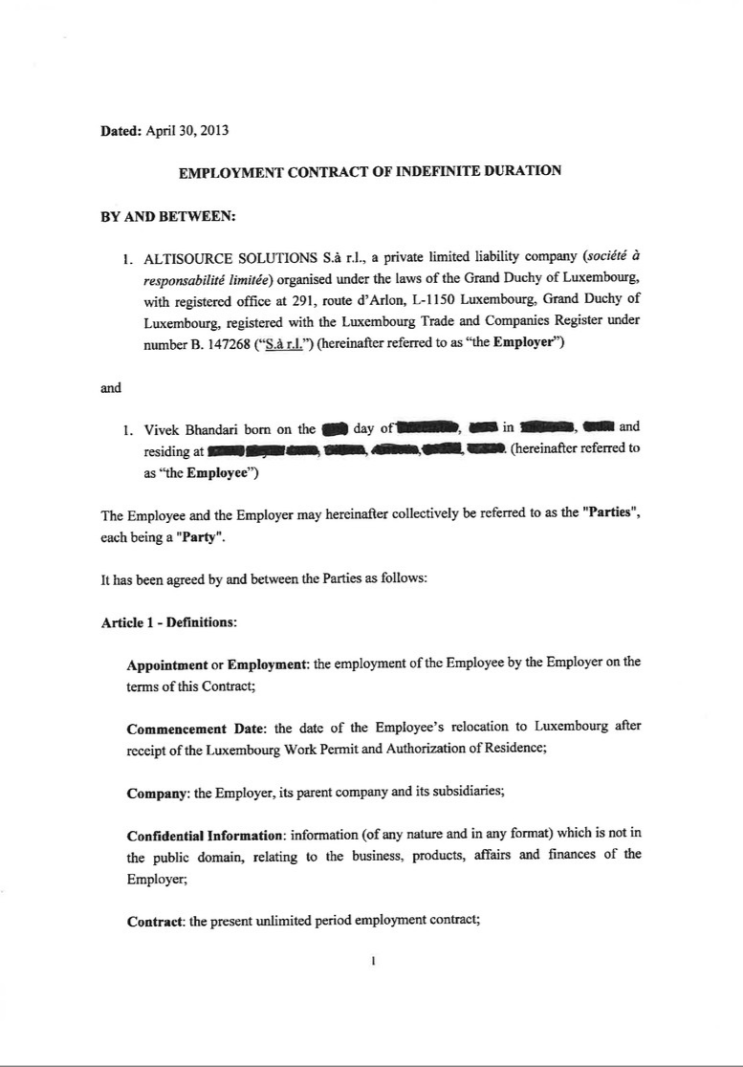

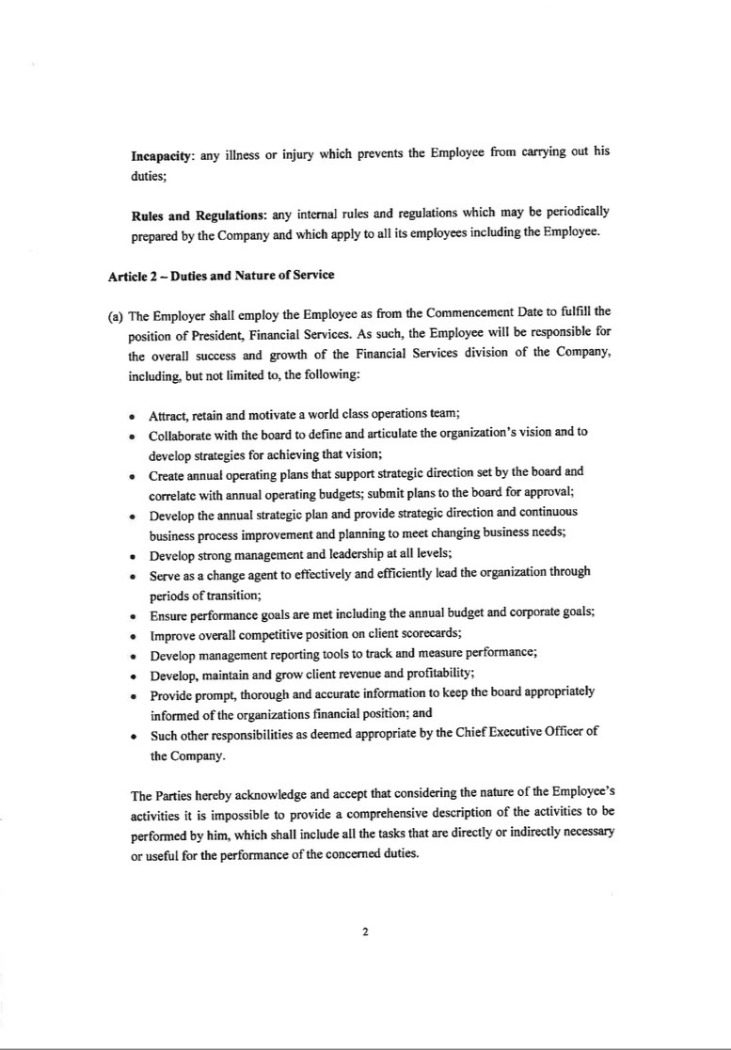

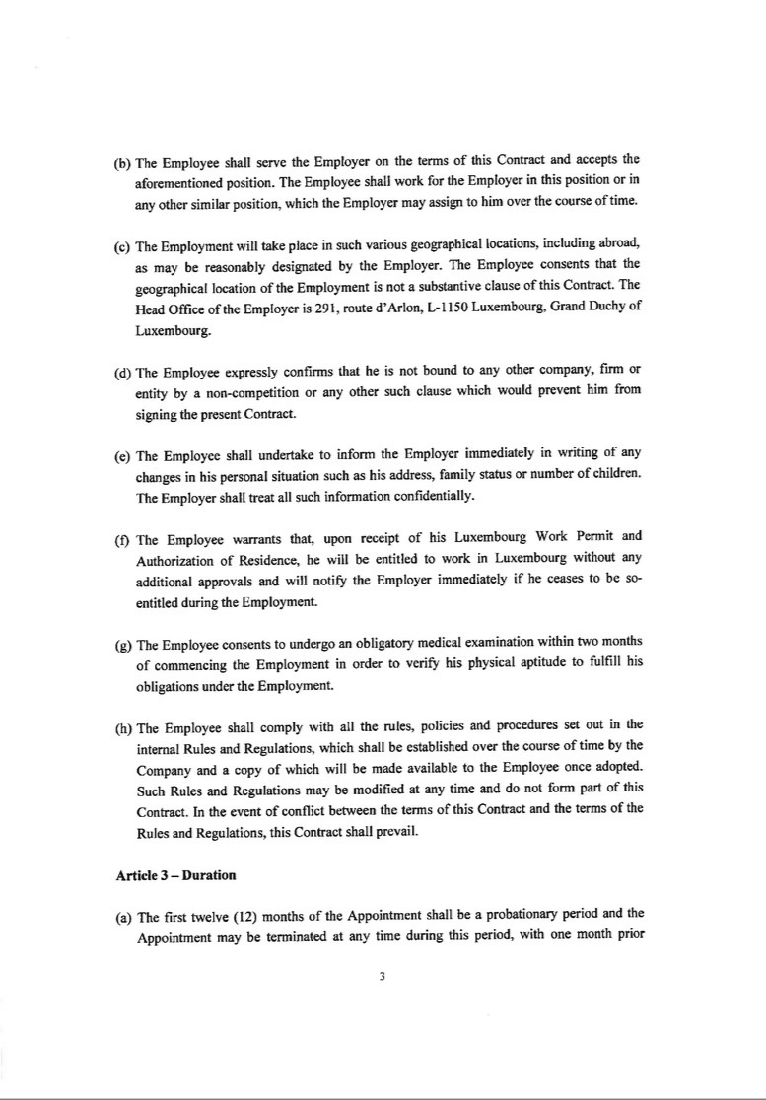

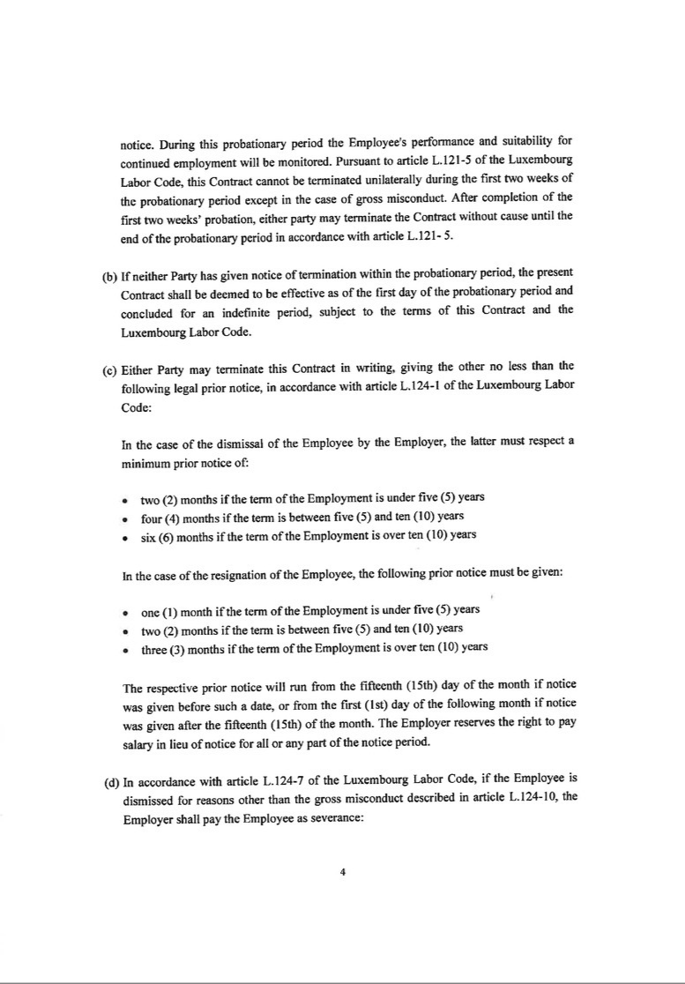

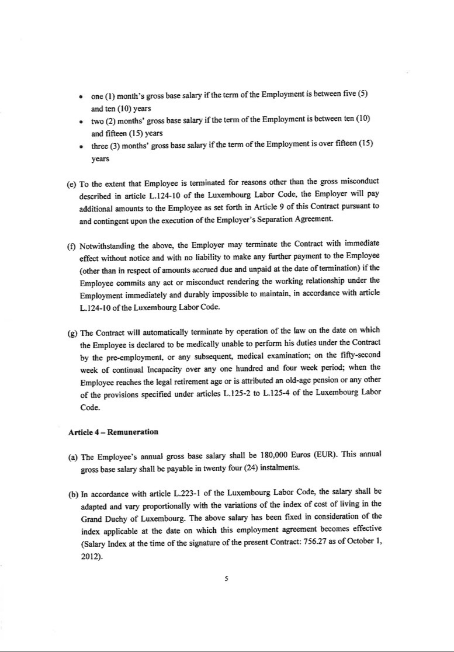

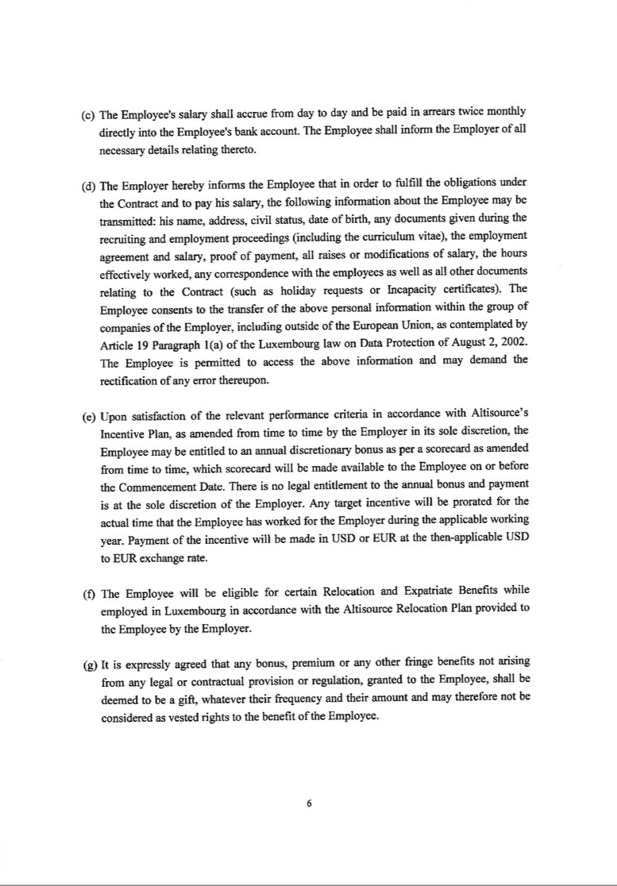

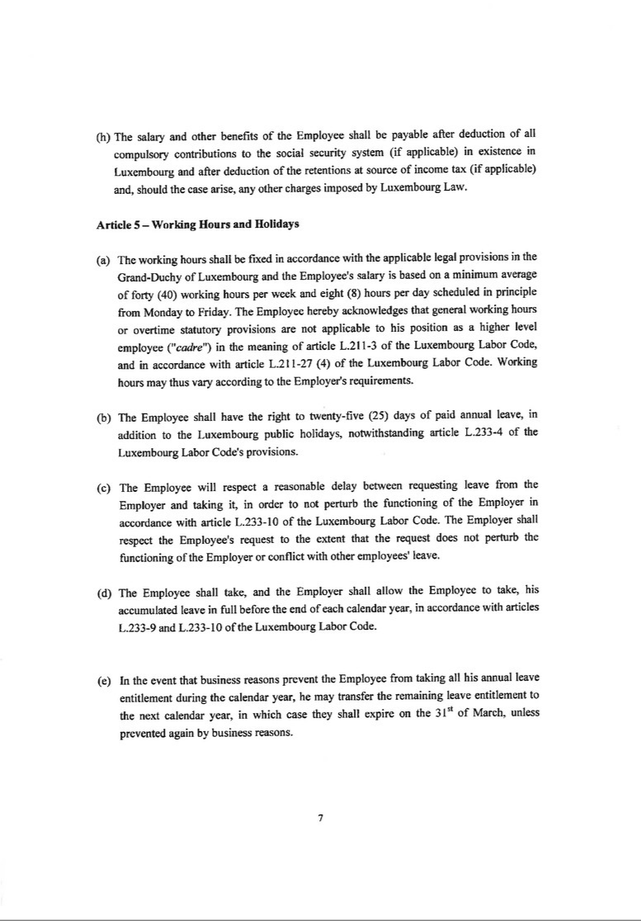

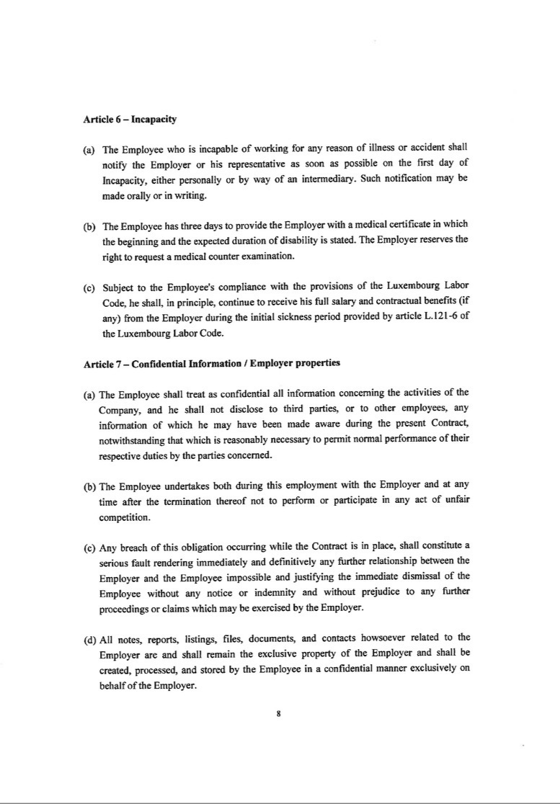

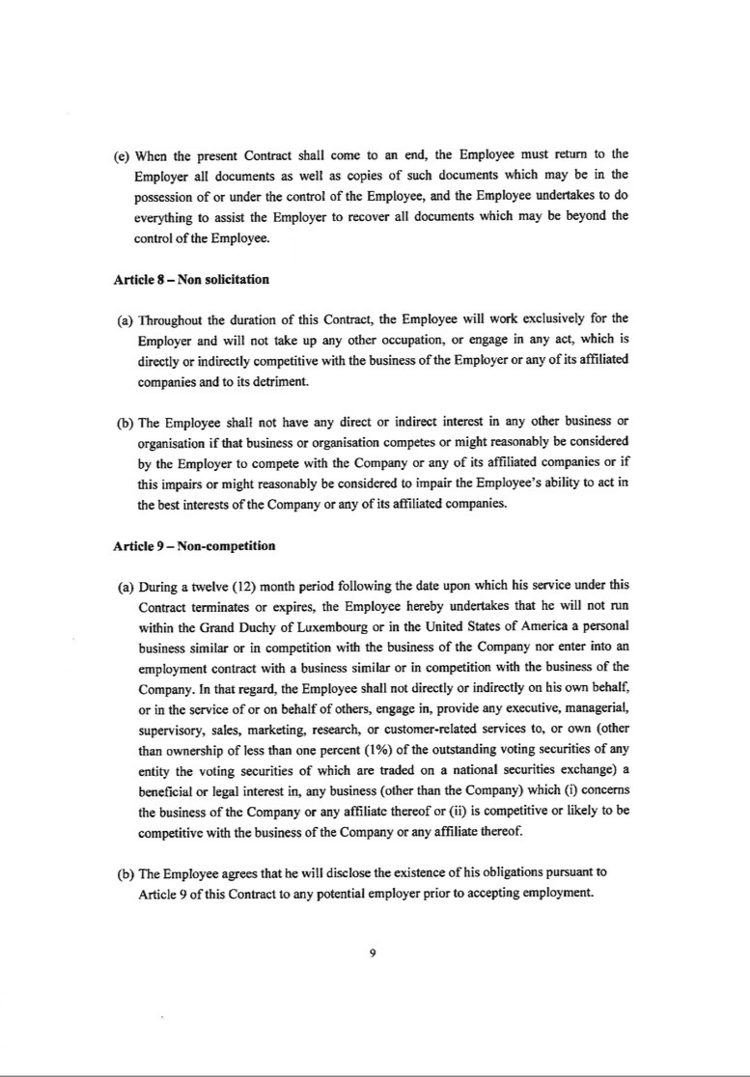

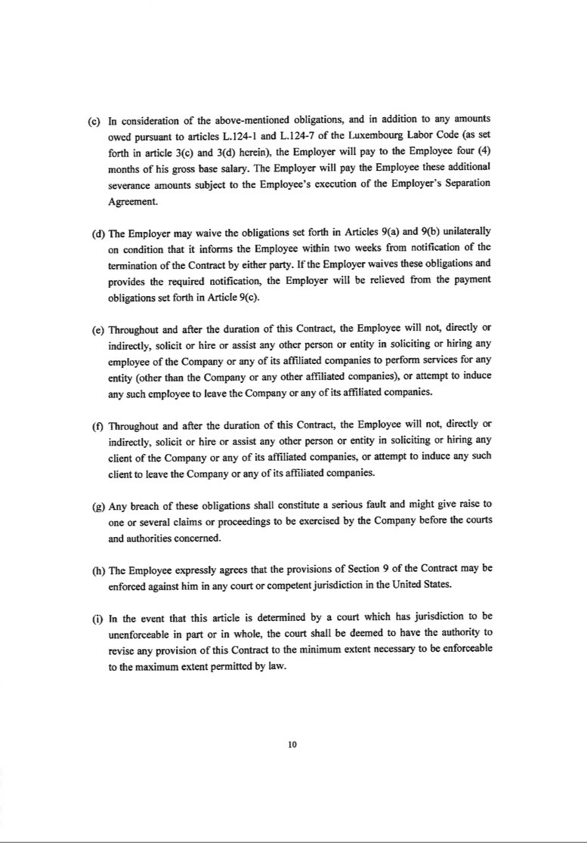

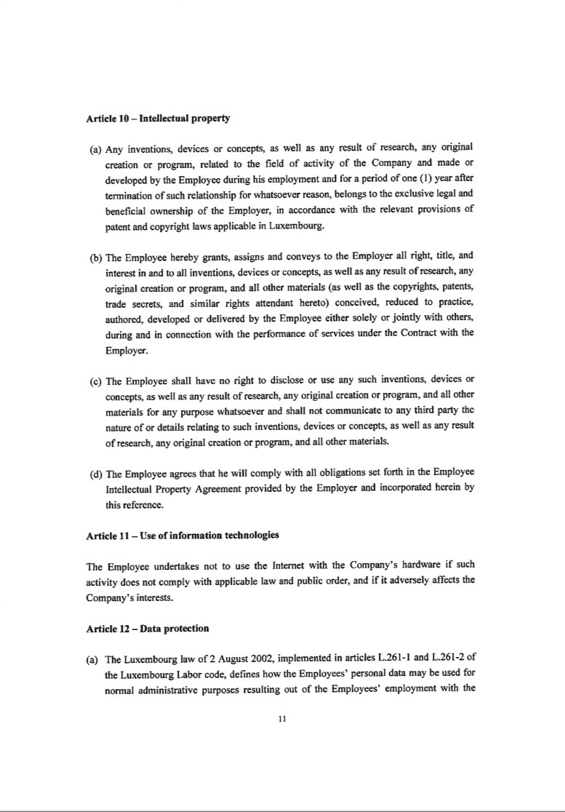

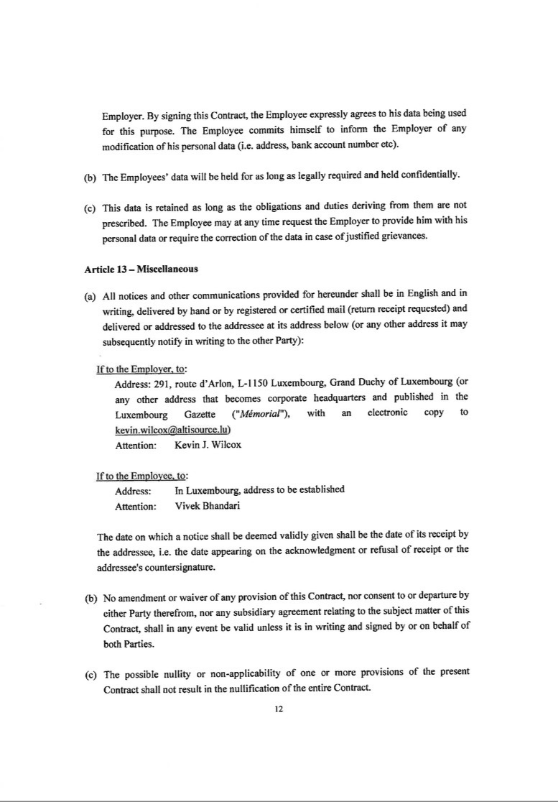

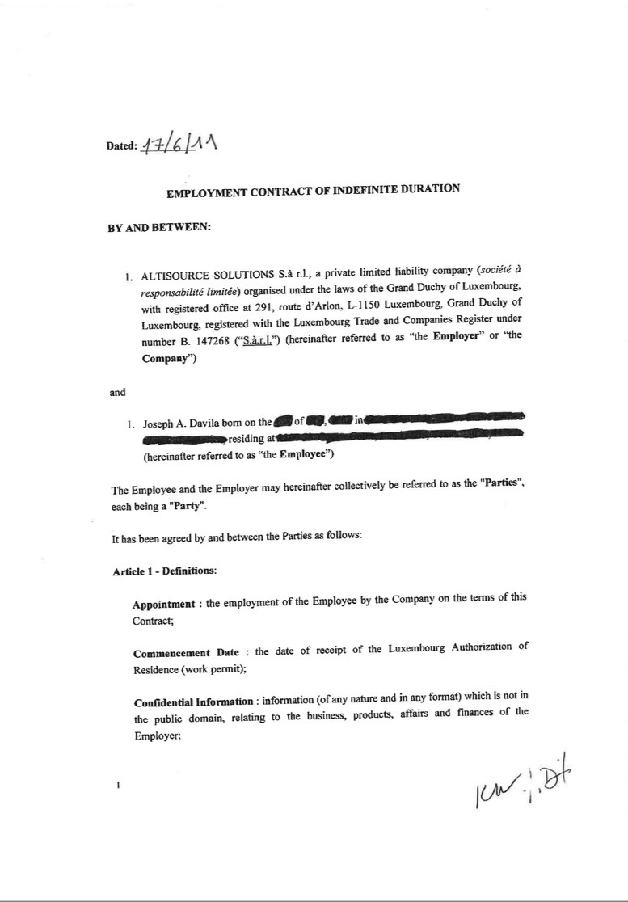

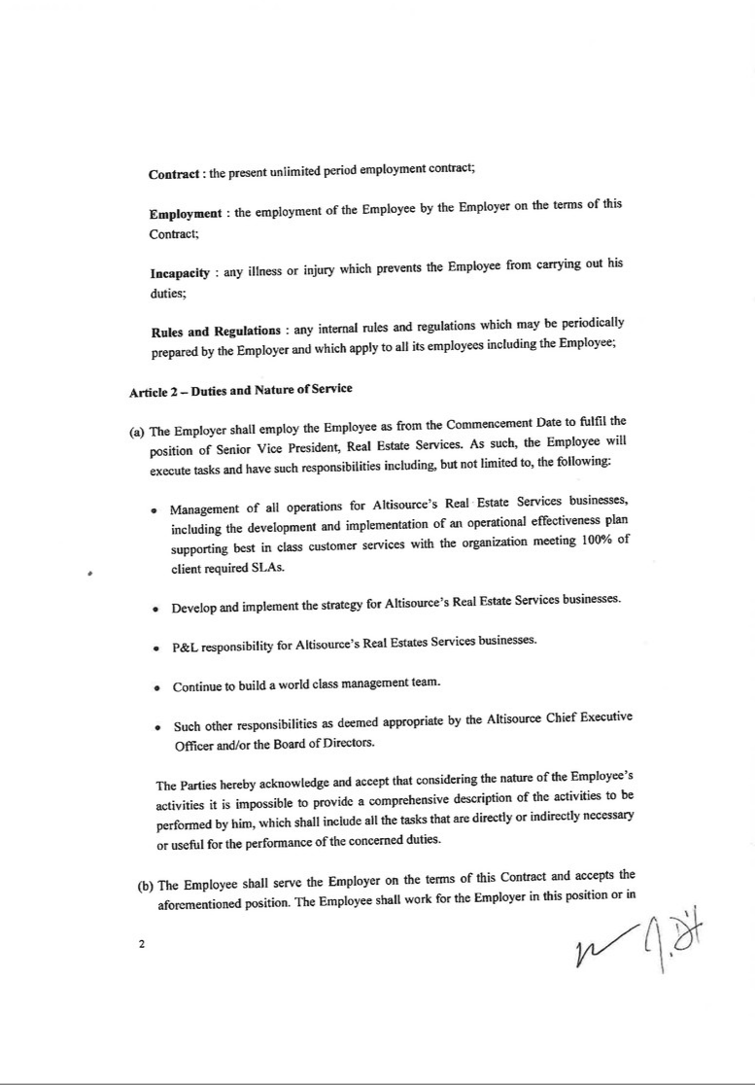

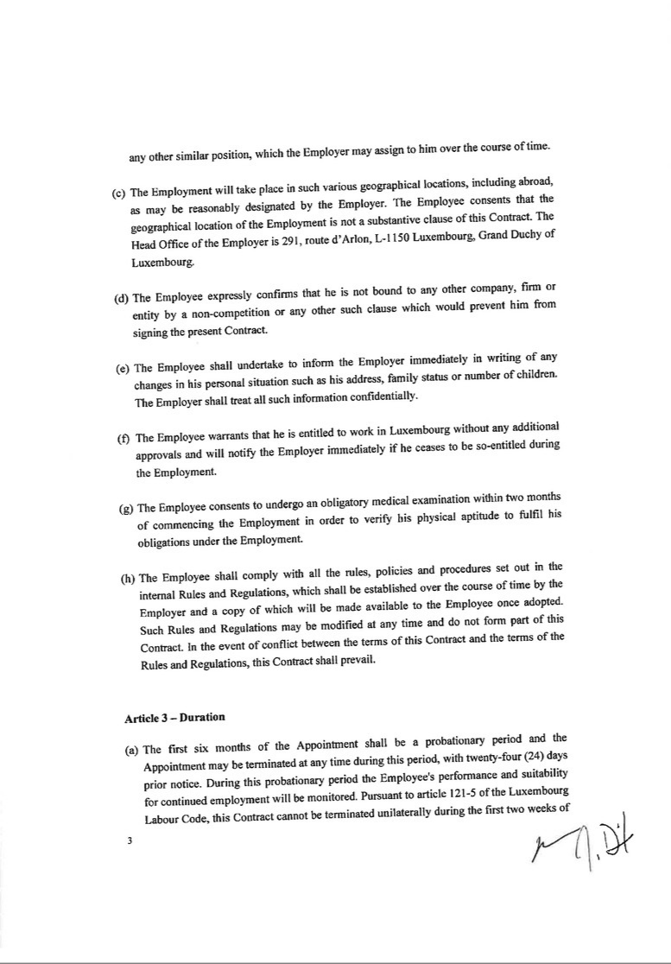

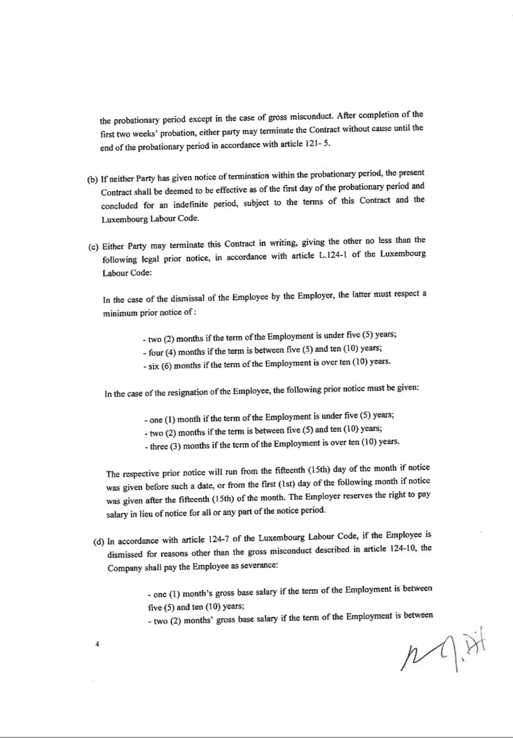

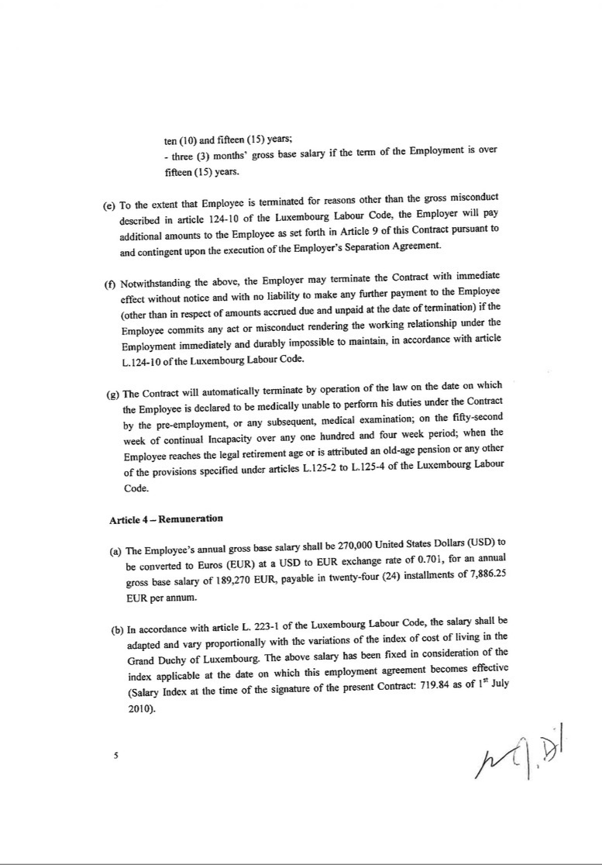

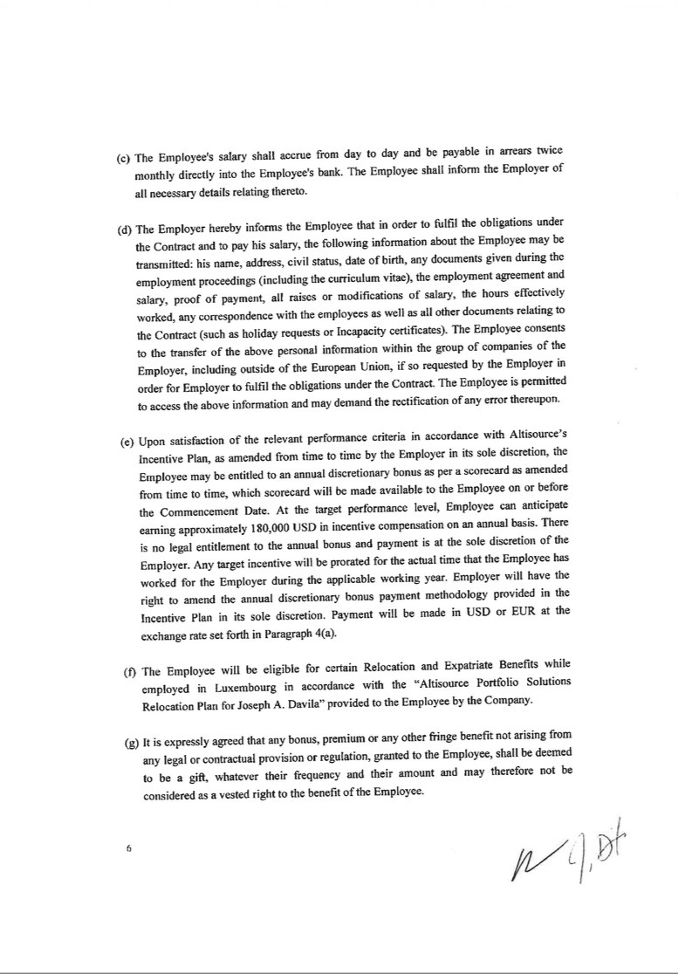

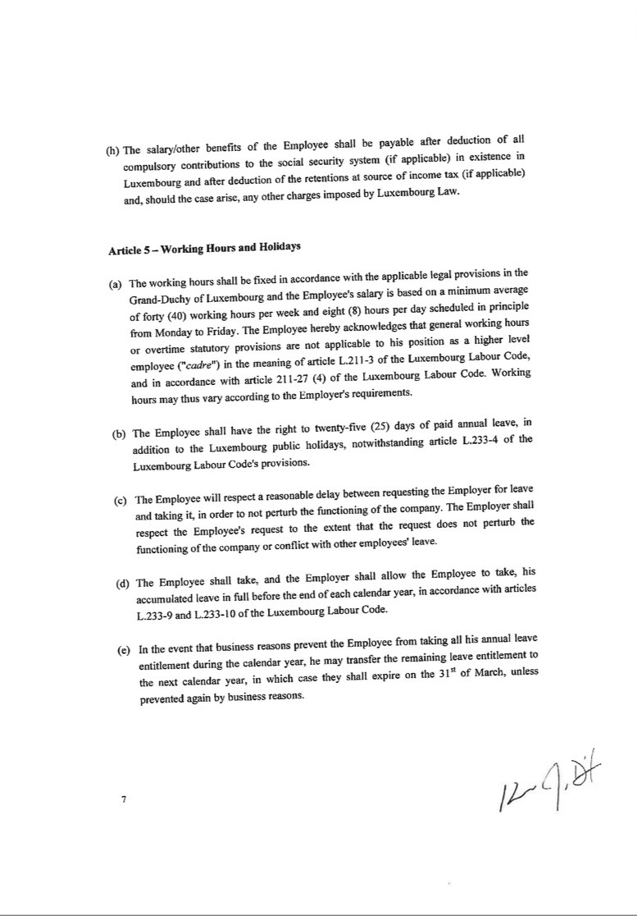

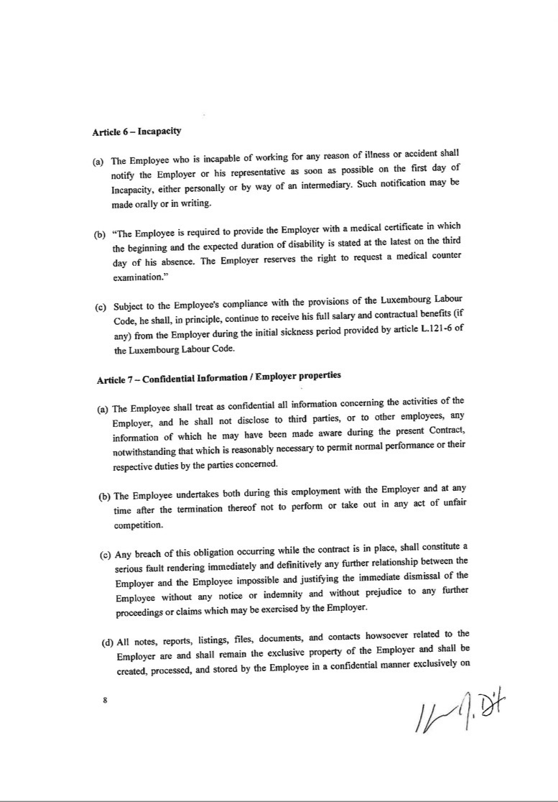

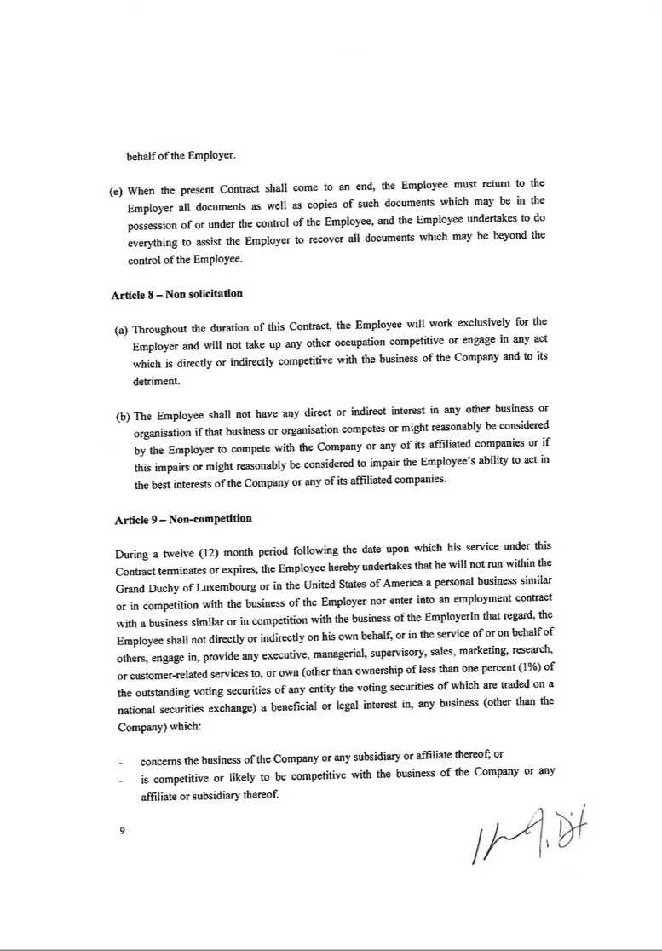

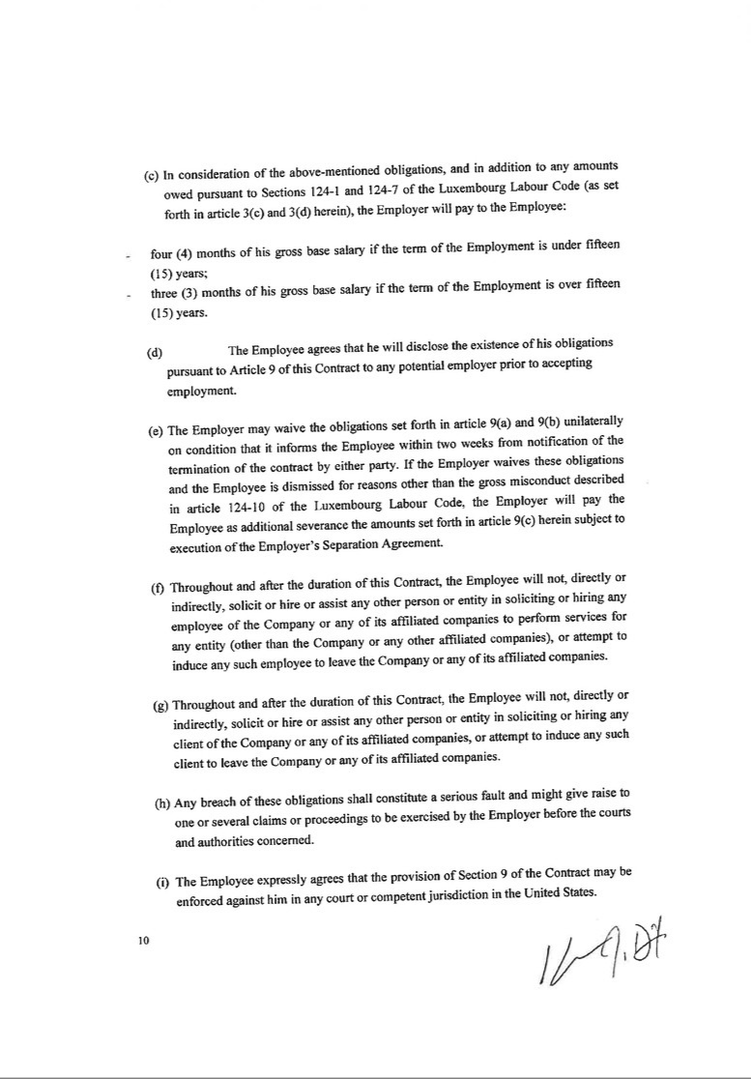

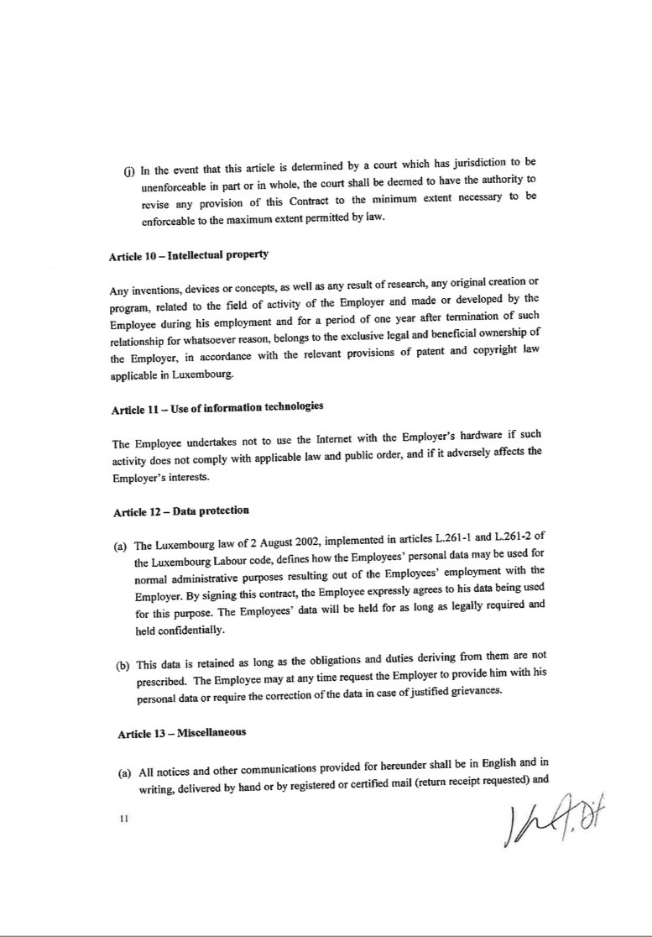

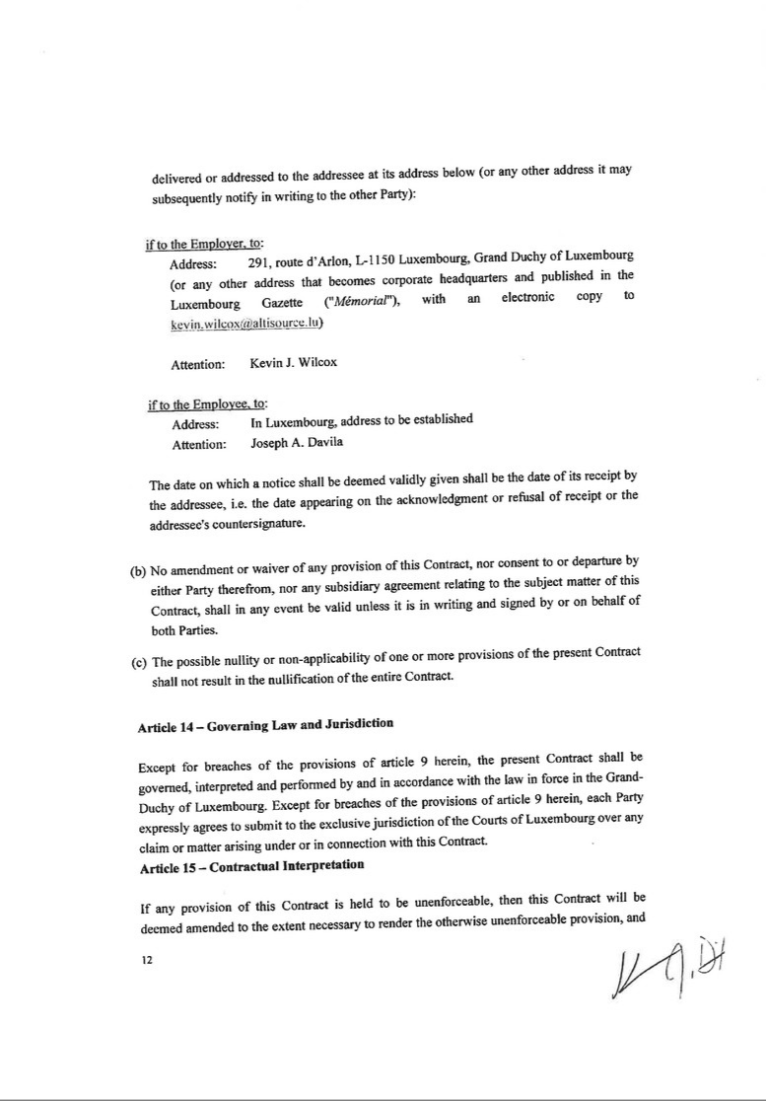

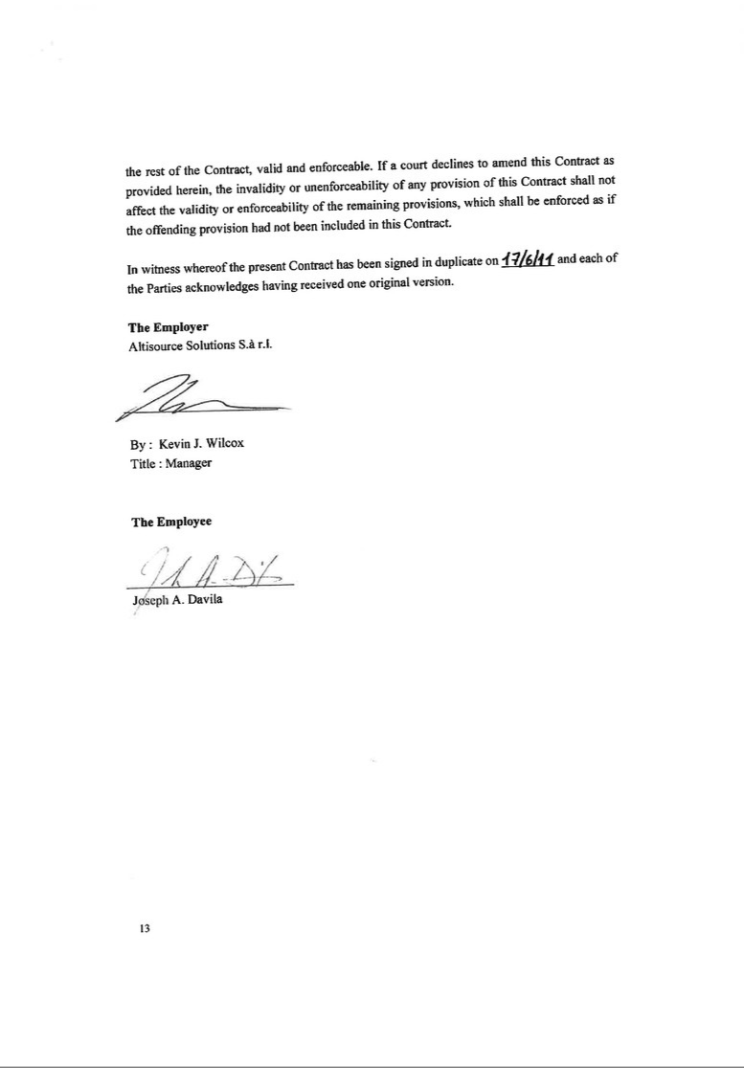

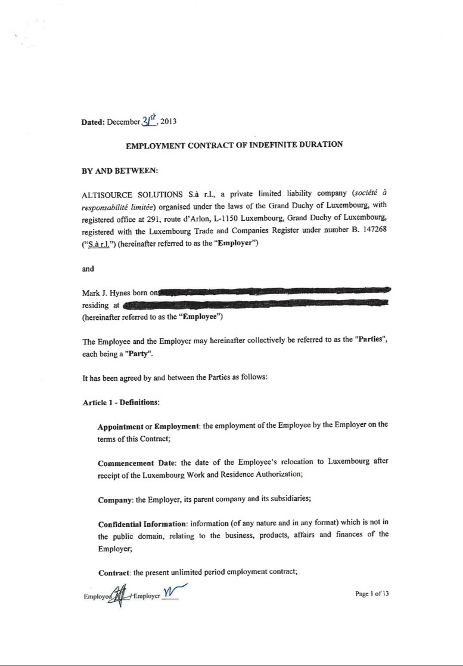

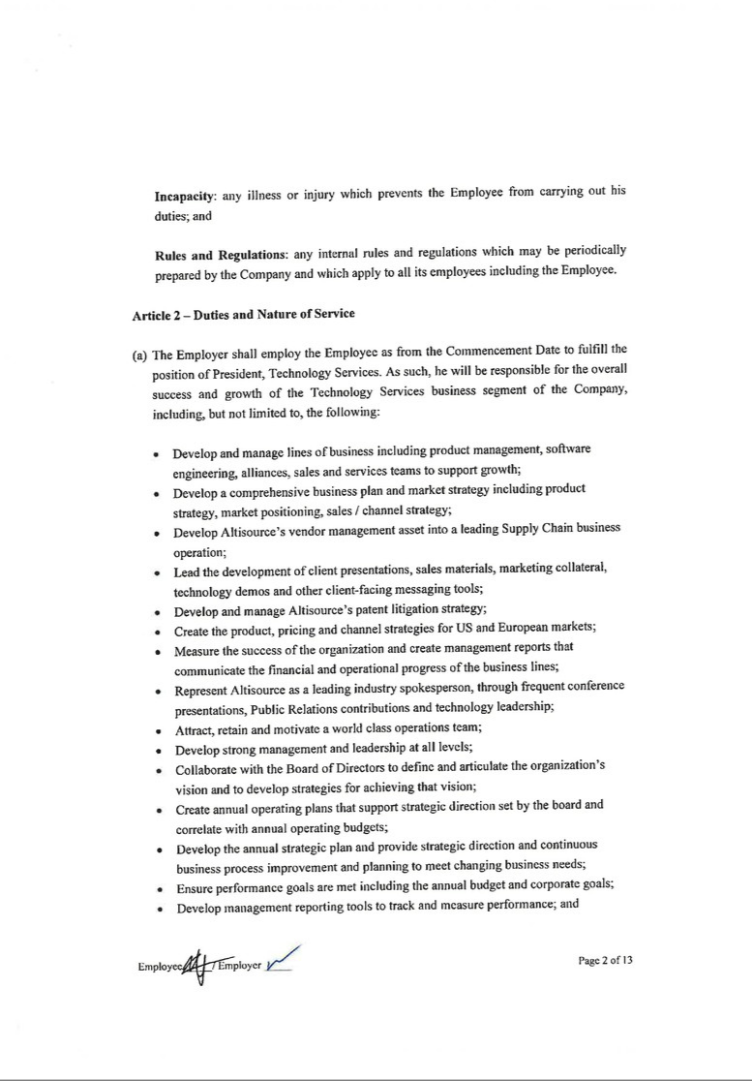

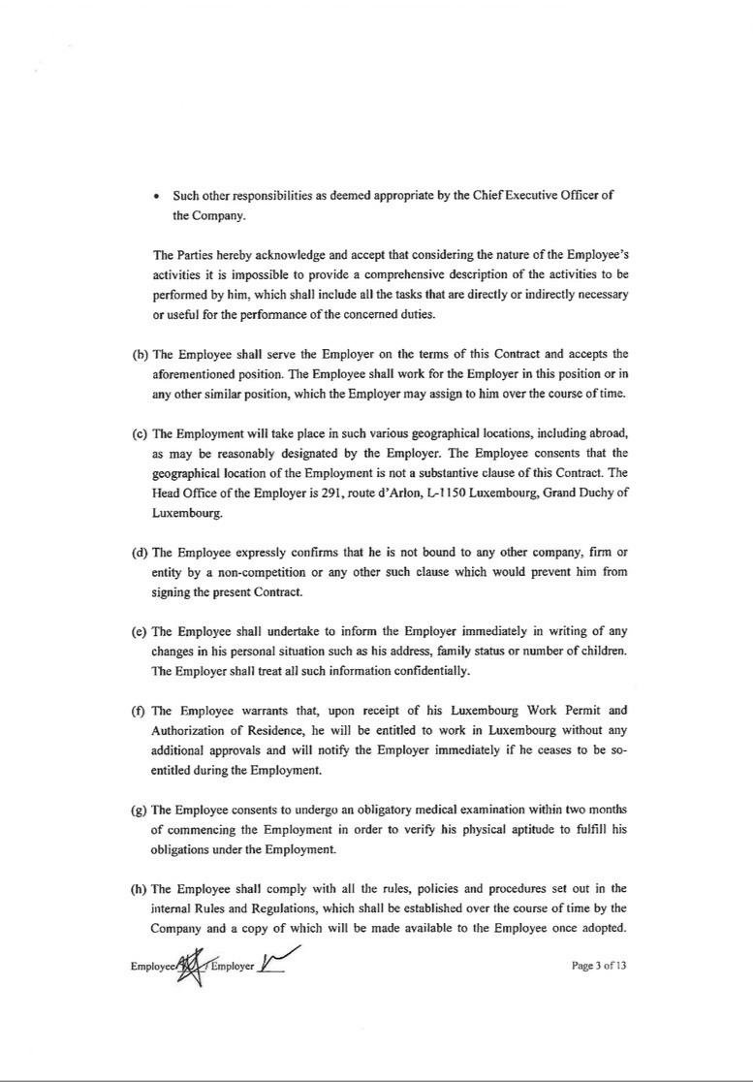

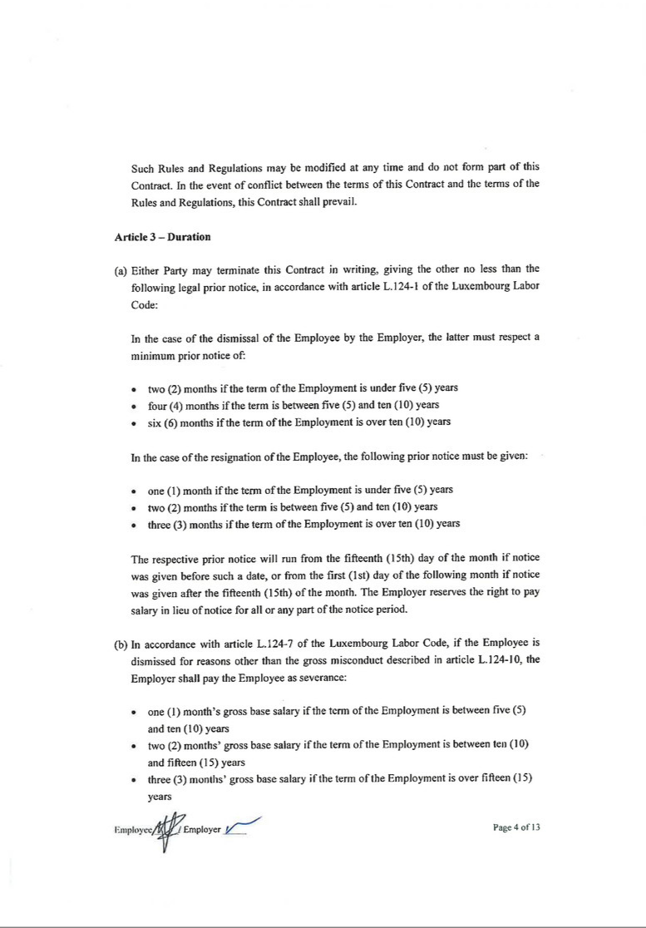

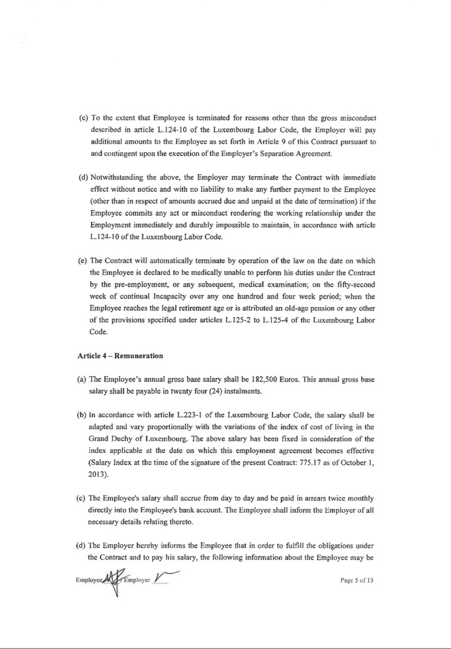

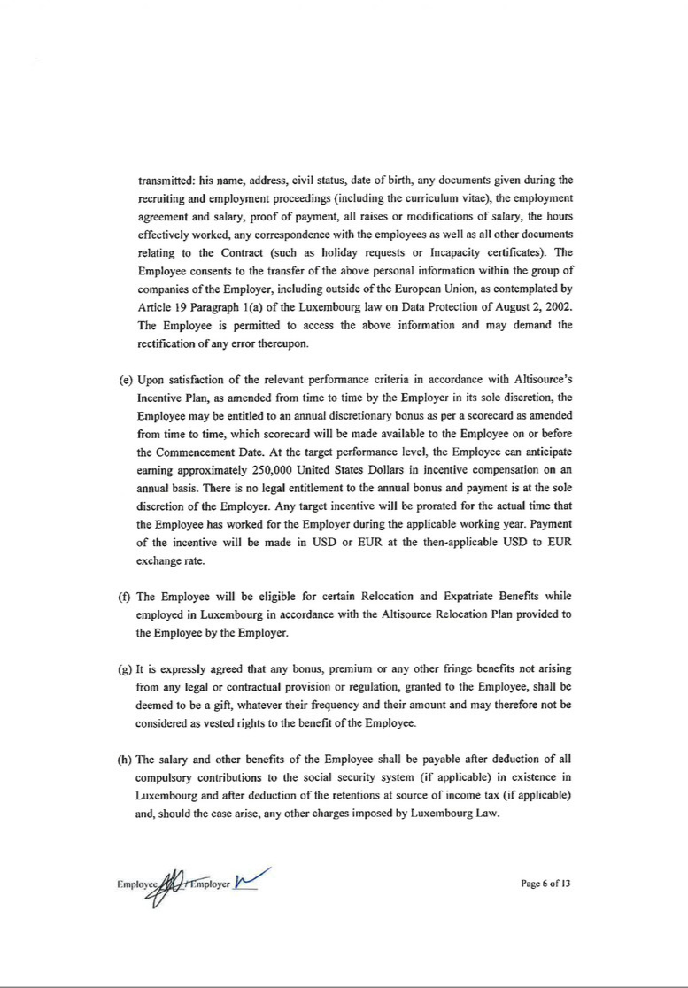

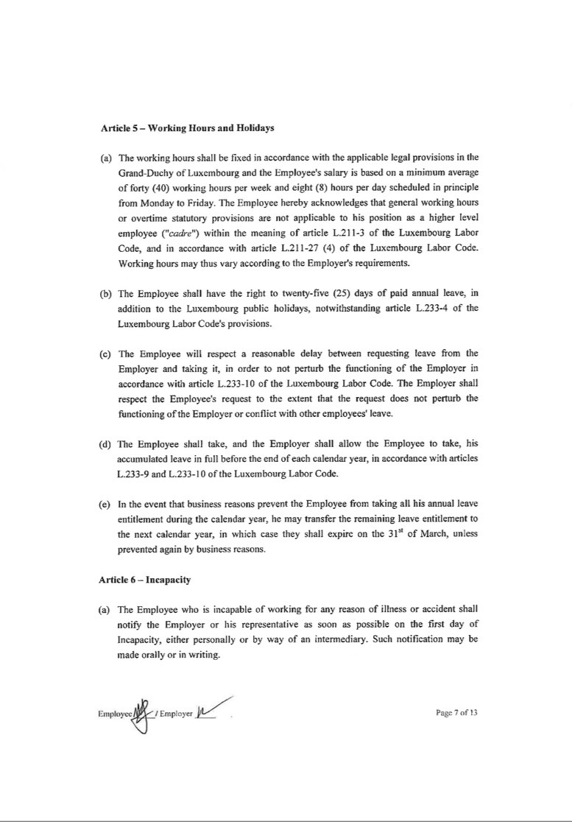

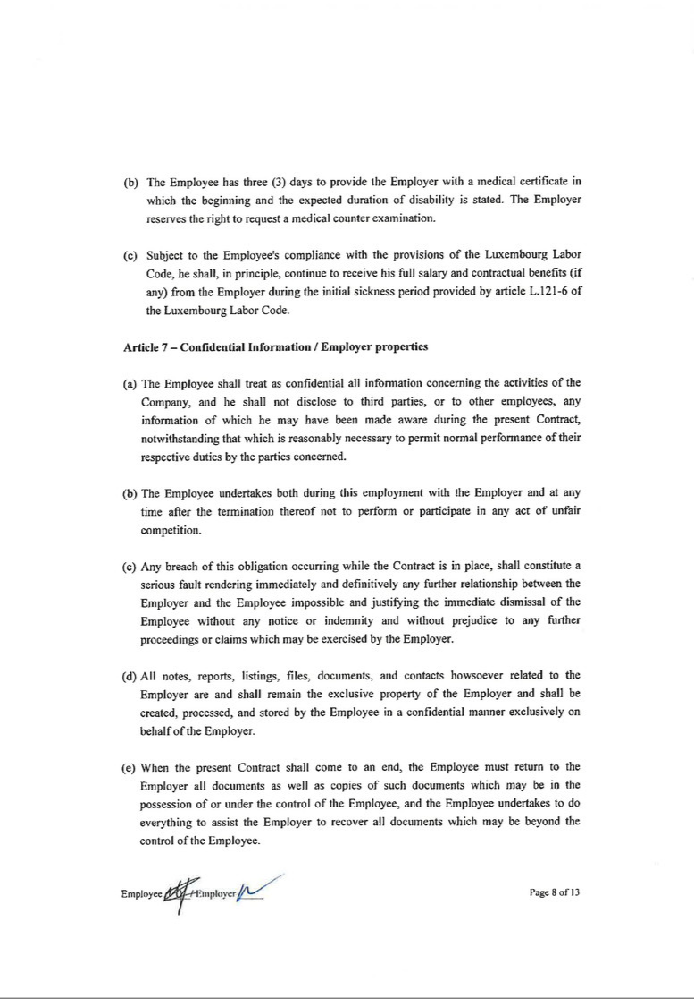

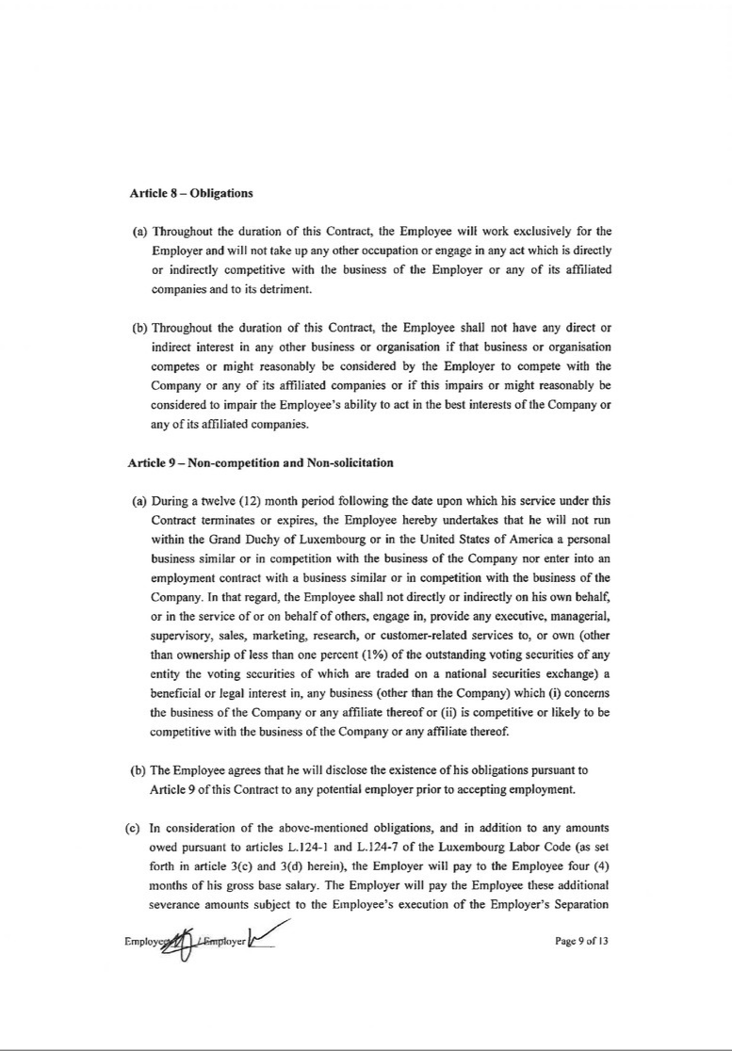

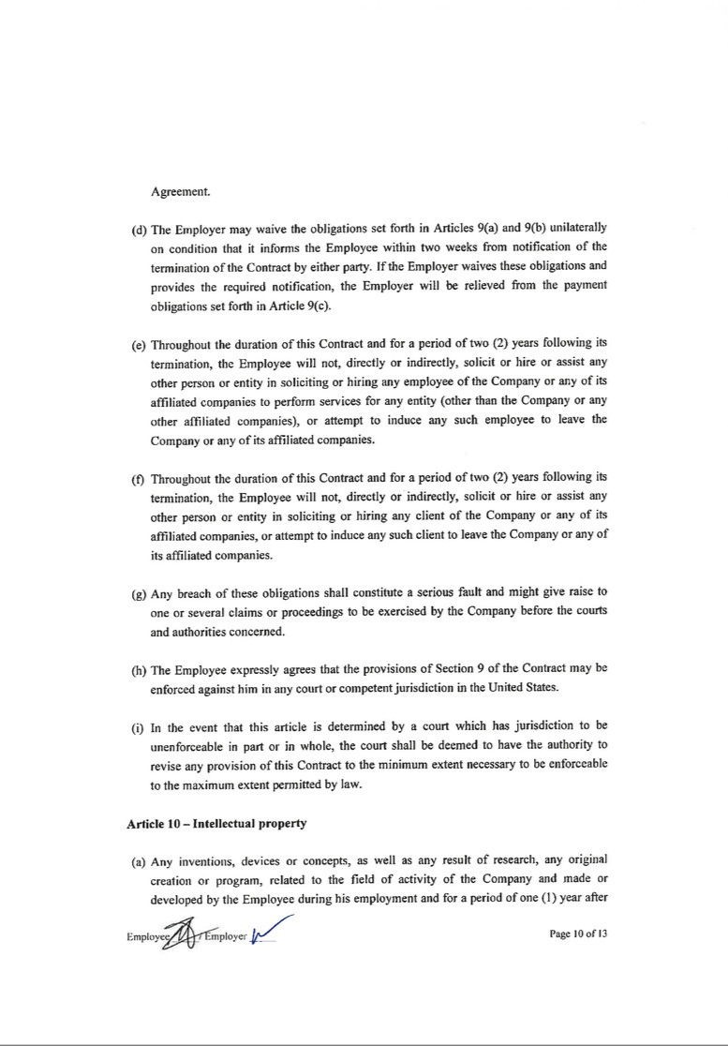

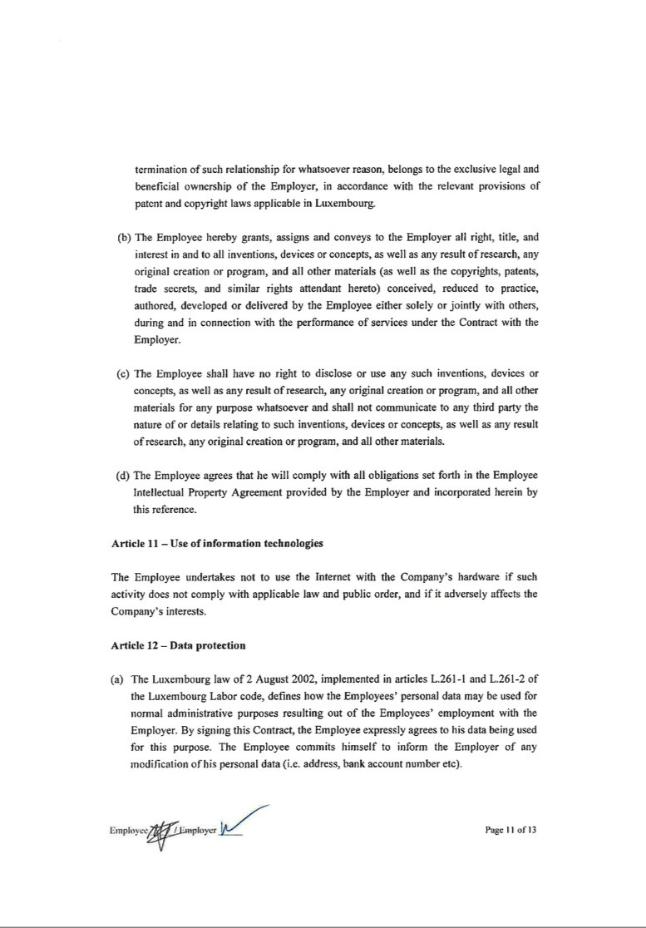

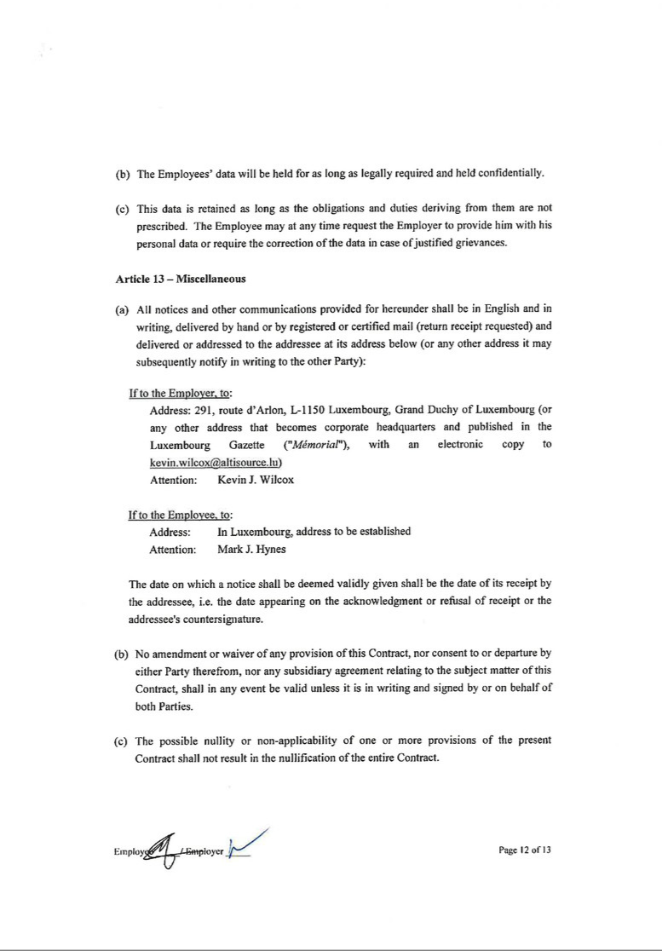

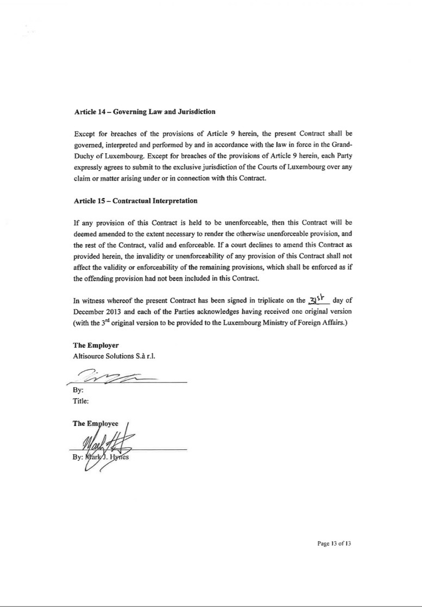

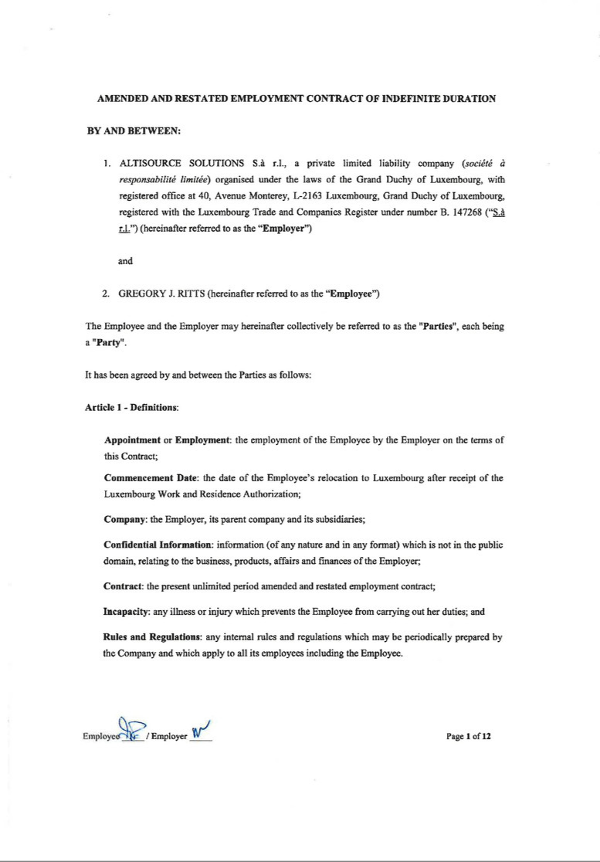

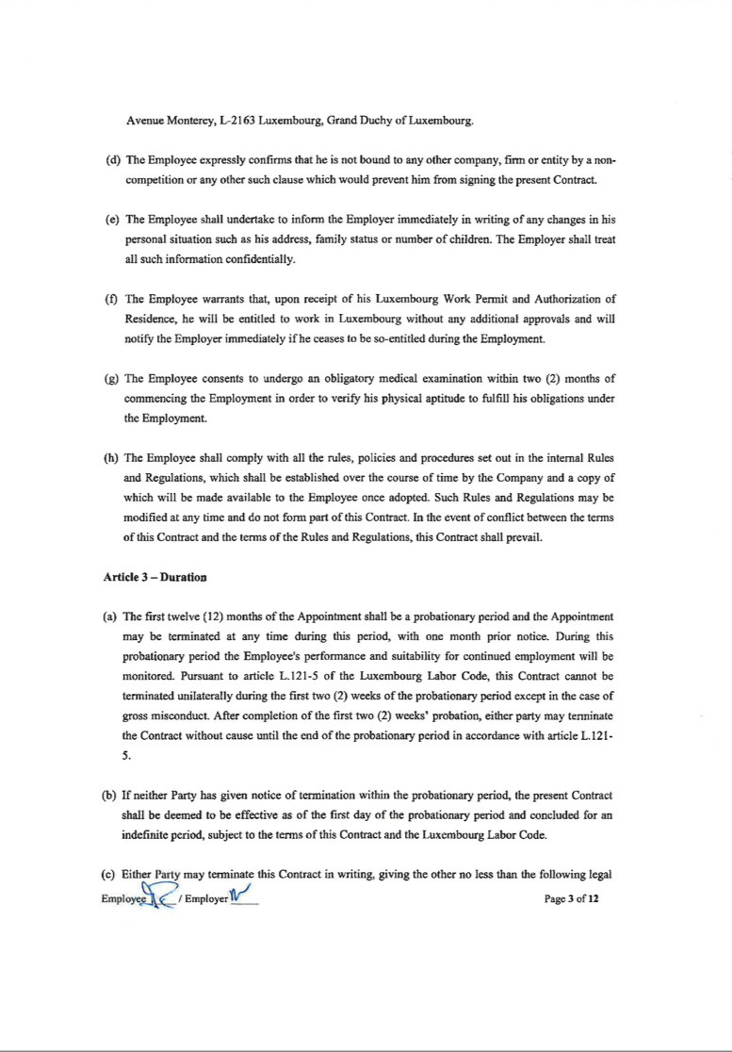

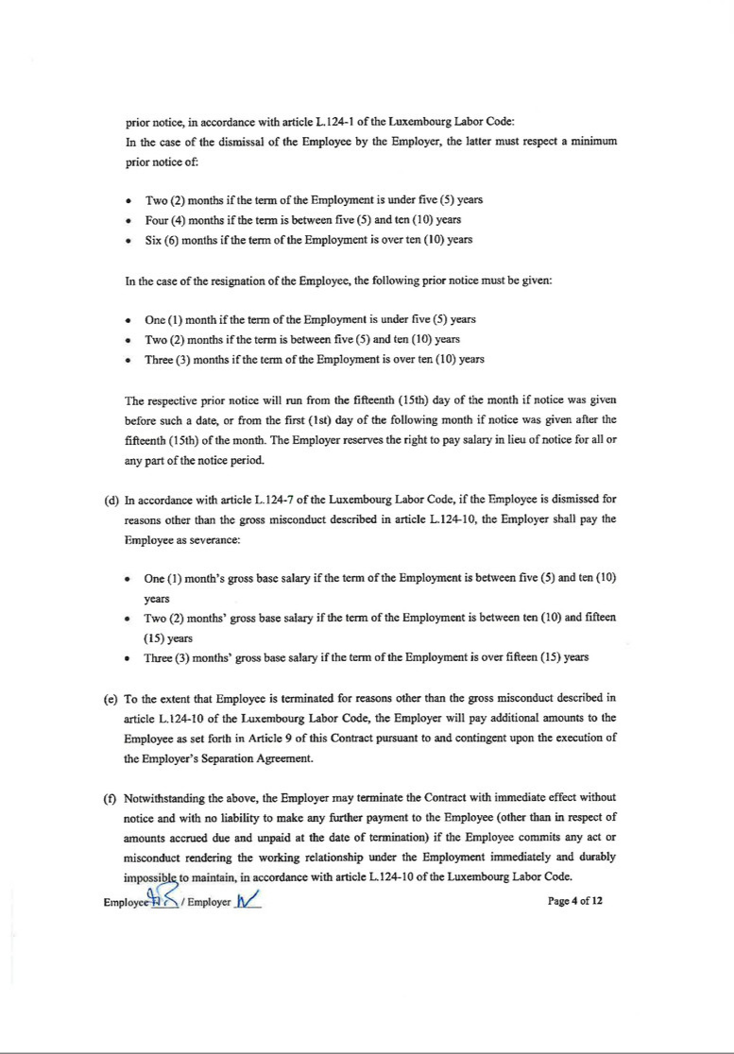

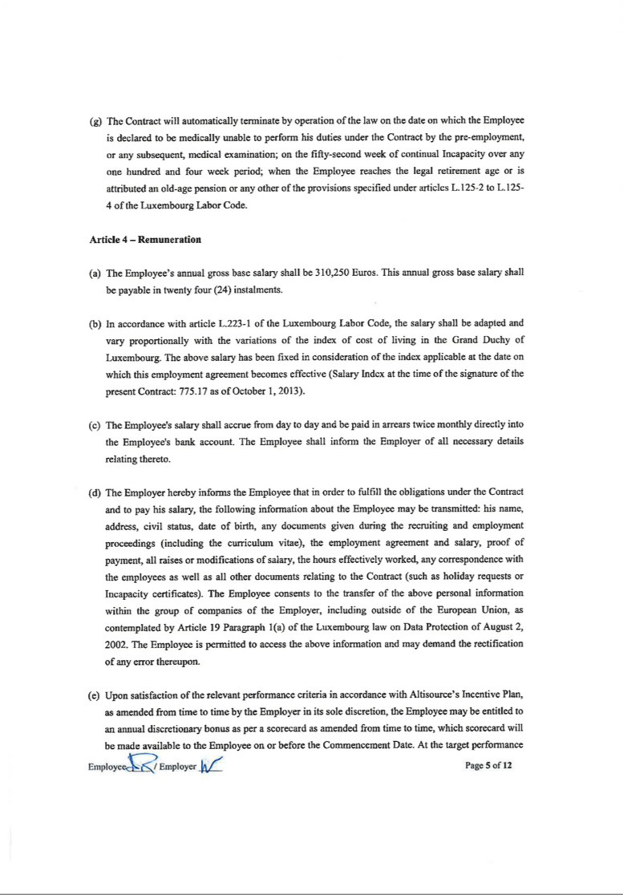

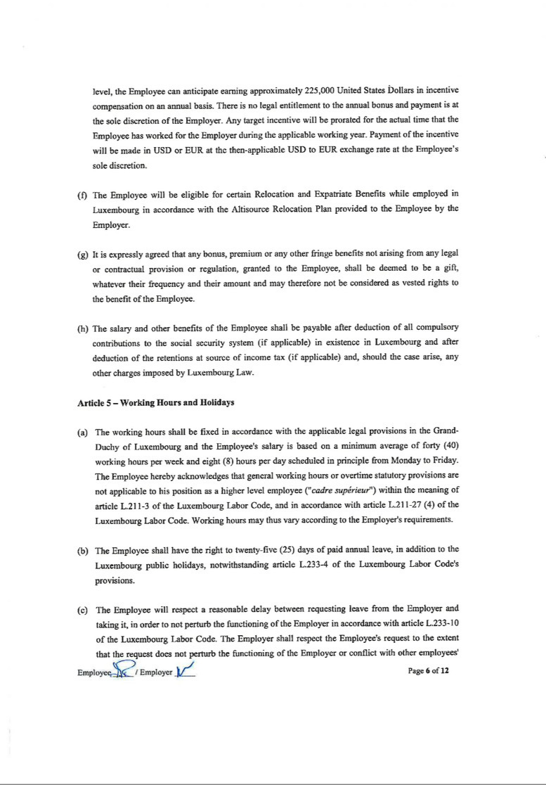

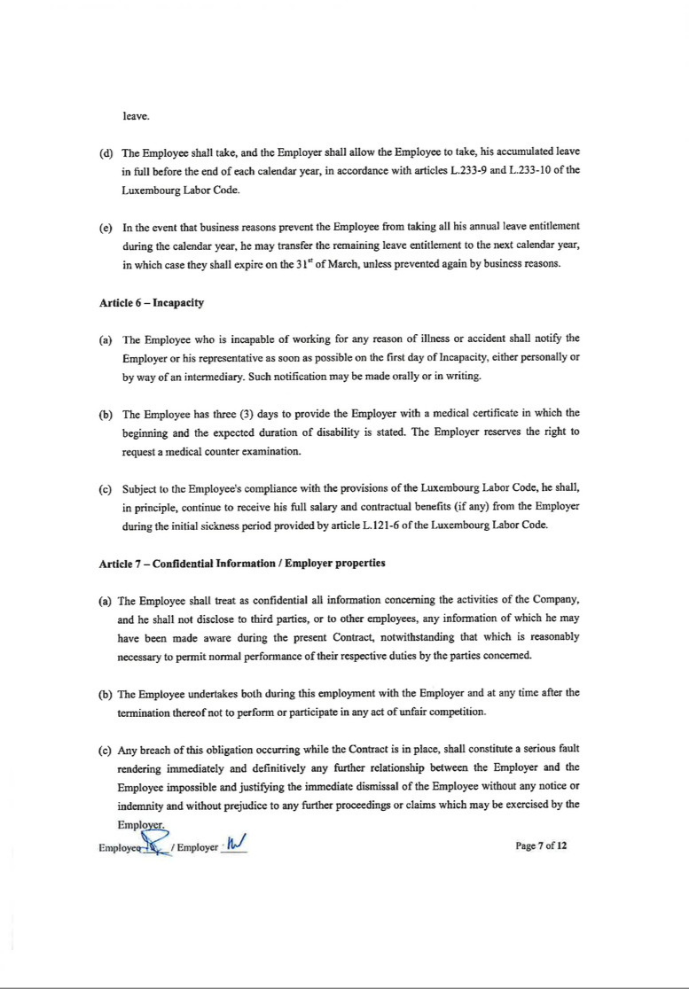

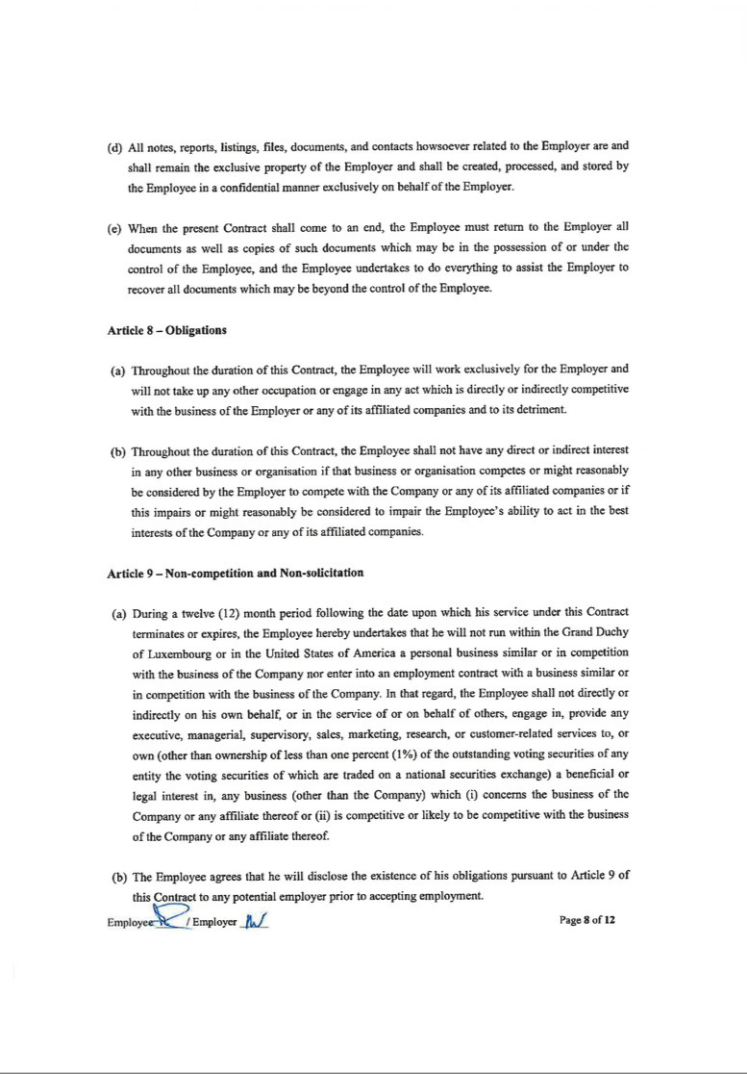

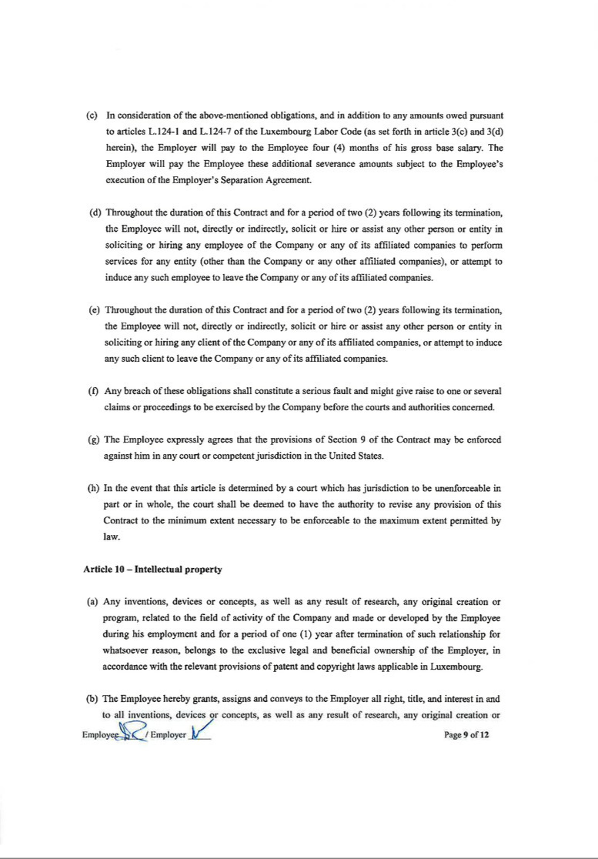

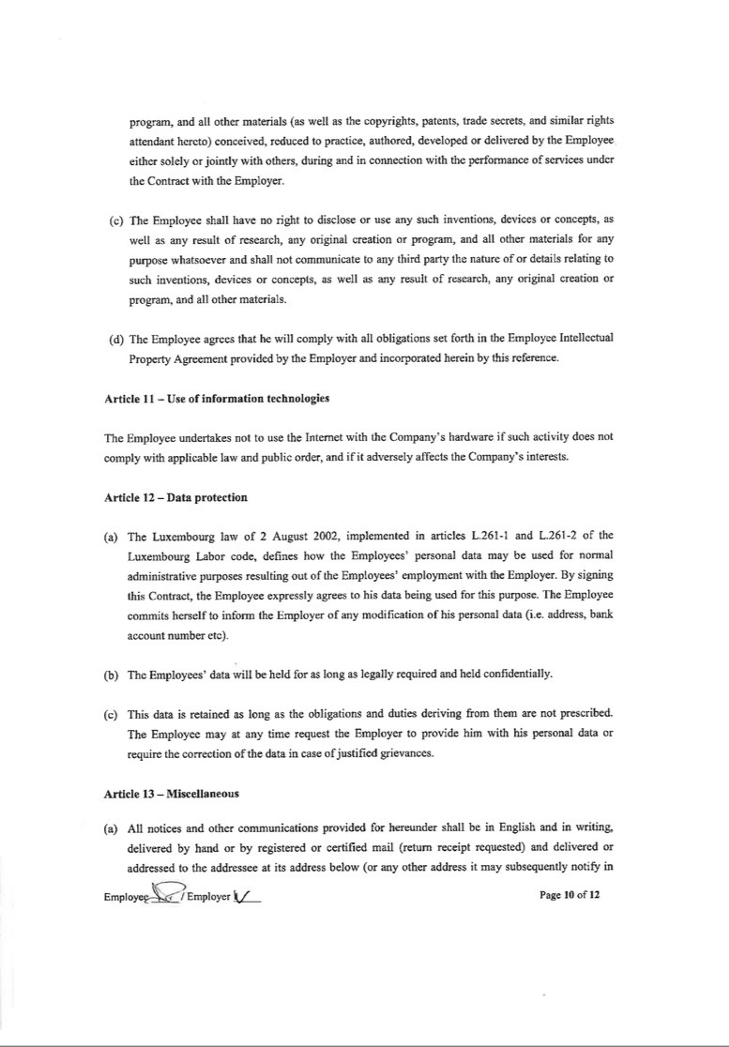

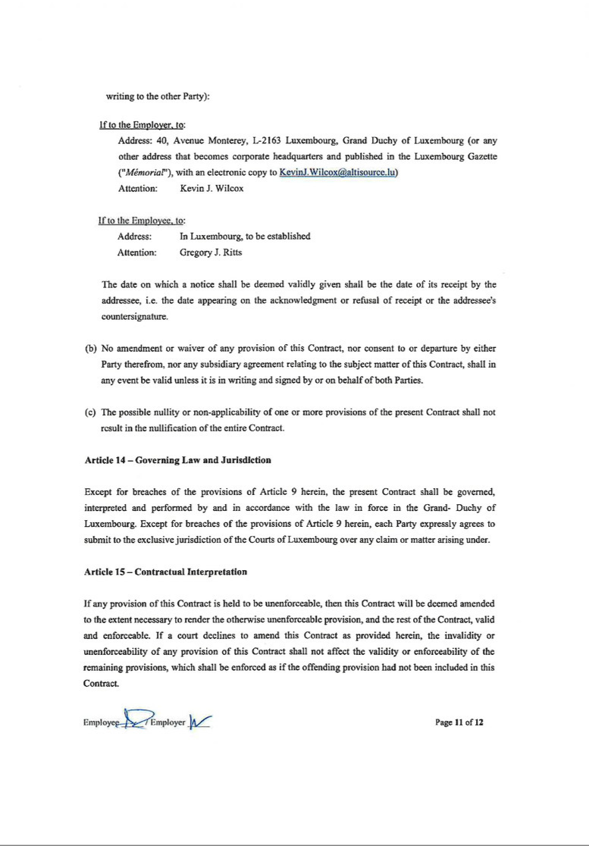



Exhibit 21.1

LIST OF SUBSIDIARIES

The following are subsidiaries of Altisource Portfolio Solutions S.A. as of December 31, 2015 and the jurisdictions in which they are organized.

Name |  | Jurisdiction of incorporation or
 |  | organization
Altisource Holdings S.à r.l. |  | Luxembourg
Altisource Solutions S.à r.l. |  | Luxembourg
Altisource Asia Holdings Ltd I |  | Mauritius
Altisource Business Solutions Private Limited |  | India
Altisource Portfolio Solutions, Inc. |  | Delaware
Altisource Fulfillment Operations, Inc. |  | Delaware
REALHome Services and Solutions, Inc. |  | Florida
Altisource Solutions, Inc. |  | Delaware
Altisource US Data, Inc. |  | Delaware
Springhouse, LLC |  | Missouri
Western Progressive – Nevada, Inc. |  | Delaware
Premium Title Services, Inc. |  | Florida
Premium Title Agency, Inc. |  | Delaware
Western Progressive – Arizona, Inc. |  | Delaware
Premium Title of California, Inc. |  | California
PTS – Texas Title, Inc. |  | Delaware
Nationwide Credit, Inc. |  | Georgia
Altisource Online Auction, Inc. |  | Delaware
Power Default Services, Inc. |  | Delaware
Beltline Road Insurance Agency, Inc. |  | Texas
Altisource Asset Acquisition, Inc. |  | Delaware
Owners Realty, Inc. |  | California
Hubzu USA, Inc. |  | Delaware
Hubzu Notes, LLC |  | Delaware
noteXchange, LLC |  | Delaware
Western Progressive Trustee, LLC |  | Delaware
Altisource Outsourcing Solutions S.R.L. |  | Uruguay
Altisource Holdings, LLC |  | Delaware
Altisource Single Family, Inc. |  | Delaware
Altisource Solutions B.V. |  | Netherlands
Altisource Business Solutions, Inc. |  | Philippines
The Mortgage Partnership of America, L.L.C. |  | Missouri
Equator, LLC |  | California
Altisource Real Estate Web Portal S.à r.l. |  | Luxembourg
Altisource Consumer Analytics S.à r.l. |  | Luxembourg
Altisource Mortgage Solutions S.à r.l. |  | Luxembourg
Altisource Spend Management S.à r.l. |  | Luxembourg
Altisource Business Solutions S.à r.l. |  | Luxembourg
Altisource Technology Solutions S.à r.l. |  | Luxembourg
Altisource Collaborative S.à r.l. |  | Luxembourg
Altisource Document Solutions S.à r.l. |  | Luxembourg
Association of Certified Originators |  | Nevada
Association of Certified Mortgage Originators Risk Retention Group, Inc. |  | Nevada
CastleLine Re, Inc. |  | Nevada
CastleLine Risk and Insurance Services, LLC |  | Nevada
CastleLine Holdings, LLC |  | Delaware
GoldenGator, LLC |  | Colorado
REIsmart, LLC |  | Colorado
Onit Solutions, LLC |  | Colorado
Altisource Access, Inc. |  | Delaware
Altisource Access CA, Inc. |  | Delaware
Western Progressive - Washington, Inc. |  | Washington

Exhibit 23.1

CONSENT OF INDEPENDENT REGISTERED PUBLIC ACCOUNTING FIRM

We consent to the incorporation by reference in Registration Statement No. 333-161175 on Form S-8 of our reports dated March 15, 2016, relating to the consolidated financial statements and financial statement schedule of Altisource Portfolio Solutions S.A. and subsidiaries (the “Company”) (which report expresses an unqualified opinion on the consolidated financial statements and includes an explanatory paragraph related to the concentration of revenue with Ocwen Financial Corporation and an emphasis of a matter paragraph related to uncertainties faced by Ocwen), and our report dated March 15, 2016, relating to internal control over financial reporting (which report expressed an adverse opinion on the effectiveness of the Company’s internal control over financial reporting because of a material weakness) appearing in this Annual Report on Form 10-K of the Company for the year ended December 31, 2015.

/s/ Deloitte and Touche LLP

Atlanta, Georgia

March 15, 2016

Exhibit 31.1

CERTIFICATION BY THE CHIEF EXECUTIVE OFFICER PURSUANT TO SECTION 302

OF THE SARBANES-OXLEY ACT OF 2002

I, William B. Shepro, hereby certify that:

- I have reviewed this annual report on Form 10-K for the period ending December 31, 2015 of Altisource Portfolio Solutions S.A.;

- Based on my knowledge, this report does not contain any untrue statement of a material fact or omit to state a material fact necessary to make the statements made, in light of the circumstances under which such statements were made, not misleading with respect to the period covered by this report;

- Based on my knowledge, the financial statements, and other financial information included in this report, fairly present in all material respects the financial condition, results of operations and cash flows of the registrant as of, and for, the periods presented in this report;

- The registrant’s other certifying officer and I are responsible for establishing and maintaining disclosure controls and procedures (as defined in Exchange Act Rules 13a-15(e) and 15d-15(e)) and internal control over financial reporting (as defined in Exchange Act Rules 13a-15(f) and 15d-15(f)) for the registrant and have:

  - designed such disclosure controls and procedures, or caused such disclosure controls and procedures to be designed under our supervision, to ensure that material information relating to the registrant, including its consolidated subsidiaries, is made known to us by others within those entities, particularly during the period in which this report is being prepared;

  - designed such internal control over financial reporting, or caused such internal control over financial reporting to be designed under our supervision, to provide reasonable assurance regarding the reliability of financial reporting and the preparation of financial statements for external purposes in accordance with generally accepted accounting principles;

  - evaluated the effectiveness of the registrant’s disclosure controls and procedures and presented in this report our conclusions about the effectiveness of the disclosure controls and procedures, as of the end of the period covered by this report based on such evaluation; and

  - disclosed in this report any change in the registrant’s internal control over financial reporting that occurred during the registrant’s most recent fiscal quarter (the registrant’s fourth fiscal quarter in the case of an annual report) that has materially affected, or is reasonably likely to materially affect, the registrant’s internal control over financial reporting; and

- The registrant’s other certifying officer and I have disclosed, based on our most recent evaluation of internal control over financial reporting, to the registrant’s auditors and the audit committee of the registrant’s board of directors (or persons performing the equivalent functions):

  - all significant deficiencies and material weaknesses in the design or operation of internal control over financial reporting which are reasonably likely to adversely affect the registrant’s ability to record, process, summarize and report financial information; and

  - any fraud, whether or not material, that involves management or other employees who have a significant role in the registrant’s internal control over financial reporting.

Date: March 15, 2016 By: /s/ William B. Shepro

William B. Shepro

Director and Chief Executive Officer

(Principal Executive Officer)

Exhibit 31.2

CERTIFICATION BY THE CHIEF FINANCIAL OFFICER PURSUANT TO SECTION 302

OF THE SARBANES-OXLEY ACT OF 2002

I, Michelle D. Esterman, hereby certify that:

- I have reviewed this annual report on Form 10-K for the period ending December 31, 2015 of Altisource Portfolio Solutions S.A.;

- Based on my knowledge, this report does not contain any untrue statement of a material fact or omit to state a material fact necessary to make the statements made, in light of the circumstances under which such statements were made, not misleading with respect to the period covered by this report;

- Based on my knowledge, the financial statements, and other financial information included in this report, fairly present in all material respects the financial condition, results of operations and cash flows of the registrant as of, and for, the periods presented in this report;

- The registrant’s other certifying officer and I are responsible for establishing and maintaining disclosure controls and procedures (as defined in Exchange Act Rules 13a-15(e) and 15d-15(e)) and internal control over financial reporting (as defined in Exchange Act Rules 13a-15(f) and 15d-15(f)) for the registrant and have:

  - designed such disclosure controls and procedures, or caused such disclosure controls and procedures to be designed under our supervision, to ensure that material information relating to the registrant, including its consolidated subsidiaries, is made known to us by others within those entities, particularly during the period in which this report is being prepared;

  - designed such internal control over financial reporting, or caused such internal control over financial reporting to be designed under our supervision, to provide reasonable assurance regarding the reliability of financial reporting and the preparation of financial statements for external purposes in accordance with generally accepted accounting principles;

  - evaluated the effectiveness of the registrant’s disclosure controls and procedures and presented in this report our conclusions about the effectiveness of the disclosure controls and procedures, as of the end of the period covered by this report based on such evaluation; and

  - disclosed in this report any change in the registrant’s internal control over financial reporting that occurred during the registrant’s most recent fiscal quarter (the registrant’s fourth fiscal quarter in the case of an annual report) that has materially affected, or is reasonably likely to materially affect, the registrant’s internal control over financial reporting; and

- The registrant’s other certifying officer and I have disclosed, based on our most recent evaluation of internal control over financial reporting, to the registrant’s auditors and the audit committee of the registrant’s board of directors (or persons performing the equivalent functions):

  - all significant deficiencies and material weaknesses in the design or operation of internal control over financial reporting which are reasonably likely to adversely affect the registrant’s ability to record, process, summarize and report financial information; and

  - any fraud, whether or not material, that involves management or other employees who have a significant role in the registrant’s internal control over financial reporting.

Date: March 15, 2016 By: /s/ Michelle D. Esterman

Michelle D. Esterman

Chief Financial Officer

(Principal Financial Officer and

Principal Accounting Officer)

Exhibit 32.1

CERTIFICATION UNDER SECTION 906 OF THE SARBANES-OXLEY ACT OF 2002 (UNITED STATES CODE, TITLE 18, CHAPTER 63, SECTION 1350) ACCOMPANYING ANNUAL REPORT ON FORM 10-K OF ALTISOURCE PORTFOLIO SOLUTIONS S.A. FOR THE YEAR ENDED DECEMBER 31, 2015

In connection with the Annual Report on Form 10-K of Altisource Portfolio Solutions S.A. (the “Company”) for the year ended December 31, 2015, as filed with the Securities and Exchange Commission on the date hereof (the “Report”), William B. Shepro, as Chief Executive Officer of the Company, and Michelle D. Esterman, as Chief Financial Officer of the Company, each hereby certifies, pursuant to 18 U.S.C. Section 1350, that:

- The Report fully complies with the requirements of Section 13(a) or 15(d), as applicable, of the Securities Exchange Act of 1934; and

- The information contained in the Report fairly presents, in all material respects, the financial condition and results of operations of the Company.

By: | /s/ William B. Shepro | By: | /s/ Michelle D. Esterman
 | William B. Shepro |  | Michelle D. Esterman
 | Director and Chief Executive Officer |  | Chief Financial Officer
 | (Principal Executive Officer) |  | (Principal Financial Officer and
 |  |  | Principal Accounting Officer)
 | March 15, 2016 |  | March 15, 2016

