QuickLinks -- Click here to rapidly navigate through this document

UNITED STATES

SECURITIES AND EXCHANGE COMMISSION

Washington, D.C. 20549

SCHEDULE 14A INFORMATION

Proxy Statement Pursuant to Section 14(a) of the

Securities Exchange Act of 1934

Filed by the Registrant ☒

Filed by a Party other than the Registrant o

Check the appropriate box:

- Preliminary Proxy Statement

- Confidential, For Use of the Commission only (as permitted by Rule 14a-6(e)(2))

- Definitive Proxy Statement

- Definitive Additional Materials

- Soliciting Material Pursuant to ss.240.14a-12

ALTISOURCE PORTFOLIO SOLUTIONS S.A.

(Name of Registrant as Specified in its Charter)

N/A

(Name of Person(s) Filing Proxy Statement, if other than the Registrant)

Payment of Filing Fee (Check the appropriate box):

- No Fee Required

- Fee computed on table below per Exchange Act Rules 14a-6(i)(1) and 0-11

- Title of each class of securities to which transaction applies: N/A
- Aggregate number of securities to which the transaction applies: N/A
- Per unit price or other underlying value of transaction computed pursuant to Exchange Act Rule 0-11 (Set forth the amount on which the filing fee is calculated and state how it was determined):
N/A

- Proposed maximum aggregate value of transaction:

- Total fee paid:

oFee paid previously with preliminary materials.

oCheck box if any part of the fee is offset as provided by Exchange Act Rule 0-11(a)(2) and identify the filing for which the offsetting fee was paid previously. Identify the previous filing by registration statement number, or the Form or Schedule and the date of its filing.

- Amount Previously Paid: N/A
- Form, Schedule or Registration Statement No.: N/A
- Filing Party:

- Date Filed: N/A


February 13, 2014

Dear Fellow Shareholder:

On behalf of the Board of Directors, we cordially invite you to attend the Special Meeting of Shareholders of Altisource Portfolio Solutions S.A. which will be held at the offices of the Company located at 40, avenue Monterey, L-2163 Luxembourg City, Grand Duchy of Luxembourg on Friday, February 28, 2014, at 9:00 a.m., Central European Time. The matters to be considered by shareholders at the Special Meeting of Shareholders are described in detail in the accompanying materials.

It is very important that you be represented at the Special Meeting of Shareholders regardless of the number of shares you own or whether you are able to attend the Special Meeting of Shareholders in person. We urge you to complete your proxy card in one of the manners described in the accompanying materials even if you plan to attend the Special Meeting of Shareholders. This will not prevent you from voting in person but will ensure that your vote is counted if you are unable to attend.

Your support of and interest in Altisource Portfolio Solutions S.A. is sincerely appreciated.

Sincerely,
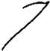

William C. Erbey

Chairman of the Board of Directors
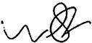

William B. Shepro

Chief Executive Officer and Director
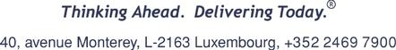

ALTISOURCE PORTFOLIO SOLUTIONS S.A.

40, avenue Monterey

L-2163 Luxembourg City

Grand Duchy of Luxembourg

R.C.S. Luxembourg B 72 391

NOTICE OF SPECIAL MEETING OF SHAREHOLDERS

TO BE HELD ON FEBRUARY 28, 2014

NOTICE

Our Special Meeting of Shareholders will be held:

Date: Friday, February 28, 2014

Time: 9:00 a.m., Central European Time

Location: Altisource Portfolio Solutions S.A.

40, avenue Monterey

L-2163 Luxembourg City

Grand Duchy of Luxembourg

- To approve a share repurchase program whereby Altisource Portfolio Solutions S.A. may repurchase outstanding shares of its common stock within certain limits; and

- To transact such other business as may properly come before the meeting and any adjournment of the meeting.

PROCEDURES

- Our Board of Directors has fixed February 5, 2014 as the record date for the determination of shareholders entitled to notice of and to vote at the Special Meeting of Shareholders.

- Only shareholders of record at the close of business on that date will be entitled to vote at the Special Meeting of Shareholders, unless otherwise provided under Luxembourg law.

By Order of the Board of Directors,
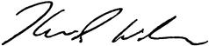

Kevin J. Wilcox

Secretary

February 13, 2014

Luxembourg City, Grand Duchy of Luxembourg

ALTISOURCE PORTFOLIO SOLUTIONS S.A.

PROXY STATEMENT

SPECIAL MEETING OF SHAREHOLDERS

General Information

We have made this proxy statement available to you on or about February 13, 2014, as a holder of common stock of Altisource Portfolio Solutions S.A. ("Altisource" or the "Company") because our Board of Directors is soliciting your proxy to be used at our Special Meeting of Shareholders and at any adjournment or postponement of this meeting. The Special Meeting of Shareholders will be held at our offices located at 40, avenue Monterey, L-2163 Luxembourg City, Grand Duchy of Luxembourg on Friday, February 28, 2014, at 9:00 a.m., Central European Time for the purposes listed in the Notice of Special Meeting of Shareholders.

How a Proxy Works

If you properly complete, sign and return your proxy to Altisource and do not revoke it prior to its use, it will be voted in accordance with your instructions. If no contrary instructions are given, other than as discussed below with respect to broker "non-votes," each proxy received will be voted to approve a share repurchase program whereby Altisource may repurchase outstanding shares of its common stock within certain limits; and with regard to any other business that properly comes before the meeting in accordance with the best judgment of the persons appointed as proxies.

How to Revoke a Proxy

Your proxy may be used only at the Special Meeting of Shareholders and any adjournment or postponement of this meeting and will not be used for any other meeting.

You have the power to revoke your proxy at any time before it is exercised by:

- filing written notice with our Corporate Secretary at the following address:

Kevin J. Wilcox, Corporate Secretary

Altisource Portfolio Solutions S.A.

40, avenue Monterey

L-2163 Luxembourg City

Grand Duchy of Luxembourg

- submitting a properly executed proxy bearing a later date; or

- appearing at the Special Meeting of Shareholders and giving the Corporate Secretary notice of your intention to vote in person.

Who May Vote

Under Luxembourg law, you are entitled to vote at the Special Meeting of Shareholders or any adjournment or postponement of the Special Meeting of Shareholders if you are a holder of record of our common stock on the meeting date, or, if you hold our common stock through a clearing agency, you are a holder as midnight, Luxembourg time on the fourteenth day prior to the meeting date. For purposes of establishing those holders to whom proxies will be mailed, our Board of Directors has set a record date and time of the close of business on February 5, 2014. At the close of business on February 5, 2014, there were 25,412,748 issued shares of which 22,628,618 shares of common stock are outstanding and able to be voted and no other class of equity securities outstanding. Each share of our

1

common stock is entitled to one (1) vote at the Special Meeting of Shareholders on all matters properly presented.

Voting Information

The proposal to approve a share repurchase program whereby Altisource may repurchase outstanding shares of its common stock within certain limits will be approved if the votes cast in favor of the action exceed the votes cast opposing the action, irrespective of the number of shares present or represented at the meeting. Any other matter properly submitted for your consideration at the Special Meeting of Shareholders will be approved with such vote as required by Luxembourg law.

Abstentions and broker "non-votes" will not be counted in determining the votes cast in connection with the foregoing matters. A broker "non-vote" occurs when a shareholder has not provided voting instructions to the broker on a non-routine item. In the event of a broker non-vote, brokers may not vote on behalf of their clients on the above proposals.

If the shares you own are held in "street name" by a bank or brokerage firm, your bank or brokerage firm, as the record holder of your shares, is required to vote your shares according to your instructions. To vote your shares, you will need to follow the directions your bank or brokerage firm provides you. Please contact your bank or brokerage firm for further information.

IMPORTANT NOTICE REGARDING THE AVAILABILITY OF PROXY MATERIALS FOR THE SPECIAL MEETING OF SHAREHOLDERS TO BE HELD ON FEBRUARY 28, 2014: This Proxy Statement can be accessed on our website under Investor Relations—Financial Information at http://ir.altisource.com/financials.cfm or on the Securities and Exchange Commission's website (www.sec.gov). In addition, you may access this proxy statement at www.proxyvote.com, a website that does not identify or track visitors of the site, by entering the 12 digit Control Number found on your Proxy Card in the space provided.

2

APPROVAL OF A SHARE REPURCHASE PROGRAM WHEREBY ALTISOURCE MAY REPURCHASE OUTSTANDING SHARES OF ITS COMMON STOCK WITHIN CERTAIN LIMITS

At the Annual Meeting of Shareholders on May 16, 2012, our shareholders approved a share repurchase program authorizing up to fifteen percent (15%) of the outstanding shares of the Company's stock to be repurchased. Under that program, shares are eligible for repurchase at a minimum price of one dollar ($1.00) per share and a maximum price of one hundred and twenty-five dollars ($125.00) per share. As of February 5, 2014, the total number of shares repurchased under the program amounted to 4.7% of Altisource's 25,412,748 issued shares. On February 5, 2014, the closing trading price of the Company's common stock was one hundred and thirty-three dollars and forty cents ($133.40), which exceeds the upper repurchase limitation of the program. Therefore, the Board of Directors of Altisource has approved presenting a new share repurchase program (the "Share Repurchase Program") to the shareholders, whereby the Board of Directors is empowered to purchase outstanding shares of the Company's stock within the following limits.

The Share Repurchase Program will continue to be subject to Luxembourg law and provides for the equal treatment of shareholders. The term of authorization for repurchases will be five (5) years from the date of shareholder approval. The maximum number of shares authorized to be repurchased will be up to fifteen percent (15%) of shares outstanding as of the date of the shareholder approval. Shares will be eligible for purchase at a minimum price of one dollar ($1.00) per share and a maximum price of five hundred dollars ($500.00) per share. The purchase volumes will be subject to daily volume restrictions per SEC regulations. The Board of Directors shall be empowered to give authority to the Company's Chief Executive Officer, with power of substitution, to decide within the limits of the authorization set out above, the timing and conditions of the Share Repurchase Program.

Altisource has historically demonstrated strong cash earnings capabilities. In lieu of accumulating cash, which provides a low rate of return to shareholders, or paying dividends, which are often subject to double taxation, the Board of Directors believes the Share Repurchase Program will continue to be an effective use of Altisource's cash earnings and will provide flexibility for Altisource to be opportunistic in generating shareholder value. Additionally, the Board of Directors believes the Share Repurchase Program will assist in offsetting shareholder dilution resulting from periodic grants of equity incentive awards.

OUR BOARD OF DIRECTORS UNANIMOUSLY RECOMMENDS THAT YOU VOTE "FOR" THE APPROVAL OF A SHARE REPURCHASE PROGRAM WHEREBY ALTISOURCE MAY REPURCHASE OUTSTANDING SHARES OF ITS COMMON STOCK WITHIN CERTAIN LIMITS

3

SECURITY OWNERSHIP OF CERTAIN BENEFICIAL OWNERS

AND RELATED SHAREHOLDER MATTERS

Beneficial Ownership of Common Stock

The following table sets forth certain information regarding the beneficial ownership of our common stock as of February 5, 2014 by:

- each Director and named executive officer of Altisource;

- all Directors and named executive officers of Altisource as a group; and

- all persons known by Altisource to own beneficially 5% or more of the outstanding common stock.

The table is based upon information supplied to us by Directors, executive officers and principal shareholders and filings under the Exchange Act. Unless otherwise indicated, the address of all persons below is: 40, avenue Monterey, L-2163 Luxembourg City, Grand Duchy of Luxembourg.


Shares Beneficially Owned as of February 5, 2014⁽¹⁾ |  |  | &zwsp;
Name of Beneficial Owner: |  | Amount | Percent
FMR LLC⁽²⁾ |  | 2,031,803 | 8.98%
Neuberger Berman Group LLC⁽³⁾ |  | 1,885,767 | 8.33%
Renaissance Technologies LLC⁽⁴⁾ |  | 1,232,500 | 5.45%
Barry N. Wish⁽⁵⁾ |  | 1,139,329 | 5.03%
Entities Affiliated with Luxor Capital Group, LP⁽⁶⁾ |  | 1,163,431 | 5.14%

 |  | Directors and Named Executive Officers:
 |  | William C. Erbey⁽⁷⁾ | 6,809,683 | 28.97%
 |  | Michelle D. Esterman⁽⁸⁾ | 21,939 | *
 |  | Roland Müller-Ineichen⁽⁹⁾ | 10,837 | *
 |  | W. Michael Linn⁽¹⁰⁾ | 18,273 | *
 |  | William B. Shepro⁽¹¹⁾ | 493,599 | 2.14%
 |  | Timo Vättö⁽¹²⁾ | 9,837 | *
 |  | Kevin J. Wilcox⁽¹³⁾ | 303,978 | 1.33%
 |  | All Directors and Named Executive Officers as a Group (7 persons) | 7,668,146 | 31.56%
* |  | Less than 1%

- For purposes of this table, an individual is considered the beneficial owner of shares of common stock if he or she directly or indirectly has, or shares, voting power or investment power as defined in the rules promulgated under the Exchange Act. Unless otherwise indicated, an individual has sole voting power and sole investment power with respect to the indicated shares. No shares have been pledged as security by the named executive officers or Directors.

- Based on information contained in a Schedule 13G filed with the SEC on February 14, 2013 by FMR LLC ("FMR"). Includes 331,627 shares as to which sole voting power and 2,031,803 shares

4

as to which sole dispositive power is claimed. FMR's address is 82 Devonshire Street, Boston, Massachusetts 02109.

- Based on information contained in a Schedule 13G filed jointly with the SEC on February 13, 2013 by Neuberger Berman Group LLC, Neuberger Berman LLC, Neuberger Berman Management LLC and Neuberger Berman Equity Funds ("Neuberger"). Includes 1,841,670 shares as to which shared voting power and 1,885,767 shares as to which shared dispositive power is claimed. Neuberger's address is 605 Third Avenue, New York, New York 10158.

- Based on information contained in a Schedule 13G filed jointly with the SEC on February 12, 2013 by Renaissance Technologies LLC and Renaissance Technologies Holdings Corporation ("Renaissance"). Includes 1,122,805 shares as to which sole voting power is claimed, 1,199,748 shares as to which sole dispositive power is claimed and 32,752 shares as to which shared dispositive power is claimed. Renaissance's address is 800 Third Avenue, New York, New York 10022.

- Based on information contained in a Schedule 13D/A filed jointly by Barry N. Wish, Wishco, Inc., a Delaware corporation ("Wishco"), and Barry Wish Family Foundation, Inc., a Florida non-profit corporation ("Foundation"), with the SEC on March 13, 2013. Includes (i) 17,000 shares owned by Barry N. Wish directly, (ii) 15,000 shares owned by Foundation, which is controlled by Mr. Wish and (iii) 1,107,329 shares owned by Wishco, which is controlled by Mr. Wish pursuant to his ownership of 93.0% of the common stock thereto. Mr. Wish's address is 1661 Worthington Road, Suite 100, West Palm Beach, Florida 33409.

- Based on the information contained in a Schedule 13G filed with the SEC on May 6, 2013, includes 385,258 shares beneficially owned by Luxor Capital Partners, LP (the "Onshore Fund"); 123,710 shares beneficially owned by Luxor Wavefront, LP (the "Wavefront Fund"); 586,610 shares beneficially owned by Luxor Capital Partners Offshore Master Fund, LP (the "Offshore Master Fund") and, potentially, Luxor Capital Partners Offshore, Ltd. (the "Offshore Feeder Fund"); 40,759 shares beneficially owned by Luxor Spectrum Offshore Master Fund, LP (the "Spectrum Offshore Master Fund") and, potentially, Luxor Spectrum Offshore, Ltd. (the "Spectrum Offshore Feeder Fund"); 1,163,431 shares beneficially owned by Luxor Capital Group, LP ("Luxor Capital Group"), and potentially Luxor Management, LLC ("Luxor Management") and Christian Leone (27,904 of which are held in a separately managed account); and 1,136,337 shares beneficially owned by LCG Holdings, LLC ("LCG Holdings"), and potentially Christian Leone. The Onshore Fund, Luxor Capital Group, LCG Holdings, Luxor Management and Mr. Leone have shared voting and dispositive power over the 385,258 shares of Common Stock individually beneficially owned by the Onshore Fund. The Wavefront Fund, Luxor Capital Group, LCG Holdings, Luxor Management and Mr. Leone have shared voting and dispositive power over the 123,710 shares of Common Stock individually beneficially owned by the Wavefront Fund. The Offshore Master Fund, the Offshore Feeder Fund, Luxor Capital Group, LCG Holdings, Luxor Management and Mr. Leone have shared voting and dispositive power over the 586,610 shares of Common Stock individually beneficially owned by the Offshore Master Fund. The Spectrum Offshore Master Fund, the Spectrum Offshore Feeder Fund, Luxor Capital Group, LCG Holdings, Luxor Management and Mr. Leone have shared voting and dispositive power over the 40,759 shares of Common Stock individually beneficially owned by the Spectrum Offshore Master Fund. Luxor Capital Group, Luxor Management and Mr. Leone have shared voting and dispositive power over the 27,094 shares of Common Stock held in a separately managed account. The business address of each of the Onshore Fund, the Wavefront Fund, Luxor Capital Group, Luxor Management, LCG Holdings and Mr. Leone is 1114 Avenue of the Americas, 29th Floor, New York, New York 10036. The business address of each of the Offshore Master Fund, the Offshore Feeder Fund, the Spectrum Offshore Master Fund and the Spectrum Offshore Feeder Fund is c/o M&C

5

Corporate Services Limited, P.O. Box 309 GT, Ugland House, South Church Street, George Town, Grand Cayman, Cayman Islands.

- Includes options to acquire 873,501 shares which are exercisable on or within 60 days after February 5, 2014. Includes 5,935,932 shares held by Salt Pond Holdings, LLC, a United States Virgin Islands limited liability company, of which the members are William C. Erbey and his spouse, E. Elaine Erbey; FF Plaza Limited Partnership, a Delaware partnership, of which the partners are Mr. and Mrs. Erbey and Delaware Permanent Corporation, a Delaware corporation wholly owned by Mr. Erbey; and Erbey Holding Corporation, a Delaware corporation, wholly owned by Mr. Erbey. Includes 250 shares of unvested restricted common stock, subject to forfeiture until vested.

- Consists of options to acquire 21,939 shares which are exercisable on or within 60 days after February 5, 2014.

- Includes 250 shares of unvested restricted common stock, subject to forfeiture until vested.

- Includes (a) 2,338 shares held by Brown's Valley Development Co, LP; (b) 3,019 shares held by Stella-Rowan CO LP, a limited partnership in which Mr. Linn's spouse, Elizabeth S. Linn, is a 99% partner; (c) 400 shares held by Mr. Linn's minor child(ren) or adult children sharing the same household; (d) 2,000 shares held by W M Linn Trust; (e) 176 shares held by the William Michael Linn, Roth IRA; (f) 315 shares held by the Elizabeth S. Linn, Roth IRA and (g) 224 shares held by William M. Linn, Simple IRA. Includes 250 shares of unvested restricted common stock, subject to forfeiture until vested.

- Includes options to acquire 468,716 shares which are exercisable on or within 60 days after February 5, 2014. Includes 24,883 shares held by the William B. Shepro Revocable Trust. Mr. and Mrs. William B. Shepro share voting and dispositive power with respect to these shares.

- Includes 250 shares of unvested restricted common stock, subject to forfeiture until vested.

- Includes options to acquire 303,246 shares which are exercisable on or within 60 days after February 5, 2014.

6

SHAREHOLDER PROPOSALS FOR THE 2014 ANNUAL MEETING

Any proposal which a shareholder desires to have included in our proxy materials relating to our next Annual Meeting of Shareholders, which is scheduled to be held on May 21, 2014, must have been received at our executive offices no later than December 3, 2013.

For any proposal that is not submitted for inclusion in the 2014 Annual Meeting proxy statement, but is instead sought to be presented directly at the 2014 Annual Meeting of Shareholders, SEC rules permit management to vote proxies in its discretion if we:

- receive notice of the proposal before the close of business on February 16, 2014 and advise shareholders in the 2014 Annual Meeting proxy statement about the nature of the matter and how management intends to vote on such matter, or

- do not receive notice of the proposal prior to the close of business on February 16, 2014.

Notice of intent to present a proposal at the 2014 Annual Meeting of Shareholders should be directed to our Corporate Secretary at Altisource Portfolio Solutions S.A., 40, avenue Monterey, L-2163 Luxembourg City, Grand Duchy of Luxembourg.

OTHER MATTERS

Proxies will be solicited on behalf of the Board of Directors by mail, and we will pay the solicitation costs. Copies of this proxy statement will be made available to brokers, dealers, banks and voting trustees, or their nominees, for the purpose of soliciting proxies from beneficial owners. In addition to solicitations by mail, our Directors, officers and employees may solicit proxies personally or by telephone without additional compensation.

The shares represented by all valid proxies received will be voted in the manner specified. Where specific choices are not indicated, the shares represented by all valid proxies received will be voted for approval of a share repurchase program whereby Altisource may repurchase outstanding shares of its common stock within certain limits. Should any matter not described above be properly presented at the meeting, the persons named in the proxy form will vote in accordance with their judgment.

If you are the beneficial owner, but not the record holder of shares of our common stock and have requested a copy of this proxy statement, your broker, bank or other nominee may only deliver one (1) copy of this proxy statement to multiple shareholders who share an address unless that nominee has received contrary instructions from one (1) or more of the shareholders. Shareholders at an address to which a single copy of this proxy statement was sent may request a separate copy by contacting Investor Relations, Altisource Portfolio Solutions S.A., 40, avenue Monterey, L-2163 Luxembourg City, Grand Duchy of Luxembourg, or by calling our Investor Relations department at +352 2469 7950. Beneficial owners sharing an address who are receiving multiple copies and who wish to receive a single copy of the materials in the future will need to contact their broker, bank or other nominee to request that only a single copy of each document be mailed to all shareholders at the shared address.

ALL STOCKHOLDERS ARE URGED TO EXECUTE THE ACCOMPANYING PROXY AND TO RETURN IT PROMPTLY IN THE ACCOMPANYING ENVELOPE. STOCKHOLDERS MAY REVOKE ANY PROXY IF SO DESIRED AT ANY TIME BEFORE IT IS VOTED.

7

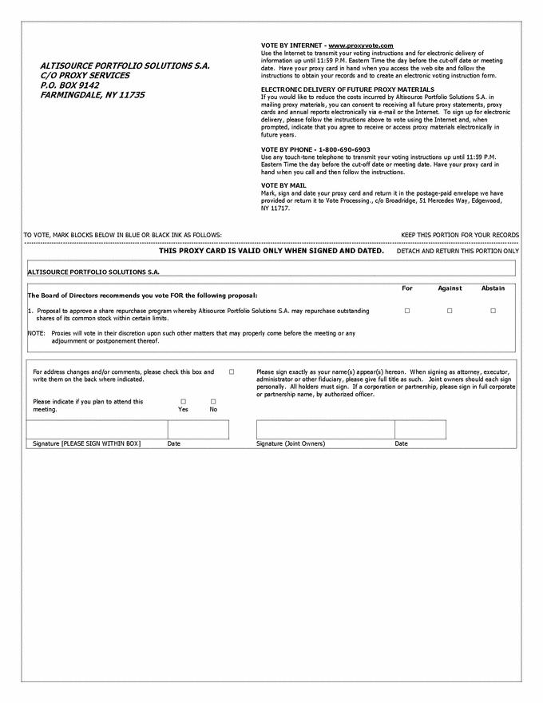

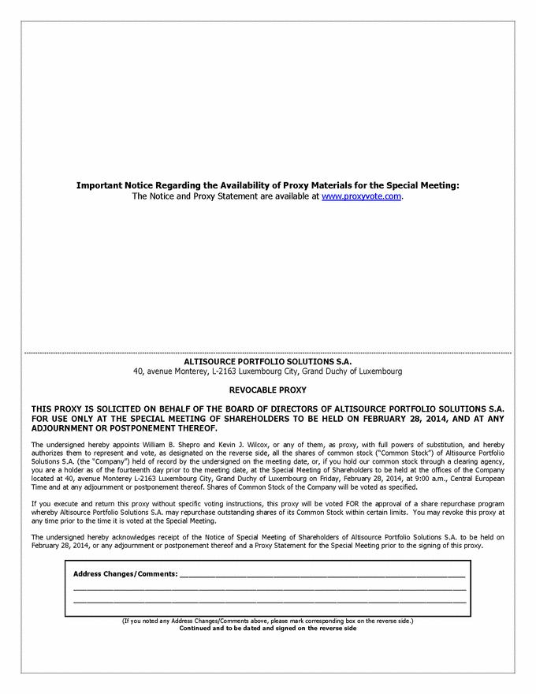

QuickLinks

ALTISOURCE PORTFOLIO SOLUTIONS S.A. 40, avenue Monterey L-2163 Luxembourg City Grand Duchy of Luxembourg R.C.S. Luxembourg B 72 391 NOTICE OF SPECIAL MEETING OF SHAREHOLDERS TO BE HELD ON FEBRUARY 28, 2014
ALTISOURCE PORTFOLIO SOLUTIONS S.A. PROXY STATEMENT SPECIAL MEETING OF SHAREHOLDERS

APPROVAL OF A SHARE REPURCHASE PROGRAM WHEREBY ALTISOURCE MAY REPURCHASE OUTSTANDING SHARES OF ITS COMMON STOCK WITHIN CERTAIN LIMITS

SECURITY OWNERSHIP OF CERTAIN BENEFICIAL OWNERS AND RELATED SHAREHOLDER MATTERS SHAREHOLDER PROPOSALS FOR THE 2014 ANNUAL MEETING OTHER MATTERS

